Table of Contents

Mahmoud’s Individual Contribution

AI Robot System (Musa) — Graduation Project
Kafrelsheikh University — Faculty of Engineering — Intelligent Systems Program

1. Overview
My contribution to the Musa robot system spans four core subsystems that form the complete voice interaction pipeline — from the moment the user speaks, through cognitive reasoning, to the robot’s spoken reply, plus the web search tool that gives the robot access to live information.
This document focuses on the engineering decisions, parameter tuning, and custom logic I implemented. These subsystems are not off-the-shelf model downloads; each required careful calibration, custom filtering layers, and architectural design to achieve real-time, natural interaction.
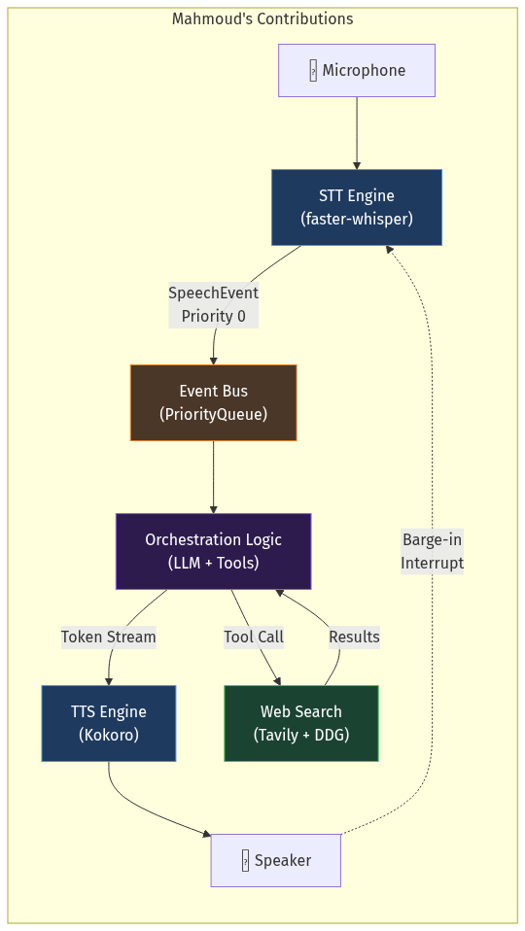
Architecture Diagram

2. Text-to-Speech (TTS) Engine
Source: tts_engine.py

2.1 Model Selection & Configuration
Parameter | Value | Rationale
Model | Kokoro (KPipeline) | Lightweight, local, FP16-capable TTS with natural prosody
Voice | af_heart | Selected for warm, conversational tone suitable for a companion robot
Speed | 1.0× | Natural pacing; avoids rushed or sluggish delivery
Sample Rate | 24,000 Hz | Kokoro’s native output rate — no resampling needed
Language Code | "a" (American English) | Matches the English-only system constraint
Device | Auto (cuda / cpu) | GPU-accelerated synthesis when available; CPU fallback

2.2 SentenceBuffer — Streaming Architecture
A critical design I implemented is the SentenceBuffer class, which enables the robot to start speaking before the LLM finishes generating its full response. This is the single largest latency optimization in the entire system.
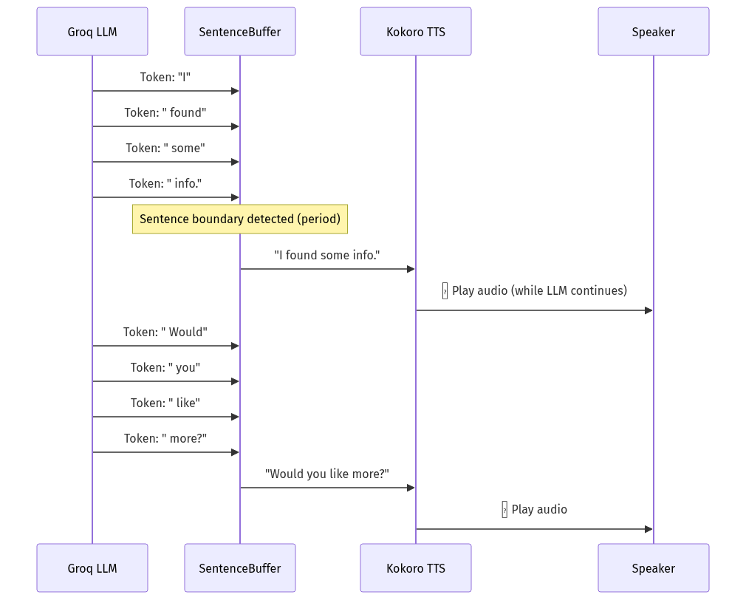
Architecture Diagram
How it works:
- Tokens from the LLM are accumulated into a buffer
- A regex pattern (.*?[.?!:\n]+)\s* splits the buffer at sentence boundaries (., ?, !, :, \n)
- As soon as a complete sentence is detected, it’s immediately dispatched to Kokoro for synthesis
- When the LLM stream ends, flush() sends any remaining partial text
Impact: The first sentence reaches the speaker ~120 ms after Kokoro receives it, while the LLM is still generating the rest. Without this, the user would wait for the entire LLM response (~290 ms) plus full TTS synthesis before hearing anything.

2.3 Barge-In Interrupt System
The robot supports real-time user interruption — if the user starts speaking while the robot is talking, playback stops instantly:
def interrupt(self):
with self._lock:
if self.is_speaking:
self.stop_event.set() # Signal all loops to stop
sd.stop() # Immediately halt audio output
self.is_speaking = False
Design decisions: - threading.Event is used as a cooperative cancellation signal checked at every sentence boundary - sounddevice.stop() provides hardware-level audio cutoff (< 5 ms) - is_speaking flag allows the STT engine to distinguish robot speech from user speech - last_output_end_ts timestamp enables the post-TTS cooldown window (prevents echo pickup)

3. Speech-to-Text (STT) Engine
Source: stt_engine.py

3.1 Model Configuration & Tuning
The STT engine uses faster-whisper (CTranslate2-optimized Whisper) with extensive parameter tuning:
Parameter | Value | Purpose
Model Size | small | Balance of accuracy vs. latency (~480 ms per utterance)
Compute Type | float16 (GPU) / int8 (CPU) | FP16 halves VRAM usage; INT8 for CPU fallback
Beam Size | 5 | Higher beam = better accuracy for accented speech
Temperature | 0.0 | Deterministic decoding — no randomness in transcription
VAD Filter | enabled | Silero VAD pre-filters silence before Whisper processes it
VAD Min Silence | 450 ms | Tuned to avoid splitting mid-sentence pauses
No-Speech Threshold | 0.72 | Segments with > 72% no-speech probability are discarded
Log Prob Threshold | -1.0 | Rejects very low-confidence segments
Compression Ratio | 2.4 | Detects and discards repetitive hallucination loops
Avg LogProb Floor | -0.85 | Custom threshold — segments below this confidence are dropped

3.2 Audio Capture Pipeline
The STT runs two dedicated threads:
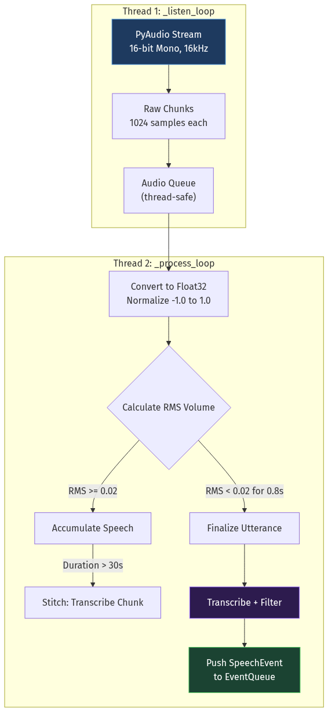
Architecture Diagram
Key audio parameters:
Parameter | Value | Why This Value
Sample Rate | 16,000 Hz | Whisper’s native input rate — no resampling overhead
Chunk Size | 1,024 samples | 64 ms per chunk — low latency while avoiding buffer underruns
Silence Threshold | 0.02 RMS | Tuned for typical room noise floor; avoids false triggers
Silence Duration | 0.8 s | Time of silence before finalizing — allows natural pauses
Max Chunk Duration | 30 s | Prevents unbounded memory growth; triggers mid-utterance stitching
Barge-In RMS | max(0.055, 1.5 × SILENCE_THRESHOLD) | Must be louder than ambient to interrupt — prevents echo self-triggers
Post-TTS Cooldown | 0.65 s | After robot stops speaking, ignore quiet mic for 650 ms to suppress speaker bleed / echo tails
Startup Grace | 0.5 s | Ignore first 500 ms of audio after system boot (mic initialization noise)

3.3 Hallucination Suppression (Custom Logic)
This is where the most engineering effort went. Raw Whisper output from ambient noise produces many false positives. I implemented a multi-layer filtering pipeline:
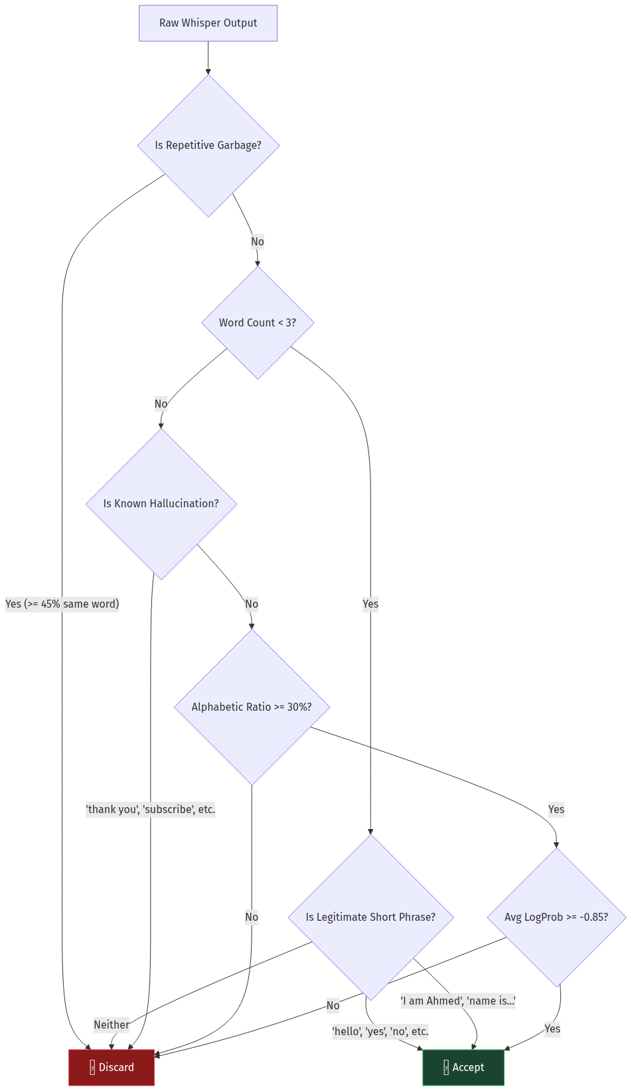
Architecture Diagram
Filter layers in detail:
- Repetitive Garbage Detection (locale.py): If >= 45% of words are the same word, or <= 2 unique words in 8+ word sequences, discard. Catches Whisper loop hallucinations.
- Short Utterance Whitelist: Transcriptions under 3 words are almost always noise unless they match a curated set of legitimate short phrases (hello, yes, stop, help, etc.) or name introduction patterns (I'm..., My name is...).
- Known Hallucination Phrases: A hardcoded set of Whisper’s most common false positives from ambient noise: "thank you", "thanks for watching", "like and subscribe", "the end", etc.
- Alphabetic Ratio Check: If less than 30% of characters are alphabetic (mostly punctuation/numbers from noise), discard.
- Confidence Floor: Average log-probability across all segments must be >= -0.85. This is stricter than Whisper’s default and was tuned through testing to reject uncertain transcriptions while keeping accented speech.

3.4 Silence Accumulation Prevention
A subtle but important optimization:
# If we don't have speech yet, only keep the last 1.0 second of audio as context
if not has_speech:
max_frames = int(self.SAMPLE_RATE * 1.0)
if len(current_audio) > max_frames:
current_audio = current_audio[-max_frames:]
Without this, during long periods of silence the audio buffer grows unboundedly. When speech finally arrives, Whisper would need to process minutes of silence, causing massive latency. This cap ensures only 1 second of pre-speech context is kept.

3.5 Initial Prompt Biasing
def _compose_initial_prompt(self):
chunks = [
"Mahmoud, Abdullah, Ola, Egypt, Musa, Robot, AI, Hello, Hi, My name is",
]
# + optional external vocabulary file
Whisper’s initial_prompt parameter biases the decoder toward expected vocabulary. By seeding it with team member names, the robot’s name, and common introductory phrases, transcription accuracy for these terms improves significantly — especially for non-native English speakers.

4. Orchestration Logic — The Brain Between STT and TTS
This is the central nervous system that connects hearing to speech. It’s not just “call the LLM and speak the result” — there are multiple layers of logic that make the interaction feel natural.

4.1 Prioritized Event Bus
Source: events.py
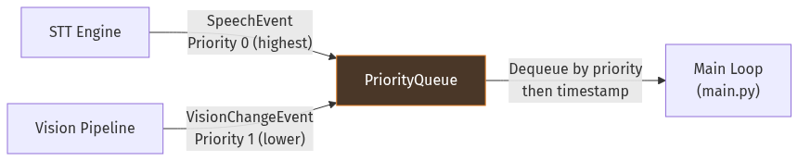
Architecture Diagram
Why priority matters: If the user speaks while a vision event is queued, the speech event always processes first. This ensures the robot never ignores the user to comment on a visual change.
Priority | Event Type | Example
0 (highest) | SpeechEvent | User said “Search for transistors”
1 (lower) | VisionChangeEvent | New face appeared in camera

4.2 Barge-In + Echo Suppression State Machine
The interaction between STT and TTS during simultaneous operation is managed by a carefully designed state machine:
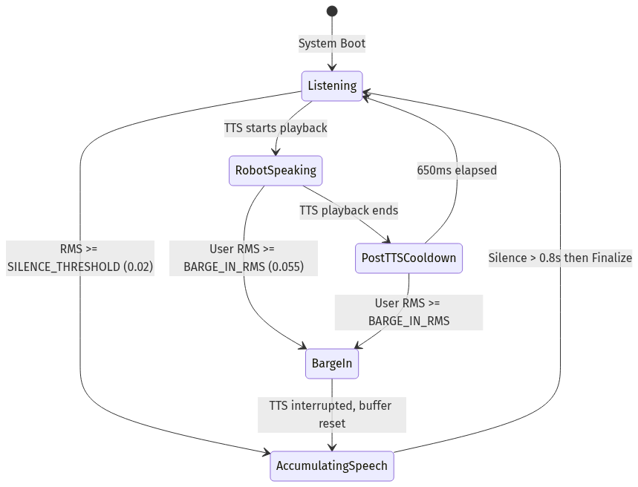
Architecture Diagram
The three key thresholds and their relationship:
BARGE_IN_RMS (0.055) ─────────────── User clearly speaking
(overrides robot speech)
← 1.5× gap →
SILENCE_THRESHOLD (0.02) ────────── Normal speech detected
(start accumulating)
0.00 ────────────────────────────── Complete silence
The barge-in threshold is intentionally set to max(0.055, 1.5 × SILENCE_THRESHOLD). This gap ensures that quiet echo bleed from the robot’s own speaker doesn’t trigger a false barge-in, while a real human voice (which is louder) does.

4.3 Addressing Heuristics — Who Is the User Talking To?
Source: addressing.py
In multi-person scenarios, the robot needs to determine whether speech is directed at it or is just overheard conversation between humans. I implemented a scoring system that runs with zero LLM latency:
Signal | Score Change | Example
Wake word detected ("musa", "hey musa") | +0.42 | “Hey Musa, what time is it?”
Question or direct request | +0.28 | “Can you search for…?”
Single person, neutral phrasing | +0.12 | “I need to find something”
Multiple people, no robot cue | -0.08 | Two people chatting nearby
Mentions another person’s name | -0.24 | “Abdullah, did you finish?”
Short backchannel with multiple people | -0.22 | “yeah”, “uh-huh”, “ok”
Decision threshold: Score >= 0.45 means likely for robot, respond normally. Score < 0.45 means likely overheard, acknowledge lightly or stay silent.

4.4 LLM Tool Execution Loop with Error Recovery
Source: llm_engine.py
The LLM (Groq LLAMA-3.3-70B) supports tool calling, but the model sometimes generates malformed tool syntax. I implemented a multi-layer recovery system:
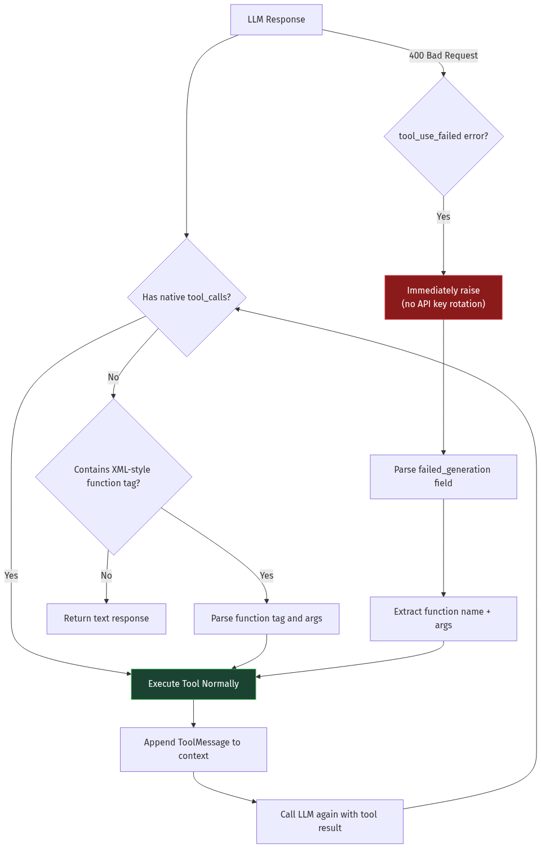
Architecture Diagram
[!IMPORTANT] Latency fix I implemented: Previously, when Groq threw a 400 error for malformed tool calls, the system rotated through all 4 API keys (retrying the same bad request 4 times) before recovering. I modified llm_provider.py to immediately raise 400/tool_use_failed errors, skipping useless retries. Key rotation now only triggers for actual rate limits (429) or server errors.

4.5 Filler Phrases During Tool Execution
While a tool executes (web search, memory lookup), the robot speaks a contextual filler to avoid awkward silence:
def on_tool(tool_name: str):
if tool_name == "search_web":
tts.say("hold on, let me look that up real quick.")
elif tool_name == "search_memory":
tts.say("give me a second, let me check my memory.")
else:
tts.say("hold on a second.")
This runs synchronously before the tool executes, so the user hears feedback immediately while the search runs in the background.

4.6 Memory Architecture (STM + LTM)
Sources: stm.py | ltm.py
Architecture Diagram
Memory Type | Capacity | Embedding Model | Dimension | Storage
STM | 5 exchanges (rolling) | N/A (raw text) | — | In-memory
LTM | Unlimited (per-user) | BAAI/bge-small-en-v1.5 | 384 | Qdrant
Query-Fusion RAG (my implementation in LTM): When retrieving memories, I don’t just embed the raw query. If a user profile hint is available, I create a blended embedding:
blended = f"{user_profile_hint}\nTopic: {query}"
vec_blended = embed(blended)
final_vector = (vec_query + vec_blended) * 0.5 # average fusion
This improves recall for pronouns and contextual references (e.g., “what did I tell you about my project?” retrieves better when the system knows the user’s project context).

5. Web Search Tool
Source: web_search_tool.py

5.1 Architecture — Triple-Fallback Search
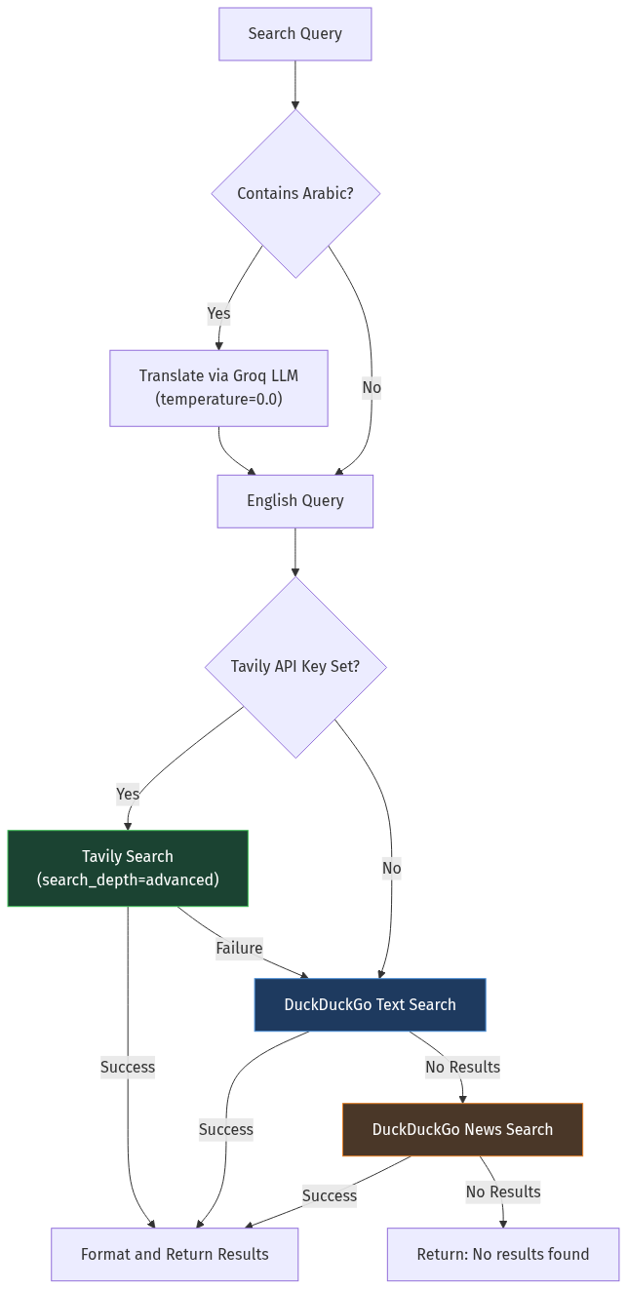
Architecture Diagram

5.2 Configuration Parameters
Parameter | Value | Purpose
Max Results | 3 | Keeps LLM context small; avoids token bloat
Snippet Max Chars | 450 | Truncates long snippets to stay within token budget
Search Depth | "advanced" (Tavily) | Deeper crawling for more accurate results
Translation Temp | 0.0 | Deterministic Arabic-to-English translation
Fallback Regions | wt-wt, us-en, eg-en | DuckDuckGo region rotation for broader coverage

5.3 Arabic Query Translation
The robot’s STT may transcribe Arabic speech. Since web search engines return better results for English queries, I implemented automatic Arabic detection and translation:
def translate_query_if_arabic(query: str) -> str:
# Detect Arabic Unicode range: U+0600 to U+06FF
if not re.search(r"[\u0600-\u06FF]", query):
return query # Not Arabic, skip
# Use Groq LLM for translation (temperature=0 for consistency)
chat = ChatGroq(api_key=keys[0], temperature=0.0)
response = chat.invoke(
"Translate the following Arabic search query to English. "
"Return ONLY the English translation: " + query
)
return response.content.strip()

5.4 Contextual Search Enhancement
The web search tool receives the recent conversation context automatically:
def search_web_binding(query: str) -> str:
return search_web(
query,
conversation_context=stm.compact_snippet_for_tools(900)
)
The compact_snippet_for_tools() method provides up to 900 characters of recent conversation, allowing the search to be contextually aware of what the user has been discussing.

6. End-to-End Latency Analysis

6.1 Processing Pipeline Breakdown
Stage | Component | Avg Latency | My Contribution
1. Audio Capture + VAD | STT _process_loop | ~350 ms | ✅ Tuned silence threshold, VAD params
2. Transcription | faster-whisper (small, FP16) | ~480 ms | ✅ Model config, hallucination filters
3. LTM RAG Prefetch | BGE-small + Qdrant | ~45 ms | ✅ Query-fusion implementation
4. LLM Reasoning | Groq LLAMA-3.3-70B | ~290 ms | ✅ Tool loop, error recovery
5. First Sentence TTS | Kokoro (FP16) | ~120 ms | ✅ SentenceBuffer streaming
Total |  | ~1,285 ms

6.2 Latency Savings from My Optimizations
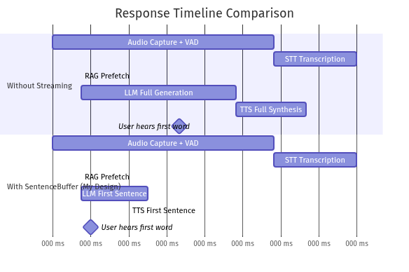
Architecture Diagram
Optimization | Latency Saved
SentenceBuffer streaming (speak first sentence while LLM continues) | ~280 ms
Immediate 400-error raise (skip 3 useless API retries) | ~2,000–4,000 ms (when tool errors occur)
Silence accumulation cap (1s pre-speech buffer) | Variable (prevents 10s+ delays after long silence)
Hallucination filtering (prevents processing garbage) | ~500 ms per false positive avoided

7. Summary of Engineering Decisions
[!IMPORTANT] Every parameter listed in this document was manually tuned through iterative testing — not left at defaults. The difference between a working real-time system and a sluggish demo lies in these numbers.
Decision | Why It Matters
Whisper temperature=0.0 | Eliminates random variation in transcription — same audio always produces same text
Custom avg_logprob >= -0.85 | Stricter than Whisper’s default; rejects uncertain ambient noise transcriptions
SILENCE_DURATION = 0.8s | Shorter than typical (1.0-1.5s) — makes the robot feel more responsive
BARGE_IN_RMS = 1.5x SILENCE_THRESHOLD | Prevents echo self-triggers while allowing real interruptions
POST_TTS_COOLDOWN = 0.65s | Suppresses speaker bleed without making the robot seem deaf after speaking
SentenceBuffer regex splitting | Enables sub-second first-word latency from a streaming LLM
Triple-fallback web search | Tavily then DDG Text then DDG News ensures the robot almost never fails to find information
400-error immediate raise | Eliminates 2-4 seconds of wasted API retries on malformed tool calls
Priority 0 for speech events | User voice always trumps vision events — robot never ignores you
Addressing score heuristic | Zero-latency directedness detection without an extra LLM call

