\*Note: The following examples are similar to real-world projects that I have developed using SSAS Multi-Dimensional. These were re-created using the WorldWideImportersDW database with SQL Server 2016 for demonstration purposes.

1. SSAS Example: A Multi-Dimensional Analysis Cube:

The following shows a simple star-schema Multi-Dimensional Cube that I created from a data warehouse, using the relationships that are defined in the source database.

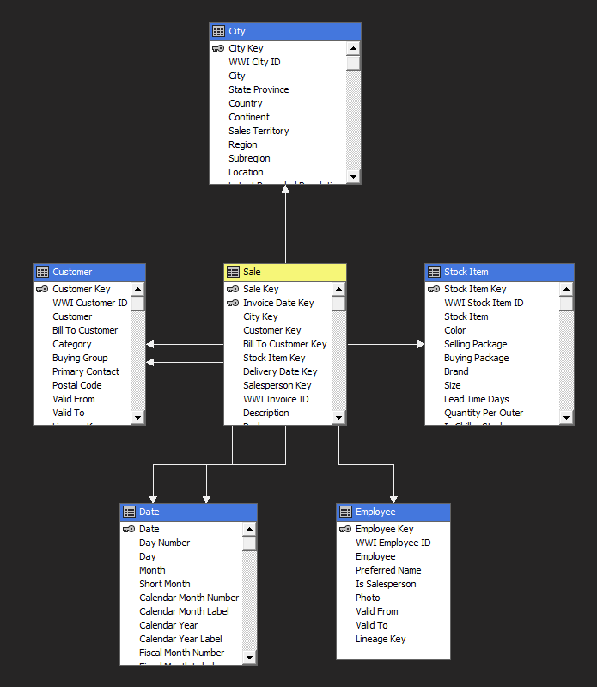

2. SSAS Example: Use of Cube Mining Structures:

The following is an example of creating/using a Mining Structure with a Multi-Dimensional Cube, for the purpose of data-mining and predictive analysis to aid the end-user in making business decisions.

