\*Note: These are real-life examples that I have used on projects, and then re-created for this demonstrational document using the WorldWideImporters and WorldWideImportersDW sample databases for SQL Server 2016.

1. SSAS Tabular Example: Data Model using Star Schema:

This is an example of an SSAS Tabular data model that was created with a Data Warehouse source, making use of the relationships that are defined within the database.

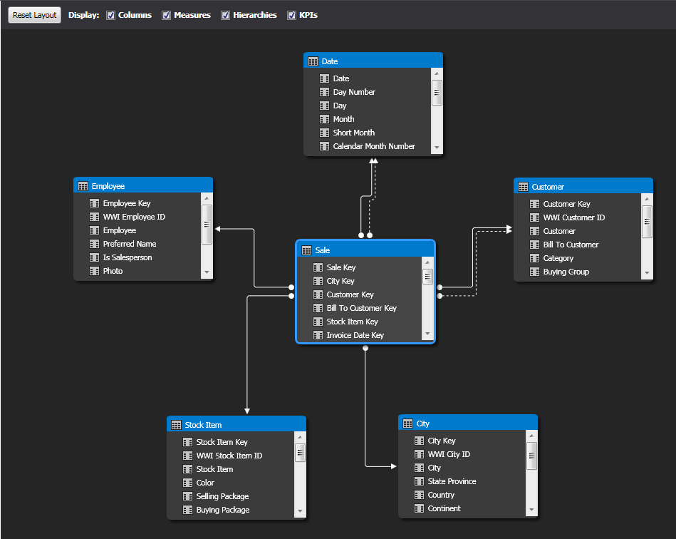

1. SSAS Tabular Example: Using features such as DAX and Hierarchies to improve end-user analysis:

This is an example of creating additional measures/calculations in the data model, as well as creating hierarchies of related data, so that the end user has more options to choose from when analyzing this data and gives them a better overall experience.

