\*Note: These are real-life examples that I have used on projects, and then re-created for this demonstrational document using the WorldWideImporters and WorldWideImportersDW sample databases for SQL Server 2016.

1. SSIS Example: Data Warehouse Dimension Table:

SSIS Data Flow example, which uses a SQL Server View from a transactional database as its source and uses components such as Lookup, Slowly Changing Dimension, Derived Column, Data Conversion and OLE DB Command to make appropriate updates/inserts into a Data Warehouse dimension table.

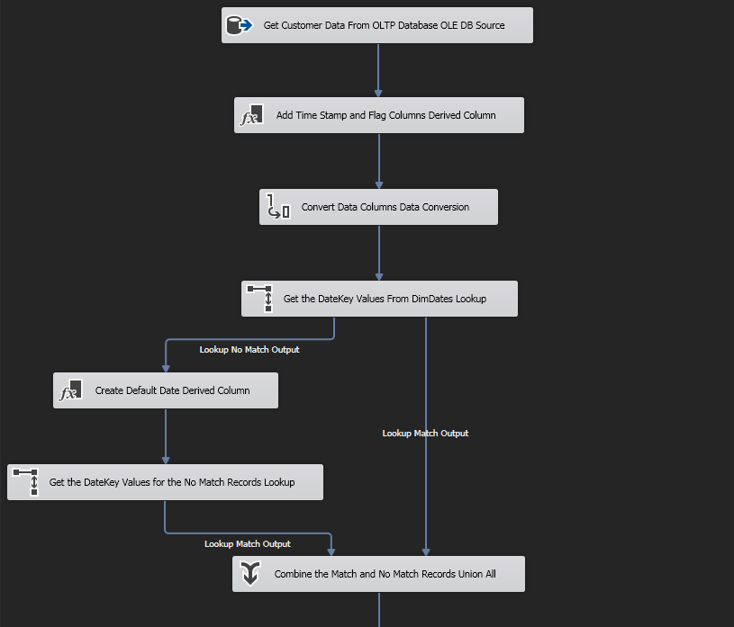

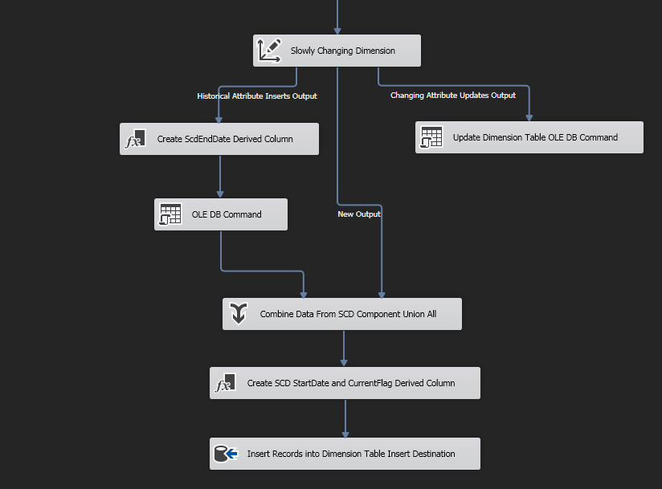

1. SSIS Example: Data Warehouse Fact Table:

SSIS Data Flow example, which uses a .csv file from a transactional database (it is downloaded after being generated by a server-side web service) as its source and uses components such as Lookups with match, no match and error paths, Derived Column and Data Conversion to insert new measure records into a Data Warehouse fact table.

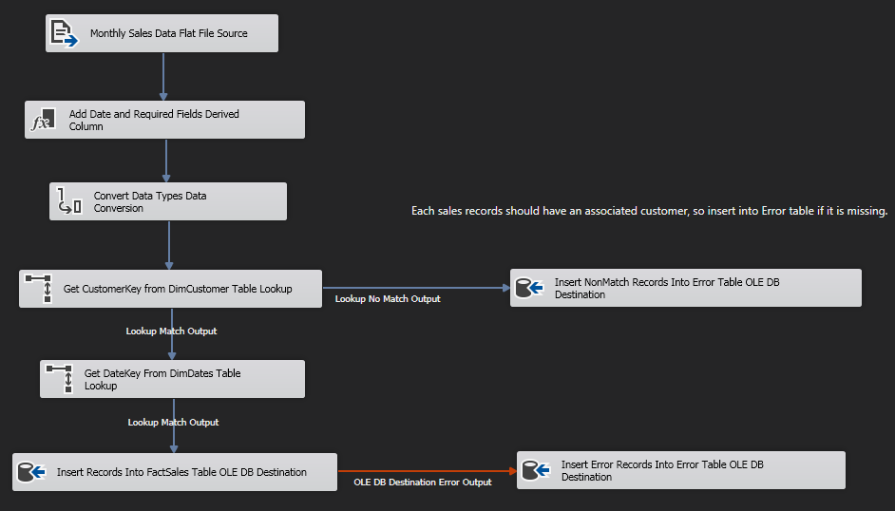

1. SSIS Example: Project Parameters, Environments, Expressions and C# Scripts:

SSIS Examples of using Project Parameters, Environments, Expressions and C# Script Components so that properties such as server name, database name, file source and destination, variable values, etc. can be set dynamically at both run and pre-execution time, and can also be used globally throughout a project.



