CS 148 Database Design for the Web

Alexander DiSanto

Assignment Final

Clip Notes

Version <1.0>

|  |  |  |  |
| --- | --- | --- | --- |
| Time Log | | | |
| Date | Time Spent (in hours) | Description | Author |
|  |  |  |  |
|  |  | Your estimated time to complete assignment: 36 hours |  |
|  |  |  |  |
|  |  |  |  |
|  |  |  |  |
|  |  |  |  |
|  |  |  |  |
|  |  |  |  |
|  |  |  |  |
|  |  |  |  |
|  |  |  |  |
|  |  |  |  |
|  |  |  |  |
|  |  |  |  |
|  |  |  |  |
|  |  |  |  |
|  |  |  |  |
|  |  |  |  |
|  |  |  |  |
|  |  |  |  |
|  |  |  |  |
|  |  |  |  |
|  |  |  |  |
|  |  |  |  |
|  |  |  |  |
|  |  |  |  |
|  |  |  |  |
|  |  |  |  |
|  |  |  |  |

Table Of Contents

Software Requirements Specifications 4

Introduction 4

Purpose 4

Definitions, acronyms, and abbreviations 4

Overview 4

Overall Description 5

Data Dictionary 5

E-R Diagram 5

Schema 5

Story Board 5

Specific requirements 5

# Software Requirements Specifications

## Introduction

### Purpose

The purpose of this document is to describe the requirement specification for the web site “Making the world a Better Place”.

The intended audience for this document is the prospective developers of this site. The goal being that you can give this document to someone and they can make the site without having to ask any questions.

### Definitions, acronyms, and abbreviations

HTML – Hypertext markup language – used to define your conent.

PHP – Personal Home Page – language that helps to customize html.

CSS – Cascading Style Sheets – used to define the look of a web site.

W3 Validation – refers to both Html and CSS validation tool provided by the W3c.org. the html validator is located at:

<http://validator.w3.org/>

with the CSS validator located at:

<http://jigsaw.w3.org/css-validator/>

### Overview

The rest of this document contains an overall description of the Making the World a Better Place web site.

## Overall Description

This site allows you to leave your self and others notes online using UVM authentication. These notes will hopefully be able to also include files and be organized like sticky notes with time important deadlines.

### Data Dictionary

### E-R Diagram

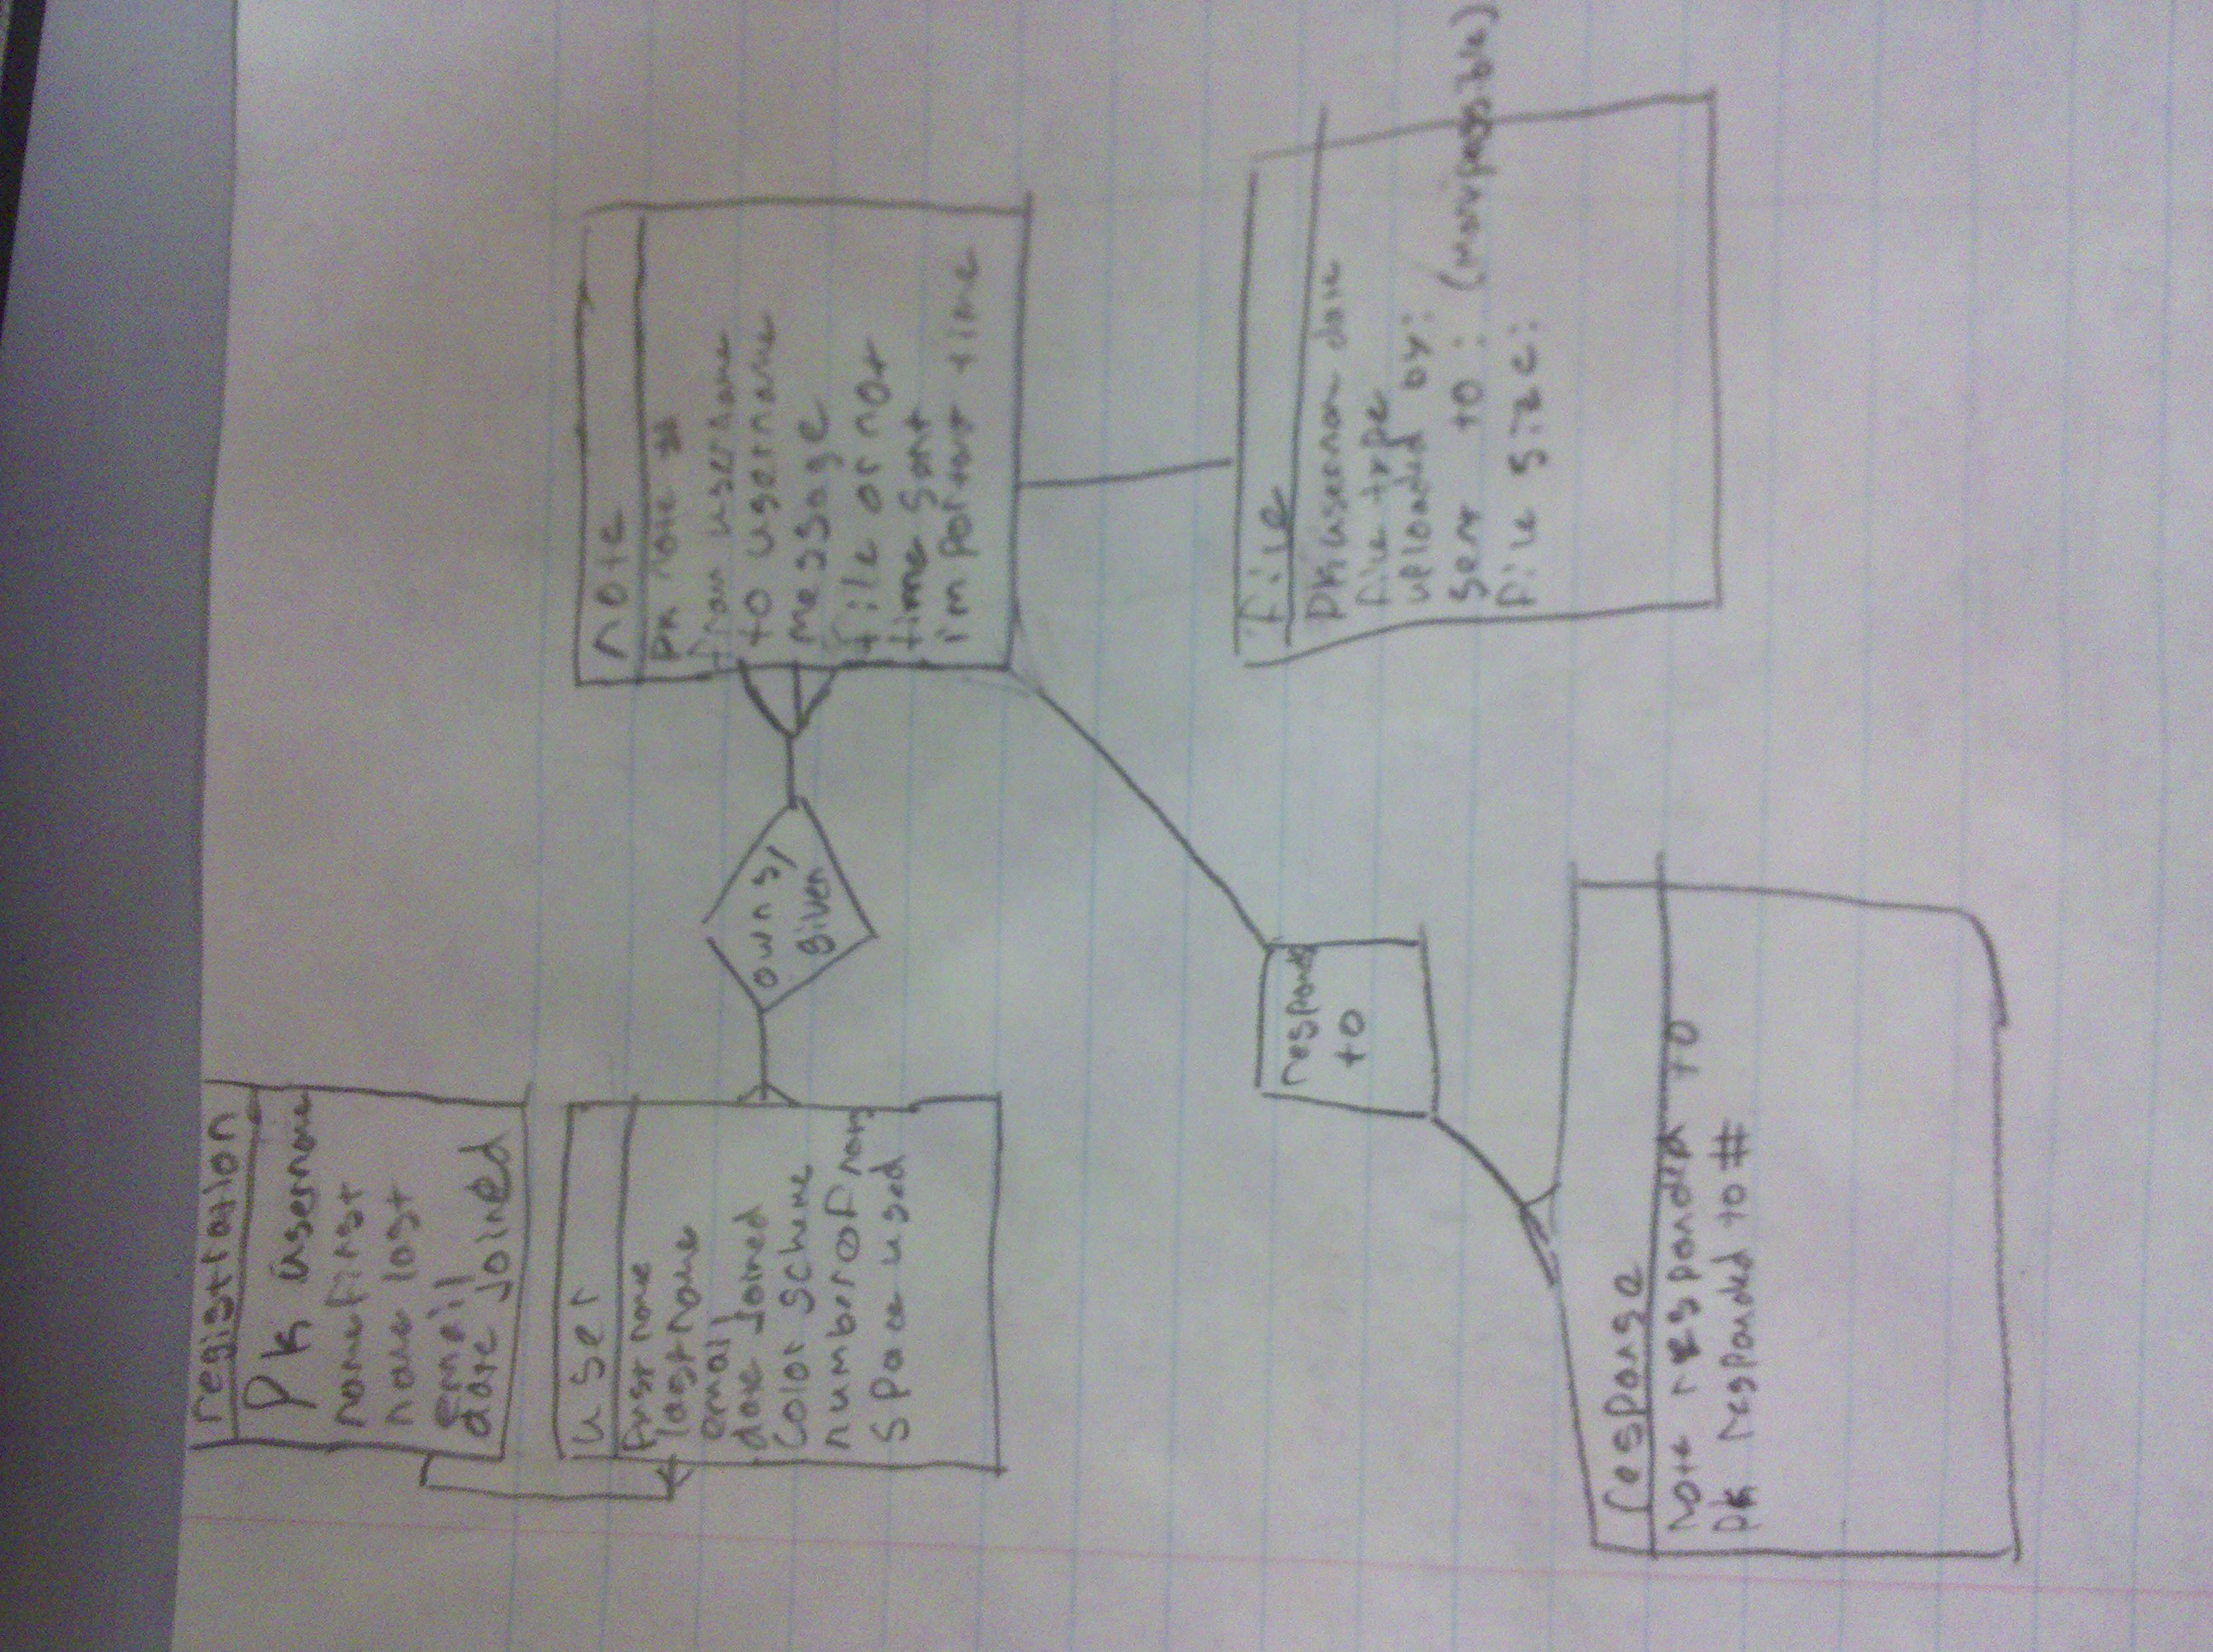

### Schema

### Story Board

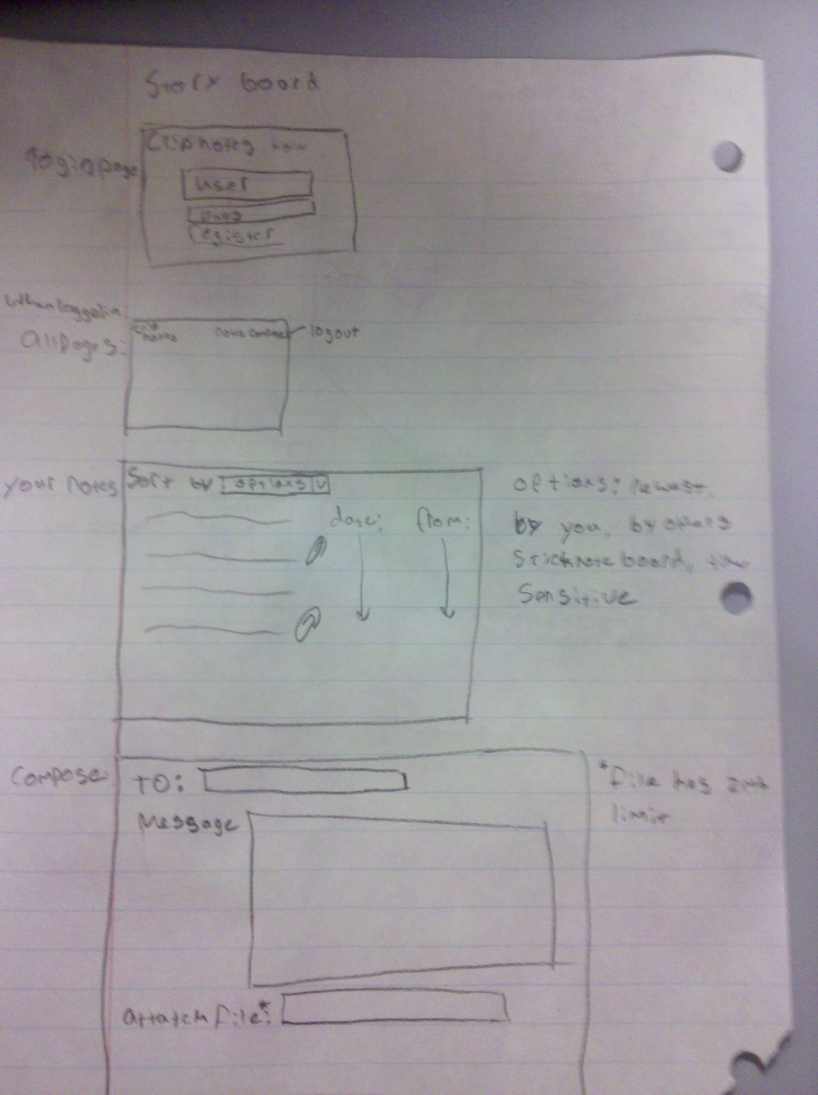

## Specific requirements

Here is just a list of things I will require you really need to write the specific requirements as they relate to your project.

1. *Location* – all files will be located in the public folder of my UVM account in the cs148/assignment7.1 folder. All files will also be available from github user apdisant repository cs148_final_project.
2. *Html Validation* – All pages will pass W3C Html validation for html 5.
3. *CSS Validation* – All pages will pass W3C 3.0 CSS validation.
4. *Meta Information* – All pages will contain a proper title tag, Meta tags (author, character set and description).
5. *CSS* – all pages will have a linked style sheet.
6. *Navigation* – All pages will contain navigation to all other pages on the site using an ordered list. Be sure to enclose the navigation in the correct element.
7. *Content* – Each page will have a minimum of 150 words not counting titles, lists or links. Be sure to use the correct elements to hold your content.
8. *Browser compatibility* - This site will be checked on Firefox, Safari, Chrome and Internet Explorer.
9. *File Names* – the main home page will be called home.php with the rest of the file names making sense.