# 2.1 Introduction to Analysis

Analysis is essential procedure in any system development. Analysis helps to identify the actual requirements of the system. By taking an analysis, we can identify the stakeholder, actual requirements, benefits, and cost for the system development.   
For this system Online Cosmetic Portal, I have taken analysis in different aspects. Primarily, I have identify the methodology to use for analysis. Then analyzing weather this system is feasible in many of the aspects to build. System requirements are identified and prioritized.

# 2.2 Analysis Methodology:

For this project, I have chosen soft approach for analysis, design and in evaluating of potential solution as this approach is user centric. Getting user involvement in system development could lead for succession of all the requirements. Not only that users will have the feeling of ownership i.e. they themselves will feel like they feeling of ownership i.e. they themselves will feel like they have develop the system. So this could results in getter satisfaction in user. There are several steps to be followed to carry out soft system approach. Some of the steps are:

1. Initially we analyze our project, Online Cosmetic Portal and make rich picture. A rich picture is
2. Then we state the root definition for our project.
3. Conceptual model is then produced based on rich pictures and root definition.
4. We now compare the conceptual model with the actual system.
5. Understanding the difference in conceptual model and the actual system, we define and come up with specific feasible decisions.
6. Finally the final decision will be implemented.

**Rich Picture:**

Rich picture represents the visual of the system that help for additional value to the system. The picture doesn’t have any limitation for its rules or plans. Rich picture are handmade



Figure 1: Rich Picture Of Online Cosmetic Portal

**Root Definition:**

These we have to answer the following question in the root definition are given below:

**What our system does i.e. the aim of the system?**

The aim of a system is to provide varieties of cosmetic goods of easily to the customer via online platform.

**How does our system do the task?**

Our system provide list of available cosmetic goods with their respective cost. User are also able to review about the products.

**What is being done in the system?**

Serving online e-commerce platform specifically on cosmetic products with users review about the products.

**Conceptual Model:**

The conceptual model for this system are:



Figure 2 Conceptual Model

# 2.3 Feasibility Study:

Feasibility study is that determines if the proposed system project is technically, financially and operationally practical in a sense that does not have any negative impact on our system succession.

Here we have different aspects that we need to care about which ensure our system is feasible to develop.

* **Technical feasibility:**

Technically this project is feasible. In order to develop this system, we don’t require high technical equipment. Hardware and softwares are easily available in the market. Thus, my project is technically feasible.

* **Economic feasibility:**

This project is not huge project. So, this project doesn’t need large budget. Therefore, economically this system is feasible. We can proceed to develop this system.

* **Time:**

With the use of scheduling, the entire work to develop the system is divided into different parts. Different parts are allocated with different period. This helps to complete the system in limited time box. So, the system is feasible by time.

* **Social:**

Socially this system doesn’t have negative side. This system doesn’t affect the existence social traditions. So socially it is feasible.

* **Legal:**

This system will be develop by following all the cyber security law and other legal alliances. There is no any possibility that can have issue in future regarding this system development. So, legally it is feasible.

# 2.4 SRS (Software Requirement Specification):

Software requirements specification is use to describe a software system to be developed. It helps to lays out the functional and non-functional requirement and it may include a set of use cases that describe user interactions that software must be provided. Requirement are the basics feature to make the analysis part easier. To make the clear details about identification and solution of problem scope and problem domain of the basic requirements are listed. Some of the information that we have gathered might be inefficient or troublesome which might leads use in the loss of time, money and effort. To solve these difficulties that might occur, we need to fulfill all the requirements and the proper resources should be gathered and analyzed.

## 2.4.1) Functional Requirement:

Functional requirement understands about the object that what the system should do. It might include data manipulation. To complete the project it should meet all the functional requirements which are listed below:

|  |  |  |  |  |  |
| --- | --- | --- | --- | --- | --- |
| ID | Title | Description | Rational | Dependency | Remarks |
| F001 | User Registration | To register themselves in the system user should provide their complete details. | To gather details about user data that is used through login. | N/A |  |
| F002 | User Login | User login granted based on authorized data matched in database. | To maintain confidentiality integrity, authenticity | F001 |  |
| F003 | View Product Details | Product details must be provided by the Admin to register products details in the system. | To collect the information about the product. | F002 |  |
| F004 | Update Product | Admin must update product details and information. | Update product details | F003 |  |
| F005 | Delete Product | Admin should approved whether the product details must be delete or not. | To delete the product details. | F004 |  |
| F005 | View Product | User can easily view the products details without user registration. | To allow user to view the product details. | F005 |  |
| F006 | View Sales | Admin can view details of product that have been sale. | To allow admin to view details of product sale | F003 |  |
| F007 | Order Products | User should be able to buy products they like. | To allow user to add their bought products in cart. | F003 |  |
| F008 | Make Checkout | It is the final step that complete the order where user can checkout their order details. | To allow user to make the final checkout about the order details. | F007 |  |
| F009 | View Orders | User can view the order details that they had made. | To allow user to view the order details. | F003, F008 |  |
| F010 | Add Review about products | User can review the product that they have been using as well as other user can view the review. | To allow the user to give review. | F002, F007 |  |
| F011 | Change Password | If user wants to change their password. | To provide user friendly platform. | F001 |  |
| F012 | Update User details | User can update their details. | To allow user to update their details. | F002 |  |
| F013 | View Reviews | Admin can view the reviews that user had made for the each product. | To allow admin to view reviews. | F002 |  |
| F014 | Logout | Both admin and normal user can logout the system after the use. | To maintain the security. | F002 |  |
| F015 | View User Guide | Both admin and normal users can have view in user guide for assistance in any errors and guidance required in any of the functions of the system. | To allow user to view guidance to maintain the efficiency of the system. | F002 |  |
| F016 | Add Products | Admin can add verities of cosmetic products in the system. | To allow user to sale their products. | F002 |  |
| F017 | Add Rate | Admin have access to fix the rate of the products. | To allow user to sale their products as per their regulations. | F002, F016 |  |
| F018 | Update Rate | Admin have access to update the rate of the products. | To maintain the reliability and integrity. | F017,F016, F002 |  |

## 2.4.2) Non-Functional Requirement:

Non-Functional requirements are related with how a system might behave and interact. These are the requirements which aren’t protected by functional requirements. They may contain such factors such as reliability, scalability etc. The non-functional requirements are given below:

|  |  |  |  |  |  |
| --- | --- | --- | --- | --- | --- |
| ID | Category | Description | Rational | Dependency | Remarks |
| NF001 | Scalable | System need to hold the variation in the data volume as per the circumstances. | To make the use of the system for long term to embrace large data. | NF003, NF004 |  |
| NF002 | Privacy | System should be able maintain the privacy of the different users. | To maintain the data integrity. | NF004 |  |
| NF003 | Availability | System should make available the data whenever required. | To maintain the data integrity and availability. | NF004 |  |
| NF004 | Security | System should be protected from the external attacks and malwares. | To maintain the integrity, confidentiality of the data. | N/A |  |
| NF005 | Concurrency | System need to maintain the security with multiple users. | To maintain security in multiple users. | NF004 |  |
| NF006 | Usability | System should be easy to use by the users without any external trainings. | To maintain the availability. | NF003 |  |
| NF007 | Supportable | System need support like fixing bugs , patches time and again. | To maintain the system performance. | NF003, NF004 |  |
| NF008 | Error-handle | Error handling manual should be provided. | To make easily available of the appropriate solutions while handling the errors. | NF003, NF004 |  |
| NF009 | Backup and recovery | System data backup provision must be there to stay in secure part. | To maintain the backups of the data for future use. | NF003, NF004, NF006 |  |

## 2.4.3) Prioritization:

For Prioritization we consider the MoSCoW Prioritization. Here we classify the must have, should have, could have and won’t have functional and non-functional requirements. The acronym of the MoSCoW is:

**M= Must have:** The requirements that is very essential for the system to run.

**S= Should have**: The requirements that is less essential than must have but do have some important for smooth running of the system.

**C= Could have:** The requirements that is not essential but can provide extra features in the system.

**W= Won’t have:** The requirement that is not required for the system.

|  |  |  |
| --- | --- | --- |
| Functional | | |
| Requirement ID | Title | MoSCoW Prioritization |
| F001 | User Registration | M |
| F002 | User Login | M |
| F003 | View Product Details | M |
| F004 | Update Product | M |
| F005 | Delete Product | M |
| F005 | View Product | S |
| F006 | View Sales | M |
| F007 | Order Products | M |
| F008 | Make Checkout | M |
| F009 | View Orders | M |
| F010 | Add Review about products | S |
| F011 | Change Password | S |
| F012 | Update User details | S |
| F013 | View Reviews | S |
| F014 | Logout | M |
| F015 | View User Guide | M |
| F016 | Add Products | M |
| F017 | Add Rate | M |
| F018 | Update Rate | S |
| Non-Functional | | |
| NF001 | Scalable | C |
| NF002 | Privacy | S |
| NF003 | Availability | M |
| NF004 | Security | S |
| NF005 | Concurrency | C |
| NF006 | Usability | M |
| NF007 | Supportable | W |
| NF008 | Error-handle | S |
| NF009 | Backup and recovery | M |

## Hardware Specification

* RAM: 2 GB minimum   
  4GB Recommended
* Processor: Dual Core minimum   
  i3 Processor Recommended
* Browser: Morzilla Firefox minimum   
  Chrome Recommended
* OS: Windowsx86, Linux, iOS   
  Windowsx64, Linux, iOS Recommended
* Storage: 1GB minimum   
  2GB Recommended

# 2.5 Use Case Diagram:

Use case diagram is a diagram that represents the interactions between the actor and different use cases of the system. There are various symbols that have specific notation in the use cases.

The Use Case Diagram for this system are:

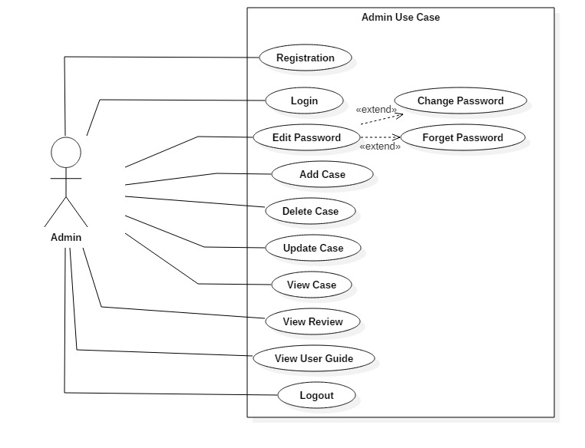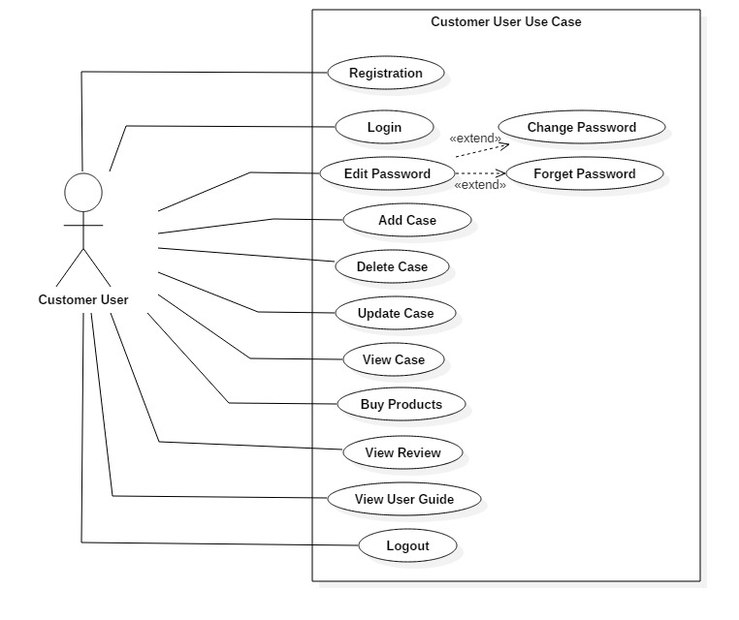

Title: “Registration”

|  |  |
| --- | --- |
| ID | UC01 |
| Justification | Valid information is to be input in this use case for authorization of the user. |
| Primary Actor(s) | Admin and Normal User |
| Supporting Actor(s) | N/A |
| Primary Flow | 1. User will enter the valid input in the field.  2. User will save the data.  3. Data will be store into the database by the system.  4. System will directs to the login Page. |
| Alternative Flow | 1. Invalid inputs may be given by the users. 2. System will verify the given inputs. 3. Error message of invalid inputs will be produced by the system.   4. Invalid inputs are expected to provide valid inputs. |

Title:”Login”

|  |  |
| --- | --- |
| ID | UC02 |
| Justification | Use case that only allows the valid users into the system. |
| Primary Actor(s) | Admin and Normal User |
| Supporting Actor(s) | N/A |
| Primary Flow | 1. User will provide their valid information.  2. System will verify the information.  3. Verified user will get access into the system. |
| Alternative Flow | 1. Invalid inputs may be given by the users.  2. System will verify the given inputs.  3. Error message of invalid inputs will be produced by the system.  4. Invalid inputs are expected to provide valid inputs. |

Title: “Edit Password”

|  |  |
| --- | --- |
| ID | UC03 |
| Justification | Use case that is important to edit password i.e. either changing the password or setting new password by forget password. |
| Primary Actor(s) | Admin and Normal User |
| Supporting Actor(s) | N/A |
| Primary Flow | 1. User will provide their valid information.  2. System will verify the information.   1. User will navigates to edit password option where they will find change option and forget password option. 2. Selecting the change password will help user to change the password. 3. System will save the changes and store into the database. |
| Alternative Flow | 1. User can choose forget password option to change incase when they forget the password. 2. User can change their password after logging into their profile. |

Title: “Add Case”

|  |  |
| --- | --- |
| ID | UC04 |
| Justification | Use case that help data to insert. |
| Primary Actor(s) | Admin and Normal User |
| Supporting Actor(s) | N/A |
| Primary Flow | 1. User will provide their valid information. 2. System will verify the information. 3. Verified user will get access into the system. 4. User directs to the add option. 5. User can add products, rate and so on. 6. System stores into the database. 7. System loads to the dashboard. |
| Alternative Flow | 1. User can input irrelevant inputs. 2. System will send error messages. 3. Users need to correct the inputs. |

Title: “Delete Case”

|  |  |
| --- | --- |
| ID | UC05 |
| Justification | Use case that allow to delete the irrelevant data. |
| Primary Actor(s) | Admin and Normal User |
| Supporting Actor(s) | N/A |
| Primary Flow | 1. User will provide their valid information. 2. System will verify the information. 3. Verified user will get access into the system. 4. User directs to the view option. 5. User select the irrelevant data and click on delete button. 6. System save the changes. 7. System loads to the page where all the information is displayed. |
| Alternative Flow | 1. User can select multiple data. 2. User can deny the confirmation message. |

Title: “Update Case”

|  |  |
| --- | --- |
| ID | UC06 |
| Justification | Use case which helps to update the changes. |
| Primary Actor(s) | Admin and Normal User |
| Supporting Actor(s) | N/A |
| Primary Flow | 1. User will provide their valid information. 2. System will verify the information. 3. Verified user will get access into the system. 4. User directs to the view option. 5. User inputs the data to be updated. 6. System save the updates. 7. System navigates to the view page where all the is displayed. |
| Alternative Flow |  |

Title: “View Case”

|  |  |
| --- | --- |
| ID | UC07 |
| Justification | Use case that helps to display all the available data. |
| Primary Actor(s) | Admin and Normal User |
| Supporting Actor(s) | N/A |
| Primary Flow | 1. User will provide their valid information. 2. System will verify the information. 3. Verified user will get access into the system. 4. User directs to the view option. 5. System shows all the data. |
| Alternative Flow | N/A |

Title: “View Review”

|  |  |
| --- | --- |
| ID | UC08 |
| Justification | Use case that displays helps to view reviews. |
| Primary Actor(s) | Admin and Normal User |
| Supporting Actor(s) | N/A |
| Primary Flow | 1. User will provide their valid information. 2. System will verify the information. 3. Verified user will get access into the system. 4. User directs to the view option. 5. System shows all the review data. |
| Alternative Flow | N/A |

Title: “View User Guide”

|  |  |
| --- | --- |
| ID | UC09 |
| Justification | Use case that displays the user manual for assistance. |
| Primary Actor(s) | Admin and Normal User |
| Supporting Actor(s) | N/A |
| Primary Flow | 1. User will provide their valid information. 2. System will verify the information. 3. Verified user will get access into the system. 4. User directs to the view option. 5. System shows the user guide where guidance is provided for needed steps and handling the errors. |
| Alternative Flow | N/A |

# Initial Class Diagram:

Class diagram is the diagram that represents the relationships between the classes. Class diagram helps to identify which classes are to create during system development. Class diagram also include the properties and function of the classes.

NLA (Natural Language Analysis)

Natural Language Analysis is the process of identifying the nouns, verbs and adjectives for class, attributes and operations of the class. There are several steps to follow to perform this.

## Scenario

Online Cosmetic Portal is one of the online platform that deals with online sales of cosmetic goods. It wishes to be a platform that particularly deals with cosmetic products. As these days many e-commerce sites are associated with multiple items with inconveniently services.

Online Cosmetic Portal will have admin privilege that can have access to add the cosmetic. Products with appropriate rate. Normal user will have to get registered to buy goods. Users can review the products and are able to delete them. While admin will be given access to view and delete reviews. This site provides varieties of cosmetic brand with convenient rate. Multiple orders can be placed by the users.

|  |
| --- |
| Name |
| Email |
| Address |
| Phone |
| Password |
| Product Name |
| Brand |
| Order |
| Quantity |
| Review |

Identifying the classes, attributes and functions:

|  |  |  |
| --- | --- | --- |
| **Nouns** | **Adjectives** | **Verbs** |
| Online Cosmetic Portal | Name | Add |
| Platform | Type | Update |
| Product | Quality | Delete |
| Order | Email | View |
| Review | Address | Post |
| Admin | Phone |  |
| User |  |  |

Removing the duplicate, similar, vague, irrelevant values

|  |  |  |
| --- | --- | --- |
| **Nouns** | **Adjective** | **Verbs** |
| Online Cosmetic Portal(Irrelevant) | Name | Add |
| Platform(Irrelevant) | Type | Update |
| Product | Quality (Irrelevant) | Delete |
| Order | Email | View(vague) |
| Review | Address | Post(vague) |
| Admin(Duplicate with users) | Phone |  |
| User | Rate |  |
|  | Quantity |  |

So after performing NLA we get the following things:

|  |  |  |
| --- | --- | --- |
| **Nouns** | **Adjective** | **Verbs** |
| Product | Name | Add |
| Order | Type | Update |
| Review | Rate | Delete |
| User | Email |  |
|  | Address |  |
|  | Phone |  |
|  | Quantity |  |

