Simple beech mapping

Anthony Davidson

13/10/2019

# sets paths for computers with other software components  
# this code block produces an enviroment warning  
# but not sure how to sort depenancies still  
# Feb2020  
  
# myPaths <- .libPaths("C:/Program Files/R/R-3.6.2/library")  
# myPaths <- c(myPaths)  
# .libPaths(myPaths) # add new path  
# .libPaths()

*[full plots coming soon…March 2020]*

# Overview

The key fact with all of this is getting the projections right. To begin with I used 460 something now I use 2193, +proj=tmerc +lat_0=0 +lon_0=173 +k=0.9996 +x_0=1600000 +y_0=10000000 +ellps=GRS80 +towgs84=0,0,0,0,0,0,0 +units=m +no_defs

## Study areas x2

### Outline of areas

## Coordinate Reference System:  
## EPSG: 2193   
## proj4string: "+proj=tmerc +lat_0=0 +lon_0=173 +k=0.9996 +x_0=1600000 +y_0=10000000 +ellps=GRS80 +towgs84=0,0,0,0,0,0,0 +units=m +no_defs"

## [1] "tmap"

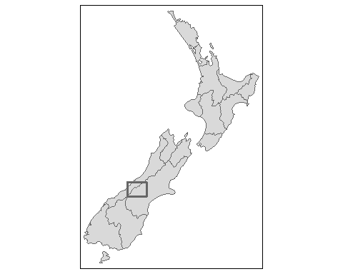

### Grid locations

## Multiple layers are present in data source C:\PhD\Davidson2020_Beech_forest_map\data\research\doc.kml, reading layer `Hollyford'.  
## Use `st_layers' to list all layer names and their type in a data source.  
## Set the `layer' argument in `st_read' to read a particular layer.  
## Reading layer `Hollyford' from data source `C:\PhD\Davidson2020_Beech_forest_map\data\research\doc.kml' using driver `KML'  
## Simple feature collection with 6 features and 2 fields  
## geometry type: POINT  
## dimension: XYZ  
## bbox: xmin: 167.9963 ymin: -45.06019 xmax: 168.1392 ymax: -44.73744  
## epsg (SRID): 4326  
## proj4string: +proj=longlat +datum=WGS84 +no_defs

### By Valley

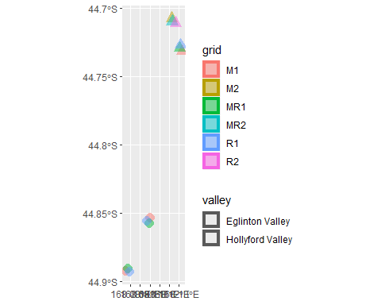

## Coordinate Reference System:  
## EPSG: 2193   
## proj4string: "+proj=tmerc +lat_0=0 +lon_0=173 +k=0.9996 +x_0=1600000 +y_0=10000000 +ellps=GRS80 +towgs84=0,0,0,0,0,0,0 +units=m +no_defs"

## [1] "tmap"

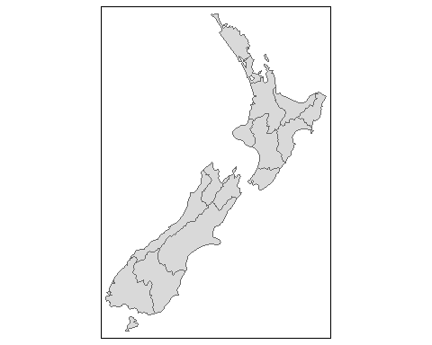

### Box on big map

### Extra code

### Another plot

### Over nz raster

### Publication map

And down to the two valley areas….

### Joining three sections of map above

ggplot/map best?

### Intergrate with overall map….

# Outlines for NZ

There is a good set of data for outlines and key statistics can be found anywhere but as I have been learning…simple examples that are robust to different approaches are not as well documented. Here are my very basic geo-spatial R scripts. Below are a few of the general outputs.

## Examples

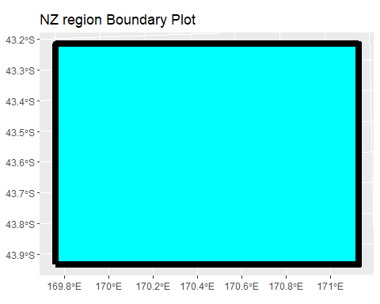

### Basic coastline only

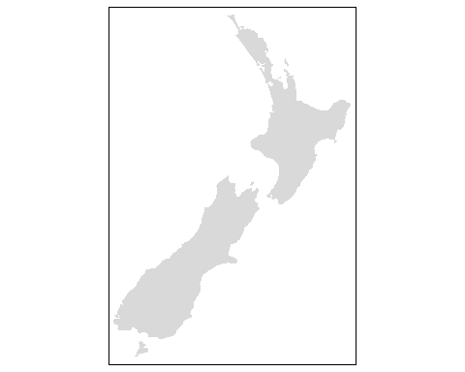

### Addional regional information

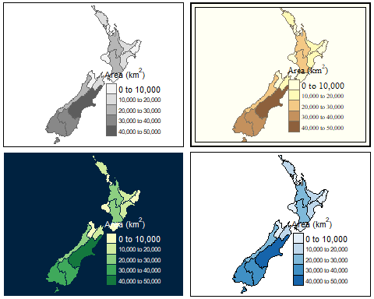

### NZ regions

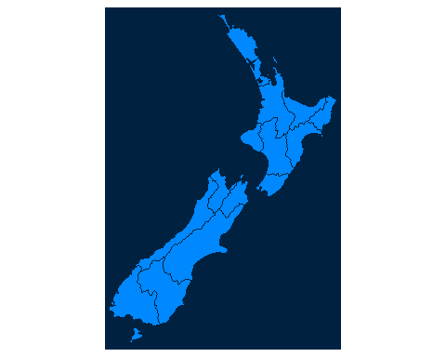

## Classes 'tbl_df', 'tbl' and 'data.frame': 16 obs. of 7 variables:  
## $ Name : chr "Northland" "Auckland" "Waikato" "Bay of Plenty" ...  
## $ Island : chr "North" "North" "North" "North" ...  
## $ Land_area : num 12501 4942 23900 12071 8386 ...  
## $ Population : num 175500 1657200 460100 299900 48500 ...  
## $ Median_income: int 23400 29600 27900 26200 24400 26100 29100 25000 32700 26900 ...  
## $ Sex_ratio : num 0.942 0.944 0.952 0.928 0.935 ...  
## $ geom :sfc_MULTIPOLYGON of length 16; first list element: List of 1  
## ..$ :List of 1  
## .. ..$ : num [1:68, 1:2] 175 175 174 174 174 ...  
## ..- attr(*, "class")= chr "XY" "MULTIPOLYGON" "sfg"  
## - attr(*, "sf_column")= chr "geom"  
## - attr(*, "agr")= Factor w/ 3 levels "constant","aggregate",..: NA NA NA NA NA NA  
## ..- attr(*, "names")= chr "Name" "Island" "Land_area" "Population" ...

### The next step

## [1] "tmap"

## Coordinate Reference System:  
## EPSG: 2193   
## proj4string: "+proj=tmerc +lat_0=0 +lon_0=173 +k=0.9996 +x_0=1600000 +y_0=10000000 +ellps=GRS80 +towgs84=0,0,0,0,0,0,0 +units=m +no_defs"

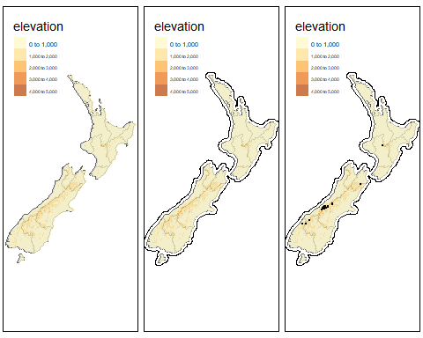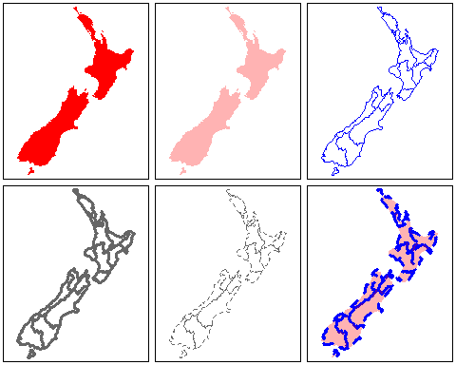

### Boxed plot

## Coordinate Reference System:  
## EPSG: 2193   
## proj4string: "+proj=tmerc +lat_0=0 +lon_0=173 +k=0.9996 +x_0=1600000 +y_0=10000000 +ellps=GRS80 +towgs84=0,0,0,0,0,0,0 +units=m +no_defs"

## [1] "tmap"



1. To cut this down to just the otago region

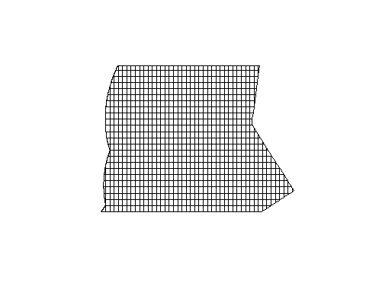

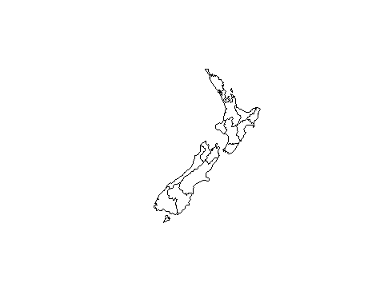

### Otago region

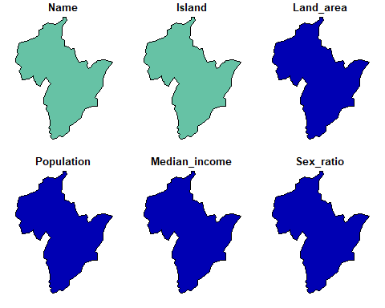

#### Build otago raster

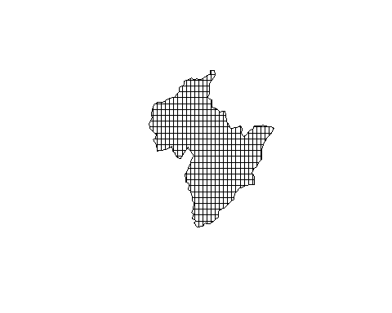

#### geo dataset

From Johan orginally.

## Reading layer `Untitled layer' from data source `C:\PhD\Davidson2020_Beech_forest_map\data\gis\ports.geojson' using driver `GeoJSON'  
## Simple feature collection with 40 features and 2 fields  
## geometry type: POINT  
## dimension: XYZ  
## bbox: xmin: 167.9263 ymin: -46.59896 xmax: 178.0252 ymax: -34.98977  
## epsg (SRID): 4326  
## proj4string: +proj=longlat +datum=WGS84 +no_defs

## Coordinate Reference System:  
## EPSG: 4326   
## proj4string: "+proj=longlat +datum=WGS84 +no_defs"

## [1] "sf" "data.frame"

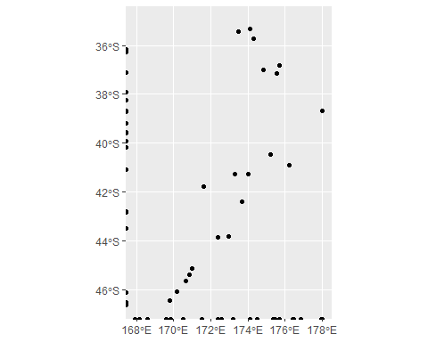

## [1] "Name" "Description" "geometry"

## sfc_POINT of length 40; first list element: 'XYZ' num [1:3] 173 -43.8 0

## [1] "Name" "Island" "Land_area" "Population"   
## [5] "Median_income" "Sex_ratio" "geom"

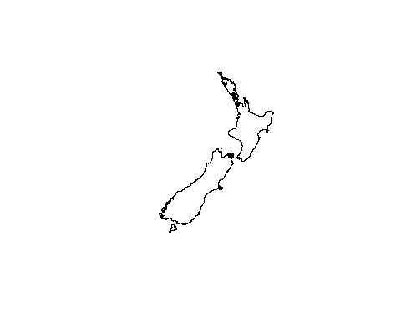

### Points

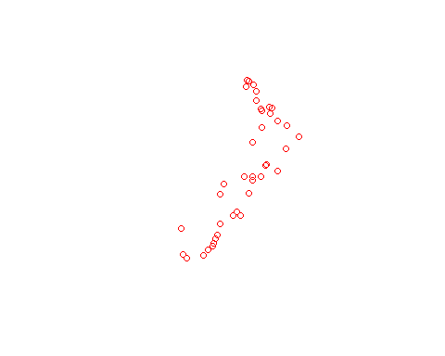

### Boxxx

## xmin ymin xmax ymax   
## 168.11721 -46.62241 171.14415 -43.95808

#### Interactive map

### Depth layers

#### Build NZSL trust area

Raster from kml data. This is the my-maps data. This could easily be a deadend.

### KML data

So from a my-map map online you take the following steps:

1. Download kml data with the following pre-reqs??
2. bla
3. bla

#### KML ggploting

# Study locations

There is a good set of data for outlines and key statistics can be found anywhere but as I have been learning…simple examples that are robust to different approaches are not as well documented. Here are my very basic geo-spatial R scripts. Below are a few of the general outputs.

## Examples

### Basic points only

## Coordinate Reference System:  
## EPSG: 2193   
## proj4string: "+proj=tmerc +lat_0=0 +lon_0=173 +k=0.9996 +x_0=1600000 +y_0=10000000 +ellps=GRS80 +towgs84=0,0,0,0,0,0,0 +units=m +no_defs"

## [1] "tmap"



### Addional regional information



### NZ regions



## Classes 'tbl_df', 'tbl' and 'data.frame': 16 obs. of 7 variables:  
## $ Name : chr "Northland" "Auckland" "Waikato" "Bay of Plenty" ...  
## $ Island : chr "North" "North" "North" "North" ...  
## $ Land_area : num 12501 4942 23900 12071 8386 ...  
## $ Population : num 175500 1657200 460100 299900 48500 ...  
## $ Median_income: int 23400 29600 27900 26200 24400 26100 29100 25000 32700 26900 ...  
## $ Sex_ratio : num 0.942 0.944 0.952 0.928 0.935 ...  
## $ geom :sfc_MULTIPOLYGON of length 16; first list element: List of 1  
## ..$ :List of 1  
## .. ..$ : num [1:68, 1:2] 175 175 174 174 174 ...  
## ..- attr(*, "class")= chr "XY" "MULTIPOLYGON" "sfg"  
## - attr(*, "sf_column")= chr "geom"  
## - attr(*, "agr")= Factor w/ 3 levels "constant","aggregate",..: NA NA NA NA NA NA  
## ..- attr(*, "names")= chr "Name" "Island" "Land_area" "Population" ...

### Points



### Boxxx

## xmin ymin xmax ymax   
## 168.11721 -46.62241 171.14415 -43.95808

#### Interactive map

### Depth layers

#### Build NZSL trust area

Raster from kml data. This is the my-maps data. This could easily be a deadend.

### KML data

So from a my-map map online you take the following steps:

1. Download kml data with the following pre-reqs??
2. bla
3. bla

#### KML ggploting