Estatus: Complete

Repository: https://github.com/apegadoboureghida/cs445_project

Lines of Code (By classes):

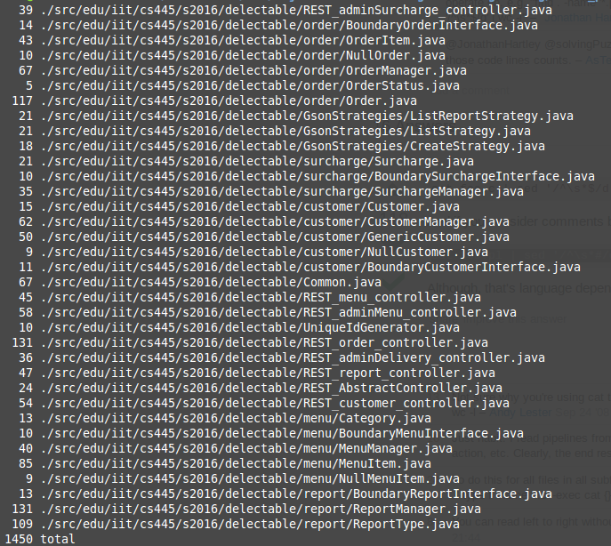
Total Lines: 1450
Note: Command used:
find . -name '*.java' -not -name '*Test.java' -not -name '*main.java'| sed '/^\s*#/d;/^\s*$/d' | xargs wc -l

Lines of Code(Unit Test):

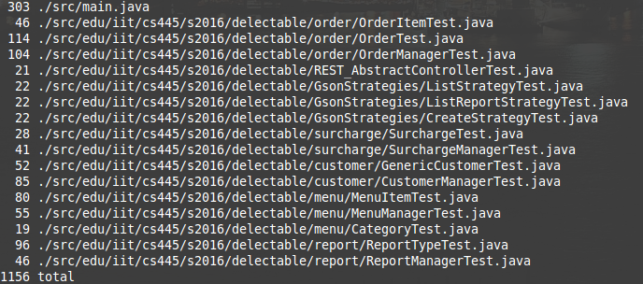
Total Lines: 1156
Note: Command used:
find -name '*Test.java' -or -name '*main.java'| sed '/^\s*#/d;/^\s*$/d' | xargs wc -l

Unit Test Coverange: 95% (100% of core functions)

Cyclomatic complexity (Calculated with Codecity):
- edu.iit.cs445.s2016.delectable.order
  - Order 1
  - OrderManager 2
  - NullOrder 2
  - OrderItem 1
- edu.iit.cs445.s2016.delectable.customer
  - GenericCustomer 1
  - CustomerManager 3
  - NullCustomer 2
  - Customer 2
- edu.iit.cs445.s2016.delectable.report
  - RerportType 1
  - ReportManager 5
- edu.iit.cs445.s2016.delectable.
  - CreateStrategy 2
  - ListStrategy 2
  - ListReportStrategy 2
- edu.iit.cs445.s2016.delectable.menu
  - MenuItem 1
  - MenuManager 2
  - Category 2
  - NullMenuItem 2
- edu.iit.cs445.s2016.delectable.surcharge
  - Surcharge 1
  - SurchargeManager 2
- edu.iit.cs445.s2016.delectable.GsonStrategies
  - CreateStrategy 2
  - ListStrategy 2
  - ListReportStrategy 2
- edu.iit.cs445.s2016.delectable
  - REST_AbstractController 1
  - Common 2
  - REST_order_controler 4
  - UniqueIdGenerator 2
  - REST_adminDelivery_controller 4
  - REST_menu_controller 2
  - REST_customer_controller 2
  - REST_report_controller 2
  - REST_adminMenu_controller 2
  - REST_adminSurcharge_controller 2

Number of hours: 78h
Number of hours preparing submission: 8h

Challenges:

- Start Working with tomcat, at the beggining I was unable to make it work properly
- Test properly the api rest.
- Make jUnit work under command line.
- Get report of coverage under command line.

