REST APIs

**Web Services:**

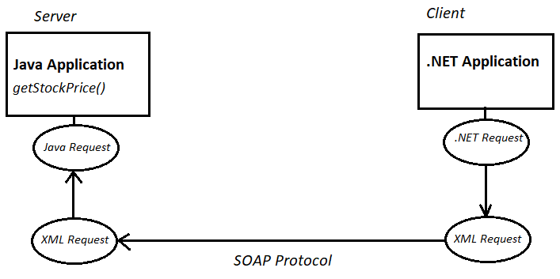

**REST Service:**

|  |  |  |  |
| --- | --- | --- | --- |
| Sr. No. | Functionality | SOAP based web services | REST Service |
|  |  |  |  |
| 1 | Create a new stock | createStock() | /stock [POST] |
| 2 | Update an existing stock | updateStock(stock_id) | /stock/{id} [PUT] |
| 3 | Delete all stocks | deleteAllStocks() | /stock [DELETE] |
| 4 | Delete a specific stock | deleteStockById(stock_id) | /stock/{id} [DELETE] |
| 5 | Read all stocks | getAllStocks() | /stock [GET] |
| 6 | Read a specific stock | getStockById(stock_id) | /stock/{id} [GET] |

1. REST means Representational State Transfer.
2. REST is completely based upon HTTP protocol.
3. In order to locate any REST service, you need URL & its HTTP method.
4. In REST everything is a resource & based upon HTTP method, you decide what operation you wish to perform on your resource.

**REST Parameters:**

|  |  |  |
| --- | --- | --- |
| **Sr. No.** | **Parameter type** | **Spring code** |
| 1 | Query parameter /order?id=55 | @GetMapping(value="/order")  public Order getOrder( @RequestParam(name="id") int orderId) |
| 2 | Template/Path parameter  /order/55 | @PutMapping(value="/order/{id}")  public Order updateOrder(@PathVariable(name="id") int orderId) |
| 3 | Header parameter | @GetMapping(value=”/order”)  public List<Order> getAllOrders(@RequestHeader(name=”id”) String clientId) |