PS/2021/091 - NISHANI P.A.A.

COSC 32133

Lab 02

**Part A**

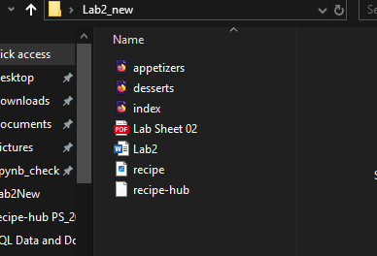

<html>

<head>

    <title>Recipe Hub</title></head>

<body>

    <style>

   body{

        background-color: darkcyan;

        font-family:'Times New Roman', Times, serif;}

         h1 {

            text-align:center;

            color: rgb(245, 173, 245);

        }

      h2{

        text-align: left;

        color: lightpink;}

        h3{

        text-align:left;

        color: black;

        }

        p{

        text-align:center;

        color: black;

      }

    </style>

    <h1>Welcome to Recipe Hub</h1>

  <p><b>Explore and share your favorite recipes with others!</b></p>

  <img src="recipe.jpg" alt="recipe image" style="display:block; margin-left:auto; margin-right:auto; width:1200; height:500;">

  <h3>Categories:</h3>

  <ul>

    <li><a href="appetizers.html">Appetizers</a></li>

    <li><a href="desserts.html">Desserts</a></li>

  </ul>

</body>

</html>

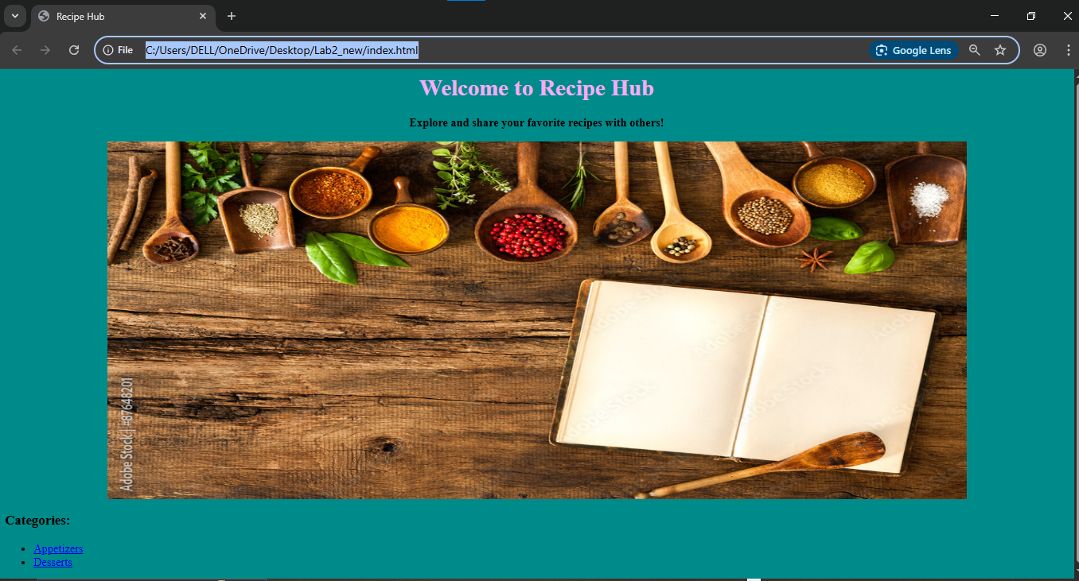

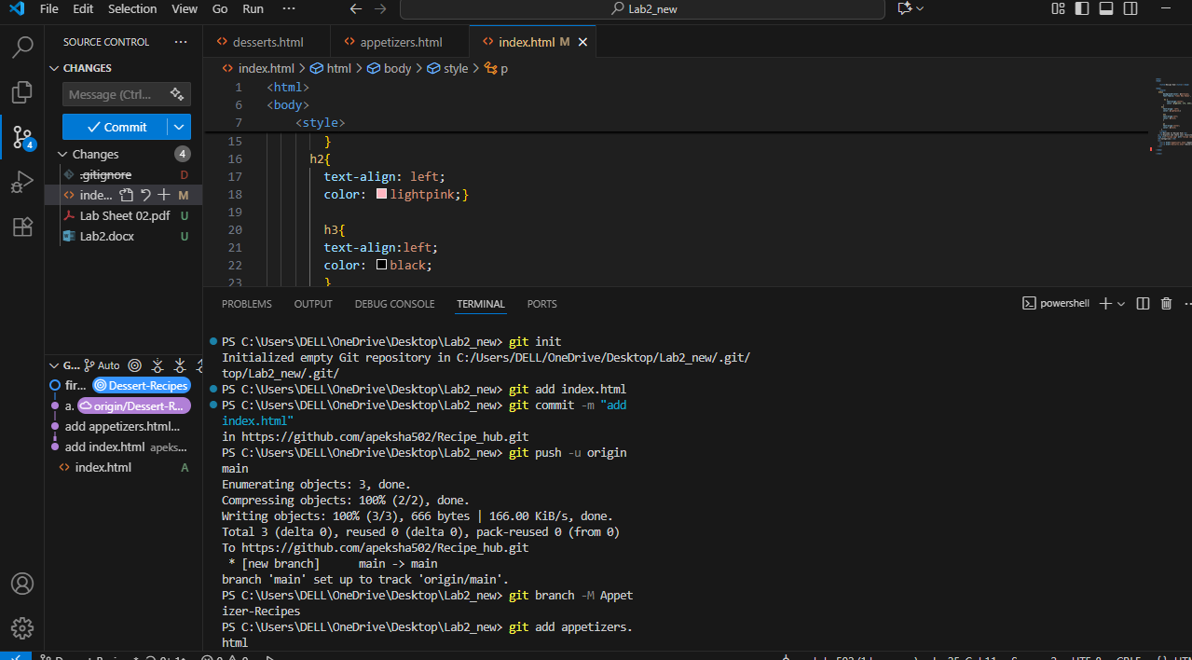

**Prat – B**

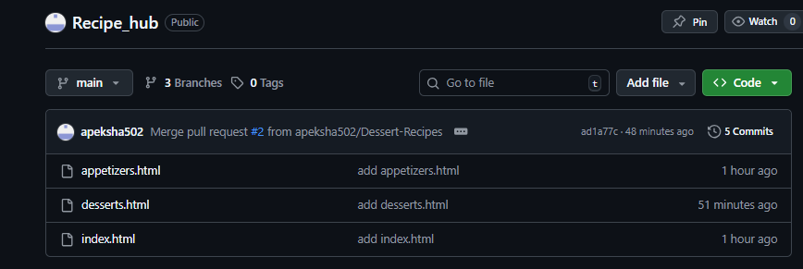

Collaborators On GitHub

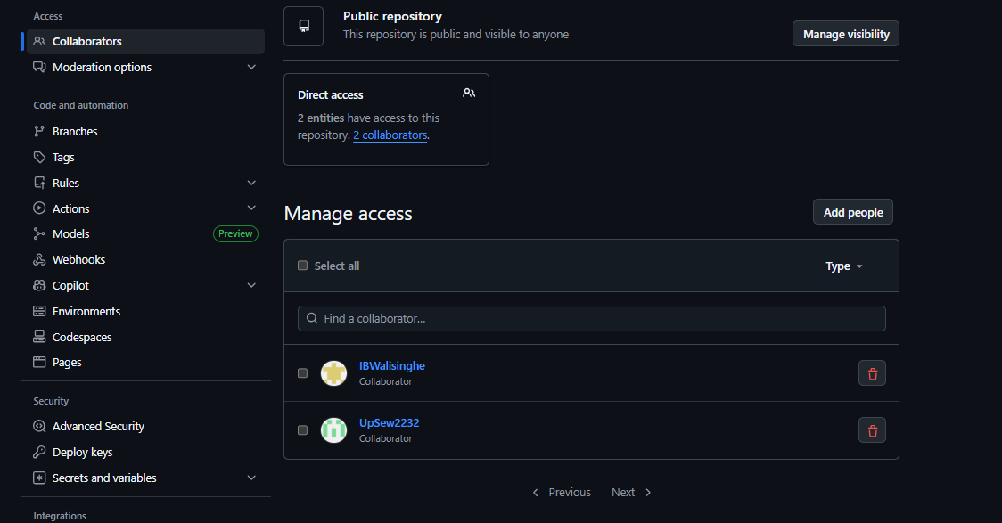

**Create Branch: Appetizer**

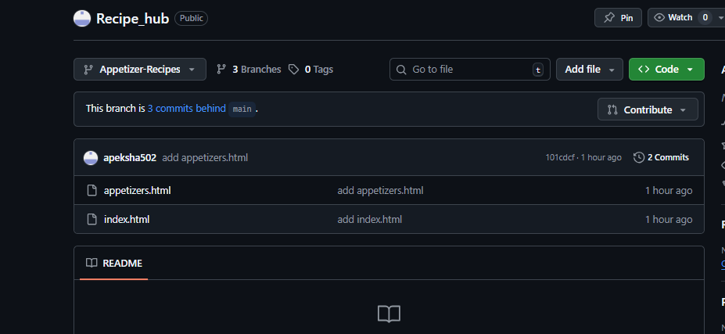

**Appetizers.html**

<html>

<head><title>Appetizer Recipe</title></head>

<body>

    <style>

        body{

        background-color: darkcyan;

        font-family:'Times New Roman', Times, serif;}

         h1 {

            text-align:center;

            color: rgb(245, 173, 245);

        }

      h2{

        text-align: left;

        color: lightpink;}

      p,h3{

        text-align:left;

        color: black;

      }

    </style>

    <h1>Appetizer Recipes</h1>

    <h2>1.Bruschetta</h2>

    <h3>Ingredients:</h3>

                <li>4 slices of baguette</li>

                <li>2 medium tomatoes (diced)</li>

                <li>2 tbsp olive oil</li>

                <li>1 clove garlic (minced)</li>

                <li>Fresh basil leaves (chopped)</li>

                <li>Salt and pepper to taste</li>

            <h3>Instructions:</h3>

            <p>1. Toast the baguette slices until golden brown.</p>

            <p>2. In a bowl, mix diced tomatoes, olive oil, garlic, basil, salt, and pepper.</p>

            <p>3. Spoon the mixture onto the toasted baguette slices and serve immediately.</p>

    <h2>2.Stuffed Mushrooms</h2>

    <h3>Ingredients:</h3>

            <ul>

                <li>12 large button mushrooms</li>

                <li>1/2 cup cream cheese (softened)</li>

                <li>1/4 cup grated Parmesan cheese</li>

                <li>2 tbsp breadcrumbs</li>

                <li>1 clove garlic (minced)</li>

                <li>1 tbsp parsley (chopped)</li>

                <li>Salt and pepper to taste</li>

            </ul>

            <h3>Instructions:</h3>

            <p>1. Preheat the oven to 375°F (190°C).</p>

            <p>2. Remove the stems from the mushrooms and finely chop them.</p>

            <p>3. In a bowl, mix the chopped stems, cream cheese, Parmesan, breadcrumbs, garlic, parsley, salt, and pepper.</p>

            <p>4. Stuff the mushroom caps with the mixture and place them on a baking sheet.</p>

            <p>5. Bake for 15-20 minutes or until the mushrooms are tender and the filling is golden brown.</p>

</body>

</html>

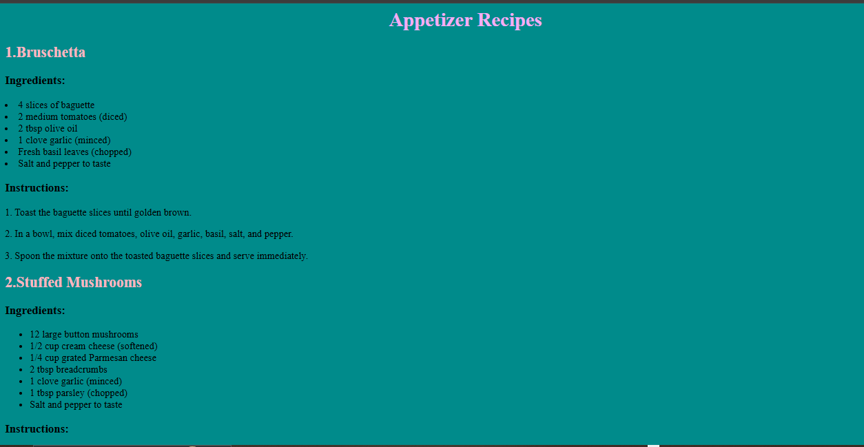

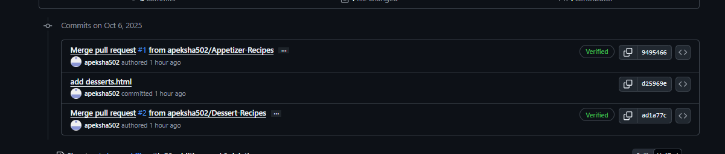

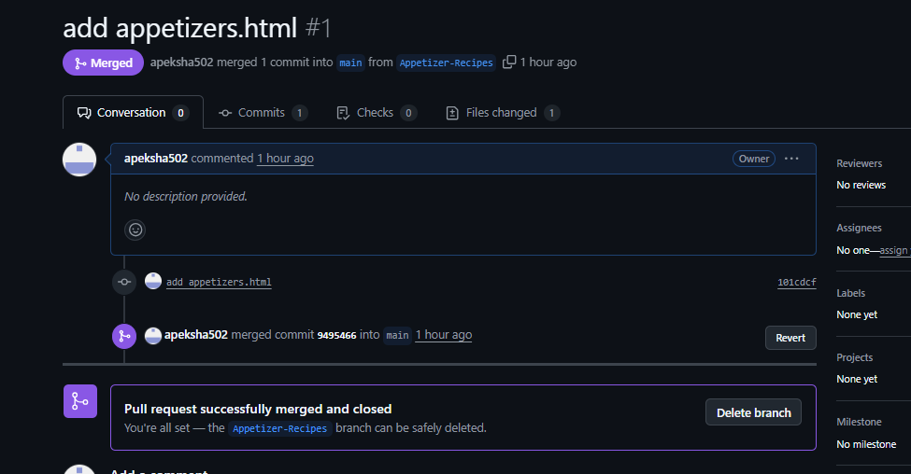

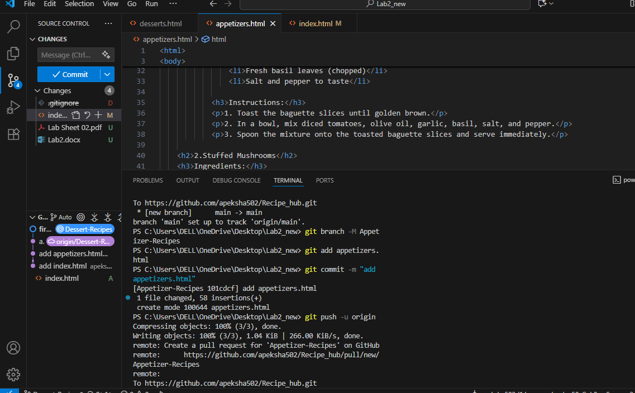

**Branch: Dessert Recipes**

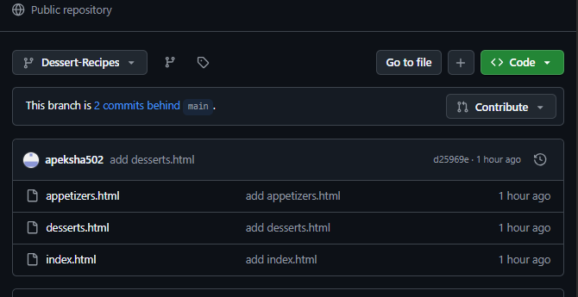

<html>

<head>

<title>Dessert Recipe</title>

</head>

<body>

   <style>

   body{

        background-color: darkcyan;

        font-family:'Times New Roman', Times, serif;}

         h1 {

            text-align:center;

            color: rgb(245, 173, 245);

        }

      h2{

        text-align: left;

        color: lightpink;}

      p,h3{

        text-align:left;

        color: black;

      }

    </style>

      <h1>Dessert Recipes</h1>

   <h2>1. Chocolate Brownie</h2>

   <h3>Ingredients:</h3>

  <ul>

    <li> Chocolate</li>

    <li> Butter</li>

    <li> Sugars</li>

    <li> Flour</li>

    <li> Egg</li>

  </ul>

  <h3>Instructions:</h3>

  <ol>

    <li>Melt chocolate and butter.</li>

    <li>Mix with sugar, eggs, and flour.</li>

    <li>Bake for 25 minutes at 180°C.</li>

  </ol>

  <h2>2. Fruit Salad</h2>

   <h3>Ingredients:</h3>

  <ul>

    <li> Apple </li>

      <li> Banana </li>

      <li> Mango</li>

      <li> Yogurt</li>

      <li>Honey</li>

  </ul>

  <h3>Instructions:</h3>

  <ol>

    <li>Cut fruits into small pieces.</li>

    <li>Add yogurt and drizzle honey on top.</li>

  </ol>

</body>

</html>

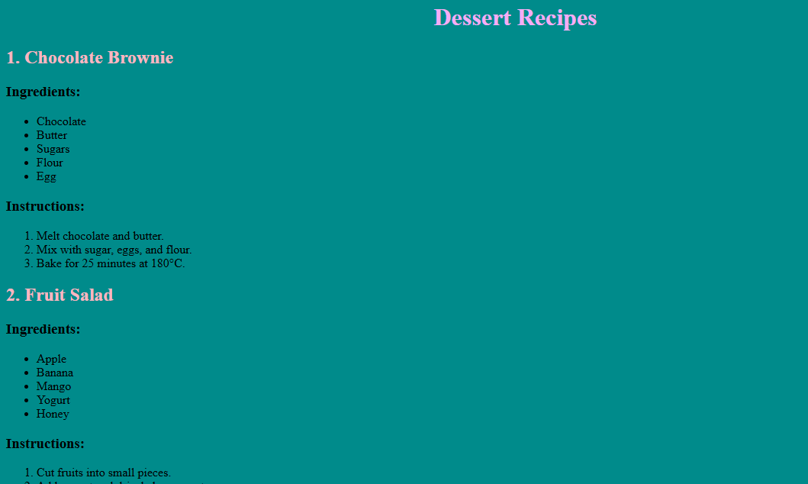

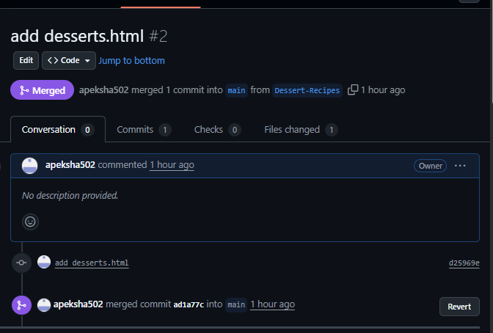

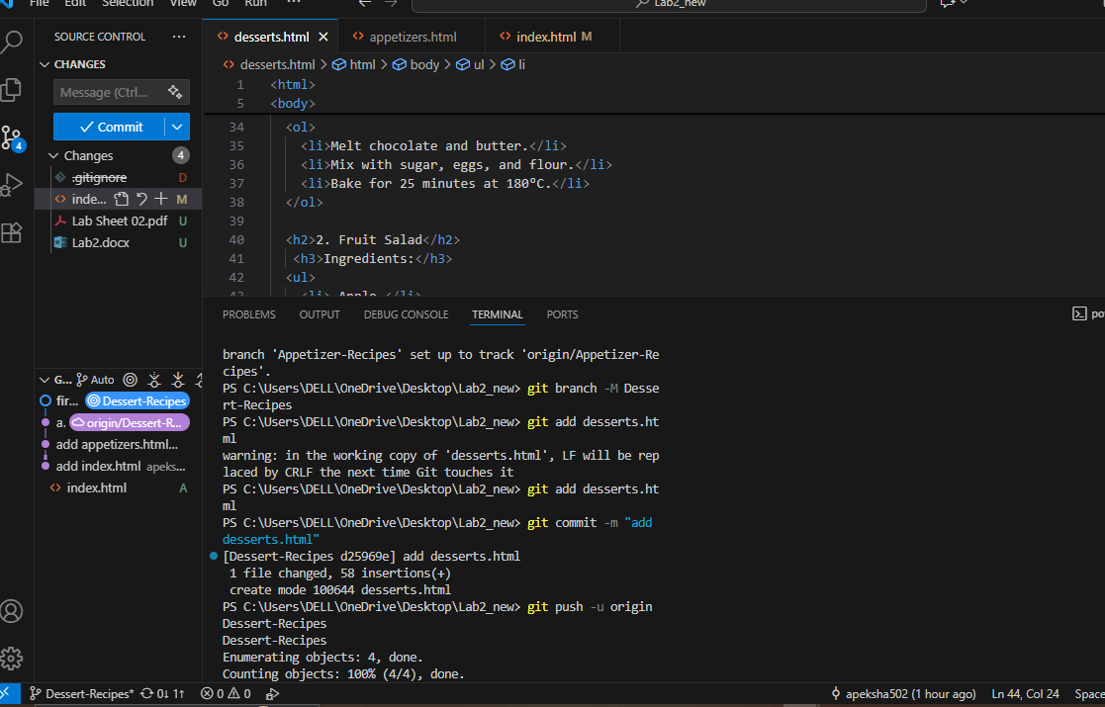

**Part – C**

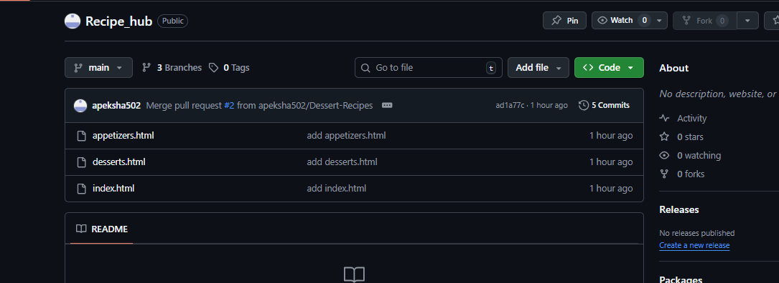

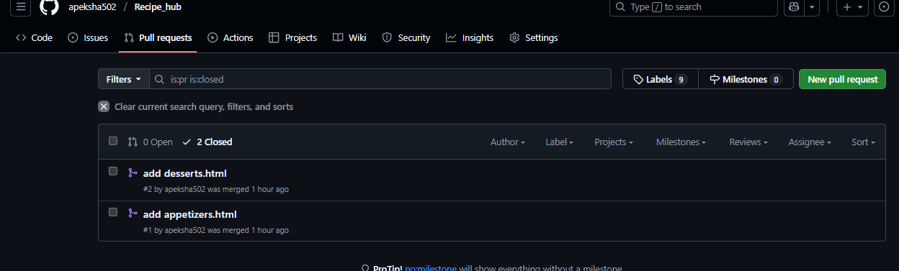

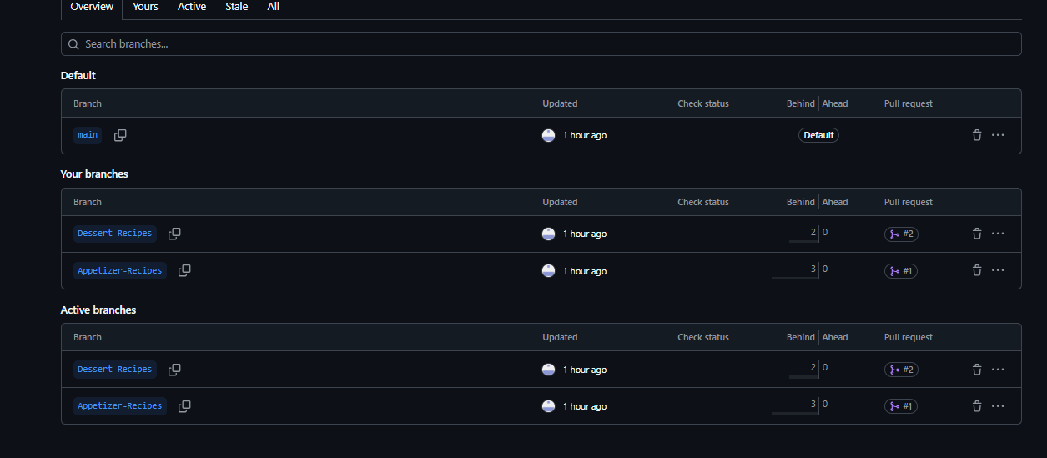

**Git hub Link :** [**https://github.com/apeksha502/Recipe_hub.git**](https://github.com/apeksha502/Recipe_hub.git)