­***CSE 5324 – Software Engineering – Analysis, Design and Testing***

AutO TASX - "automate Life"

TEAM - 7

1. Harikrishna Bokksum - 1001096002
2. Apeksha Bhat - 1000981003
3. Meghana Anoop - 1000981002
4. Kaustubh Mohgaonkar - 1001101770
5. Michael Ho - 1001135968

**Document Status: Ready for Review**

**Document History**

|  |  |  |  |
| --- | --- | --- | --- |
| **Version** | **Summary of Changes** | **Document Status** | **Date published** |
| 0.1 | Initial Version Sent for review by team members | First Draft | 06-02-2015 |
| 0.2 | Additional explanation on Story Line, iterations and Key features | Second Draft | 07-02-2015 |
| 0.3 | Data structure, prototype and Input/output description added | Third Draft | 08-02-2015 |
|  |  |  |  |
|  |  |  |  |
|  |  |  |  |
|  |  |  |  |

TABLE OF CONTENTS

1. Purpose
2. Key Features
3. **Competitors**
4. **Use Cases**
5. **Flow Chart**
6. **Prototype**
7. **Inputs and outputs**
8. **Data Structures**
9. **Refined Iteration Plan**
10. **References**

# PURPOSE

This document should adequately define the scope of AutoTasX android application and should explain the key features and functionalities. This document also covers the development Iteration plan and risk assessment plan.

# Story Line

Imagine you are in your class and your phone rings loud only to disturb the entire class and professor. Or consider you are at Walmart and you forgot to get those kitchen lights that broke last night. Or you’re visiting a new place and you don’t remember the exact location of your car park. We all fail to remember certain small details.

That’s when Auto TasX will be of help. It can automate your phone based on the location you are in. Set a profile in our app to trigger Phone Silent mode when you’re in class, or trigger a reminder notification when you are at Walmart. It’s simple, just set your location by pointing it on google maps and select an action to be triggered when you enter that location and the app will do the rest!

# Key Features

* Location Based Phone automation- One or multiple actions can be triggered when the user enters the location stored in the profile.
* Easy Material Design UI to select the ‘Where’ option on google maps and ‘what’ actions to be triggered on entering the location.
* Actions to set a reminder,
* An addition to our app is the new “ParkMyCar” widget which provides the user a one click option to save the location of his car parked. This automatically saves an entry in the app. Which then displays a push message to the user when he returns to the vicinity of his parking location.
* Additional action item to trigger toggling Wifi and Data settings option in the phone.
* An option is provided to the user to dynamically change the radius of the location trigger. Which allows the app to mitigate issues related to location unawareness inside buildings or non-network regions

# CompItetors

We did some research on our competitor apps, most of them do similar actions as our app, but are restricted to one action per app.

* The app offers multiple actions in the same application and additional actions for the same profile.
* We can argue that our material design UI is much easier than the Automagic app that is complex to understand and use for a technical layman.
* The app does not require the user to type in the address to set the location, he can use the map to simply point on the location.
* The app allows the user to set a location radius, mitigating the risk of losing location awareness by the app.
* Our app is free and with the help of AppCompat21 the app should perform well even on older versions of android.

Some of the competitors and their pros/cons are listed below:

## [Automate It](https://play.google.com/store/apps/details?id=AutomateIt.mainPackage&hl=en)

Pros -

* Free application
* Good UI

Cons -

* Does not work with android 5.0
* Auto deletes rules several times.

## [Reminja](https://play.google.com/store/apps/details?id=com.cls.reminja.ui&hl=en)

Pros -

* Easy User Interface
* All positive reviews

Cons -

* Limited just to reminders

## [Silent!](https://play.google.com/store/apps/details?id=com.hw.silentfree)

Pros -

* Added feature to add exception to important callers

Cons -

* No other features except changing mode to Silent.

## [Automagic Automation](https://play.google.com/store/apps/details?id=ch.gridvision.ppam.androidautomagic&hl=en)

Pros -

* Positive Reviews

Cons -

* Complicated user interface includes flowcharts to set triggers.
* Requires Flowchart knowledge to use
* Paid application

# Use cases

Select Location

Set Radius

Phone Silent

Set Message

Select Action

Message

Set Recipient

Name Profile

WIFI / Data

Save

Select Location

Set Radius

Select Action

Name Profile

**Use Case: Wi-Fi Toggle**

# FlowChart

|  |
| --- |
| Set Radius  Go to Home Screen  Save  Select Action  Select Location  Show Welcome Screen |

# ProtoType

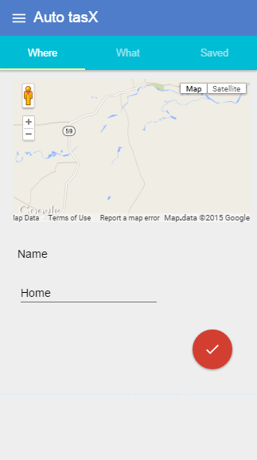 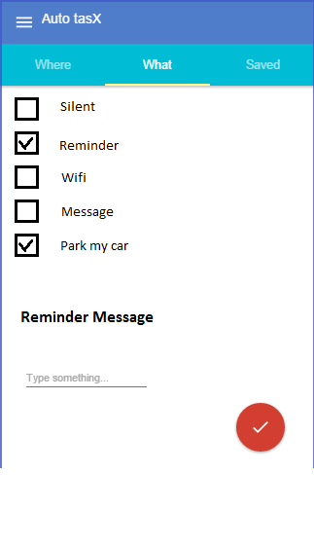

1. Select the location on the google map and give a profile name on the ‘Where’ Page

2. Select the action(s) to be triggered on the ‘What‘ page

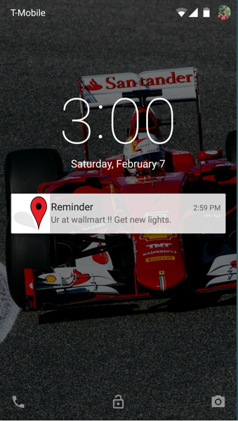 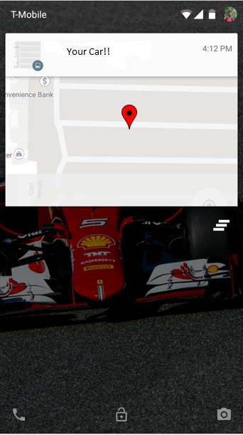

1. Reminder pops up on the screen when the user enter the Location specified, in this case: Walmart.
2. The Map pops up on the screen when you enter the parking vicinity guiding you to the location of your car.

# Inputs and OUtputs

**Input**:

Selecting the location on the maps provided in the ‘Where’ page.

Selecting the actions to be triggered in the ‘What’ page.

**Additional Inputs**

Reminder action: Reminder Message

Message action: Recipient name and the message to be sent

**Output:**

Silent Action**:** Switchesthe Phone mode to Silent.

Reject calls Action: Rejects any calls when profile turned on.

Wifi/data Action: Toggle Wifi and data option to on/off.

Reminder Action: Displays a push notification on the screen with a reminder message

ParkMyCar Action: Displays a map on the screen to show the car location on it.

# Data Structures

Auto TasX requires limited data storage since its functionalities require fewer data values. Our App will use the Android’s inbuilt database: SQLite. Android ships with the version 3.4.0. Below is a structure of how the database table might look like.

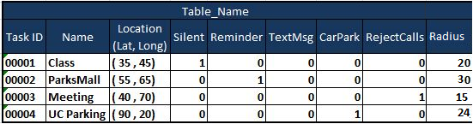

The table will include a task id, name and the location it is set for. The location includes the Latitude and the Longitude obtained from the Geofence. The table also stores the single/ multiple actions that gets triggered based on the location. A radius parameter to get the vicinity range.

Use case: Task ID: 00001-Class profile is set to trigger the Silent mode option when the user enters the vicinity of location: (35,45) lat,long with radius set to 20.

# 9. Refined Iteration Plan

The iteration plan for the application is divided into three major parts. We have listed our risks and looked at covering the major risks and complex work in our first iteration and so on.

* Iteration 1 –
  + - Getting the app to work on Geofence is our first priority. Google Geofence API is a new coding zone to our developers and involves complex functionalities.
    - The App’s Material design UI will be given importance on the first iteration.
    - Implementing one action on selected location (Sending a message to a recipient )
    - Creation of SQLite database
    - Unit Testing
* Iteration 2 –
  + - Allow the user to dynamically change the radius of the location selector.
    - Implementing more action items for the app

Change phone modes form normal-vibration-silent; toggle data or wifi option , Set up a reminder along with a message

* + - Create and achieve the working of “ParkMyCar” widget
    - Integration testing
* Iteration 3 –
  + - Implementing Multiple actions for single location profile
    - Implementing ‘edit’ option for the location and action settings
    - Performance enhancements

# 10. Refrences

<http://android-developers.blogspot.com/2014/10/appcompat-v21-material-design-for-pre.html>

<https://play.google.com/store/apps/details?id=ch.gridvision.ppam.androidautomagic&hl=en>

<https://play.google.com/store/apps/details?id=AutomateIt.mainPackage&hl=en>

<http://www.google.com/design/spec/material-design/introduction.html>