CSE 5324

SOFTWARE ENGINEERING PROJECT

**TITLE: Auto TasX**

TEAM - 7

1. Harikrishna Bokksum - 1001096002
2. Apeksha Bhat - 1000981003
3. Meghana Anoop - 1000981002
4. Kaustubh Mohgaonkar - 1001101770
5. Michael Ho - 1001135968

**INTRODUCTION:**

The purpose of this project is to develop an application that allows the user to automate his android device which usually requires user intervention based on the user’s location.

**KEY FEATURES:**

* Lollipop Material design Interface.
* Location based automation.
* Customizable “where”.
* Location based customizable reminders.
* Multiple actions for locations.

**USE CASES:**

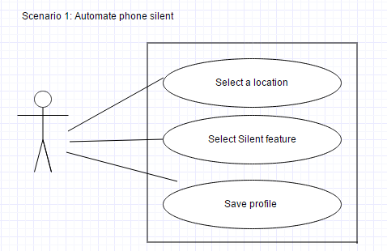

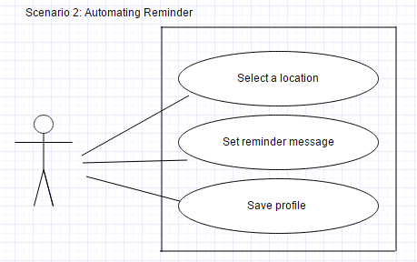

**PROTOTYPE:**

|  |  |
| --- | --- |
| C:\Users\Apeksha\Downloads\s1.PNG | C:\Users\Apeksha\Downloads\s2.PNG |
| C:\Users\Apeksha\Downloads\s3.PNG | C:\Users\Apeksha\Downloads\s4.PNG |

**COMPETITORS:**

* Geofence Tracker tasker
* Locotext
* Smart Silence

**WHY Auto TasX?**

There are a few applications like locoText , Smart Silence each of which includes only one of the features included In our application. The Geofence Tracker Tasker although does most of the functionalities included in our application ,it does not have the “Location based Reminder” feature.

**VISION AND BUSINESS CASE:**

Minimizing user intervention in performing repeated tasks by helping him achieve these task automatically through the application.

* Convenient
* Material Design UI
* Phone automation

**TOOLS:**

* Development IDE: Eclipse ADT
* Database: Parse Database
* Version Control: GitHub

**RISKS : MITIGATIONS**

* Delay or inconsistency in getting most recent location data**:** Avoiding inconsistency by using Google’s fused location API .
* Implementing multiple actions for each location**:** Initially start with one action for a location and on progress carry forward with multiple actions through the iterations
* Background activity getting killed because of memory leak**:** The problem is that under certain circumstances Android 5.0 and 5.0.1 leak memory, and when the leak has reached a critical point then Android tries to compensate by forcibly closing apps to free up resources.

**REFERENCES:**

<http://www.androidauthority.com/fix-lollipops-massive-memory-leak-coming-soon-ish-577101/>

<https://polymer-designer.appspot.com/>

<http://www.androidauthority.com/fix-lollipops-massive-memory-leak-coming-soon-ish-577101/>

<http://www.google.com/design/spec/material-design/introduction.html>

<https://developer.android.com/google/play-services/location.html>