TECHAXIS REMOTE DATA SCIEE INTERNSHIP
WEEK 2 — EDA REPORT
Data Cleaning &
Exploratory Data Analysis
Project #6 — Employee Attrition Predictor
Dataset: hr_attrition.csv | 1,470 records analyzed

1. Report Summary

Dataset | hr_attrition.csv (IBM HR Analytics Employee Attrition)
Rows × Columns | 1,470 rows × 35 columns (raw)
Final Cleaned Shape | 1,470 rows × 32 columns (after dropping constants/ID)
Missing Values Found | 0 — no imputation required
Class Balance | 83.9% No Attrition / 16.1% Yes Attrition — Imbalanced
Output File | hr_attrition_cleaned.csv

2. Data Profiling Results

2.1 Missing Value Check
A complete null-value scan was run across all 35 columns. The dataset contains zero missing values — this is consistent with it being a clean, synthetic benchmark dataset published by IBM. No imputation strategy was required.
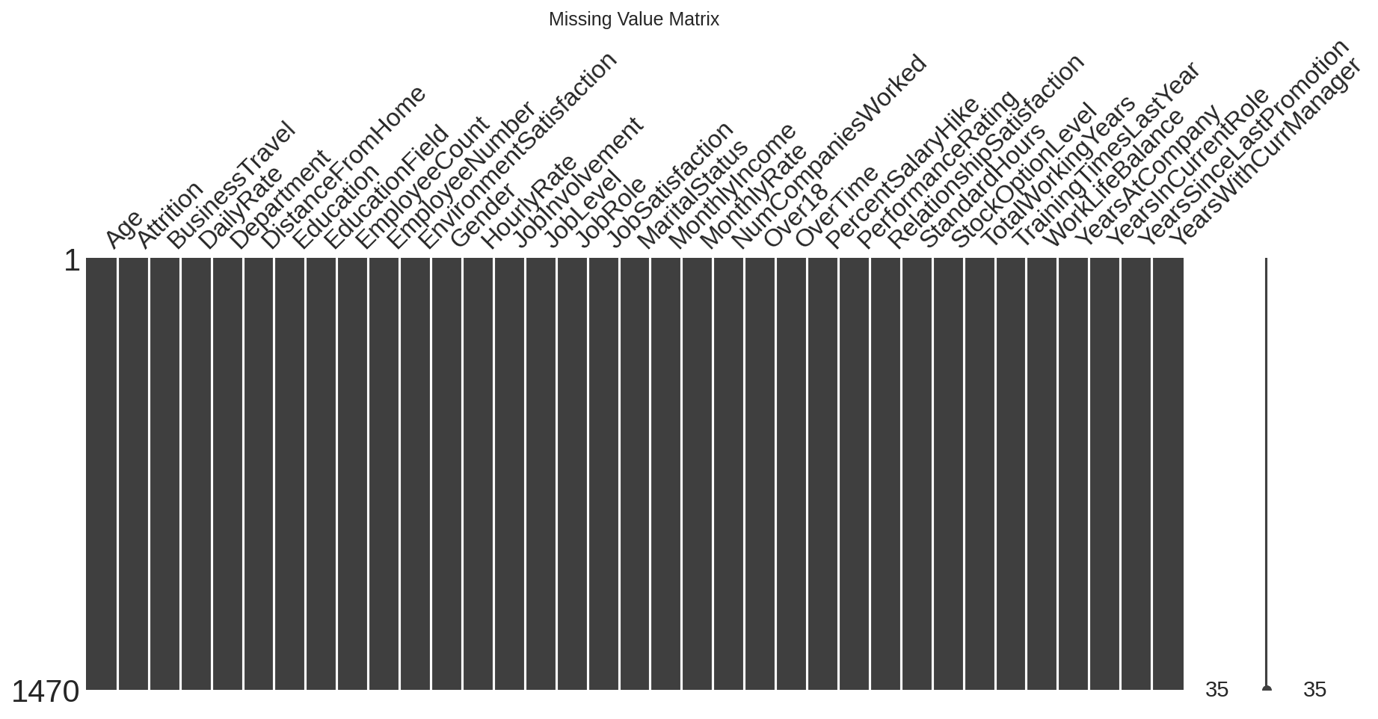
Figure 1 — Missing value matrix (fully solid white = no missing data)
2.2 Columns Dropped (Non-Predictive)
Four columns were removed because they carry zero predictive signal — confirmed by checking that they are constant or unique identifiers before dropping:
Column | Reason for Dropping
EmployeeCount | Constant — every value is 1
Over18 | Constant — every value is 'Y'
StandardHours | Constant — every value is 80
EmployeeNumber | Unique row identifier, not a feature

3. Target Variable: Class Balance

The target variable Attrition was encoded into a binary column (Attrition_Flag: Yes=1, No=0). The class distribution is significantly imbalanced:
Class | Count | Percentage
No (Stayed) | 1,233 | 83.9%
Yes (Left) | 237 | 16.1%
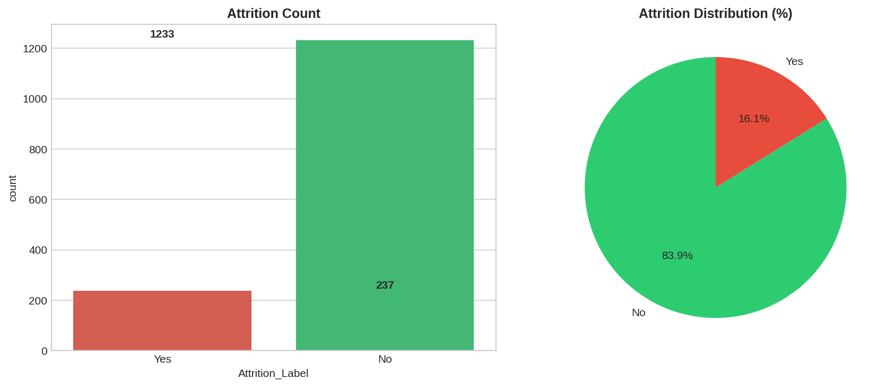
Figure 2 — Attrition class distribution: count and percentage
Decision: Because only 16.1% of employees left, training a model on this data as-is would bias predictions toward the majority class. SMOTE (Synthetic Minority Over-sampling) will be applied in Week 4, and F1-score / Recall / ROC-AUC will be prioritized over raw accuracy during model evaluation.

4. Outlier Analysis

Boxplots and the IQR method were used to scan all 14 key numeric columns for outliers.
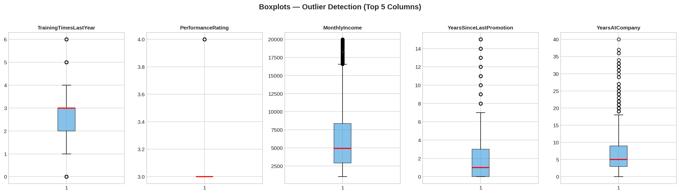
Figure 3 — Boxplots across numeric features for outlier inspection
Finding: Outliers were detected primarily in MonthlyIncome, YearsAtCompany, TotalWorkingYears, and YearsSinceLastPromotion. These represent real, legitimate employees (e.g., senior staff with long tenure or high pay) rather than data entry errors.
Decision: No outliers were removed. Tree-based models (Random Forest, XGBoost) planned for Week 4 are naturally robust to outliers, making removal unnecessary and risking the loss of meaningful signal.

5. Univariate Analysis

5.1 Numeric Feature Distributions
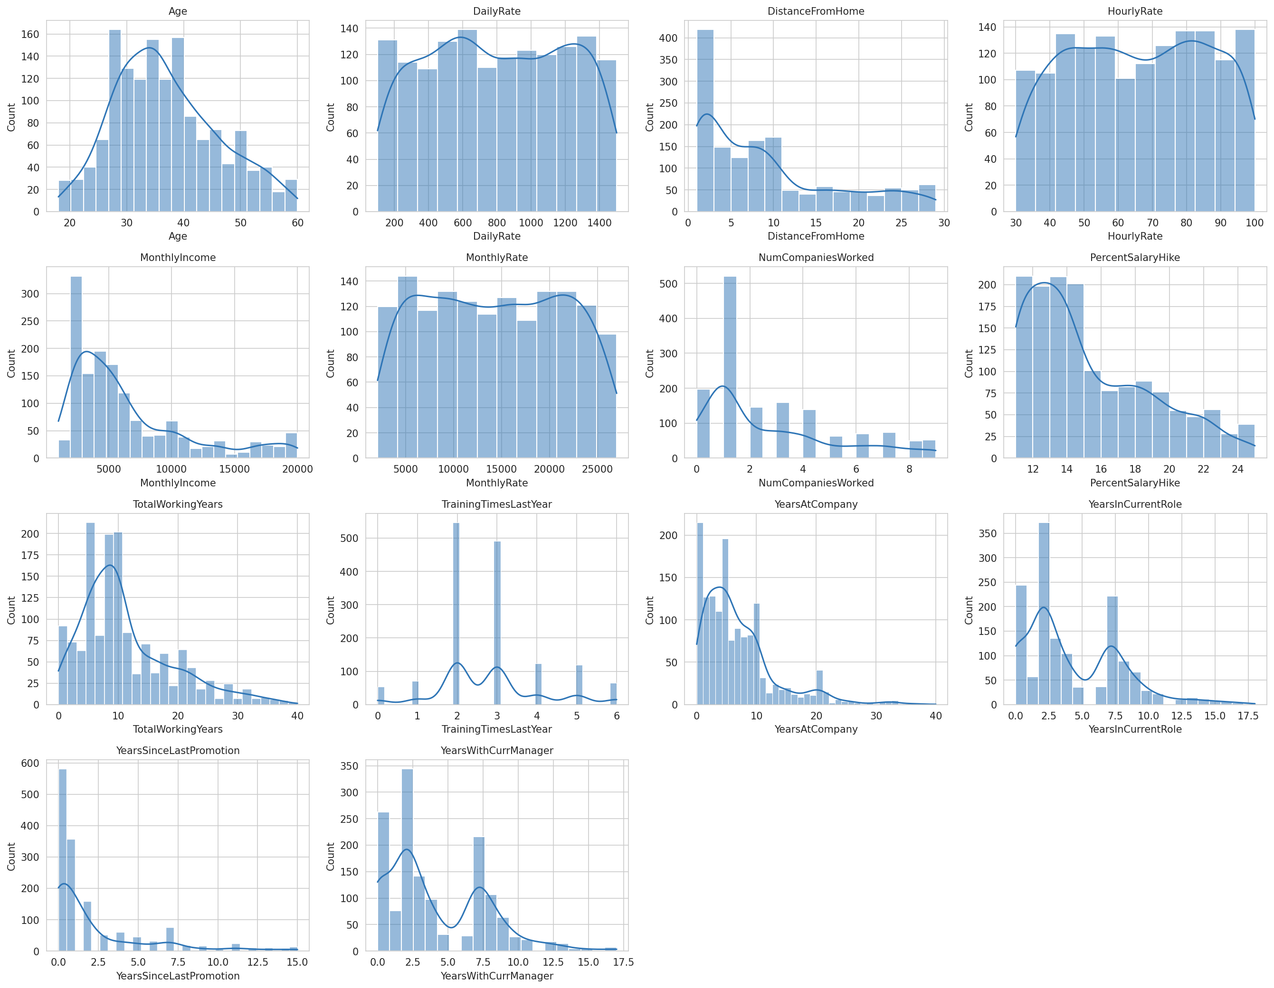
Figure 4 — Distribution histograms for all numeric features
5.2 Categorical Feature Distributions
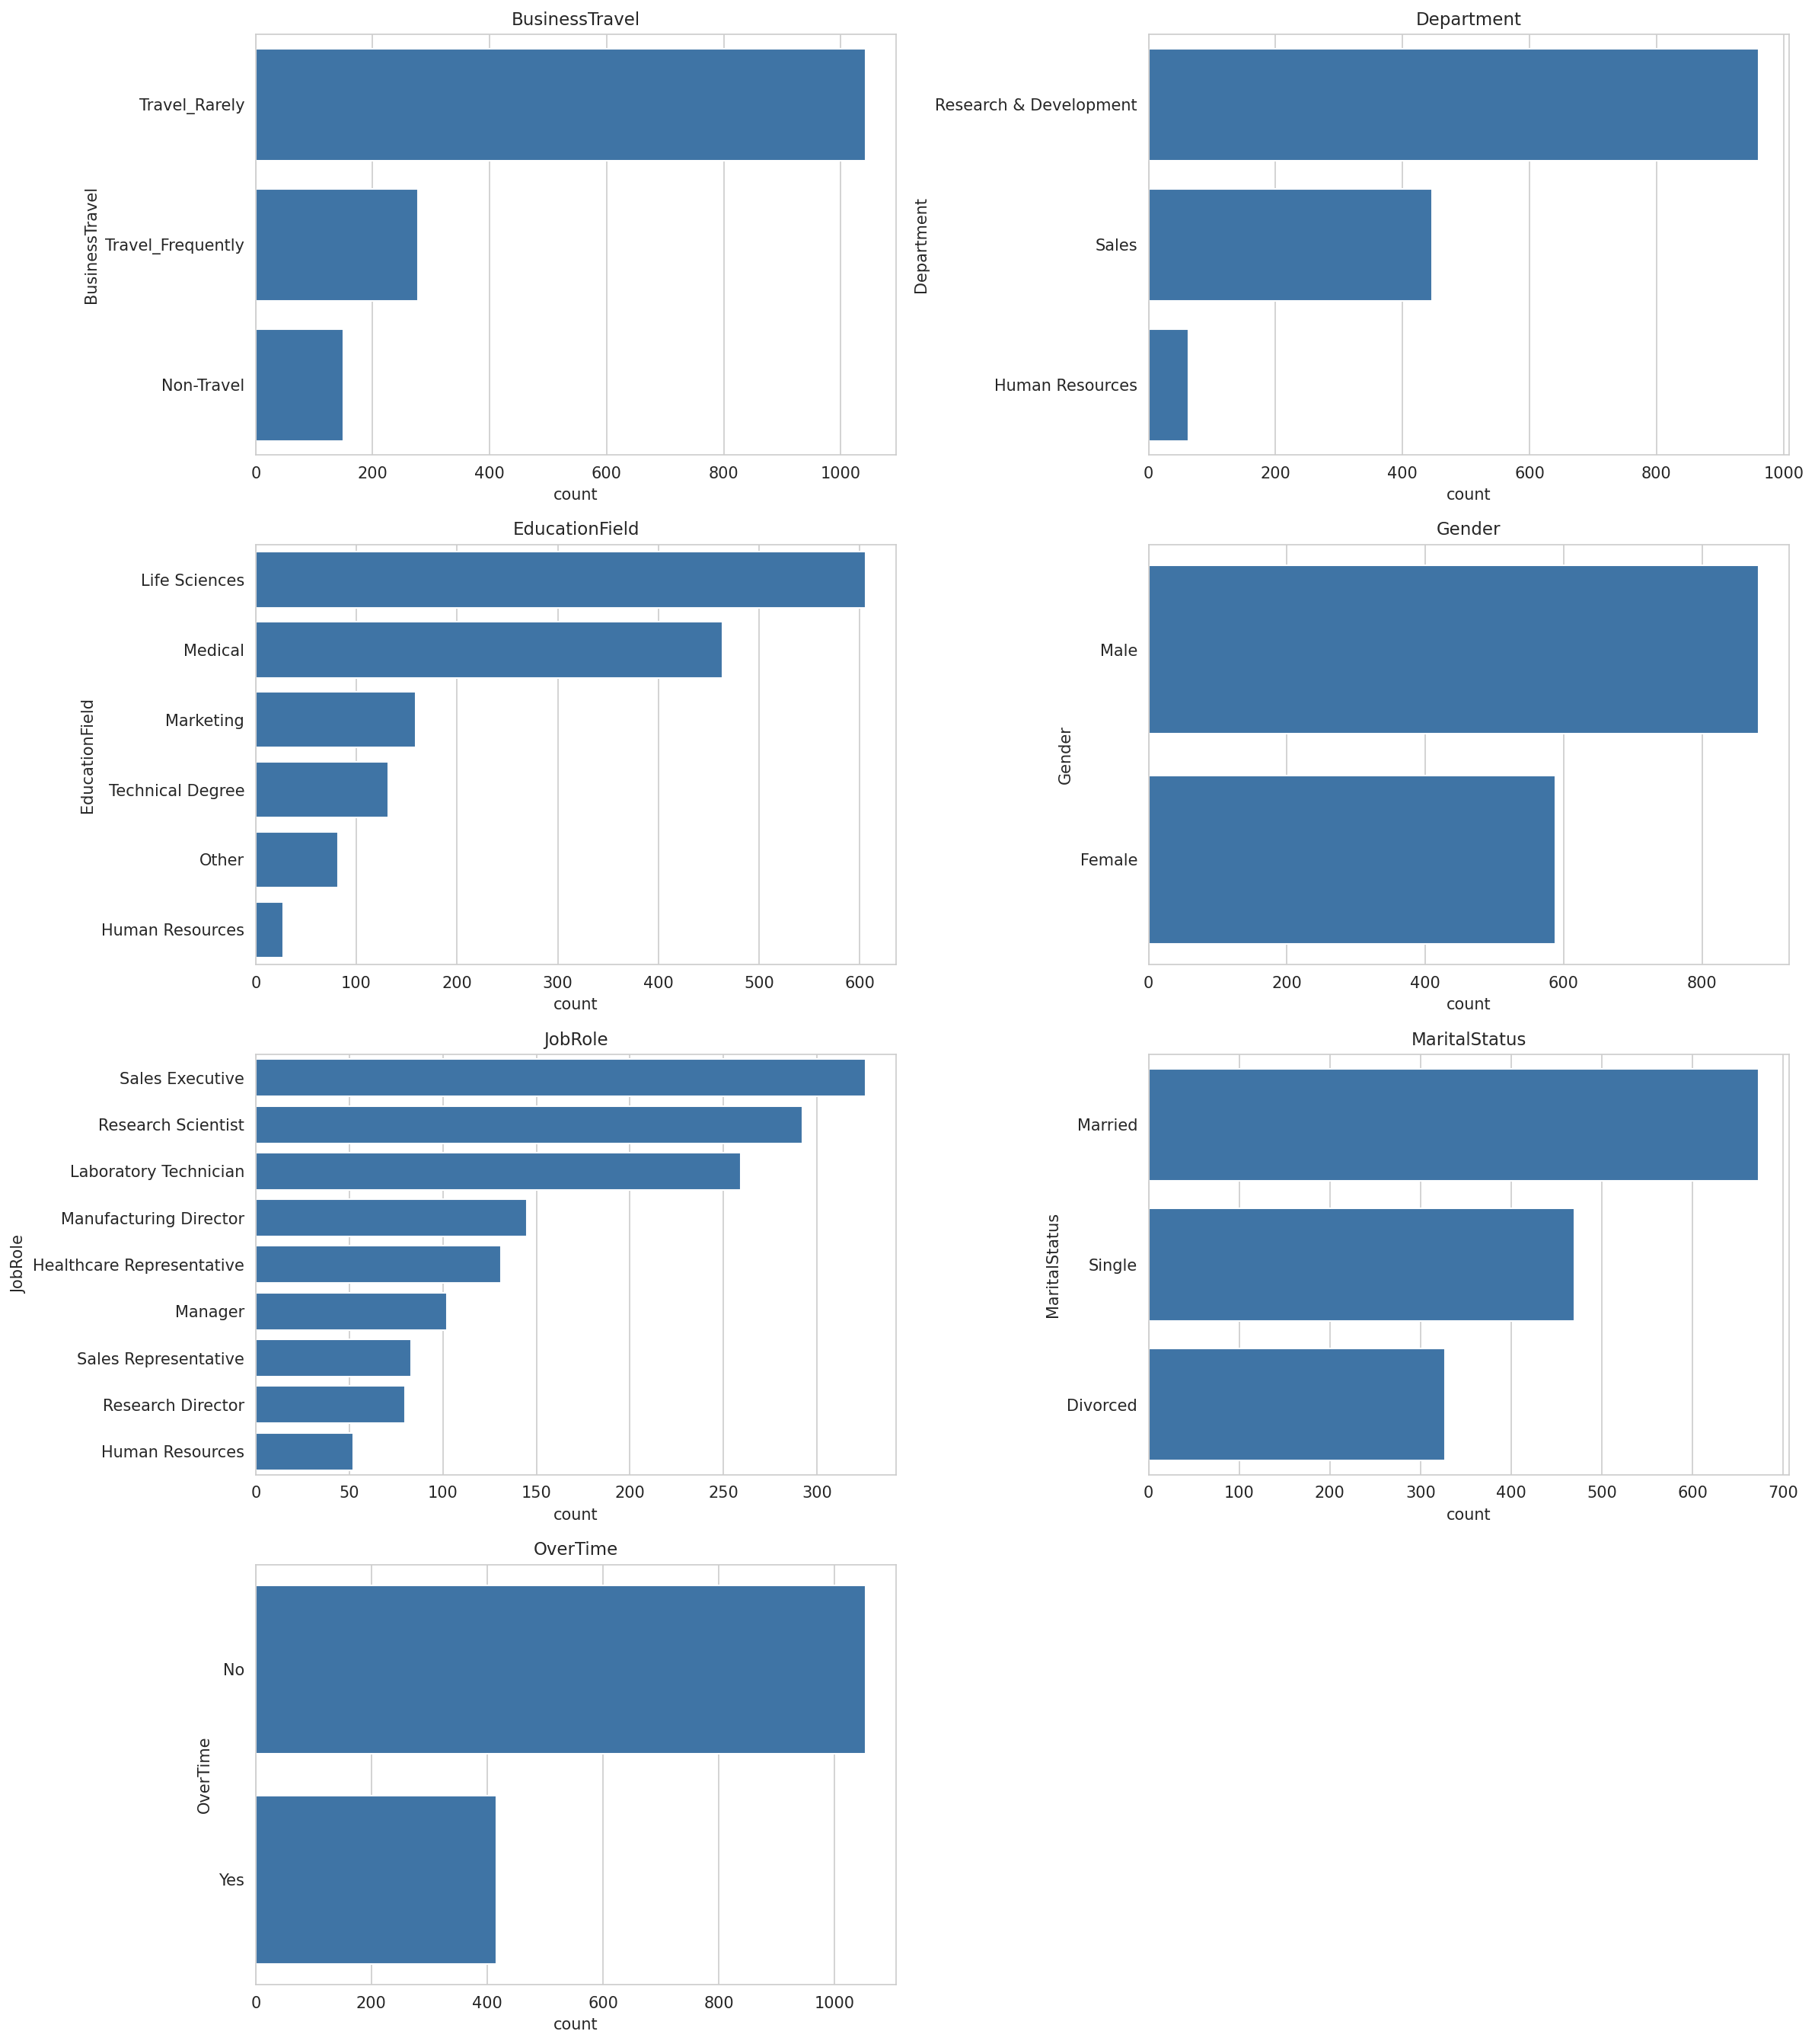
Figure 5 — Frequency counts for categorical features

6. Bivariate Analysis — Features vs. Attrition

6.1 Numeric Features vs. Attrition
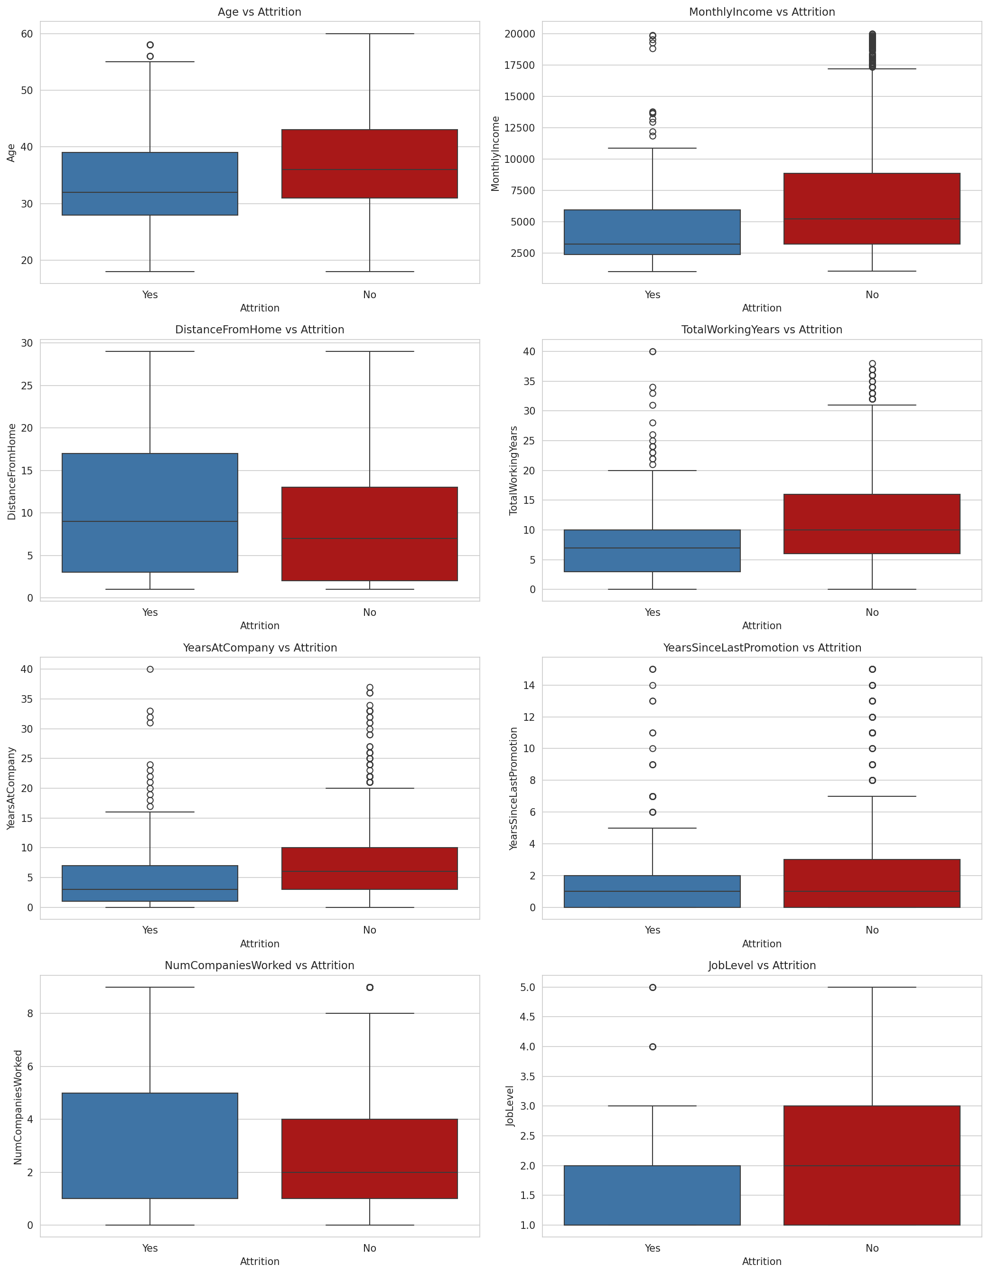
Figure 6 — Boxplots of key numeric features split by Attrition
6.2 Attrition Rate by Category (Actual Results)
The exact attrition rate (%) was computed for every categorical feature. The strongest patterns found in this dataset:
Feature → Value | Attrition Rate
OverTime = Yes | 30.5%
OverTime = No | 10.4%
MaritalStatus = Single | 25.5%
MaritalStatus = Married | 12.5%
MaritalStatus = Divorced | 10.1%
BusinessTravel = Frequent | 24.9%
BusinessTravel = Rarely | 15.0%
BusinessTravel = Non-Travel | 8.0%
JobRole = Sales Representative | 39.8% (highest of all roles)
JobRole = Research Director | 2.5% (lowest of all roles)
Department = Sales | 20.6%
Department = R&D | 13.8%
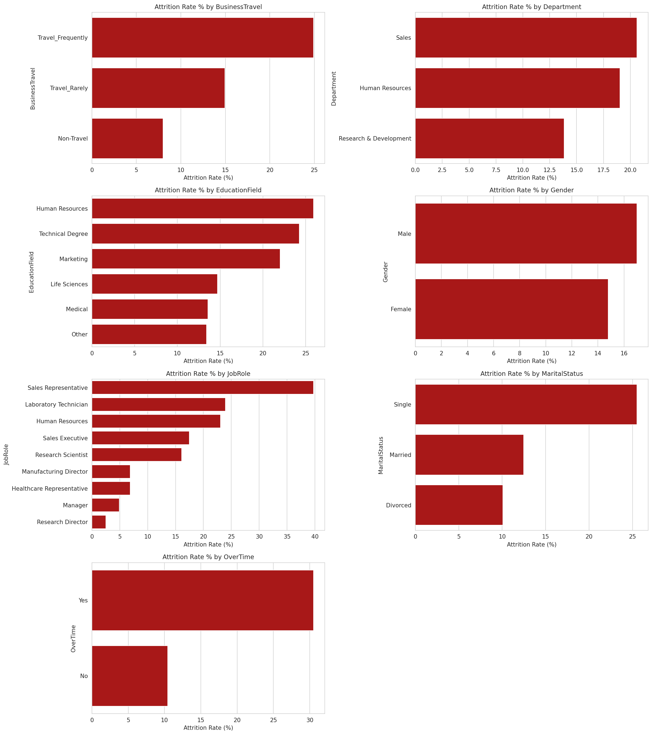
Figure 7 — Attrition rate (%) broken down by each categorical feature

7. Correlation Analysis (Mandatory Insights Tab Asset)

Per the 2026 MLOps standard, a correlation heatmap is a compulsory component of the final Streamlit Insights Tab. The full numeric correlation matrix was generated and saved as correlation_heatmap_full.png for direct reuse in Week 7.
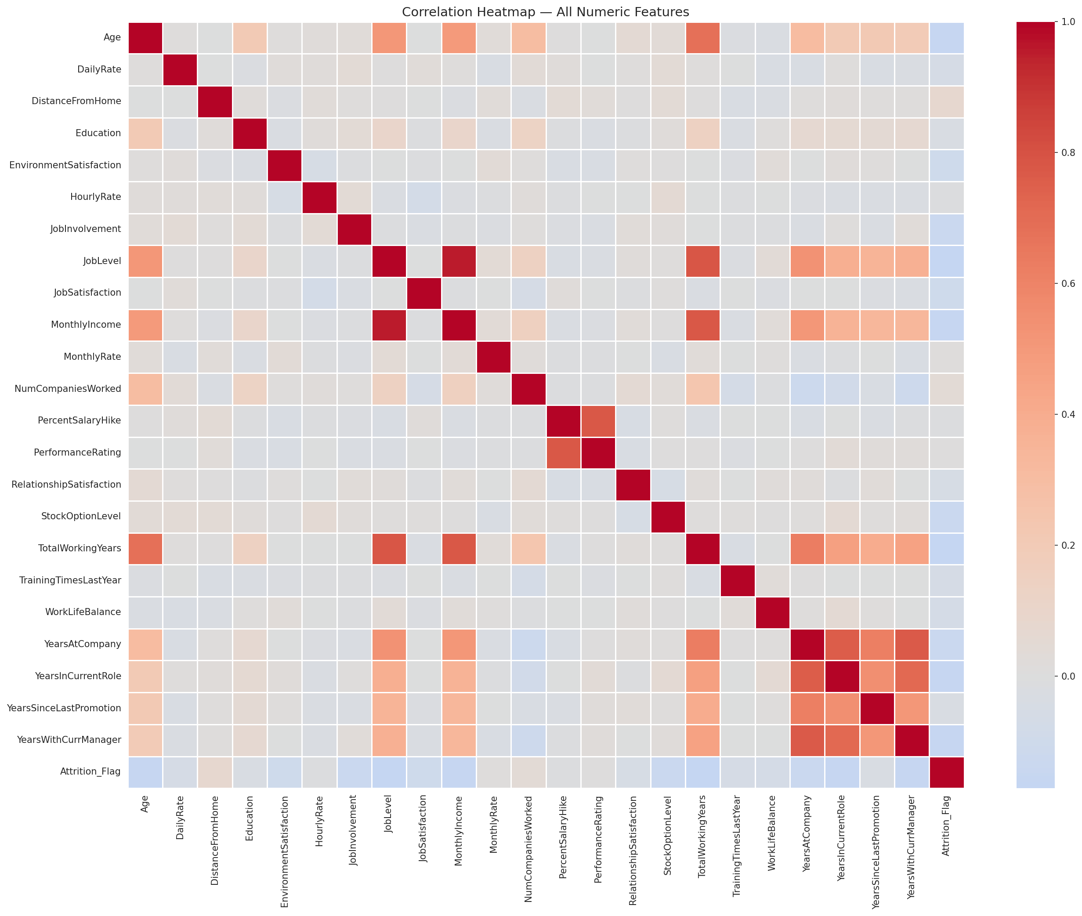
Figure 8 — Full correlation heatmap across all numeric features (Insights Tab asset)
7.1 Top Features Correlated with Attrition
Feature | Correlation with Attrition
TotalWorkingYears | -0.171
JobLevel | -0.169
YearsInCurrentRole | -0.161
MonthlyIncome | -0.160
Age | -0.159
YearsWithCurrManager | -0.156
StockOptionLevel | -0.137
YearsAtCompany | -0.134
JobInvolvement | -0.130
JobSatisfaction | -0.103
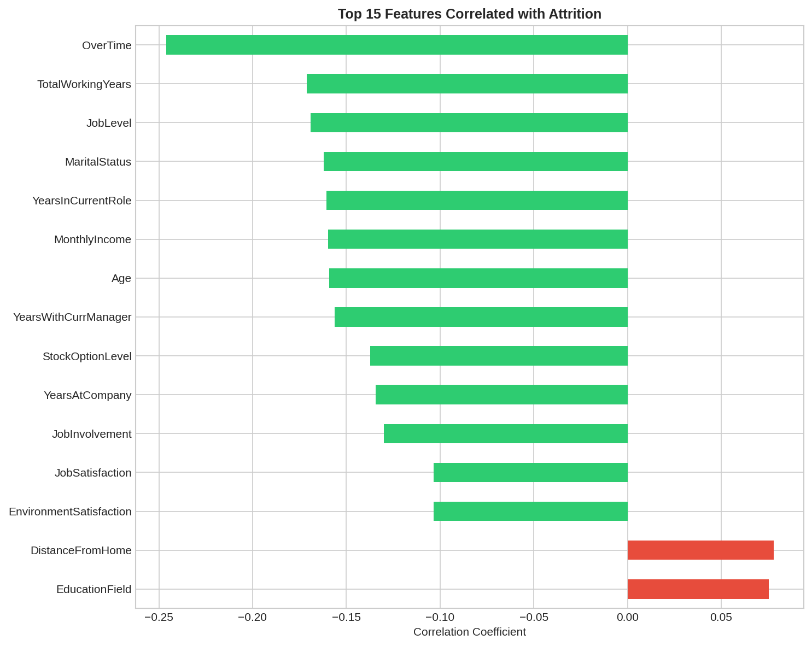
Figure 9 — Top 10 features ranked by correlation strength with Attrition
Interpretation: All top correlations are negative, meaning more experience, higher job level, higher income, older age, and longer manager tenure are all associated with LOWER attrition. This aligns directly with the categorical findings above (Single, frequent travelers, and Sales Representatives — typically less tenured profiles — show the highest attrition).

8. Key Findings Summary

- Zero missing values — no imputation needed.
- Dataset is imbalanced: 83.9% stayed vs. 16.1% left — SMOTE required in Week 4.
- OverTime is the single strongest categorical driver: 30.5% attrition vs. 10.4% for non-overtime employees.
- Sales Representatives have the highest attrition rate of any job role at 39.8%.
- Single employees leave nearly 2.5x more often than married employees (25.5% vs 12.5%).
- Frequent business travelers attrite at over 3x the rate of non-travelers (24.9% vs 8.0%).
- Tenure and seniority features (TotalWorkingYears, JobLevel, YearsInCurrentRole) show the strongest numeric correlation with attrition — all negative.
- Outliers in income/tenure fields were retained as legitimate values; tree-based models will be used in Week 4 to handle them naturally.

