PHOTOS For invitation
- Change landing page background photo (see photo no. 2 landing page)
- Change 1st page photo and make it look like a background (see photo no. 2), for the layout, see below

- Should be ‘In His Light, We Found Each Other.’
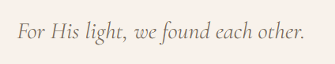
- After ng countdown, blank lang po then photos (insert no. 3 photos, 3 din po ‘yon)
- Baka po may better way to present ‘yung locations, ‘yung mas aesthetic, or ‘yung maps babaguhin ang itsura like para siyang sketch
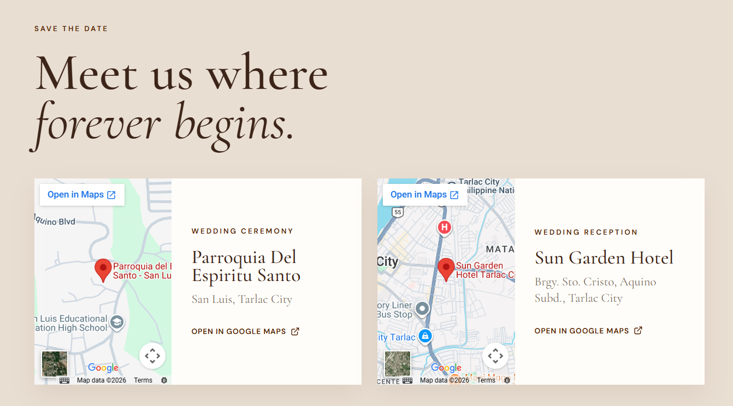

- Change entourage layout. Order should be the same with the PDF file, E on entourage should be capitalized
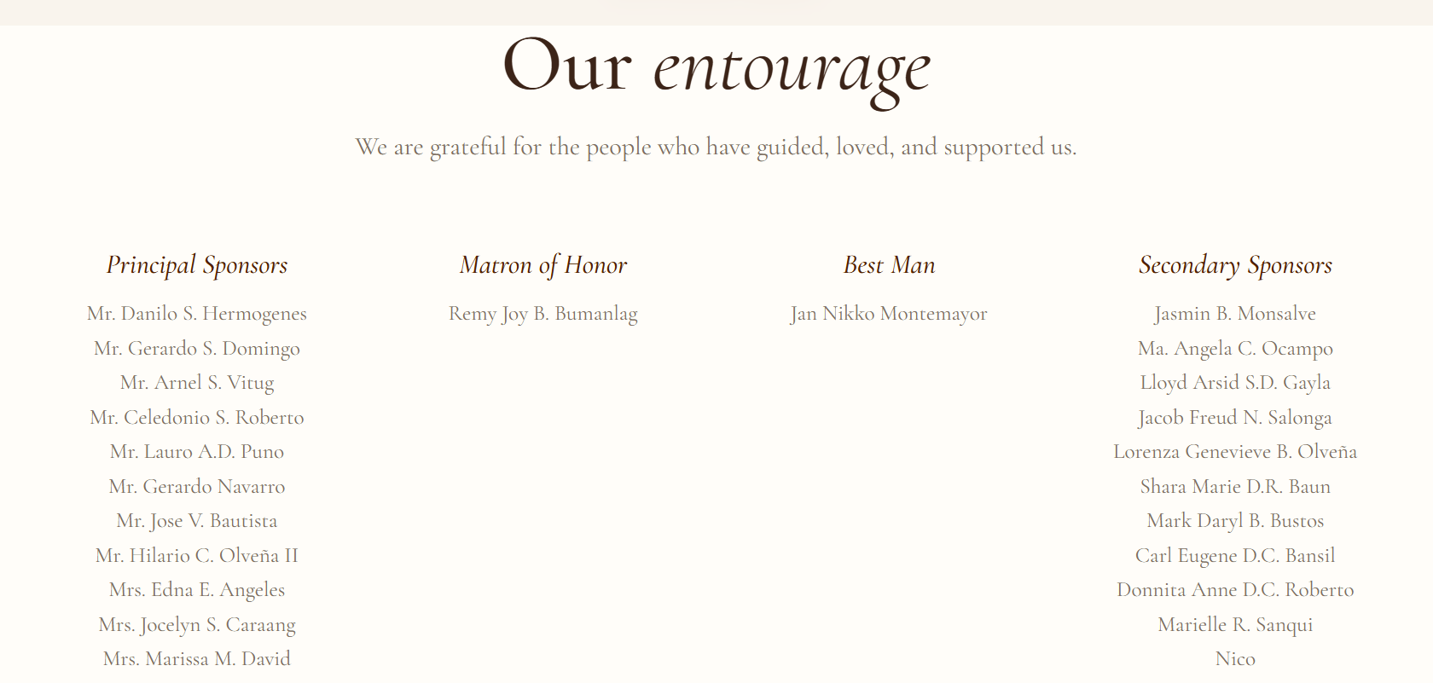
Layout:
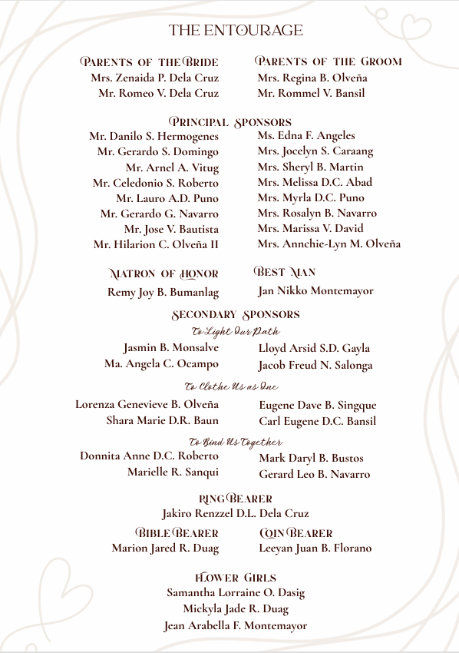

- Change background photo (see photo no. 4)
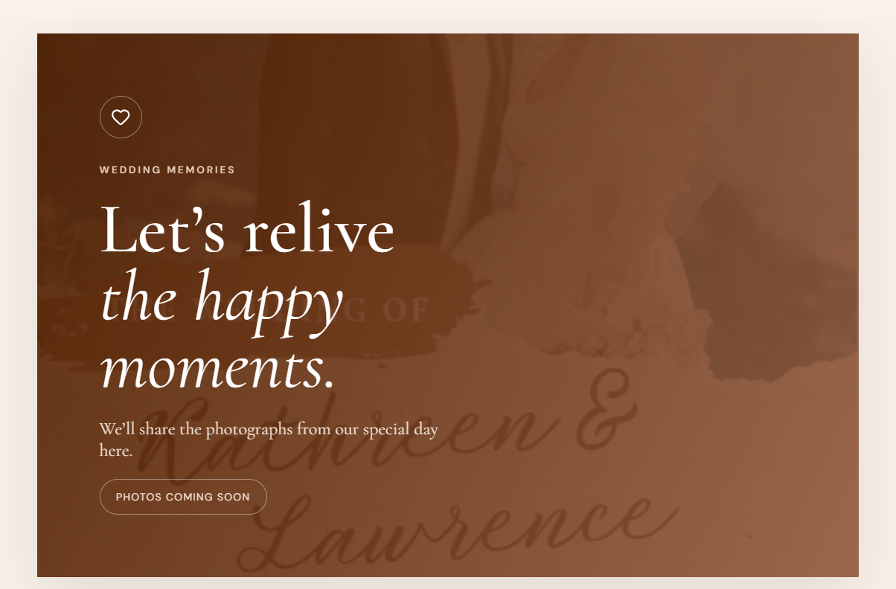
- Update this part.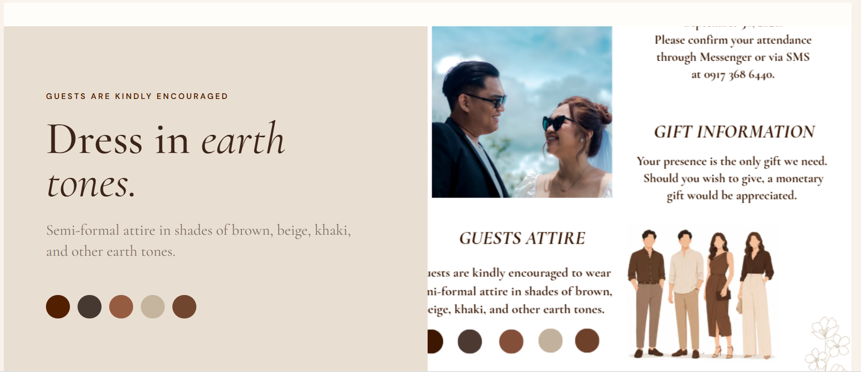
- Bigger font size for these



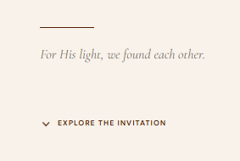
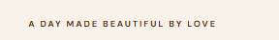
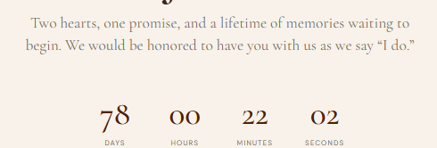
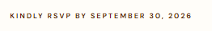


- Change K&L to monogram provided



