

Npm install ngx-toastr –save 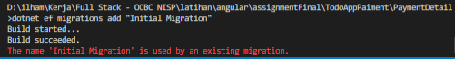

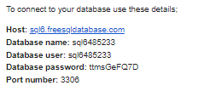 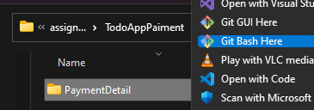

Push Github

  🡺  🡺  🡺 🡺 🡺  🡺  🡺  🡺 

 🡺 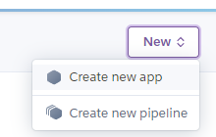 🡺 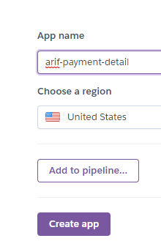🡺  🡺  🡺 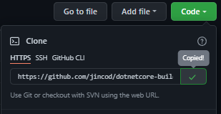 🡺 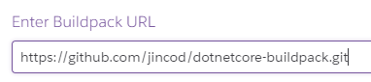 🡺  🡺 🡺  🡺 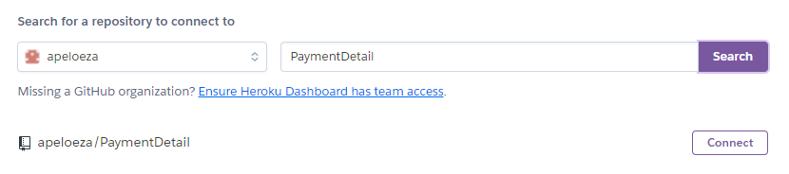🡺 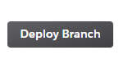

🡺 + /swagger/index.html 🡺  