<!-- p {margin: 0; padding: 0;} .ft10{font-size:21px;font-family:AAAAAA+Now;color:#323b4b;} .ft11{font-size:15px;font-family:BAAAAA+Lato;color:#323b4b;} .ft12{font-size:14px;font-family:BAAAAA+Lato;color:#323b4b;} .ft13{font-size:16px;font-family:CAAAAA+Lato;color:#323b4b;} .ft14{font-size:15px;font-family:CAAAAA+Lato;color:#323b4b;} .ft15{font-size:41px;font-family:DAAAAA+Now-Black;color:#fdfdfd;} .ft16{font-size:22px;font-family:EAAAAA+Now;color:#fdfdfd;} .ft17{font-size:15px;font-family:FAAAAA+Aileron;color:#323b4b;} .ft18{font-size:16px;font-family:GAAAAA+Aileron;color:#323b4b;} .ft19{font-size:16px;font-family:FAAAAA+Aileron;color:#323b4b;} .ft110{font-size:15px;line-height:22px;font-family:CAAAAA+Lato;color:#323b4b;} .ft111{font-size:15px;line-height:20px;font-family:BAAAAA+Lato;color:#323b4b;} .ft112{font-size:15px;line-height:20px;font-family:FAAAAA+Aileron;color:#323b4b;} -->
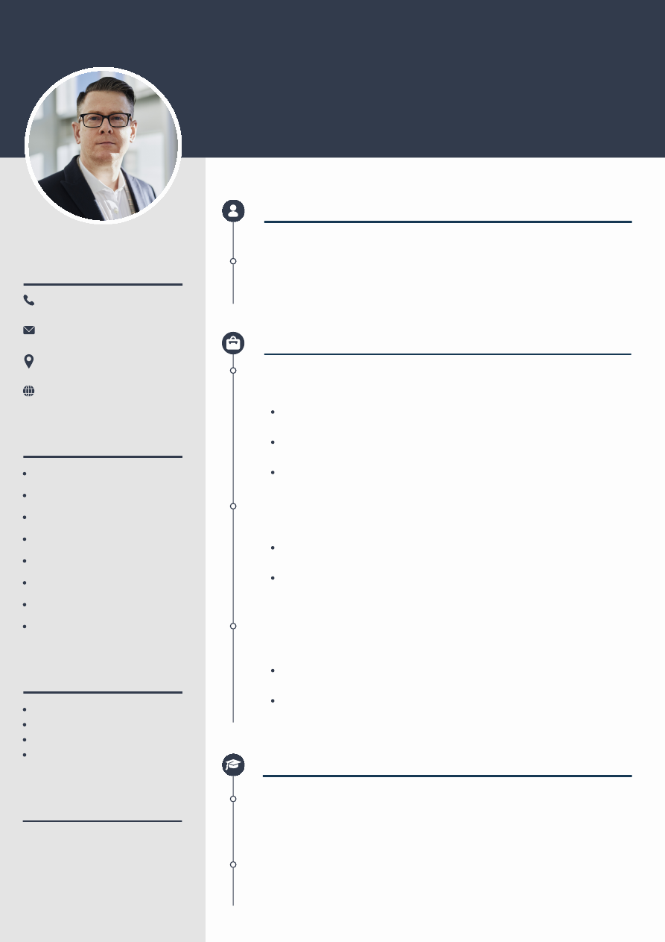
REFERENCE
CONTACT
SKILLS
LANGUAGES
+123-456-7890 this is jkjklsjk
hello@reallygreatsite.com
123 Anywhere St., Any City
www.reallygreatsite.com
123-456-7890
hello@reallygreatsite.com
Estelle Darcy
Phone: Email :
Wardiere Inc. / CTO
Project Management
Public Relations
Teamwork
Time Management
Leadership
Effective Communication
Critical Thinking
Digital Marketing
English (Fluent)
French (Fluent)
German (Basic)
Spanish (Intermediate)
Trushant Kose
Full Stack Developer Intern
WORK EXPERIENCE of trushant
EDUCATION
PROFILE kklm,m , ,,m,.m
Lorem ipsum dolor sit amet, consectetur adipiscing elit, sed do eiusmod
tempor incididunt ut labore et dolore magna aliqua. Ut enim ad minim
veniam quis nostrud exercitation. Lorem ipsum dolor sit amet, consectetur
adipiscing elit, sed do eiusmod tempor incididunt ut labore et dolore magna
aliqua. Ut enim ad minim veniam quis nostrud exercitation.
2030 - PRESENT
Borcelle Studio
Marketing Manager & Specialist
2025 - 2029
Fauget Studio
Marketing Manager & Specialist
2022 - 2025
Studio Shodwe
Marketing Manager & Specialist
Develop and execute comprehensive marketing strategies and
campaigns that align with the company's goals and objectives.
Lead, mentor, and manage a high-performing marketing team,
fostering a collaborative and results-driven work environment.
Monitor brand consistency across marketing channels and materials.
Create and manage the marketing budget, ensuring efficient
allocation of resources and optimizing ROI is it working.
Oversee market research to identify emerging trends, customer
needs, and competitor strategies my nanme is trushant kose.
Develop and maintain strong relationships with partners, agencies,
and vendors to support marketing initiatives.
Monitor and maintain brand consistency across all marketing
channels and materials how can we do that.
2029 - 2031
Master of Business Management and reviring the mindful
School of business | Wardiere University
2025 - 2029
Bachelor of Business Management
School of business | Wardiere University
GPA:
3.8 / 4.0
GPA:
3.8 / 4.0

Document Outline
- RICHARD SANCHEZ
  - MARKETING MANAGER
  - CONTACT
    - +123-456-7890
    - hello@reallygreatsite.com
    - 123 Anywhere St., Any City
    - www.reallygreatsite.com
  - SKILLS
    - Project Management
    - Public Relations
    - Teamwork
    - Time Management
    - Leadership
    - Effective Communication
    - Critical Thinking
    - Digital Marketing
  - LANGUAGES
    - English (Fluent)
    - French (Fluent)
    - German (Basic)
    - Spanish (Intermediate)
  - REFERENCE
    - Estelle Darcy
      - Wardiere Inc. / CTO
    - Phone:
    - Email :
  - PROFILE
    - Lorem ipsum dolor sit amet, consectetur adipiscing elit, sed do eiusmod tempor incididunt ut labore et dolore magna aliqua. Ut enim ad minim veniam quis nostrud exercitation. Lorem ipsum dolor sit amet, consectetur adipiscing elit, sed do eiusmod tempor incididunt ut labore et dolore magna aliqua. Ut enim ad minim veniam quis nostrud exercitation.
  - WORK EXPERIENCE
    - Borcelle Studio
    - 2030 - PRESENT
      - Marketing Manager & Specialist
      - Develop and execute comprehensive marketing strategies and campaigns that align with the company's goals and objectives.
      - Lead, mentor, and manage a high-performing marketing team, fostering a collaborative and results-driven work environment.
      - Monitor brand consistency across marketing channels and materials.
      - Fauget Studio
        - 2025 - 2029
        - Marketing Manager & Specialist
        - Create and manage the marketing budget, ensuring efficient allocation of resources and optimizing ROI.
        - Oversee market research to identify emerging trends, customer needs, and competitor strategies.
      - Studio Shodwe
        - 2024 - 2025
        - Marketing Manager & Specialist
        - Develop and maintain strong relationships with partners, agencies, and vendors to support marketing initiatives.
        - Monitor and maintain brand consistency across all marketing channels and materials.
  - EDUCATION
    - Master of Business Management
      - 2029 - 2031
      - School of business | Wardiere University
    - GPA: 3.8 / 4.0
      - Bachelor of Business Management
        - 2025 - 2029
        - School of business | Wardiere University
    - GPA: 3.8 / 4.0

