<!-- p {margin: 0; padding: 0;} .ft10{font-size:31px;font-family:AAAAAA+Lora;color:#ffffff;} .ft11{font-size:24px;font-family:BAAAAA+Lora;color:#ffffff;} .ft12{font-size:17px;font-family:CAAAAA+Montserrat-SemiBold;color:#ffffff;} .ft13{font-size:23px;font-family:AAAAAA+Lora;color:#202529;} .ft14{font-size:18px;font-family:DAAAAA+Montserrat;color:#202529;} .ft15{font-size:18px;font-family:CAAAAA+Montserrat-SemiBold;color:#000080;} .ft16{font-size:17px;font-family:DAAAAA+Montserrat;color:#202529;} .ft17{font-size:23px;font-family:DAAAAA+Montserrat;color:#202529;} .ft18{font-size:17px;font-family:CAAAAA+Montserrat-SemiBold;color:#202529;} .ft19{font-size:17px;line-height:26px;font-family:CAAAAA+Montserrat-SemiBold;color:#ffffff;} .ft110{font-size:17px;line-height:25px;font-family:CAAAAA+Montserrat-SemiBold;color:#ffffff;} .ft111{font-size:18px;line-height:28px;font-family:DAAAAA+Montserrat;color:#202529;} .ft112{font-size:18px;line-height:24px;font-family:DAAAAA+Montserrat;color:#202529;} .ft113{font-size:18px;line-height:23px;font-family:CAAAAA+Montserrat-SemiBold;color:#000080;} .ft114{font-size:17px;line-height:26px;font-family:DAAAAA+Montserrat;color:#202529;} .ft115{font-size:17px;line-height:25px;font-family:DAAAAA+Montserrat;color:#202529;} .ft116{font-size:17px;line-height:21px;font-family:DAAAAA+Montserrat;color:#202529;} .ft117{font-size:17px;line-height:21px;font-family:CAAAAA+Montserrat-SemiBold;color:#202529;} -->
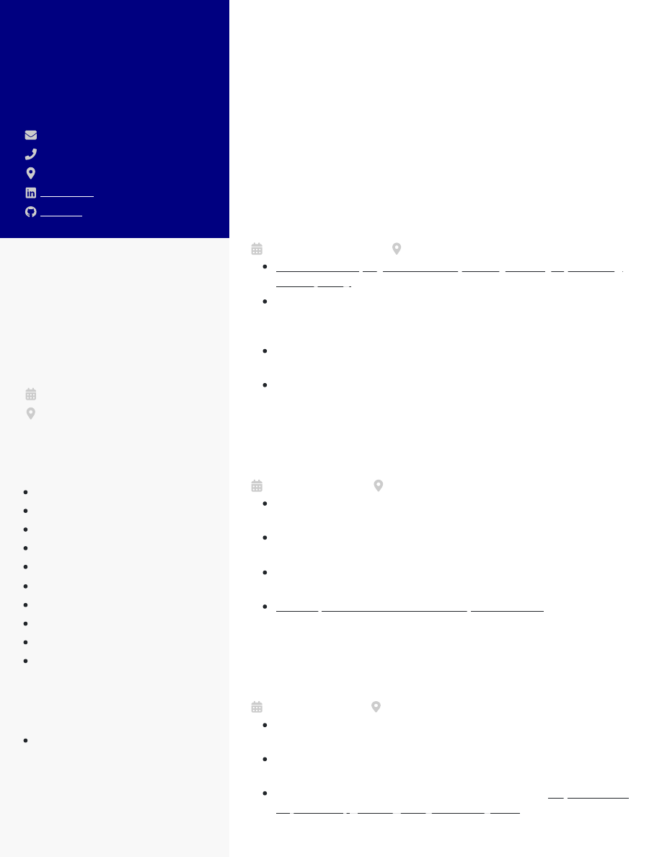
CHERRY WHITE
Junior Full Stack
Developer
c.white@email.com(123) 456-7890Boston, MALinkedInGithub
EDUCATION
Bachelor of Science
Computer Science and
Engineering
Massachusetts Institute ofTechnology
2010 - 2014
Cambridge, MA
SKILLS
JavaScript
Angular
Node.js
MySQL
API Gateway
Git
Python
Docker
SonarQube
Model Check
CERTIFICATIONS
AWS Certiﬁed Developer
CAREER OBJECTIVE
Junior full-stack developer with 5 years of experience developing
and integrating multi-faceted applications to facilitate smooth
business operations in same magnitude as at SynergisticIT.
Proﬁcient in JavaScript, PHP, MySQL, and Python, and in creating
bug-free systems to meet client expectations.
WORK EXPERIENCE in 5yrs in Apera solutions
Junior Full Stack Developer
TechCorp Solutions
2020 - current
Boston, MA
Increased employer website speed by 57% by optimizingcode quality
and safety with SonarQube
Cut down administration expenditure by $5.2K through
streamlining veriﬁcation application via Model Check to
boost data accuracy
Upgraded serverless application using API Gateway,
reducing operational costs by 91%
Fixed 98% of critical bugs to triple performance across
departments
Junior Software Developer
Wayfair
2017 - 2020
Boston, MA
Accelerated real-time data access by customers to 97%
through a NodeJS web app
Tripled return customer rate to 66% by installing a web app
to allow data transfer in CSV ﬁles
Improved bug detection to 99%, reducing customer
complaints to less than 10 weekly
Saved $501K in software development costs
by creating
reusable database components using Angular
Associate Web Developer
HubSpot
2014 - 2017
Cambridge, MA
Expanded customer satisfaction levels to 88% by revamping
database using MySQL
Boosted operations performance by 69% after launching a
new admin panel in Python
Assisted in the redesign of the existing site to
improve user
experience, growing daily trafﬁc by 53%

