Reproducible Research: Peer Assessment 1

## Loading and preprocessing the data

unzip("activity.zip")  
walkdata <- read.csv("activity.csv")

## What is mean total number of steps taken per day?

totalSteps <- aggregate(steps ~ date, data = walkdata, sum, na.rm = TRUE)  
hist(totalSteps$steps)

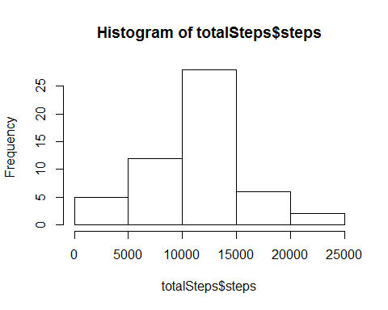

meanSteps <- mean(totalSteps$steps)  
medianSteps <- median(totalSteps$steps)

* The mean of the total number of steps taken per day is: 10766.2
* The median of the total number of steps taken per day is: 10765

## What is the average daily activity pattern?

stepsToInterval <- aggregate(steps ~ interval, data = walkdata, mean, na.rm = TRUE)  
plot(steps ~ interval, data = stepsToInterval, type = "l")

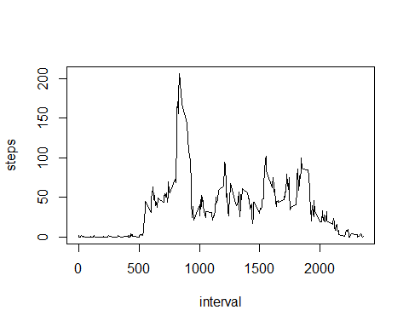

max5Minute <- stepsToInterval[which.max(stepsToInterval$steps), ]$interval

* The 5-minute interval which on average across all the days in the dataset, contains the maximum number of steps is: 835

## Imputing missing values

## Are there differences in activity patterns between weekdays and weekends?