WRFV3.7.1_LHN User guide

Overview

The LHN assimilates instantaneous rainrate observations, in mm/hr. The observation are introduced into WRF through the auxiliary input channels. The accepted file input formats and the structure is the same as the WRF output files.
Therefore, the observations file should have the same grid as the WRF one.
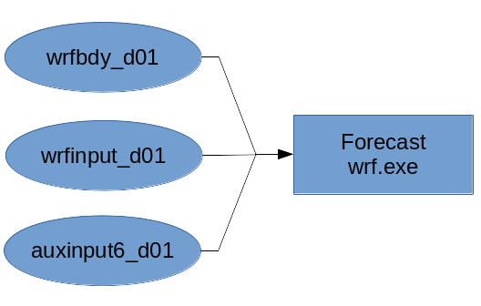
NESTED DOMAINS AND MPI NOT SUPPORTED YET!!

Two variables are used by the LHN from the input file:
- RAINRATE_OBSERVATIONS(time, lat, lon)
  - Rainrate observations in mm/hr
- OBSERVATIONS_QUALITY(time, lat, lon)
  - Observations quality mask. All observations with a quality value greater than zero are processed.

Namelist Control
The LHN data assimilation is controlled trought the namelist file. These are the options:Comien
namelist entry | section | type | defaul value | Description
auxinput6_inname | time_control | string | "auxinput6_d<domain>_<date>" | Observations input file name
auxinput6_interval_s | time_control | integer | 0 | Observations interval in seconds
io_form_auxinput6 | time_control | integer | 0 | 0=No input  1=Grib  2=Netcdf
lhn_type | latent_heat_nudging | integer | 0 | 0=No LHN  1=LHN
lhn_start | latent_heat_nudging | integer | 0 | LHN start time in seconds from the beggining of the simulation
lhn_end | latent_heat_nudging | integer | 0 | LHN end time in seconds from the beggining of the simulation
search_range | latent_heat_nudging | integer | 10 | Profile search radius [in grid points]
lhn_smooth_filter_sigma | latent_heat_nudging | float | 1.0 | Gaussian filter standard deviation [in grid points]
minimum_profile_scaling | latent_heat_nudging | float | 0.333 | Minimum profile scaling allowed
maximum_profile_scaling | latent_heat_nudging | float | 2.0 | Maximum profile scaling allowed
lhn_limit | latent_heat_nudging | float | 0.0005 | Latent heat nudging limit [K/s]

