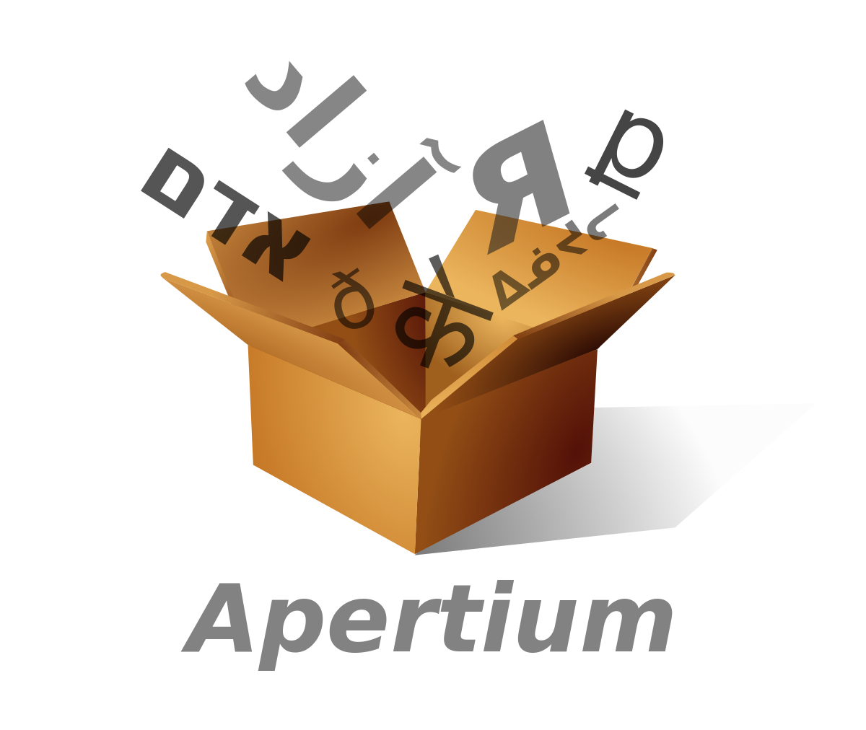

Apertium: a free/open-source platform for machine translation and basic language technology
www.apertium.org
Contact: Mikel L. Forcada <mlf@ua.es>, Francis M. Tyers <ftyers@iu.edu>

Apertium components
Since 2005, Apertium provides:
- A free/open-source, modular, language-independent machine translation engine with: text format management, finite-state lexical processing, statistical and constraint-based lexical disambiguation, dis-contiguous multi-word assembly and disassembly, anaphora resolution, and shallow structural transfer based on finite-state pattern matching (with alternative experimental deep transfer).
- Free/open-source language data in well-specified XML formats for a variety of languages and language pairs
- Free/open-source tools: compilers to turn linguistic data into a fast and compact form used by the engine and software to learn disambiguation or translation rules from corpora.
Most of the engine was developed inside the Apertium project but some external technologies are used: Helsinki Finite-State toolkit (for some morphologically-rich languages), VISL CG-3 (constraint grammars for rule-based lexical disambiguation).

Machine translation — but not only!
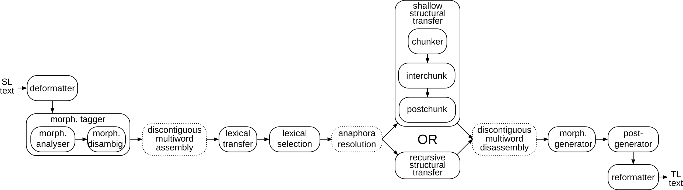
Apertium is a rule-based machine translation system but the pipeline contains many monolingual modules that can be used for other human-language technology tasks.
Most modules are based on finite-state technology; HMMs are used for part-of-speech tagging and an interpreted language is used to write structural transfer rules.

Licensing: free/open-source
Apertium language data and code are both licensed under the GNU General Public License:
- a free/open-source license allowing free distribution of unmodified and modified versions;
- a copylefted license: it avoids private appropriation and encourages giving improvements back to the project (it creates a software commons).
The free/open-source model creates a community which effectively connects researchers, developers, vendors and users.

The Apertium community
- Very active group of hundreds of developers
- Wiki documentation (wiki.apertium.org)
- Easy entry: Apertium linguistic modelling is simple, no need to program
- IRC channel #apertium in freenode.net
- Mailing lists: apertium-stuff@lists.sf.net and other lists

Research and business with Apertium
Apertium is already an active research and business platform:
- Research: 40+ publications, 2 PhD thesis, 4 master's theses.
- Business: companies (Prompsit, Eleka, Imaxin Software, etc.) offering services to customers such as Autodesk, the Government of Catalonia, the daily papers Levante and La Voz de Galicia.

Ready-to-use Apertium products
- A stand-alone Java application for the desktop: apertium-caffeine.
- An Android version for handhelds.
- A stand-alone version (Apertium Simpleton) for Windows and MacOS.
- A plug-in for the OmegaT CAT platform: apertium-omegat.
- Available as a PPA repository for GNU/Linux users.

Languages and language pairs
Language data is encoded mostly in XML, but some language pairs contain data encoded in other text-based formats. Stable language pairs (bilingual data) are currently 49.

Apertium loves small languages
Breton→French
Aragonese↔Spanish
Occitan↔Catalan
Aragonese↔Catalan
Occitan↔Spanish
North Sámi↔Norwegian

Some success cases
- In Wikimedia Content Translation, Apertium translates Wikipedia content;
- Apertium helps produce a Catalan edition of Valencia daily newspaper Levante-EMV;
- Universities in the Catalan-speaking area use Apertium to help in the generation of courseware and academic information;
- Apertium is used in PLATA, the Spanish Government platform for webpage translation.

Funding
- The Ministry of Industry, Tourism and Commerce of Spain (also, the Ministries of Education and Science and of Science and Technology of Spain)
- The Secretariat for Technology and the Information Society of the Government of Catalonia
- The European Commission (Abu-Matran project)
- The Ministry of Foreign Affairs of Romania
- Universitat d'Alacant and Universitat Oberta de Catalunya
- Ofis Publik ar Brezhoneg (Breton Language Board)
- Google Summer of Code scholarships (2009–2014, 2016–2018) and Google Code-In (2013–2019) donations.
- Companies: Prompsit Language Engineering, ABC Enciklopedioj, Eleka Ingeniartiza Linguistikoa, imaxin|software, Eolaistriu Technologies, Kaldera, etc.

[Brochure version 20191127]

