U.S. SECURITIES AND EXCHANGE COMMISSION
New York, N.Y. 15697

FORM 10-QSB/A

(Mark One)

[X] QUARTERLY REPORT PURSUANT SECTION 13 OR 15(d) OF THE SECURITIES EXCHANGE ACT OF 1934

For the quarterly period ended September 30, 2001.

[ ] TRANSACTION REPORT PURSUANT SECTION 13 OR 15(d) OF THE SECURITIES EXCHANGE ACT OF 1934

For the transition period from .................. to ....................

Commission file number: 1-23456

ABC, CO.
(Exact name of registrant as specified in its charter)

Maine | 12-34567890
(State or other jurisdiction of Incorporation or organization) | (I.R.S. Employer Identification No.)

89 S. 10th Street, Suite 135
Lewiston, Maine 54321
(514) 987-3548

(Address and telephone number of registrant's principal executive offices and
principal place of business)

Check whether the registrant (1) has filed all reports required to be filed by Section 13 or 15(d) of the Exchange Act during the preceding 12 months (or for such shorter period that the registrant was required to file such reports, or (2) has been subject to such filing requirements for the past 90 days.

Yes [X] No [ ]

State the number of shares outstanding of each of the Issuer's classes of common equity, as of the latest practicable date. 48,505,824 shares of common, $.001 par value as of October 31, 2001.
Table of Contents

PART I – FINANCIAL INFORMATION

ITEM 1. CONDENSED CONSOLIDATED FINANCIAL STATEMENTS 3
CONDENSED CONSOLIDATED STATEMENTS OF OPERATIONS AND COMPREHENSIVE LOSS 4
Financial Overview: 5
Financial Overview: 6
CONDENSED CONSOLIDATED STATEMENTS OF CASH FLOWS 7
NOTE 1 - STOCK-BASED COMPENSATION 8
NOTES TO CONDENSED CONSOLIDATED FINANCIAL STATEMENTS 9
PART II – OTHER INFORMATION

ITEM 6. EXHIBITS AND REPORTS ON FORM 10-K 10
SIGNATURES 12
CERTIFICATIONS 13

ABC, CO.
PART I. FINANCIAL INFORMATION

ITEM 1. CONDENSED CONSOLIDATED FINANCIAL STATEMENTS

 | (unaudited)
 | September 30, |  | December 31,
 | 2001 |  | 2000
 | As Adjusted
 | (Note 2)
ASSETS
Current Assets:
Cash and cash equivalents | $ 1,859 |  | $ 29,542
Accounts receivable | 37,204 |  | 10,371
Prepaid and other assets | 398,028 |  | 5,942
Total current assets | 437,091 |  | 45,855
Property and equipment, net of accumulated depreciation | 763,753 |  | 730,539
Other Assets:
Technology rights, net of accumulated amortization of $286,838 and $235,380 at September 30, 2001 and December 31, 2000, respectively | 598,166 |  | 649,624
Total assets | $ 1,799,010 |  | $ 1,426,018
LIABILITIES AND STOCKHOLDERS’ EQUITY (DEFICIT)
Current Liabilities:
Note payable | $ 225,807 |  | $ -
Accounts payable and accrued expenses | 637,329 |  | 842,416
Due to XYZ shareholder | 2,536,948 |  | -
Advances from related parties | 28,788 |  | 250,950
Total current liabilities | 3,428,872 |  | 1,093,366
Commitments and contingencies
Stockholders’ Equity (Deficit):
Common stock, $.001 par value; authorized, 500,000,000 shares; issued and outstanding 48,505,824 and 44,547,524 at September 30, 2001 and December 31, 2000, respectively | 48,505 |  | 44,547
Additional paid-in capital | 6,949,031 |  | 6,029,499
Common stock subscriptions (600,000 and 636,000 shares, respectively) | 150,000 |  | 117,000
Accumulated deficit | (8,777,398) |  | (5,858,394)
Total stockholders’ equity (deficit) | (1,629,862) |  | 332,652
Total liabilities and stockholders’ equity (deficit) | $ 1,799,010 |  | $ 1,426,018

See notes to condensed consolidated financial statements 9.

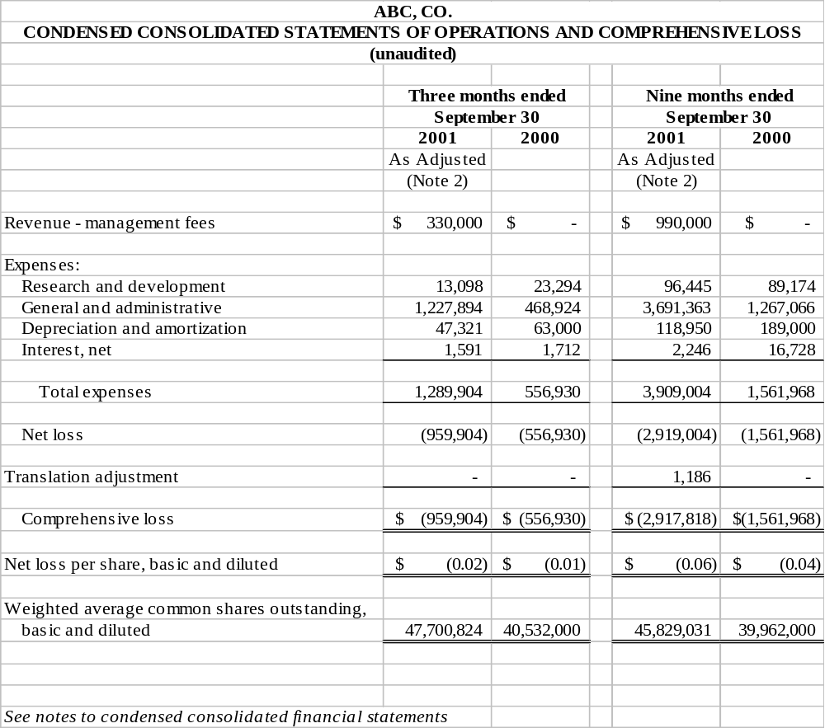

Financial Overview:

The following chart summarizes the sales, gross margin, and net profit for the year 2001 compared to 2000.

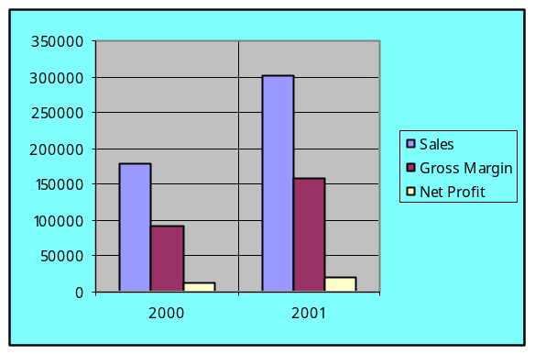

Financial Overview:

The following chart summarizes the sales, gross margin, and net profit for the year 1999 compared to 1998.

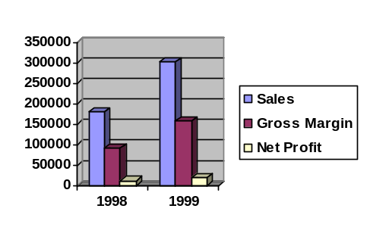
ABC, CO.

CONDENSED CONSOLIDATED STATEMENTS OF CASH FLOWS
(unaudited)

 | For the nine months ended September 30,
 | 2001 | 2000
As Adjusted
(Note 2)
Cash flows from operating activities:
Net loss | $(2,919,004) | $(1,561,968)
Adjustments to reconcile net loss to net cash provided by operating activities:
Depreciation and amortization | 118,950 | 189,000
Shares issued for wages | 175,000 | -
Write-off of business acquired for note payable | 263,307 | -
Shares issued for services and acquisition | 255,375 | -
Other | 8,456 | -
(Increase) decrease in operating assets:
Trade receivables | (26,834) | -
Prepaid expenses and other current assets | (392,086) | -
Increase (decrease) in operating liabilities:
Accounts payable and accrued expenses | (205,087) | (46,611)
Net cash used in operating activities | (2,721,923) | (1,419,579)
Cash flows from investing activities:
Capital expenditures | (108,371) | (251,309)
Net cash used in investing activities | (108,371) | (251,309)
Cash flows from financing activities:
Payments made on note payable | (37,500) | -
Advances from XYZ, shareholder, net of payments applied
to managed company | 2,536,948 | -
Proceeds from issuance of common stock and subscriptions | 525,325 | 1,355,347
Net advances (payments) to/from related parties | (222,162) | 310,959
Net cash provided by investing activities | 2,802,611 | 1,666,306
Net decrease in cash and cash equivalents | (27,683) | (4,582)
Cash and cash equivalents, beginning of period | 29,542 | 10,042
Cash and cash equivalents, end of period | $ 1,859 | $ 5,460

Note 1 - Stock-Based Compensation
 | Three Months |  |  | Nine Months
 | Ended September 30, |  |  | Ended September 30,
 | 2003 | 2002 |  | 2003 | 2002
Net income, as reported | $ 210,597 | $ 32,647 |  | $ 374,254 | $ 50,124
Deduct: Total stock-based employee
compensation expense
determined under the fair value based
method for all
awards, net of related tax effects | (123,654) | - |  | (123,654) | -
Pro Forma Net Income | $ 86,943 | $ 32,647 |  | $ 250,600 | $ 50,124
Income (Loss) per Common Share
Basic, as reported | $ 0.03 | $ (0.04) |  | $ 0.06 | $ (0.04)
Basic, pro forma | $ 0.01 | $ (0.04) |  | $ 0.04 | $ (0.04)
Diluted, as reported | $ 0.03 | $ (0.04) |  | $ 0.06 | $ (0.04)
Diluted, pro forma | $ 0.01 | $ (0.04) |  | $ 0.04 | $ (0.04)

ABC, CO.

NOTES TO CONDENSED CONSOLIDATED FINANCIAL STATEMENTS
(unaudited)

- BASIS OF PRESENTATION

The condensed consolidated financial statements included herein have been prepared by the Company, without audit, pursuant to the rules and regulations of the Securities and Exchange Commission (“SEC”). Certain information and footnote disclosures normally included in financial statements prepared in accordance with generally accepted accounting principles have been condensed or omitted pursuant to such rules and regulations. However, the Company believes that the disclosures are adequate to make the information presented not misleading. These condensed consolidated financial statements should be read in conjunction with the financial statements and notes thereto included in the Company’s Annual Report on Form 10-KSB for the year ended December 31, 2000.

The unaudited condensed consolidated financial statements included herein reflect all adjustments (which include only normal recurring adjustments), which are, in the opinion of management, necessary to state fairly the results for the interim periods presented. The results of operations for the interim periods presented are not necessarily indicative of the operating results to be expected for any subsequent interim period or for the year ending December 31, 2001.

This is an amended report for the period presented and replaces the 10-QSB filed with the Securities and Exchange Commission on November 14, 2001.

- ACQUISITION OF XYZ COMPUTERS, INC.

The Company had no revenues from operations and was considered to be in the development stage through December 31, 2000. Effective January 8, 2001, the Company entered into a management agreement with the owner of XYZ Computers, Inc. (XYZ) to manage the company until a purchase agreement can be finalized. In February 2002, a purchase agreement was finalized. Starting January 8, 2001, the Company was paid $110,000 per month to manage XYZ. During the nine months ended September 30, 2001, the Company received advances from the owner of XYZ in excess of the amounts applied to XYZ, in the amount of $2,536,948. During 2001, the Company erroneously consolidated the results of XYZ with the Company in its financial statements. This report is to amend the previously filed 10-QSB filed for the three months and nine months ended September 30, 2001.

ITEM 6. EXHIBITS AND REPORTS ON FORM 10-K

Exhibit No. Description of Exhibit

  - Restated Certificate of Incorporation of XYZ Computers, Inc., filed on January 12, 1970, incorporated by reference to the Company’s Annual Report on Form 10-K for the year ended January 31, 2000, filed on October 31, 2000.
  - Certificate of Agreement of Merger between XYZ Computers, Inc. and ABC, Co., filed on January 12, 1970, incorporated by reference to the Company’s Annual Report on Form 10-K for the year ended January 31, 2000, filed on October 31, 2000.
  - Certificate of Amendment to the Articles of Incorporation, changing the name XYZ Computers, Inc. to ABC, Co., filed on September 21, 1970, incorporated by reference to the Company’s Annual Report on Form 10-K for the year ended January 31, 2000, filed on October 31, 2000.
  - Certificate of Amendment to the Articles of Incorporation of ABC, Co., filed on August 6, 1971, incorporated by reference to the Company’s Annual Report on Form 10-K for the year ended January 31, 2000, filed on October 31, 2000.
  - Certificate of Reduction of Capital of ABC, Co., filed on June 5, 1978, incorporated by reference to the Company’s Annual Report on Form 10-K for the year ended January 31, 2000, filed on October 31, 2000.
  - Certificate of Amendment to Articles of Incorporation of ABC, Co., filed on February 12, 1993, incorporated by reference to the Company’s Annual Report on Form 10-K for the year ended January 31, 2000, filed on October 31, 2000.
  - Composite of Amendments to Articles of Incorporation of ABC, Co. (prepared by the Registrant and not filed with the Secretary of State of the State of Maine) , incorporated by reference to the Company’s Annual Report on Form 10-K for the year ended January 31, 2000, filed on October 31, 2000.
  - Bylaws of the Company, incorporated by reference to the Company’s Annual Report on Form 10-K for the year ended January 31, 2000, filed on October 31, 2000.
  - Employment Agreement, dated May 14, 2000, between ABC, Co. and E. John Adams, incorporated by reference to the Company’s Annual Report on Form 10-K for the year ended January 31, 2000, filed on October 31, 2000.
  - Employment Agreement, dated May 14, 2000, between ABC, Co. and Stephanie Williams, incorporated by reference to the Company’s Annual Report on Form 10-K for the year ended January 31, 2000, filed on October 31, 2000.
  - Employment Agreement, dated May 14, 2000, between ABC, Co. and Edward S. Smith, incorporated by reference to the Company’s Annual Report on Form 10-K for the year ended January 31, 2000, filed on October 31, 2000.
  - Employment Agreement, dated May 14, 2000, between ABC, Co. and Jennifer Caruso, incorporated by reference to the Company’s Annual Report on Form 10-K for the year ended January 31, 2000, filed on October 31, 2000.
  - Consulting Agreement, dated May 20, 2000, between ABC, Co. and Jean Tait, incorporated by reference to the Company’s Annual Report on Form 10-K for the year ended January 31, 2000, filed on October 31, 2000.
  - Supplemental Pension Plan, dated January 1, 1998, between ABC, Co. and William E. Simmons, incorporated by reference to the Company’s Annual Report on Form 10-K for the year ended January 31, 2000, filed on October 31, 2000.
  - Supplemental Pension Plan, dated as of January 1, 2001, between ABC, Co. and William E. Simmons, incorporated by reference to the Company’s Annual Report on Form 10-K for the year ended January 31, 2000, filed on October 31, 2000.
  - Loan Agreement, dated February 24, 2001, between ABC, Co. and Maine Bank.
  - Promissory Note, dated February 16, 2001, issued by ABC, Co. and QRS, Inc. to Maine Bank.
  - Term Promissory Note, dated February 16, 2001, issued by ABC, Co. and QRS, Inc. to Maine Bank.
  - Revolving Promissory Note, dated February 16, 2001, issued by ABC, Co. and QRS, Inc. to Maine Bank.
  - Section 302 Certifications
  - Section 302 Certifications
  - Section 906 Certifications
  - Section 906 Certifications

SIGNATURES

Pursuant to the requirements of the Securities Exchange Act of 1934, the Registrant has duly caused this report to be signed on its behalf by the undersigned thereunder duly authorized.

Date: April 25, 2002 | s/n/s E. John Adams
E. John Adams - Chairman of the Board,
President and Chief Executive Officer
 | s/n/s Edward S. Smith
Edward S. Smith - Vice President and
Chief Financial Officer
Exhibit 31.1

CERTIFICATIONS

I, E. John Adams, certify that:

- I have reviewed this Quarterly report on Form 10-Q of ABC, Corporation;

- Based on my knowledge, this report does not contain any untrue statement of a material fact or omit to state a material fact necessary to make the statements made, in light of the circumstances under which such statements were made, not misleading with respect to the period covered by this report;

- Based on my knowledge, the financial statements, and other financial information included in this report, fairly present in all material respects the financial condition, results of operations and cash flows of the registrant as of, and for, the periods presented in this report;

- The registrant’s other certifying officer and I are responsible for establishing and maintaining disclosure controls and procedures (as defined in Exchange Act Rules 13a-15(e) and 15d-15(e)) for the registrant and have:

  - Designed such disclosure controls and procedures, or caused such disclosure controls and procedures to be designed under our supervision, to ensure that material information relating to the registrant, including its consolidated subsidiaries, is made known to us by others within those entities, particularly during the period in which this report is being prepared;

  - Evaluated the effectiveness of the registrant’s disclosure controls and procedures and presented in this report our conclusions about the effectiveness of the disclosure controls and procedures, as of the end of the period covered by this report based on such evaluation; and

  - Disclosed in this report any change in the registrant’s internal control over financial reporting that occurred during the registrant’s most recent fiscal quarter that has materially affected, or is reasonably likely to materially affect, the registrant’s internal control over financial reporting; and

- The registrant’s other certifying officer and I have disclosed, based on our most recent evaluation of internal control over financial reporting, to the registrant’s auditors and the audit committee of the registrant’s board of directors:

  - All significant deficiencies and material weaknesses in the design or operation of internal control over financial reporting which are reasonably likely to adversely affect the registrant’s ability to record, process, summarize and report financial information; and

  - Any fraud, whether or not material, that involves management or other employees who have a significant role in the registrant’s internal control over financial reporting.

Date: April 25, 2002

/s/ E. John Adams
E. John Adams
Chief Executive Officer

See notes to condensed consolidated financial statements.

