CHAPTER 5

LINEAR BEST FITTING AND USER-DEFINED FUNCTIONS IN MATLAB
MATLAB Programming with AI | Undergraduate Engineering

Chapter Learning Outcomes
Students will organize engineering observations; derive least-squares regression; solve coefficients manually and using MATLAB; create reusable functions; assess residuals, RMSE and R²; distinguish interpolation from extrapolation; and calculate confidence and prediction intervals.

5.1 Engineering Problem: Rainfall and Runoff
Engineers often seek empirical relationships between observed variables. Here, five hypothetical rainfall events provide paired total rainfall depths P and corresponding direct-runoff depths R. Both are expressed in millimetres. These illustrative values are not field-validated.
Event | Rainfall P (mm) | Runoff R (mm)
1 | 10 | 4
2 | 20 | 7
3 | 30 | 11
4 | 40 | 14
5 | 50 | 18

P = [10;20;30;40;50];
R = [4;7;11;14;18];
figure; scatter(P,R,70,"b","filled"); grid on;
xlabel("Rainfall, P (mm)"); ylabel("Runoff depth, R (mm)");

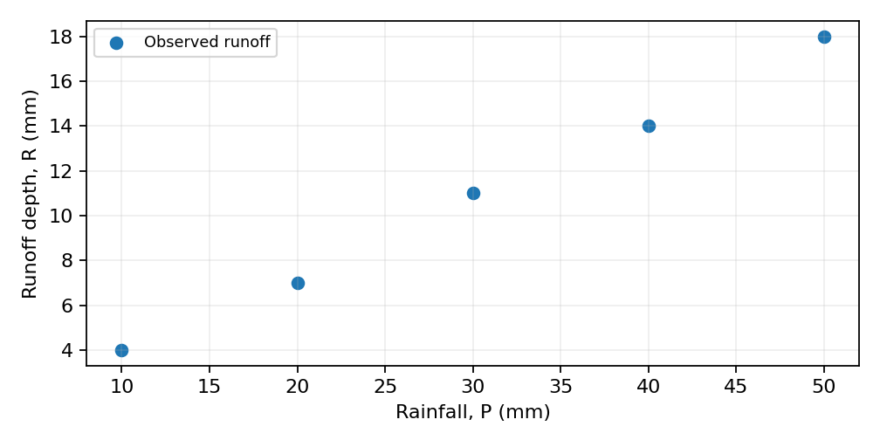
Figure 5.1. Observed rainfall and runoff depths.
Observed events are plotted as individual points without connecting lines.

5.2 Linear Relationship
Assume a linear model relating predicted runoff to rainfall:
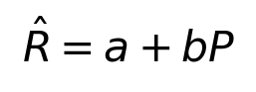
Here a is the intercept (mm), b is the slope (dimensionless), and the hat indicates a predicted response. The intercept need not have a physical interpretation at zero rainfall.

5.3 Least-Squares Principle

5.3.1 Residuals
A residual is the difference between an observed and predicted runoff depth:
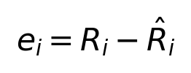
Positive residuals mean observed runoff exceeds predicted runoff; negative residuals mean the model overpredicts.

5.3.2 Sum of Squared Errors
Least squares selects coefficients minimizing the sum of squared residuals:
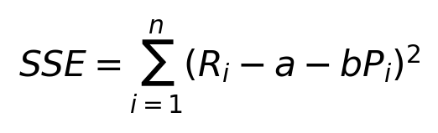
The optimum satisfies both derivative conditions:
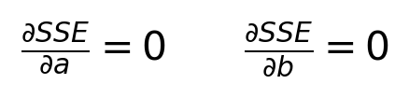

5.4 Manual Calculation of Regression Coefficients
Differentiating SSE yields the normal equations:
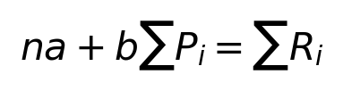
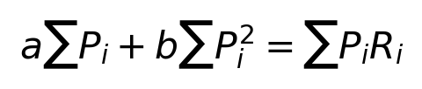
P | R | P² | PR
10 | 4 | 100 | 40
20 | 7 | 400 | 140
30 | 11 | 900 | 330
40 | 14 | 1600 | 560
50 | 18 | 2500 | 900
150 | 54 | 5500 | 1970

With n = 5, substitution gives:
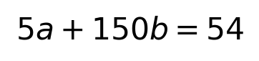
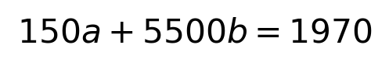
Subtracting 30 times the first equation from the second gives 1000b = 350, hence b = 0.35 and a = 0.30.
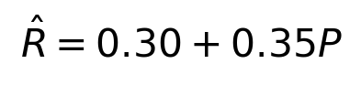

5.5 Solving Regression Using Matrices
The normal equations can be expressed as a matrix system, connecting this chapter to Chapter 4:
n = length(P);
A = [n sum(P); sum(P) sum(P.^2)];
d = [sum(R); sum(P.*R)];
c = A\d; a = c(1); b = c(2);

A numerically preferable direct least-squares approach avoids explicitly forming the normal equations:
X = [ones(length(P),1), P];
c = X\R; a = c(1); b = c(2);
P_line = linspace(min(P),max(P),100);
scatter(P,R,70,"b","filled"); hold on;
plot(P_line,a+b*P_line,"r-","LineWidth",2);
legend("Observed runoff",sprintf("R = %.2f + %.2fP",a,b));
xlabel("Rainfall, P (mm)"); ylabel("Runoff depth, R (mm)"); grid on;

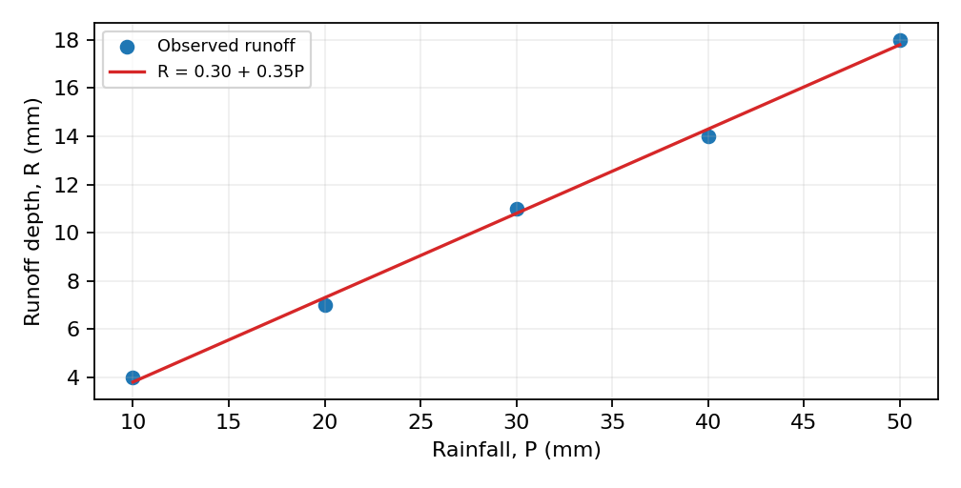
Figure 5.3. Observed points and fitted regression equation.

5.6 MATLAB Built-in Fitting
polyfit calculates polynomial coefficients; polyval evaluates the fitted polynomial. For a straight line, degree = 1. Coefficients are returned in descending powers: [b a].
p = polyfit(P,R,1);
b = p(1); a = p(2);
R_pred = polyval(p,P);

P (mm) | Observed R (mm) | Predicted R (mm)
10 | 4 | 3.8
20 | 7 | 7.3
30 | 11 | 10.8
40 | 14 | 14.3
50 | 18 | 17.8

The normal-equation solution, direct X\R least-squares solution, and polyfit agree for this dataset (up to numerical rounding).

5.7 Creating a User-Defined Function
A function accepts inputs, performs a calculation in its own workspace, and returns outputs. Save the following as myLinearFit.m:
function [a,b,R_pred] = myLinearFit(P,R)
P = P(:); R = R(:);
if numel(P) ~= numel(R) || numel(P) < 2
error("Input vectors must have equal lengths >= 2.");
end
if any(~isfinite(P)) || any(~isfinite(R))
error("Inputs must contain finite numbers.");
end
if numel(unique(P)) < 2
error("P must contain two distinct values.");
end
X = [ones(numel(P),1), P];
c = X\R;
a = c(1); b = c(2);
R_pred = a + b*P;
end

Call the function from a separate script in the same folder:
[a,b,R_pred] = myLinearFit(P,R);
fprintf("a = %.4f, b = %.4f\n",a,b);

5.8 Model Evaluation
Model evaluation quantifies residual magnitude and explained variation.
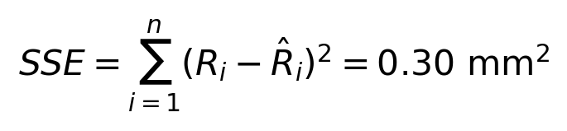
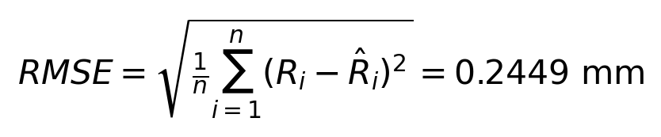
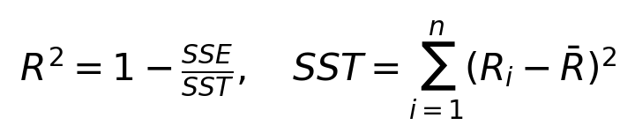
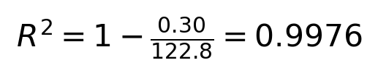
A high R² does not guarantee reliable predictions, particularly for a small synthetic dataset.
e = R-R_pred;
SSE = sum(e.^2);
RMSE = sqrt(mean(e.^2));
SST = sum((R-mean(R)).^2);
R2 = 1-SSE/SST;
figure; scatter(P,e,70,"b","filled"); hold on;
yline(0,"r--"); grid on;

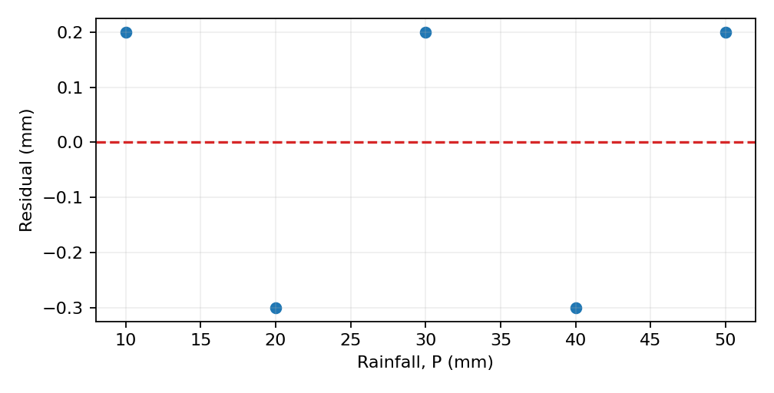
Figure 5.6. Residuals versus rainfall.
MATLAB also supports rmse(R_pred,R). With Statistics and Machine Learning Toolbox, fitlm(P,R) provides mdl.Rsquared.Ordinary and mdl.RMSE. The latter divides SSE by residual degrees of freedom (n − 2), yielding about 0.3162 mm rather than 0.2449 mm.

5.9 Engineering Interpretation and Prediction
The slope of 0.35 means each additional millimetre of rainfall corresponds to approximately 0.35 mm additional fitted runoff within the calibration range. For P = 35 mm (interpolation):
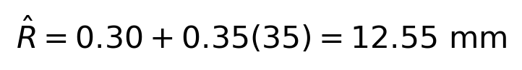
For P = 80 mm (extrapolation):
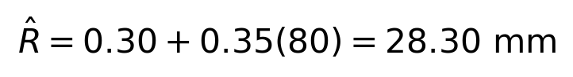
Extrapolation beyond the observed 10–50 mm rainfall range requires particular caution because hydrological behavior may change.

5.10 Confidence and Prediction Intervals
A confidence interval describes uncertainty in the estimated mean response. A prediction interval describes uncertainty for an individual new observation and is generally wider. For P₀, the classical intervals are:
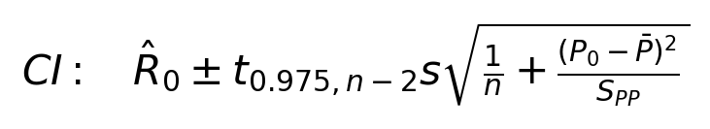
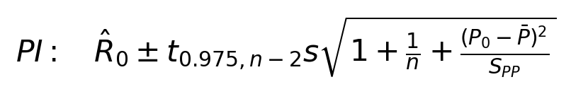
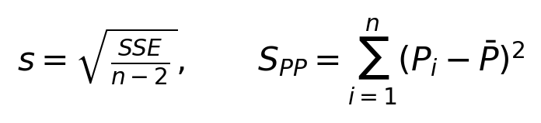
At P₀ = 35 mm, the predicted mean is 12.55 mm. The approximate 95% CI for mean runoff is 12.04–13.06 mm, and the approximate 95% PI for an individual observation is 11.42–13.68 mm.
mdl = fitlm(P,R);
P_line = linspace(10,50,100)';
[R_mean,CI] = predict(mdl,P_line,"Alpha",0.05,...
"Prediction","curve");
[~,PI] = predict(mdl,P_line,"Alpha",0.05,...
"Prediction","observation");
figure; h1 = scatter(P,R,60,"b","filled"); hold on;
h2 = plot(P_line,R_mean,"r-","LineWidth",2);
h3 = plot(P_line,CI(:,1),"g--");
plot(P_line,CI(:,2),"g--","HandleVisibility","off");
h4 = plot(P_line,PI(:,1),"m:");
plot(P_line,PI(:,2),"m:","HandleVisibility","off");
legend([h1 h2 h3 h4],"Observed runoff",...
"R = 0.30 + 0.35P","95% confidence interval",...
"95% prediction interval"); grid on;

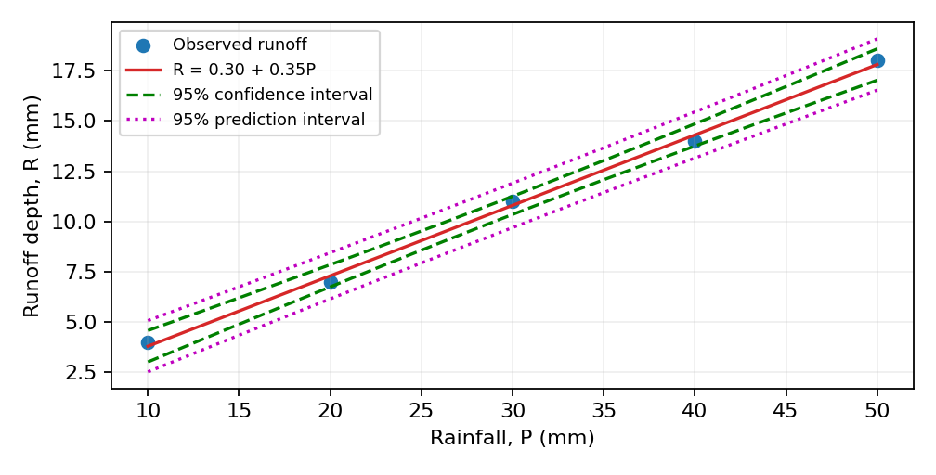
Figure 5.7. Fitted line with 95% confidence and prediction intervals.
These intervals assume an appropriate linear model with independent, normally distributed errors and constant error variance. Five observations are insufficient to assess these assumptions confidently. A 95% confidence procedure has 95% long-run coverage; it does not assign 95% probability to a fixed parameter after observing the sample.

5.11 Student Assignment: Load and Deflection
A structural engineer measures the following hypothetical applied loads and vertical deflections. Fit the empirical model δ = a + bF within the measured range.
Observation | Load F (kN) | Deflection δ (mm)
1 | 2 | 0.8
2 | 4 | 1.7
3 | 6 | 2.5
4 | 8 | 3.4
5 | 10 | 4.1
6 | 12 | 5.1

Required tasks: (1) scatter plot; (2) manual normal-equation derivation; (3) matrix solution; (4) polyfit/polyval; (5) myLinearFit function; (6) SSE, RMSE and R²; (7) residual plot; (8) predict at 7 and 15 kN and identify interpolation/extrapolation; (9) 95% confidence and prediction intervals; (10) interpret limitations.
Assessment component | Weight
Manual derivation | 15%
Matrix calculations | 15%
Built-in fitting and plotting | 15%
User-defined function | 15%
Model evaluation | 15%
Intervals | 15%
Engineering interpretation | 10%

Chapter Summary
The chapter connects engineering observations to mathematical models, least-squares derivation, MATLAB matrix computation, built-in fitting, reusable functions, error assessment, uncertainty intervals, and engineering interpretation. Students should distinguish numerical agreement from physical validity and avoid uncritical extrapolation.
Key MATLAB commands: scatter, plot, sum, mean, \, polyfit, polyval, function, sqrt, rmse, fitlm, predict.

