Labour Force, Disability and Child Labour in Bangladesh, 2022: A Data-Driven 2D and 3D Analysis
[A report submitted for the course Special Topics in Data Analytics (Course Code: 826818) in partial fulfillment of the requirements for the degree of Postgraduate Diploma (PGD) in Data Analytics]
Submitted by
Mst. Najnin Sultana
ID: 25868400021
Course: Special Topics in Data Analytics
Course Code: 826818
Supervisor
Professor Dr. Abu Darda
PGD in Data Analytics
Skill-based PGD Program
National University, Bangladesh
October 2026
Abstract
This report analyses three official 2022 surveys of the Bangladesh Bureau of Statistics: the National Child Labor Survey (NCLS), Chapter 8 of the Labor Force Survey (LFS) and Chapter 4 of the Disability Insights of the Labor Force Survey (DILFS). The tables were merged into one tidy file of 1,869 values, cleaned, and presented as paired 2D and 3D charts in a Streamlit dashboard, an ERP-style web dashboard and this report. Unemployment is low and almost equal for men and women (3.5% and 3.6%), but it is concentrated among people aged 15–24 (10.97%) and rises with education to 12.0% for tertiary graduates. Persons with disabilities are largely outside the labor market: their participation rate is 22.5% against 62.3% for others. About 3.54 million children aged 5–17 work, 99% of them informally, and school attendance falls from 86.6% at ages 5–11 to 51.4% at ages 14–17. Paired t-tests and Wilcoxon tests find no statistically significant male–female unemployment gap. The report compares 2D and 3D chart forms, explains when each is appropriate, and closes with recommendations and limitations of aggregate data.
Keywords: labour force, unemployment, disability, child labour, Bangladesh, 2D and 3D visualization, dashboard

Chapter 1: Introduction

1.1 Background
Labour statistics describe who works, who is looking for work, and who is outside the labor market. In Bangladesh these figures come mainly from the Labor Force Survey and its thematic extensions. Two groups are rarely visible in headline numbers: persons with disabilities, and children who work. Both are covered by 2022 surveys of the Bangladesh Bureau of Statistics (BBS), but the results are spread over many separate tables.

1.2 Problem statement
A reader who wants to understand disability, unemployment and child work together must read dozens of tables in three publications. The tables use different units (thousands of persons, percentages, counts, taka) and different definitions. The problem addressed here is how to merge them reliably and present them so that patterns, gaps and limits of the data are easy to see.

1.3 Objectives
- Merge NCLS 2022, LFS 2022 (Chapter 8) and DILFS 2022 (Chapter 4) into one documented dataset.
- Describe the labour force, unemployment, disability and child labour with paired 2D and 3D charts.
- Test whether male–female unemployment differences are larger than chance.
- Explain when 3D charts help and when they mislead.
- Provide an interactive dashboard (Streamlit and ERP-style HTML/PHP), a report and slides.

1.4 Why the problem matters
Unemployment rates alone can mislead. A low unemployment rate for persons with disabilities does not mean good access to work if few of them are in the labour force. Child labour is a rights issue as well as an economic one, because work during school age reduces schooling and exposes children to hazards. Evidence presented in one place supports better targeted policy.

1.5 Insights sought
- Who is unemployed (age, sex, education, area) and how large is the gender gap?
- How much does disability reduce labour-force participation, and in which jobs do people with disabilities work?
- In which sectors do children work, how does work compete with school, and which hazards do they face?

1.6 Structure of the report
Chapter 2 gives the theoretical background. Chapter 3 describes data and methods. Chapters 4 and 5 are the two analysis chapters: labour force and disability, and child labour. Chapter 6 gives conclusions, recommendations and limitations. References are on the last page.

Chapter 2: Theoretical Background

2.1 Labour-force concepts
Labour statistics follow resolutions of the International Conference of Labour Statisticians (ICLS) of the International Labour Organization (ILO). A person of working age is classified as employed, unemployed or outside the labour force. The employed and the unemployed together form the labour force. The unemployed are people without work who are available for work and have looked for it. People who neither work nor look for work are outside the labour force.

2.2 The 13th and 19th ICLS frameworks
The 13th ICLS (1982) counted as employed anyone who worked at least one hour in the reference week for pay or profit, and also included much production for own consumption. The 19th ICLS (2013) narrowed “employment” to work done for pay or profit and treated unpaid own-use production as other forms of work. Because the definitions differ, the same population gives different labour-force counts. DILFS publishes tables under both frameworks. This report uses the 13th ICLS tables unless stated, as the source report does for most disability tables.

2.3 Core indicators
Table 2.1: Indicators used in this report
Indicator | Formula | Reads as
Unemployment rate | Unemployed ÷ Labour force × 100 | Share of active people who cannot find work
Labour-force participation rate (LFPR) | Labour force ÷ Working-age population × 100 | Share of the population active in the market
Employment-to-population ratio | Employed ÷ Working-age population × 100 | Share of the population that works
Informality share | Informal workers ÷ Employed × 100 | Share without formal job protections
School attendance share | Children attending ÷ Working children × 100 | How far work coexists with schooling

Unemployment rate and participation must be read together. A low unemployment rate can coexist with very low participation when many people are discouraged or excluded and therefore never counted as unemployed.

2.4 Disability and employment
The social model of disability treats exclusion as the result of barriers in the environment, attitudes and institutions rather than of impairment alone. Barriers include inaccessible transport and workplaces, limited education, and employer attitudes. Empirically, persons with disabilities show lower participation, more informal and self-employed work, and concentration in agriculture. DILFS follows the Washington Group style of functional-difficulty questions (seeing, hearing, walking, communication, remembering, self-care) to identify persons with disabilities.

2.5 Child labour
Not all work by children is child labour. The ILO distinguishes light work that is permitted at certain ages, child labour that should be abolished, and the worst forms of child labour. Minimum Age Convention No. 138 (1973) sets the general minimum age for work and permits light work at an earlier age; Convention No. 182 (1999) requires immediate action on the worst forms, including hazardous work likely to harm health, safety or morals. The NCLS reports three nested groups: working children aged 5–17, children in child labour, and children in hazardous child labour. Hours worked, age and the nature of the work decide which group a child belongs to.

2.6 Statistical methods
- Paired t-test. Tests whether the mean difference between two matched series (male and female rates for the same age group) differs from zero. It assumes the differences are roughly normal.
- Wilcoxon signed-rank test. A non-parametric alternative that uses the ranks of the differences; it is robust when n is small or the data are skewed.
- Linear trend. A least-squares line through survey rounds gives a slope in points per year, with R² and a p-value. With five rounds the result is indicative only.
- IQR outlier rule. Values beyond 1.5 times the interquartile range from the quartiles are flagged for review, not automatically removed.

2.7 2D versus 3D visualization
Two-dimensional bar, line and pie charts encode values by length, position or angle, which people read accurately. Three-dimensional charts add a depth axis. They can show a second categorical dimension (for example sex across the side axis) and are engaging, but they introduce perspective distortion and occlusion: front bars hide rear bars and heights are harder to read from the axis. Tufte (2001) argues that decoration that does not carry data should be minimized. This report therefore draws the same numbers twice, as a 2D and a 3D chart, so that readers can compare. As a rule, 2D is preferred for precise reading and 3D for overview or interactive exploration where the chart can be rotated.

Chapter 3: Data and Methodology

3.1 Data sources
Table 3.1: Data sources (all from the Bangladesh Bureau of Statistics)
Survey | Part used | Content | Unit
NCLS 2022 | Chapters 4, 5, 6 | Working children, child labour, hazardous work, health and safety | Counts, %, Tk.
LFS 2022 | Chapter 8 | Unemployment by age, education, sex, area; trend 2010–2022 | Thousands, %
DILFS 2022 | Chapter 4 | Labour force, employment, unemployment of persons with disabilities | Thousands, %, hours, Tk.

All figures are published aggregates, not individual records. The three workbooks were stacked into one long table with columns for survey, chapter, table identifier, row and column labels, unit, value and notes. The merged file holds 1,869 values from 52 tables and figures.

3.2 Preprocessing and cleaning
- Missing values and duplicates: none were found in the merged table.
- Outliers: IQR checks flag mainly the Rural/Urban/Total columns of count tables. These are real magnitudes, so nothing was removed.
- Label fix: the education label “None” was renamed “None (no education)” so software does not read it as a blank.
- Units: counts are in thousands of persons; NCLS fractions were converted to percentages.
- Source quirks: retained as printed (for example urban earnings of 11,522.72 in the table against 11,552.72 in the text).

3.3 Tools and implementation
The analysis uses Python (pandas, NumPy, SciPy, scikit-learn), Plotly for interactive 3D charts and Matplotlib for the static comparison figures in this report. Shared functions live in labour_core.py and lfs_core.py. The Streamlit application offers seven chart styles (3D pie, 2D pie, bar, horizontal bar, stacked bar, 3D bar, 3D cylinder). An ERP-style web dashboard (HTML, CSS, JavaScript with a PHP version) lets a user choose a survey, table and series from drop-down lists, enter a benchmark value, and see a results table and graph.

3.4 Analytical workflow
The workflow is: load and merge; clean; explore with summary tables; draw paired 2D and 3D charts; run paired tests and a trend fit; interpret; and record what the data cannot answer. Each step is reproduced in the notebook labour_force_analysis.ipynb and described in the README file.

Chapter 4: Labour Force, Disability and Unemployment
This chapter is the first of the two analysis chapters. It draws on LFS 2022 Chapter 8 and DILFS 2022 Chapter 4.

4.1 Key findings at a glance
- Unemployment is low and nearly equal by sex: 3.5% of men and 3.6% of women in the labour force; 2,582 thousand people in total.
- Young people carry the problem: ages 15–24 have a 10.97% rate and about 65% of all unemployed persons; from age 35 the rate is below 1%.
- People with disabilities are largely outside the labour market: participation is 22.5% against 62.3% for others, and 11.3% for women with disabilities.
- Work is informal and agricultural: 87.2% of employed persons with disabilities are informal, 52.2% work in agriculture and 54.6% are own-account workers.
- Education does not protect against unemployment: rates reach 8.78% for higher-secondary and 12.0% for tertiary graduates.

4.2 Employed and unemployed labour force by sex
Men have 45,612 thousand employed and 1,656 thousand unemployed; women 24,856 and 926; in total 70,468 and 2,582. The three pies are almost identical (96.5%, 96.4% and 96.5% employed), so the headline unemployment rate does not differ by sex. The real gender gap lies in participation: women are only 35.3% of the labour force and 74.5% of everyone outside it.
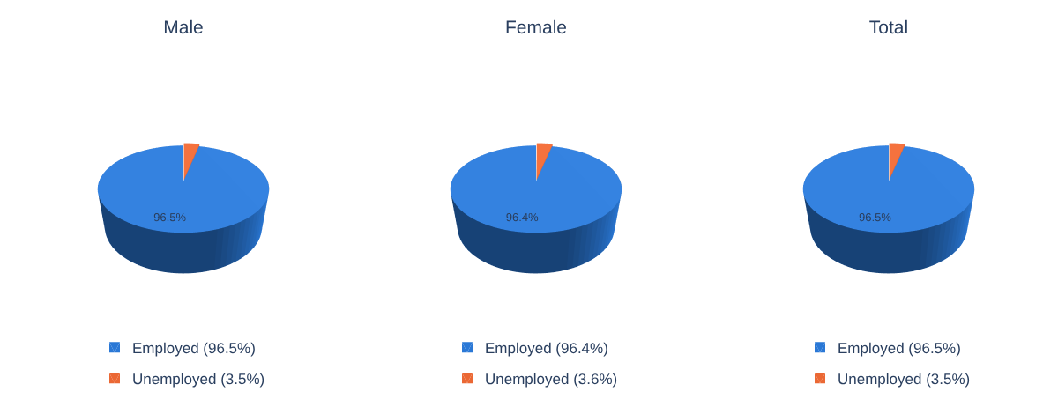
Figure 4.1: 3D pies of the employed and unemployed labour force by sex (DILFS 4.2.1 and 4.3.1, 13th ICLS).

4.3 Labour force with disabilities
Of 761.5 thousand labour-force members with disabilities, 583.9 thousand (76.7%) are men and 177.6 thousand (23.3%) are women. People with disabilities are about 1.04% of the 73,050 thousand labour force. Women are over a third of the general labour force but under a quarter of the labour force with disabilities, so disability widens the gender gap.
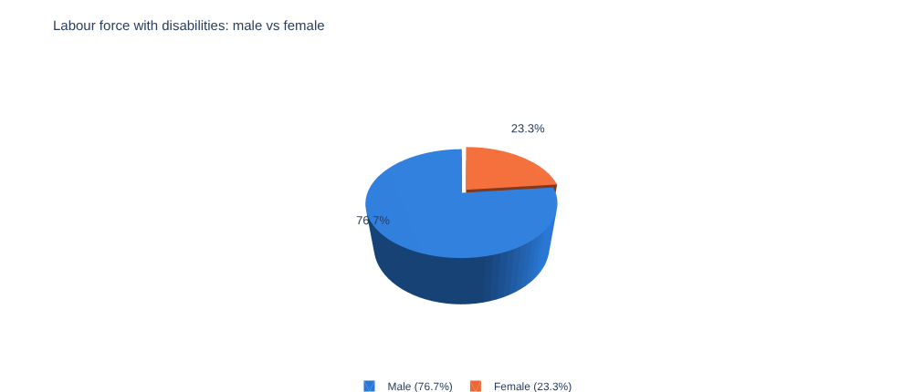
Figure 4.2: 3D pie of men and women in the labour force with disabilities (DILFS 4.1.1).
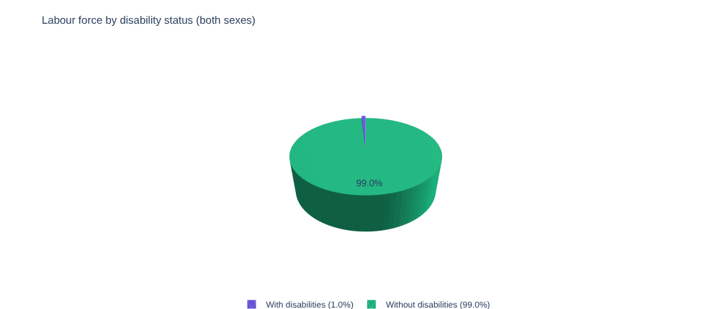
Figure 4.3: 3D pie of the labour force by disability status (DILFS 4.1.1).

4.4 Unemployment by age group, sex and area
The tall cluster at ages 15–24 is 14.30% for men, 7.54% for women and 10.97% overall. At 25–34 the rates fall to 3.26%, 2.47% and 2.88%. Unemployment is a youth problem: 1,689 thousand of the 2,582 thousand unemployed (65%) are aged 15–24. Young men are almost twice as likely as young women to be unemployed, but the pattern reverses from age 35.
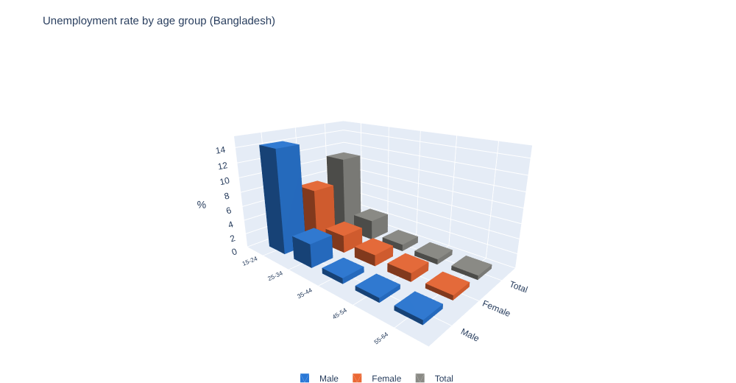
Figure 4.4: 3D bar chart of unemployment rate by age group and sex (LFS 8.3.1).
Figure 4.5 draws the same numbers in 2D beside a 3D version. In 2D the heights of the male, female and total bars are read directly against one axis; in 3D the tall 15–24 bars hide the small bars behind them, so values for older ages are hard to read. For precise comparison the 2D form is better; the 3D form is useful as an overview.
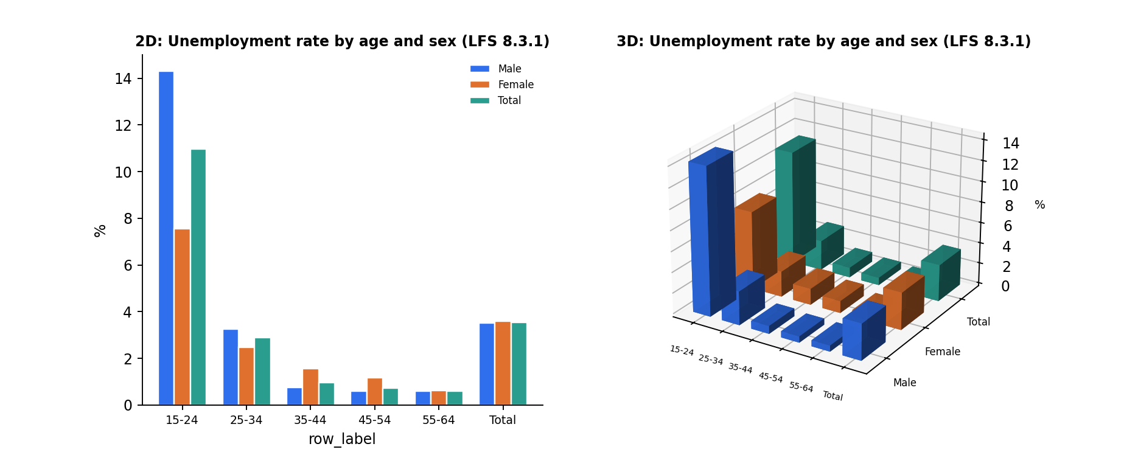
Figure 4.5: 2D versus 3D comparison, unemployment rate by age group and sex (LFS 8.3.1).
Urban areas have higher unemployment in every age band up to 54. At 15–24 the urban rate is 14.90% against 9.97% in rural areas. The sharpest gap is urban young women, at 18.26% against 5.94% for rural young women.
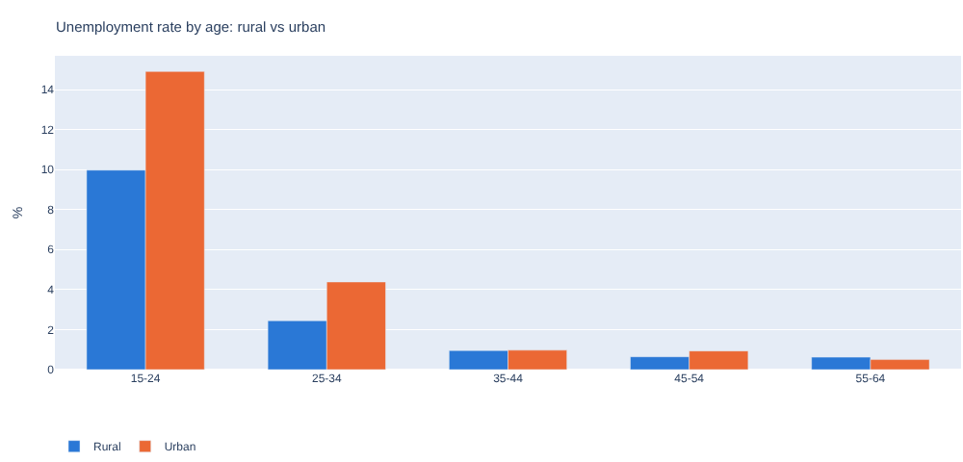
Figure 4.6: Bar chart of unemployment rate by age group, rural versus urban (LFS 8.3.1).

4.5 Outside the labour force
Among men outside the labour force 10.39% have a disability; among women 4.03%; overall 5.65%. In absolute terms 2,617 thousand people with disabilities are outside the labour force against 762 thousand inside it. The male share is higher because the male outside-labour-force group is small, so disability makes up a larger fraction of it.
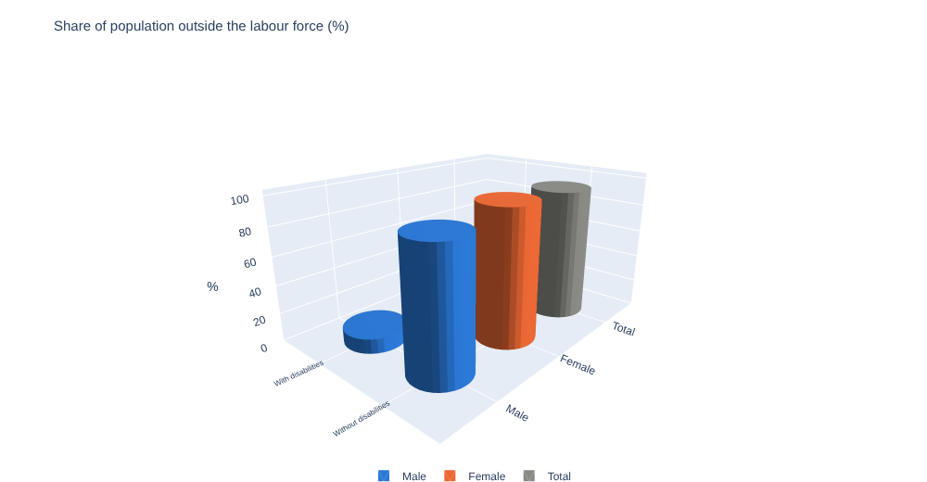
Figure 4.7: 3D cylinders of the population outside the labour force by disability status and sex (DILFS 4.4.1).

4.6 Unemployment and participation by disability
People with disabilities have a lower unemployment rate (1.63% against 3.55%), but participation tells the opposite story: 22.54% against 62.32% overall, and 11.34% for women with disabilities. The employment-to-population ratio is 22.17% against 60.10%. A low unemployment rate here reflects exclusion from the labour force, not good access to work.
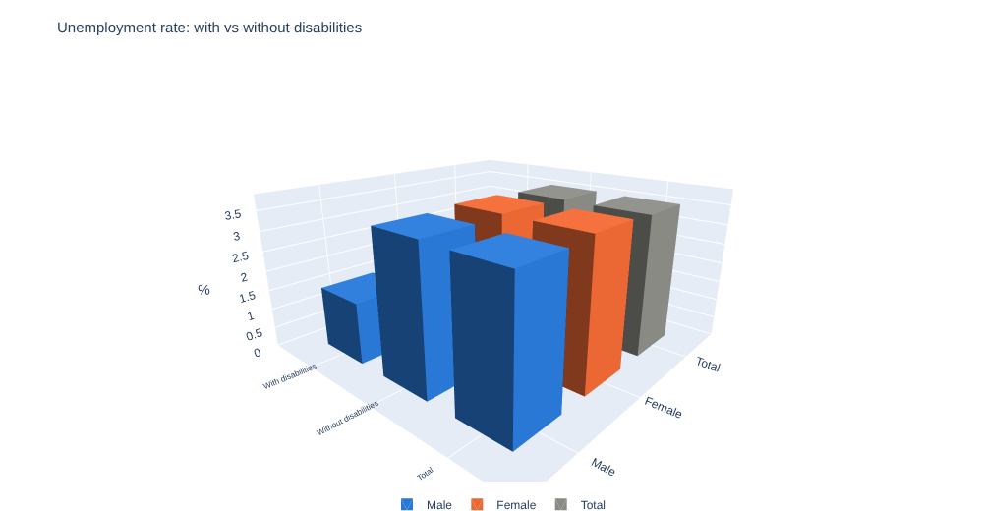
Figure 4.8: 3D bar chart of unemployment rate by disability status and sex (DILFS 4.5.1).
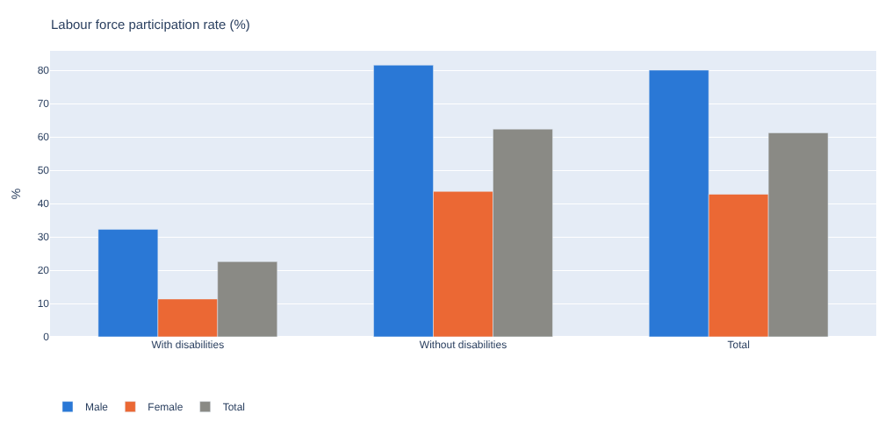
Figure 4.9: Bar chart of labour-force participation rate by disability status and sex (DILFS 4.12.1).

4.7 Sector and status in employment
Among employed men with disabilities 47.9% work in agriculture, 12.6% in industry and 39.5% in services; among women 66.1%, 6.3% and 27.6%. Own-account work is the most common status (55.19% of men, 52.47% of women). Employees are 34.99% of men but only 21.76% of women, while contributing family workers are 5.09% of men and 23.48% of women. Informality is 87.2% overall and 96.9% for women.
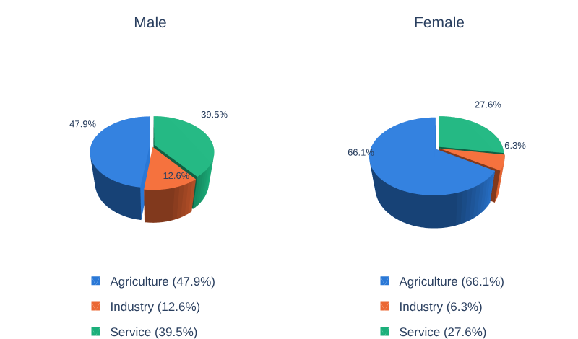
Figure 4.10: 3D pies of employment by sector for men and women with disabilities (DILFS 4.7).
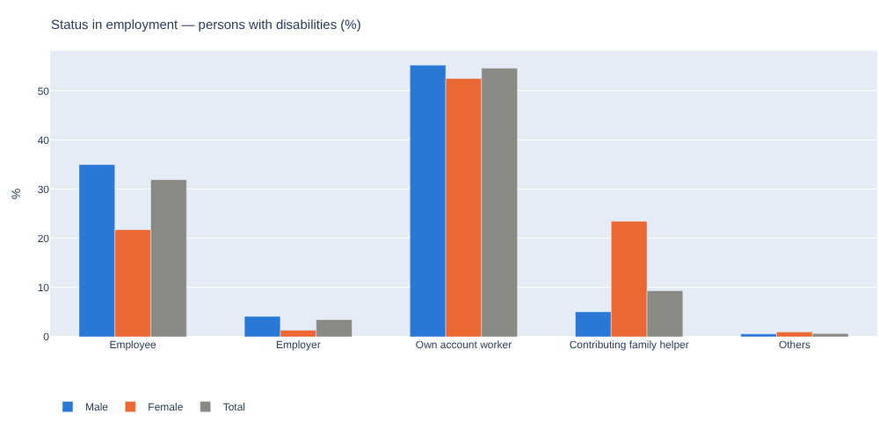
Figure 4.11: Bar chart of status in employment of persons with disabilities by sex (DILFS 4.6).

4.8 Unemployment by education
The unemployment rate rises with education: 1.07% with no education, 1.69% primary, 2.82% secondary, 8.78% higher secondary and 12.00% tertiary. Among tertiary graduates the female rate is 18.88% against 9.49% for men. Better-educated people can afford to search for suitable work, while people with little education usually take any job; the pattern points to a graduate-jobs mismatch.
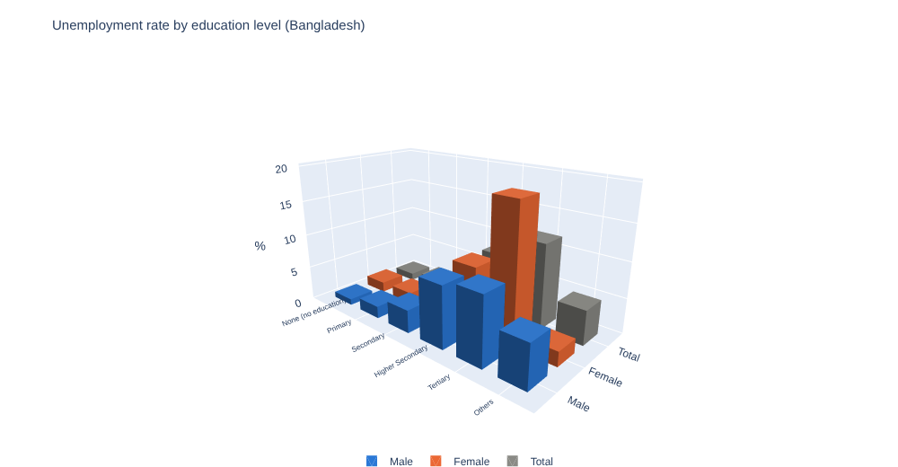
Figure 4.12: 3D bar chart of unemployment rate by education level and sex (LFS 8.4.1).

4.9 Trend, 2010–2022
The national rate drifts down from 4.6% in 2010 to 3.53% in 2022. The female rate was far above the male rate through 2016–17 (6.7% against 3.1%) and then fell to 3.57% in 2022, almost equal to the male rate of 3.51%. The change is abrupt and coincides with changes in labour-statistics definitions, so it should not be read as a steady trend. A straight-line fit through five rounds gives −0.09 points per year (R² 0.95, p = 0.005), which is indicative only.
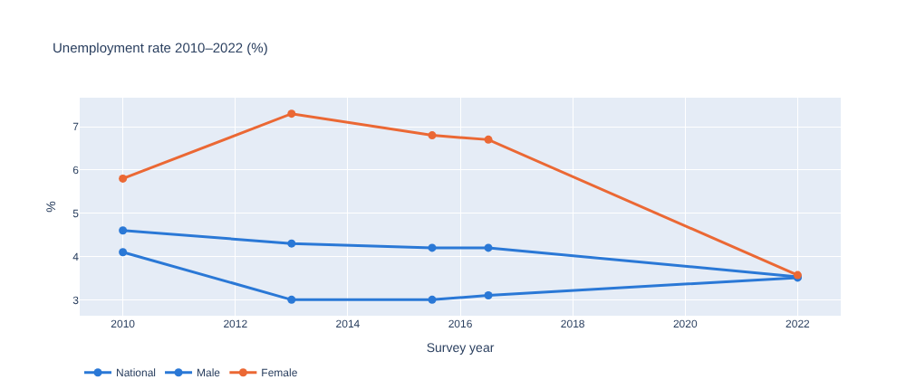
Figure 4.13: Line chart of national, male and female unemployment rates (LFS Figure 8.7).

4.10 Statistical tests
Paired t-tests and Wilcoxon signed-rank tests compared male and female unemployment across age groups (5 pairs) and education levels (6 pairs).
Table 4.1: Male–female unemployment tests (LFS 8.3.1 and 8.4.1)
Breakdown / area | n | Mean male % | Mean female % | p (t-test) | p (Wilcoxon)
Age group — Rural | 5 | 3.954 | 2.220 | 0.389 | 0.813
Age group — Urban | 5 | 3.750 | 5.744 | 0.151 | 0.188
Age group — Bangladesh | 5 | 3.900 | 2.670 | 0.432 | 1.000
Education — Rural | 6 | 5.935 | 5.543 | 0.794 | 0.688
Education — Urban | 6 | 3.758 | 7.277 | 0.245 | 0.313
Education — Bangladesh | 6 | 5.003 | 5.880 | 0.653 | 1.000

No male–female gap is significant at the 5% level. The urban gap points the other way (women higher) than the rural gap (men higher), which is why national figures look balanced. With only five or six pairs per test the power is low, so the p-values are indicative and do not prove the absence of a gender gap.

Chapter 5: Child Labour in Bangladesh
This chapter is the second analysis chapter. It uses NCLS 2022 Chapter 4 (working children), Chapter 5 (child labour) and Chapter 6 (occupational safety and health).

5.1 Three nested groups
NCLS identifies 3,536,927 working children aged 5–17. Of these, 1,776,097 are in child labour and 1,068,212 are in hazardous child labour. Most working children are aged 14–17 (2,290,835, or 64.8%).
Table 5.1: Headline NCLS 2022 indicators
Indicator | Value | Source
Working children aged 5–17 | 3,536,927 | NCLS Table 4.2
Children in child labour | 1,776,097 | NCLS Table 5.2
Children in hazardous child labour | 1,068,212 | NCLS Table 5.3
Working children in informal employment | 99.0% | NCLS Table 4.4
Working more than 48 hours a week | 7.7% (child labour 15.2%; hazardous 25.4%) | Tables 4.11, 5.19, 5.21
Average weekly hours of working children | 27.1 | NCLS Table 4.13
Average monthly income of working children | Tk. 6,661 | NCLS Table 4.16
Currently attending school | 60.7% of working children | NCLS Table 4.6
Paid child domestic workers | 76,195 (girls 42,084) | NCLS Table 6.4

5.2 Where children work
Among working children, agriculture accounts for 30.5%, manufacturing 25.3% and wholesale and retail trade 20.4% (Table 4.2). Among the 1.78 million in child labour, manufacturing is the largest sector (33.3%) followed by agriculture (23.6%) and trade (18.6%). In hazardous child labour manufacturing rises to 43.9%, with trade at 21.4% and construction at 16.9%. By broad sector, services employ 1,266,949 children, industry 1,190,419 and agriculture 1,079,559.
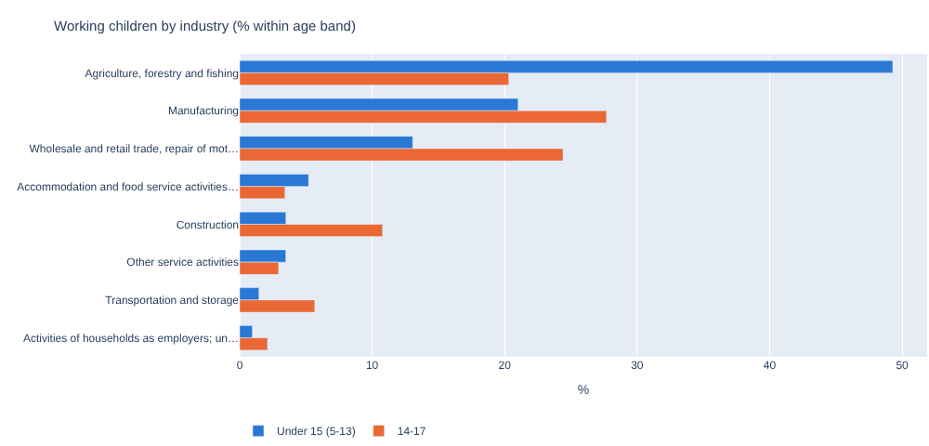
Figure 5.1: Horizontal bars of working children by industry, under-15s and 14–17-year-olds (NCLS Table 4.2).
Boys are 77.3% of working children (2,734,044) and girls 22.7% (802,883). Figure 5.2 compares the sector-by-sex split in 2D and 3D. Boys outnumber girls in every sector; girls are most visible in agriculture, where they are 28.3% of working children. In the 3D version the girls’ bars sit behind the boys’ bars and are partly hidden, which illustrates the occlusion problem described in Section 2.7.
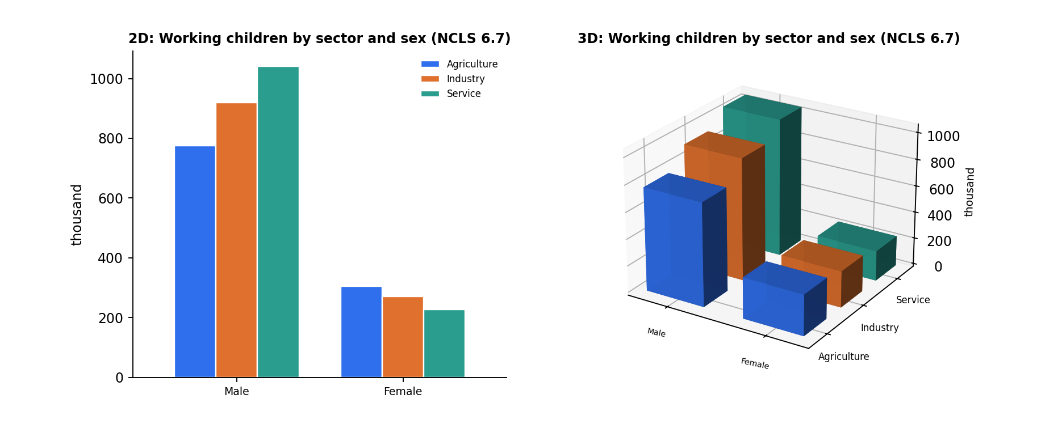
Figure 5.2: 2D versus 3D comparison, working children by sector and sex, in thousands (NCLS Table 6.7).

5.3 Schooling
Work and schooling compete most from about age 12. Attendance falls from 86.6% at ages 5–11 to 68.0% at 12–13 and 51.4% at 14–17, while the share not attending rises from 6.0% to 30.5% and 42.9%. Among children who never attended school (5.4%), the main reasons are that education is not considered valuable (25.5%), unpaid family work (18.8%) and work for income (17.5%). Among those who dropped out, the commonest reasons are the cost of education (25.9%) and lack of interest (25.7%).
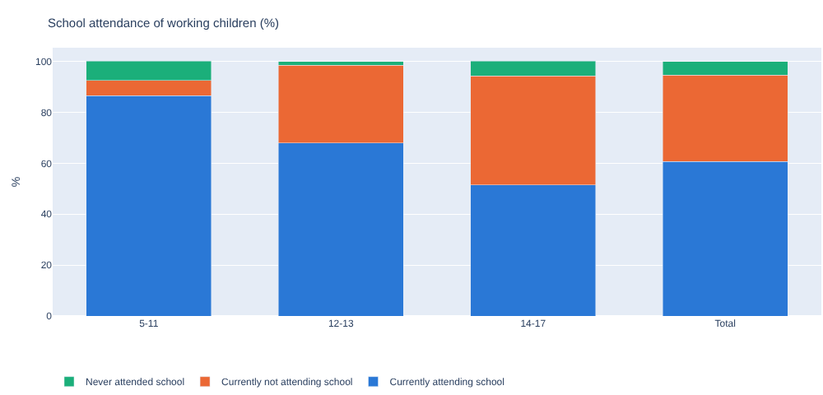
Figure 5.3: Stacked bars of school-attendance status of working children by age group (NCLS Table 4.6).
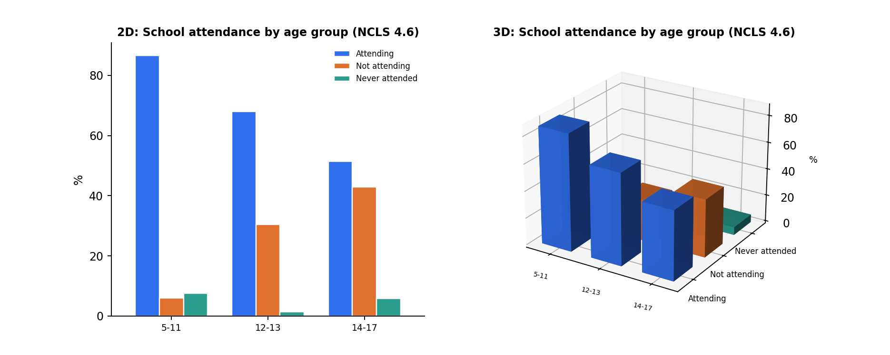
Figure 5.4: 2D versus 3D comparison, school-attendance status by age group (NCLS Table 4.6).

5.4 Earnings
The average monthly income of working children is Tk. 6,661 and rises with age: Tk. 5,491 at ages 5–11, Tk. 6,031 at 12–13 and Tk. 7,041 at 14–17. Urban children earn slightly more than rural children (Tk. 6,841 against Tk. 6,596). The one exception is ages 12–13, where the rural figure (Tk. 6,085) is above the urban figure (Tk. 5,875).
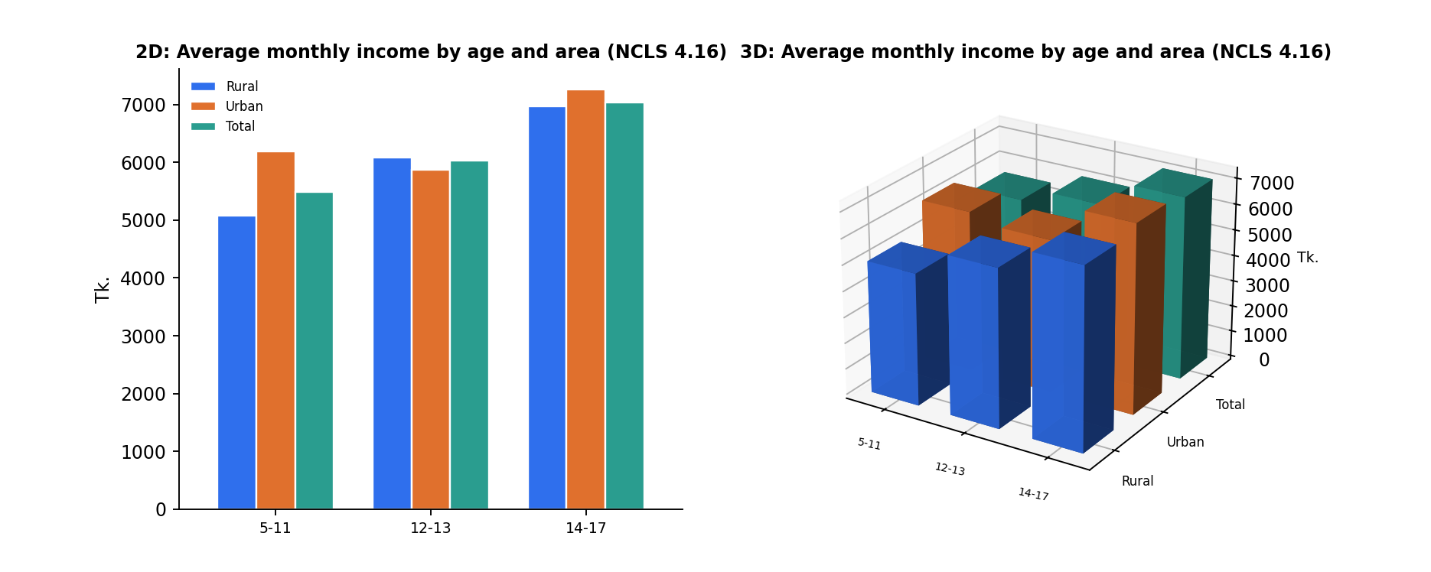
Figure 5.5: 2D versus 3D comparison, average monthly income by age group and area (NCLS Table 4.16).

5.5 Safety, health and abuse
Chapter 6 of the NCLS asks children about hazards at work. Exposure is generally low in percentage terms but rises with age: carrying heavy loads affects 9.2% of 14–17-year-olds, sharp tools 8.0% and long hours in the hot sun 7.5%. Overall, 7.0% of working children carry heavy loads, 6.2% work with sharp tools, 6.1% work in the hot sun and 6.2% work at night or very early in the morning.
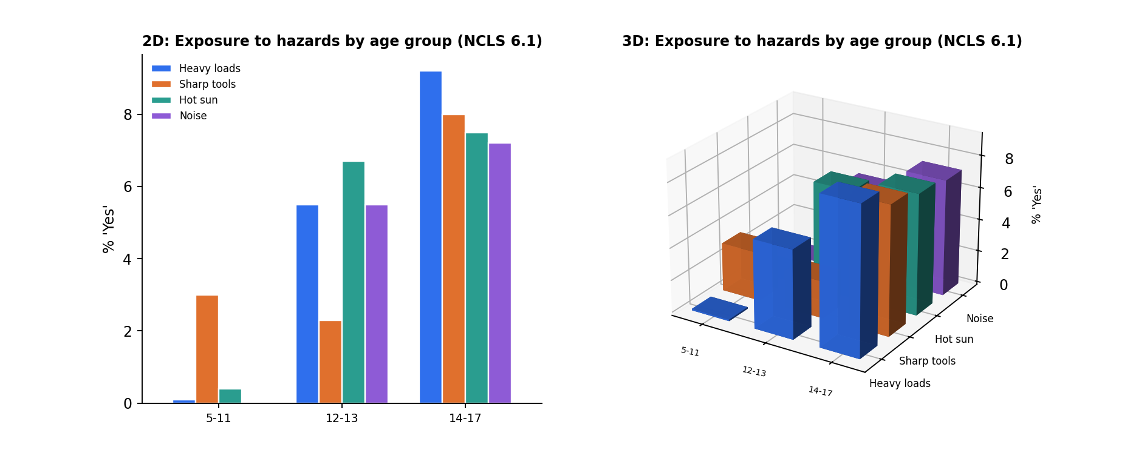
Figure 5.6: 2D versus 3D comparison, share of children exposed to selected hazards by age group (NCLS Table 6.1).
On mental-health indicators most children answer “no” to symptoms, but the youngest report more distress: 33.5% of children aged 5–11 feel nervous or easily scared against 7.9% at 14–17, and 28.9% feel unhappy or tearful. Overall 65.1% have someone to talk to about their problems and 55.7% feel proud of their work, while 4.2% report being physically hurt at work and 11.8% report being ridiculed or insulted (21.0% at ages 5–11). Where harm occurred, an adult was the source in 69.3% of physical-hurt cases.

5.6 Summary of the 2D and 3D comparison
Across the five comparison figures, the 2D charts let the reader compare values within an age or sex group directly. The 3D charts convey the grid structure at a glance, but rear bars are hidden when front bars are tall. For reports and policy briefs the 2D form is therefore the primary figure; the 3D form is most useful in the interactive dashboard where it can be rotated.

Chapter 6: Conclusions, Recommendations and Limitations

6.1 Summary of findings
- Overall unemployment is low (3.53%) and equal by sex, but concentrated among young people and, in cities, among young women (18.26% at ages 15–24).
- Participation, not unemployment, reveals exclusion: persons with disabilities participate at 22.5% against 62.3%, and women with disabilities at 11.3%.
- Higher education is associated with higher unemployment, suggesting a mismatch between graduate skills and available jobs.
- Child work is almost entirely informal, begins in agriculture and moves into manufacturing, trade and construction, where hazards are greatest; school attendance halves between ages 5–11 and 14–17.
- Male–female unemployment gaps are not statistically significant, but the tests have little power.

6.2 Recommendations
- Youth employment: target job-search, apprenticeship and entry-level programmes at ages 15–24, with attention to urban young women.
- Graduate transition: strengthen links between tertiary education and employers and track graduate outcomes.
- Disability inclusion: improve accessible transport and workplaces, support self-employment and skills training, and prioritise women with disabilities.
- Child labour: focus inspection and enforcement on manufacturing, construction and trade; extend stipends and school-retention support at ages 12–17; address household chores and cost of schooling.
- Safety and wellbeing: provide protective equipment guidance, limits on night and long-hour work, and counselling for the youngest working children.
- Data: publish age × disability and training tables so that questions in the brief can be answered directly.

6.3 Limitations
Table 6.1: Questions the published tables cannot answer
Question | Not available | Used instead
Employed/unemployed by age with disability | No age × disability table | Unemployment by age, sex and area (Figures 4.4–4.6)
Sector for people without disabilities | Table 4.7 covers persons with disabilities only | Persons with disabilities by sex (Figure 4.10)
Freelancing; urban/rural self-employment | No such category or area split | Own-account plus employer by sex (Figure 4.11)
Unemployment after training | No training variable | Unemployment by education (Figure 4.12)
Children’s literacy by age | NCLS reports attendance | School attendance by age (Figure 5.3)

The data are aggregates; the analysis is descriptive, and small-sample tests have little power. Definitions differ between the 13th and 19th ICLS, and the 2022 gender convergence coincides with definitional change.

6.4 Future work
- Use microdata, if released, to model unemployment and child labour with regression or classification.
- Add the literacy and vocational-training dataset to enable the machine-learning section of the dashboard.
- Add division-level maps and confidence intervals once available.

References
Bangladesh Bureau of Statistics (BBS). National Child Labour Survey (NCLS) 2022. Dhaka: Statistics and Informatics Division, Ministry of Planning.
Bangladesh Bureau of Statistics (BBS). Labour Force Survey (LFS) 2022. Dhaka: Statistics and Informatics Division, Ministry of Planning.
Bangladesh Bureau of Statistics (BBS). Disability Insights of the Labour Force Survey (DILFS) 2022. Dhaka: Statistics and Informatics Division, Ministry of Planning.
Hunter, J. D. (2007). Matplotlib: A 2D graphics environment. Computing in Science & Engineering, 9(3), 90–95.
International Labour Organization (1973). Convention No. 138 concerning the Minimum Age for Admission to Employment. Geneva: ILO.
International Labour Organization (1982). Resolution concerning statistics of the economically active population, employment, unemployment and underemployment, adopted by the 13th International Conference of Labour Statisticians. Geneva: ILO.
International Labour Organization (1999). Convention No. 182 concerning the Prohibition and Immediate Action for the Elimination of the Worst Forms of Child Labour. Geneva: ILO.
International Labour Organization (2013). Resolution concerning statistics of work, employment and labour underutilization, adopted by the 19th International Conference of Labour Statisticians. Geneva: ILO.
McKinney, W. (2010). Data structures for statistical computing in Python. Proceedings of the 9th Python in Science Conference, 56–61.
Plotly Technologies Inc. (2015). Collaborative data science. Montreal: Plotly Technologies Inc.
Student (Gosset, W. S.) (1908). The probable error of a mean. Biometrika, 6(1), 1–25.
Tufte, E. R. (2001). The Visual Display of Quantitative Information (2nd ed.). Cheshire, CT: Graphics Press.
Wilcoxon, F. (1945). Individual comparisons by ranking methods. Biometrics Bulletin, 1(6), 80–83.

