**CSCI 346 Computer Graphics Spring 2016**

Exam 2

**Name:**_____________________________________________________

**Instructions:**

Answer 100 points of questions. This is an open book and open notes exam. This is a closed neighbor exam. You may use Moodle and the text book’s website. Submit by 11:59pm Monday, April 18, 2016.

[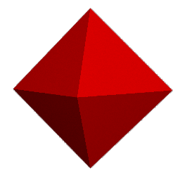](http://www.mathconsult.ch/showroom/unipoly/anim05.gif)

1. The figure shown at the right is an octahedron. It has 8 faces, 12 edges, and 6 vertices. **(25 points)**
   1. Describe two ways to represent an octahedron.
   2. For each representation list the advantages of that representation and the limitations.
2. Two vectors, *v1* and *v2*, are considered orthogonal. **(25 points)**
   1. What is the value of the dot product 
   2. If *v1* = (a, b, c), give a possible vector value for *v2*.
3. **(25 points)** Consider a window with bottom left corner (-10, -10), and top right corner (100, 100) that maps to a viewport with bottom left corner (-1, -1) to top right corner (1, 1). Derive the equations that will map the point (x, y) in the window to the point (vx, vy) in the viewport.
4. (**25 points)** Given a window with bottom left corner (0,0) and top right corner (10,10), simulate the Sutherland-Cohen line clipping algorithm on the line traversing the points (-10, -5) and (10, 5).
5. **(25 points)**For two-dimensional data, explain how to transform this data to effect :
   1. a reflection about the y axis;
   2. a reflection about a line through the origin inclined at an angle theta to the y axis;
   3. a reflection about a line parallel to the y axis passing through the point x0 on the x axis;
   4. a reflection about a line inclined at an angle theta to the y axis passing through point x0 on the x axis.
6. **(50 points).** A circle with radius 100 centered at (0, 5, 0). It is to be rotated 45 degrees about the vector (1, 1, 1). A point P(x,y,z) is on this circle. Give the coordinates of point P ***after*** the rotation. ***Rotate using Matrices***. (Do not write a program.) Show your work. If you only submit the rotated point, you will receive 10 points.
7. **(75 points)** Program: Implement a webGL program to display and rotate a quadratic surface. For a list of equations see <http://mathworld.wolfram.com/QuadraticSurface.html> Remember, parametric equations are better suited for drawing. You may shade as you see fit.