# CSCI 346: Computer Graphics

*Lab: Draw Square*

Objective: Create first WebGL Program

Tasks:

1. Logon to arden:
   1. Hostname: arden.cs.unca.edu
   2. User Account: your linux account name
   3. Password: I can only give accounts to people with new accounts.
   4. Various Platforms:
      1. From windows…use Putty
      2. From Mac from your terminal window type:
         1. ssh yourAccountName@arden.cs.unca.edu
         2. enter your password when prompted.
2. Create a directory for your CSCI 346 Work
   1. Change directory to public_html

**cd** public_html

* 1. Create a directory

**mkdir** CSCI346.Spring2016

1. On your local machine, open your IDE for creating websites. I will include the instructions for using netbeans:
   1. Create a New Project
   2. Select PHP Application….. We are not using PHP but this component allows connection to a remote site.
   3. Fill in the Dialog box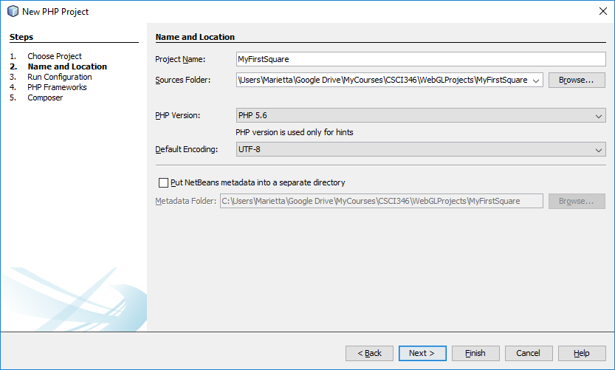
   4. Set up remote connection….click on manage and enter the values show with your account name replacing my own.

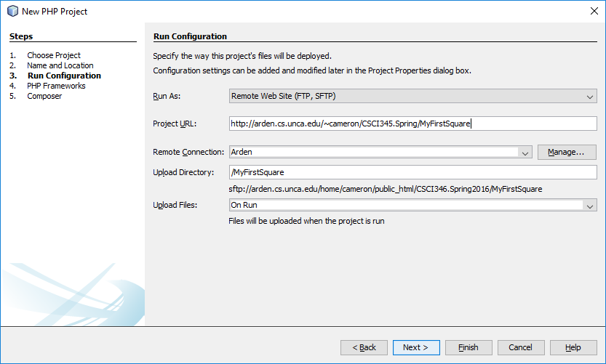

* 1. Change Upload files to “On Save”
  2. Click Finish. You have now setup your netbeans to sync with your account on arden’s webserver.

1. Delete the index.php
2. In your project under sources, create a file, **square.html** Copy and paste the code given on Moodle site.
3. In your project under sources, create a file, square.js Copy and paste the code given on Moodle.
4. View the results by clicking run or by entering the project’s URL in a browser

http://arden.cs.unca.edu/~yourAccountName/CSCI346.Spring2016/MyFirstSquare/square.html

1. Instructor and class will discuss code.
   1. Describe page (HTML file)
      1. request WebGL Canvas
      2. read in necessary files
   2. Define shaders (HTML file)
   3. Compute or specify data (JS file)
   4. Send data to GPU (JS file)
   5. Render data (JS file)
2. Try the following:
   1. Change color via shader
   2. Change drawing modes via javascript
   3. Change pointsize via shader