Task 1:

Added Remote repository in github:

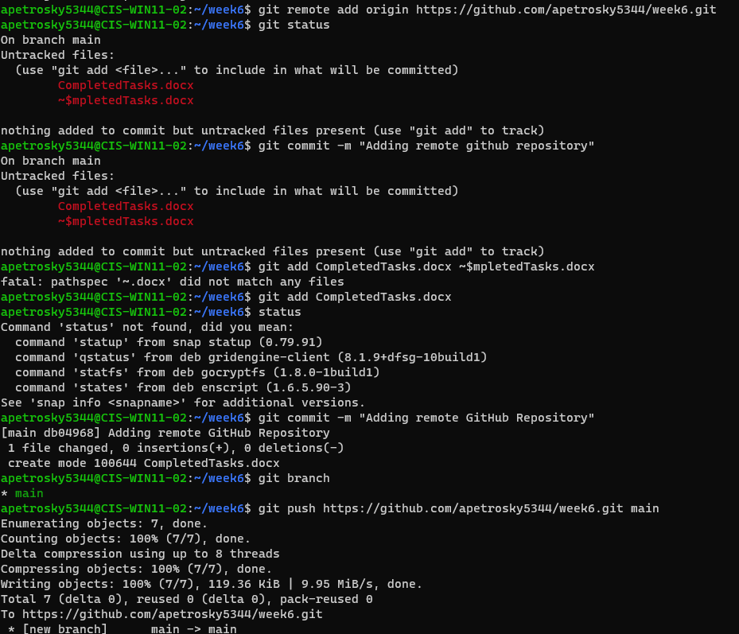

Task 2: