Table of Contents

Introduction 2

Setting up environment 2

Restlet 2

Postman 2

SoapUI Open Source 2

Run the service 2

Download the sample solution 2

Enable the HTTP endpoint 2

Run the solution 3

Accessing service endpoints 3

Restlet 3

GET 3

POST 4

GET 4

DELETE 4

V1 4

Postman 4

SoapUI 4

# Introduction

The first step is to start with testing of a sample solution. This is a server holding a collection of cats, supporting two versions of REST API, some JSON and HTML output and simple action against objects.

# Setting up environment

## Restlet

Install it from Chrome Web Store:

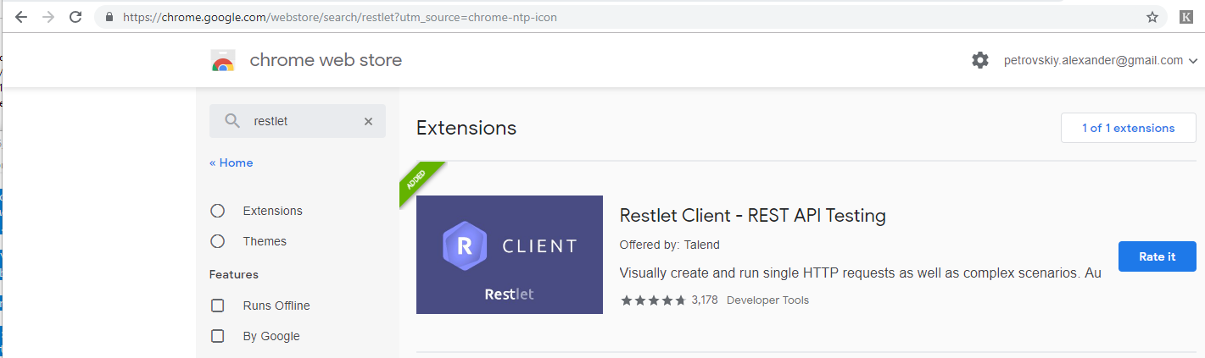

## Postman

Download it from here: <https://www.getpostman.com/downloads/>

## SoapUI Open Source

download SoapUI Open Source from the link

https://www.soapui.org/downloads/soapui.html

https://s3.amazonaws.com/downloads.eviware/soapuios/5.5.0/SoapUI-x32-5.5.0.exe

## Run the service

### Download the sample solution

download from <https://github.com/apetrovskiy/moreNetSamples>, or clone to a folder via Github Desktop

### Enable the HTTP endpoint

run cmd as Administrator

issue the command:

netsh http add urlacl url=http://+:1235/ user=everyone

### Run the solution

to run the service just run Animals.Runner

(1 - right click on the project, select 'Set as Start Up', F5/Run or

2 - right click on the project, select Run)

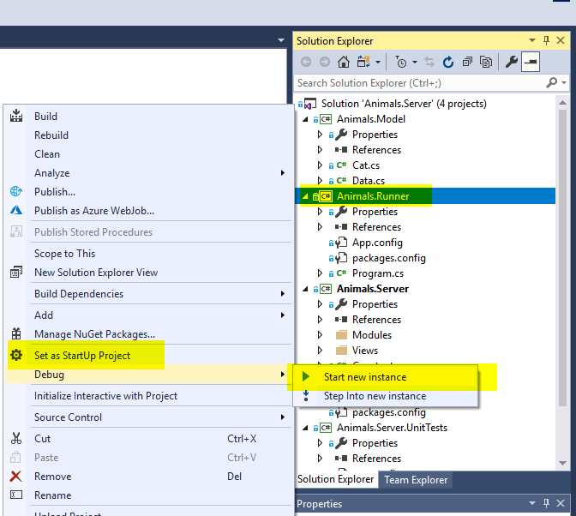

# Accessing service endpoints

## Restlet

### GET

Open the Restlet tab and navigate to <http://localhost:1235/v2/cats> (GET) and click on the Send button.

Examine the result (by default, there are three cats in the output).

### POST

Experiment with POST to <http://localhost:1235/v2/cats> by sending a typical cat object with exception of fields id, owned.

### GET

Try getting an individual cat by issuing a parameterized request to the same GET endpoint:

http://localhost:1235/v2/cats&name=Barsik

### DELETE

Try deleting a cat by issuing a DELETE request to

<http://localhost:1235/v2/cats&name=Barsik>

### V1

Try running the same requests against V1: http://localhost:1235/v1/...

## Postman

Try doing the same in Postman

## SoapUI

Open ..\moreNetSamples\Animals.Server.SoapUI\REST-Project-3-soapui-project.xml

It’s written to test V1 endpoints

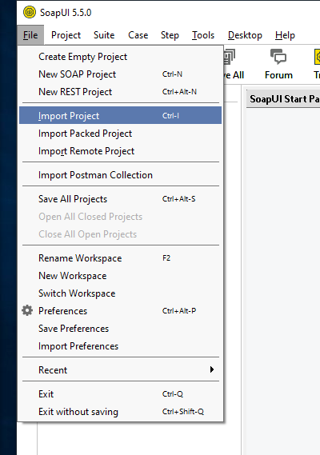

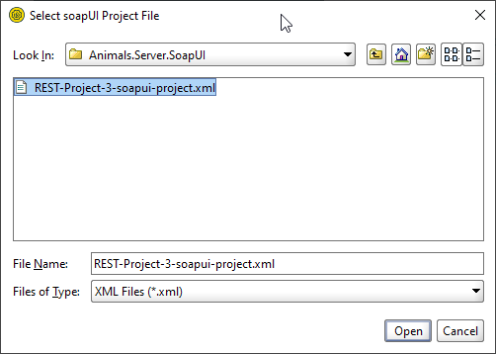

Then run TestRunner, which can be done for the whole project or test by test independently:

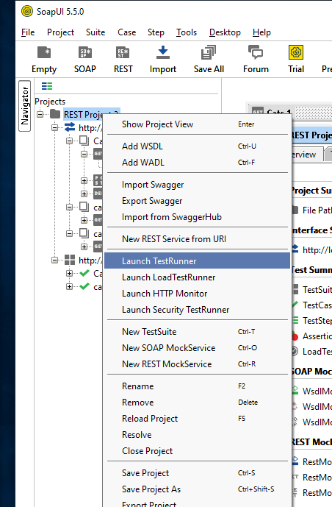

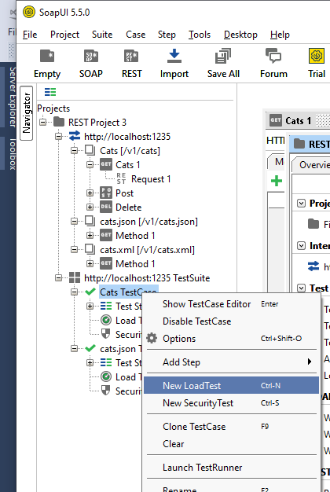

After displaying some errors related to inability to create a log file or whatever, the tool says that it finished successfully:

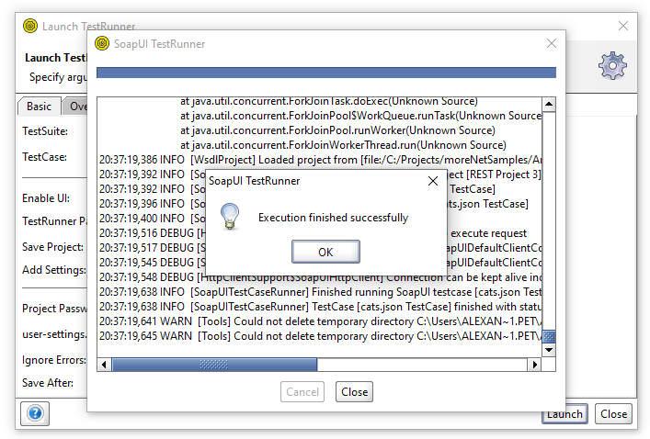

A good idea is to create more tests by analogy to test the same endpoints in V2.