Creating a new REST service

Table of Contents

How to create a solution 3

Add necessary packages to the projects 7

# How to create a solution

Select a class library project:

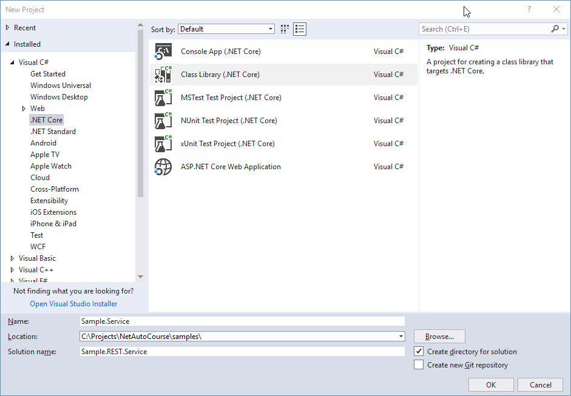

delete a clas created by default

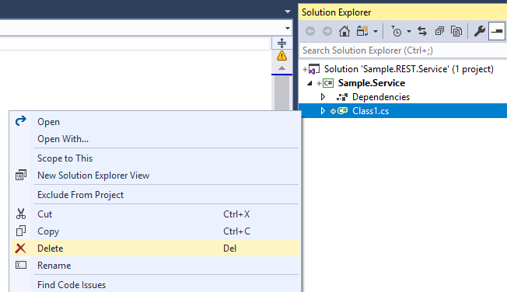

Add one more project to the solution



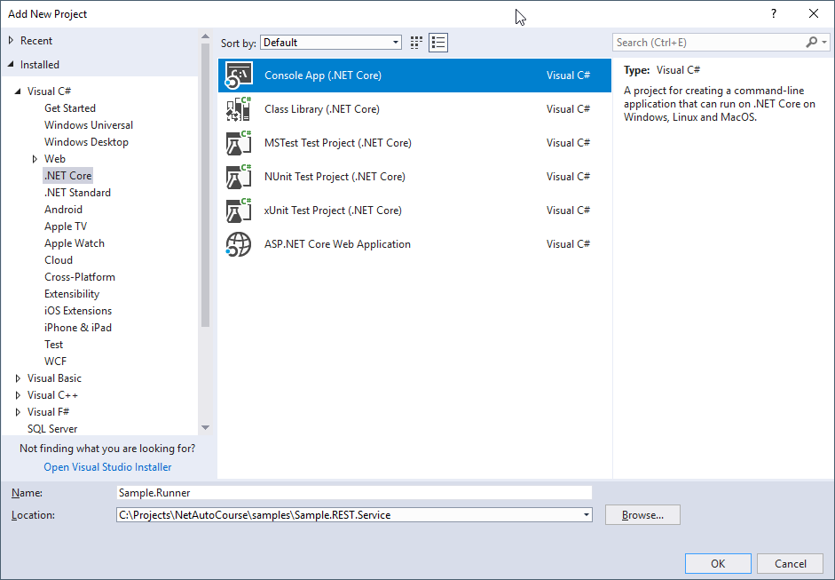

Then, add one more project to the solution

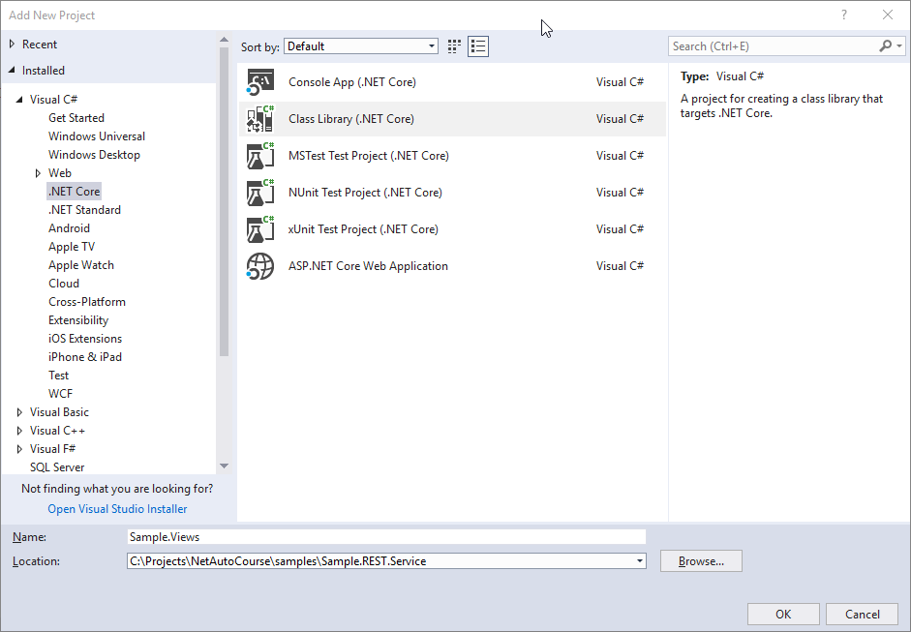

Finally, add one more project to the solution



# Add necessary packages to the projects

