RPM方式安装MySQL5.6

安装完成后 mysql 的目录为 /var/lib/mysql

a. 检查MySQL及相关RPM包，是否安装，如果有安装，则移除（rpm -e 名称）

[root@localhost ~]# rpm -qa|grep mariadb

mariadb-libs-5.5.52-1.el7.x86_64

[root@localhost ~]# rpm -e --nodeps mariadb-libs-5.5.52-1.el7.x86_64

b. 下载Linux对应的RPM包，如：centos7对应的RPM包，如下：

[root@centos7 mysql]# ll

total 84212

-rw-r--r--. 1 root root 20314880 Jul 1 19:13 MySQL-client-5.6.36-1.el7.x86_64.rpm

-rw-r--r--. 1 root root 3533736 Jul 1 19:13 MySQL-devel-5.6.36-1.el7.x86_64.rpm

-rw-r--r--. 1 root root 62378644 Jul 1 19:13 MySQL-server-5.6.36-1.el7.x86_64.rpm

c. 安装mysql

[root@localhost rpm]# rpm -ivh MySQL-server-5.6.36-1.el7.x86_64.rpm

[root@localhost rpm]# rpm -ivh MySQL-devel-5.6.36-1.el7.x86_64.rpm

[root@localhost rpm]# rpm -ivh MySQL-client-5.6.36-1.el7.x86_64.rpm

#修改配置文件位置

[root@localhost rpm]# cp /usr/share/mysql/my-default.cnf /etc/my.cnf

d. 初始化MySQL及设置密码

[root@localhost rpm]# /usr/bin/mysql_install_db

出现错误：

FATAL ERROR: please install the following Perl modules before executing /usr/local/mysql/scripts/mysql_install_db:

Data::Dumper

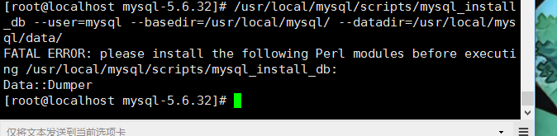   
解决方法 ：安装autoconf库   
命令：yum -y install autoconf //此包安装时会安装Data:Dumper模块   
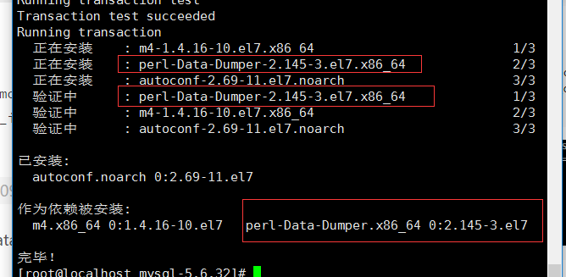   
安装完autoconf库，再运行/usr/local/[**MySQL**](http://lib.csdn.net/base/mysql)/scripts/mysql_install_db –user=[**mysql**](http://lib.csdn.net/base/mysql) –basedir=/usr/local/mysql/ –datadir=/usr/local/mysql/data/ 问题消失！！！

[root@localhost rpm]# service mysql start

[root@localhost rpm]# cat /root/.mysql_secret #查看root账号密码

# The random password set for the root user at Wed Dec 11 23:32:50 2013 (local time): qKTaFZnl

[root@localhost ~]# mysql -uroot –pqKTaFZnl

mysql> SET PASSWORD = PASSWORD('root'); #设置密码为root

mysql> exit

[root@localhost ~]# mysql -uroot -proot

e. 允许远程登陆

mysql> use mysql;

mysql> select host,user,password from user;

+-----------------------+------+-------------------------------------------+

| host | user | password |

+-----------------------+------+-------------------------------------------+

| localhost | root | *6BB4837EB74329105EE4568DDA7DC67ED2CA2AD9 |

| localhost.localdomain | root | *1237E2CE819C427B0D8174456DD83C47480D37E8 |

| 127.0.0.1 | root | *1237E2CE819C427B0D8174456DD83C47480D37E8 |

| ::1 | root | *1237E2CE819C427B0D8174456DD83C47480D37E8 |

+-----------------------+------+-------------------------------------------+

mysql> update user set password=password('root') where user='root';

mysql> update user set host='%' where user='root' and host='localhost';

mysql> flush privileges;

mysql> exit

f. 设置开机自启动

[root@localhost ~]# chkconfig mysql on

[root@localhost ~]# chkconfig --list | grep mysql

mysql 0:off 1:off 2:on 3:on 4:on 5:on 6:off

g. MySQL的默认安装位置

/var/lib/mysql/ #数据库目录

/usr/share/mysql #配置文件目录

/usr/bin #相关命令目录

/etc/init.d/mysql #启动脚本

修改字符集和数据存储路径

配置/etc/my.cnf文件,修改数据存放路径、mysql.sock路径以及默认编码utf-8.

[client]

password= root

port= 3306

default-character-set=utf8

[mysqld]

port= 3306

character_set_server=utf8

character_set_client=utf8

collation-server=utf8_general_ci

#(注意linux下mysql安装完后是默认：表名区分大小写，列名不区分大小写； 0：区分大小写，1：不区分大小写)

lower_case_table_names=1

#(设置最大连接数，默认为 151，MySQL服务器允许的最大连接数16384; )

max_connections=1000

[mysql]

default-character-set = utf8

查看字符集

show variables like '%collation%';

show variables like '%char%';