**Project Task 1**

Andre Burger - 577387

Devon van Heerden - 577334

Werner Janse van Rensburg - 577930

Marizaan Joubert - 577344

Wian Joubert - 577737

**ApexCare SolutionsProject Management Plan**

**Table of Contents**

Introduction 2

Gantt Chart 2

Risks 2

Work Breakdown Structure 3

Conclusion 3

# Introduction

# Gantt Chart

# Resource Management

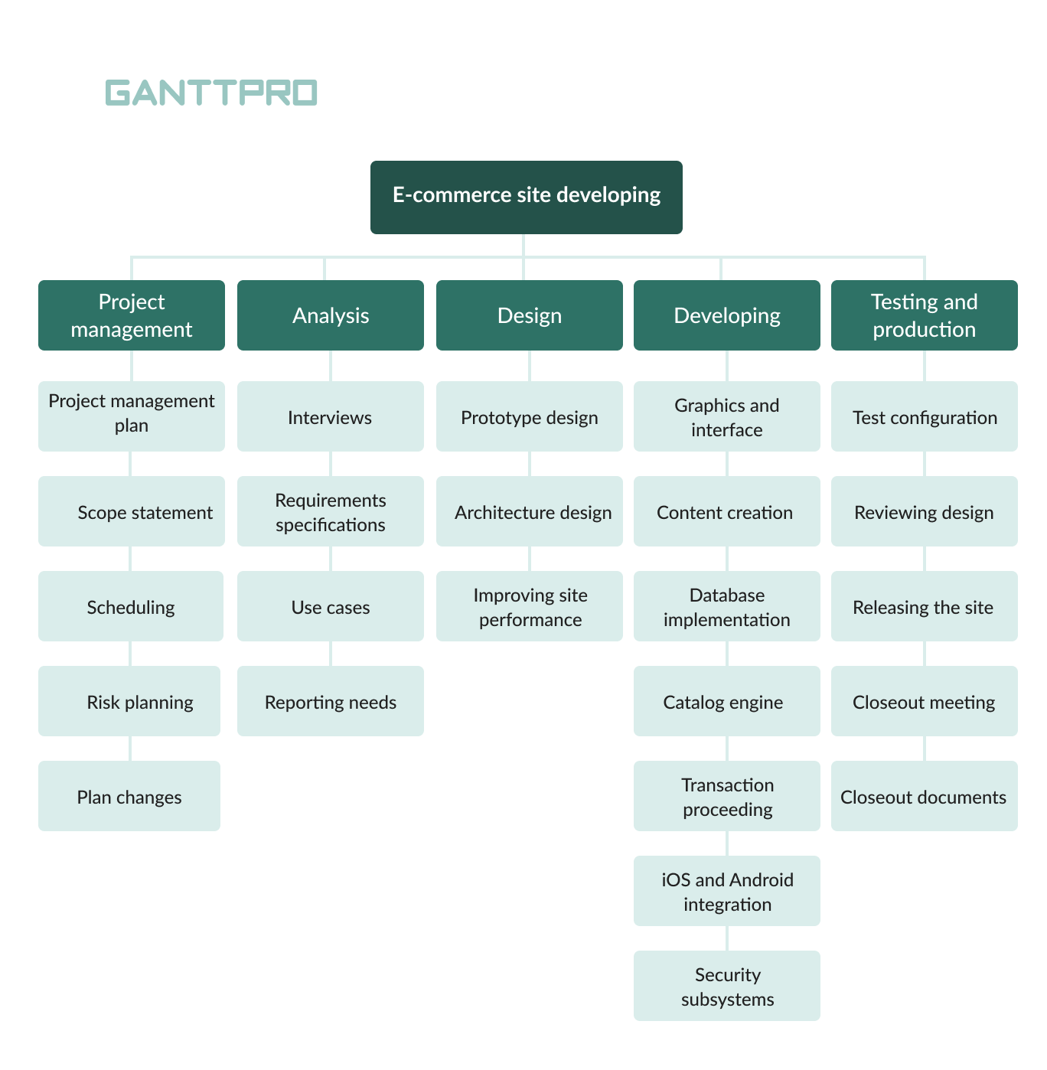

## Human Resources

* Project Manager (PM)
* Solutions Architect (SA)
* UI/UX Designer (UX)
* Front-End Developer (FED)
* Back-End Developer (BED)
* Database Administrator (DBA)
* Mobile App Developer (MAD)
* Quality Assurance Engineer (QA)

## Resource Allocation Strategy

* Cross-functional Teams: The collaboration between the UI/UX designers and front-end developers will speed up design-and developing processes.
* Task Prioritization: Each task which is assigned will be prioritized based on their significance, preventing any delays.
* Modular development: Each task is broken down into smaller independent units ensuring that developers can work on their tasks simultaneously.+

## Project Management Phase

|  |  |  |  |
| --- | --- | --- | --- |
| Task | Resource Allocation | Estimated Duration | Notes |
| Project Management Plan | Project Manager | 3 days | The project manager will consult with team to outline and assign tasks. |
| Scope Statement | Project Manager | 1 day | Project manager defines the scope of the project. |
| Scheduling | Project Manager | 3 days | Project manager assigns tasks to members with estimated timelines. |
| Risk Planning | Project Manager, QA Engineer | 2 days | Project manager and QA engineer identify risks along with mitigation strategies. |
| Plan Changes | Project Manager | Ongoing | Project manager monitors each task and makes adjustments as needed. |

## Analysis Phase

|  |  |  |  |
| --- | --- | --- | --- |
| Task | Resource Allocation | Estimated Duration | Notes |
| Interviews | Project Manager | 3 days | Project manager will meet with stakeholders to gather requirements. |
| Requirement Specifications | Project Manager, SA, FED, BED, MAD, UX | 2 days | Project manager and developer team analyse requirements to identify needs. |
| Use Cases | Project Manager, Solutions Architect | 1 week | Suitable scenarios are created for the team. |
| Reporting Needs | Project Manager | 2 days | Project manager analyses process performance and quality; ensures customer satisfaction. |

## Design Phase

|  |  |  |  |
| --- | --- | --- | --- |
| Task | Resource Allocation | Estimated Duration | Notes |
| Prototype Design | SA, UX, BED, FED, MAD, DBA | 1 weeks | Entire development team works together designing the prototype. |
| Architecture Design | SA, DBA | 1 week | Solutions architect leads with designing the system architecture as the database administrator designs the database schema. |
| Improving Site Performance | SA, UX, FED, MAD, BED | 5 days | Focus on improving website and mobile performance, reducing loading times, simplifying user interface. |

## Developing Phase

|  |  |  |  |
| --- | --- | --- | --- |
| Graphics and Interface | FED, UX, MAD | 4 days | Front-end, mobile, and UX developer design the user interface. |
| Content Creation | FED, UX | 2 days | Front-end and UX developers focus on creating engaging content for user. |
| Database Implementation | DBA | 3 days | Database administrator builds the central database as well as integrating it into the system. |
| Catalog Engine | BED | 5 days | Back-end developers build the catalog and contract management module. |
| Transaction Processing | BED | 5 days | Back-end developers design and implements the auto job scheduling functionality. |
| iOS and Android Integration | MAD | 3 days | Mobile app developers integrate the mobile app with the system. |
| Security Subsystems | SA, BED | 2 days | Systems architect and back-end developers work on implementing necessary security protocols. |

## Testing and Production Phase

|  |  |  |  |
| --- | --- | --- | --- |
| Task | Resource Allocation | Estimated Duration | Notes |
| Test Configuration | QA, SA | 2 days | QA team works with the system architect to run tests, ensuring the system works. |
| Reviewing Design | Project Manager, UX, FED, MAD | 2 days | Project manager reviews the final design for the web and mobile interfaces with the UX, front-end and mobile app developers. |
| Releasing the Site | Project Manager | 1 day | Project manager releases final for client approval. |
| Closeout Meeting | Project Manager, QA Engineer | 1 day | Project manager and QA engineer review the outcomes to collect feedback. |
| Closeout Documents | Project Manager, QA Engineer | 3 days | Documents are finalized and a post-project support plan is presented. |

# Risks

|  |  |  |  |
| --- | --- | --- | --- |
| **Risk Description** | **Likelihood that risk occurs** | **Impact if risk occurs** | **Mitigation Strategy** |
| System Downtime | LOW | HIGH | Implement redundant servers, backup systems, and real time monitoring systems to detect, prevent and resolve the issues resulting in downtime. |
| Poor incident categorization | MEDIUM | MEDIUM | Regular training of the AI model will reduce the likelihood of incorrect categorization and improve its accuracy when sorting queries. |
| Inaccurate data integration | MEDIUM | HIGH | Implement data validation and error handling |
| Privacy and Security Breaches | LOW | HIGH | Make use of strong security protocols (encryption, authentication, vulnerability assessment, regular security updates) |
| Scalability and performance risks as user amount increases | LOW | HIGH | Design the system with scalability in mind by using a cloud infrastructure |
| Mobile App compatibility | MEDIUM | HIGH | Various mobile platforms and devices will be tested to ensure compatibility. |
| Bugs after deployment | HIGH | MEDIUM | After the system goes live, bug-tracking software will monitor and fix issues. |
| AI bias | LOW | MEDIUM | Developers will regularly review the AI models manually to ensure that there are no biases in the data scheduling |
| Faulty prioritization of service requests | MEDIUM | MEDIUM | Update priority settings regularly.  Manually review service requests that are critical to the system. |
| Issues when depending on a third-party service | HIGH | HIGH | Fallback plans like backup API’s, and alternative service providers will be utilized in case of a third-party service crashing. |
| Data loss when integrating updates or migrations | LOW | HIGH | Backing up all data before an update/migration. Do a smaller scale test before involving the entire system. Have rollback procedures in place. |
| Inadequate user training | MEDIUM | MEDIUM | Have user guides and tutorials available to users so that they can utilize the system to its full ability. Having a simple and straightforward UI will also aid in the ease of use of the system |
| Incorrect Resource Allocation | MEDIUM | HIGH | Utilize tools to constantly monitor and update resources. This will ensure that the entire team stays aware of how everything is progressing. |
| Increasing operational costs | MEDIUM | HIGH | Regularly monitor and review costs to optimize resource allocation and accurately predict future expenses, ensuring effective budget management. |
| Inaccurate prediction of demands | LOW | MEDIUM | Make use of predictive models to analyse historical data to generate accurate forecasting demands. |
| Poor Disaster Recovery Strategy | LOW | HIGH | Develop and test disaster recovery plans to minimize downtimes when a system failure occurs. |

# Work Breakdown Structure

# Conclusion