# Apex Embedded Systems Demo GUI Application Quick Start

Contents

Apex Embedded Systems STX104 Demo Application Quick Start 1

Prerequisite 2

Scope 2

Overview 2

Setup / Installation 2

Run The Demo 4

Demo Walk Through 5

# Prerequisite

In order to utilize the C# Demo GUI Application using Mono, you must be running kernel version 3.2 or later. You can verify your current kernel version by entering the following command

$ uname –r

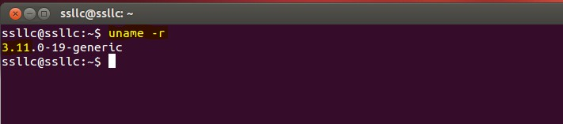

# Scope

This document applies to the aul_tree project being built as a shared resource.

The objective in doing so is to consume the library project from within the accompanying C# executable when run within Mono.

# Overview

This application demonstrates using C# and Mono to build a graphical user interface to allow interaction and manipulation of an STX104 PC/104 card.

It is intended to be used to demonstrate utilization of the AUL library interface.

It is not intended to be used for production.

# Setup / Installation

-To run the Demo GUI Application for the first time a few setup steps are required. Please see Pre-requisite section before proceeding.

1. Mono Complete must be installed. This is required to run the demo application. This can be accomplished by running:

$ sudo apt-get install mono-complete

--Normal installation steps apply. Answer yes when asked if you want to continue. Enter root password to allow install when prompted.

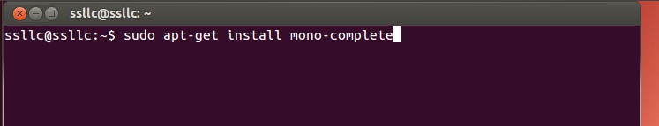

1.b To verify correct Mono install you need to verify that Mono 4.0 is installed. To do so enter the following command and verify the mono directory contains a 4.0 directory as highlighted below.

$ dir /etc/mono

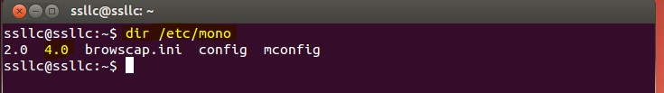

2. Install the correct library. Scripts have been provided to aid in this step and are located in the _Demo_Csharp directory.

There are two options for the library build. The simulator project that does not require hardware (Option A) and the full library (Option B)

2.(Option A) To use the simulator project use the build_aul_use_simulator script with the following command:

$ sh build_aul_use_simulator

-- Root password will be required to copy library to /usr/lib

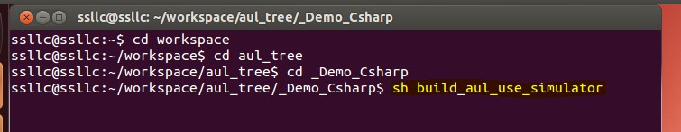

2.(Option B)

To install the full library ( for use with STX104 driver and hardware installed ) use the build_aul_use_driver script with the following command:

sh build_aul_use_driver

-- Root password will be required to copy library to /usr/lib

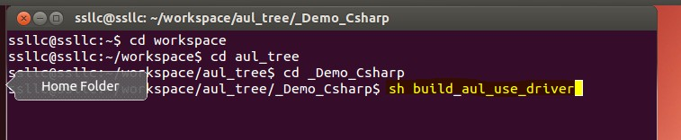

# Run The Demo

A launch script has been provided to aid in setting Mono and starting the application.

To run the application, navigate to the _Demo_Csharp directory and run the following command:

$ sudo sh launch

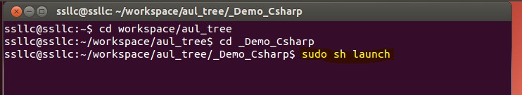

Doing so will start Mono and the Demo GUI Application.

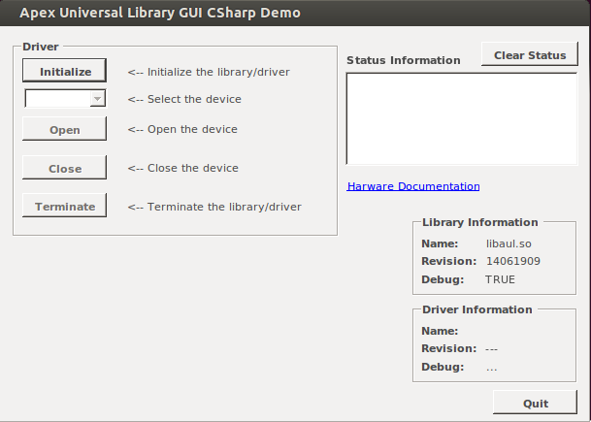

# Demo Walk Through

This document provides a simple walk through to Setup and run the Apex Universal Library GUI Demo

1. Run demo GUI application. Initialize, Select Your Device and Open drive. Verification of success is displayed in the Status Information window. NOTICE the Configuration and Data Flow buttons as they will be discussed later.

