**APEXX Payment Extension for Magento2**

**USER MANUAL Supported Version Magento 2.x**

**DocumentVersion1.0**

**TABLE OF CONTENT**

• Admin General setting

• Basic or Global settings

• Credit Card Direct Payment Method

• Saved Credit Card Settings

• 3Ds Settings

• Processing Flow

• Payment Status flow

• CSE Credit Card Settings

• Afterpay Payment Method Settings

• Applepay payment Method Settings

• Paypal Payment Method Settings

• Googlepay Payment Method Settings

• Hosted Payment Method Settings

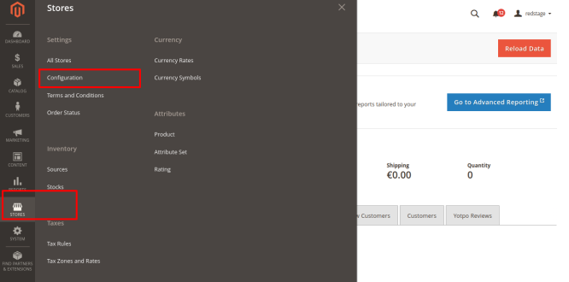**ADMIN CONFIGURATION**

**WHERE IS APEXX MODULE**

All Payment methods will be available on magento payment section. Below are steps for locating to settings :

1. Log in to your Magento admin panel.

2. On the Admin sidebar, go to **Stores** > **Configuration**.

3. On the Configuration page that loads, go to **Sales** > **Payment Methods.**

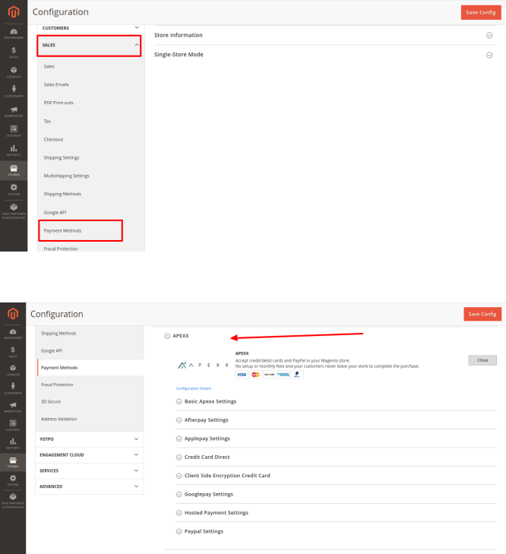4. Click the Configure button next to the **APEXX** logo.

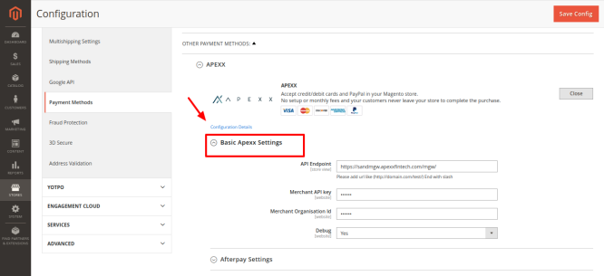**BASIC SETTINGS**

1. **API Endpoint** : Set URL according to payment mode (sandbox Or live).

2. **Merchant API key** : Enter your Merchant API Key provided by **APEXX**.

3. **Merchant Organisation Id** : Enter your Merchant organization Id.

4. **Debug** : Set Enable Logging at Debug Level to Yes in order to record the entire request and responses that are being sent to and received from the payment processors in a log

file.

**Note**: We recommend this to be turned off since it may impact performance and use up disk space on your server(s)

**CREDIT CARD DIRECT PAYMENT METHOD**

**GENERAL SETTINGS**

1. **Enabled :** Enable or disable Credit card direct using the Enable options.

2. **Title :** The name for this payment method that appears to customers during checkout.

3. **Payment Action**: Use Payment Action to select the action that has to be triggered when a user places an order. It can be either Authorize or Authorize and Capture (Invoice).

4. **Credit Card Types** : Select the supported cards from Credit card types.

5. **Allowed Currencies** : Select the supported currencies from Allowed Currencies section.

6. **Webhook Transaction URL** : A webhook url that is called when a transaction is updated. Set it as below example. Ex.https://domainname.com/rest/V1/ccdirect/webhookdata

7. **Dynamic Descriptor**: A short reference/descriptor that will show up on the customers bank statement.

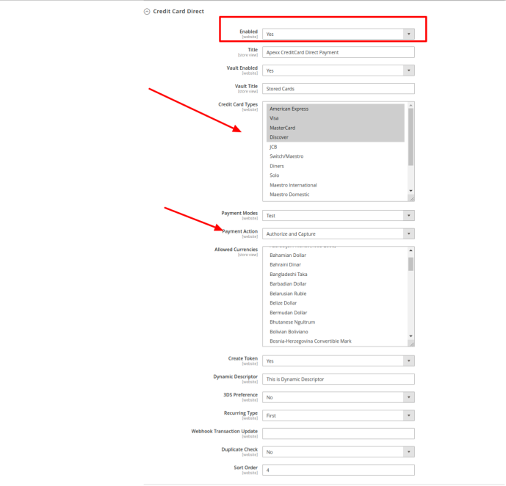**SAVED CREDIT CARD SETTINGS :**

1. **Vault Enabled** : Enable vault by 'Vault Enable' option.

2. **Vault Title** : Set tittle for Saved credit card.

3. **Create Token** : Make Create Token to "Yes". Its required for saved credit card.

4. **Recurring Type** : Set 'Recurring Type' as if you want to enter CVV or not. if set '**First**' CVV will required while making transaction by saved card. If set 'One-click' it will not ask for CVV by saved cards.

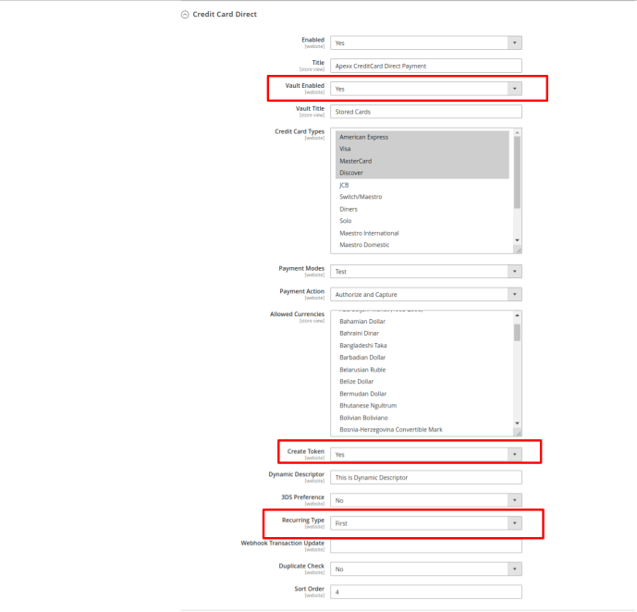**3DS PREFERENCE :**

**3DS Preference** : Enable 3Ds Preferences if need to enable 3Ds for payment. Else keep it 'No'.

**DocumentVersion1.0**

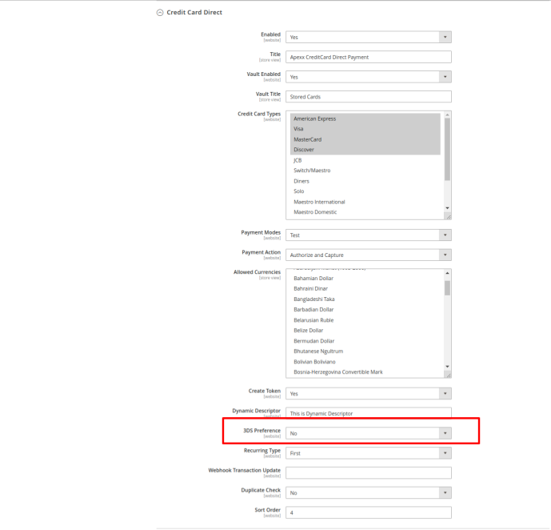

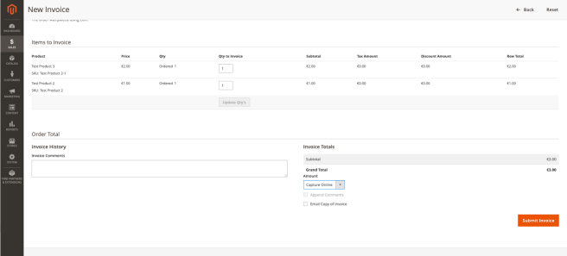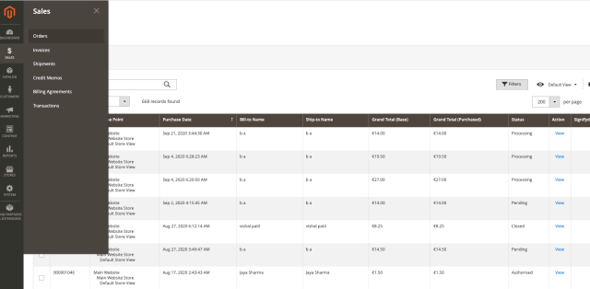**Payment Status Flow**

Depending on the Payment Action setting you have chosen to select, the Order Status will differ. You can find all Orders placed by going to **Sales** > **Orders,** here you will find the Status of each transaction that has taken place.

If the Payment action is set to **Authrorize,** the Order status will show *Authorosed*. By selecting the action tab, you now have the option to either **Cancel** the transaction or **Invoice** the Authorised amount.

By selecting **submit Order** the order status moves from **Authorised** to **Processing**

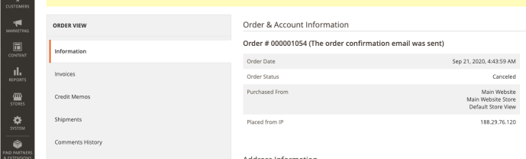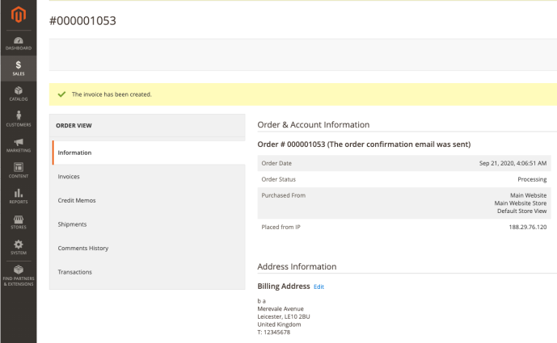If you had chosen to Cancel the transaction, the status would have moved from **Authroised** to **Canceled**.

Refunding a transaction can be actioned under the **Sales > Invoice > Credit Memo** tab. By selecting to refund a transaction, the status moved from **Processing** to **Closed**

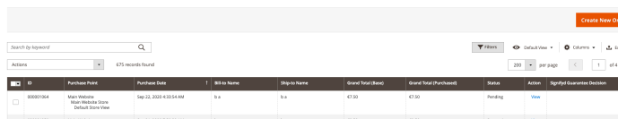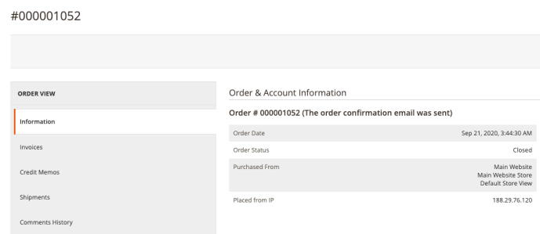Please note, a **Pending** status against a transactions means an action still needs to be taken, This can either be moved to process the payment or **Cancel** the order.

**CSE CREDIT CARD DIRECT PAYMENT METHOD**

1. **Enables**: Enable or disable Credit card direct using the Enable options.

2. **Title**:The name for this payment method that appears to customers during checkout.

3. **Encryption Key** : Enter Encryption Key provided by APEXX.

4. **Payment Action**: Use Payment Action to select the action that has to be triggered when a user places an order. It can be either Authorize or Authorize and Capture (Invoice).

5. **Credit Card Types** : Select the supported cards from Credit card types.

6. **Allowed Currencies** : Select the supported currencies from Allowed Currencies section.

7. **Webhook Transaction URL** : A webhook url that is called when a transaction is updated. Note: Set it as below example.

Ex.https://domainname.com/rest/V1/ccdirect/webhookdata

8. **Dynamic Descriptor**: A short reference/descriptor that will show up on the customers bank statement.

**3DS Settings :**

1. Enable 3Ds Preferences if need to enable 3Ds for payment. Else keep it 'No'.

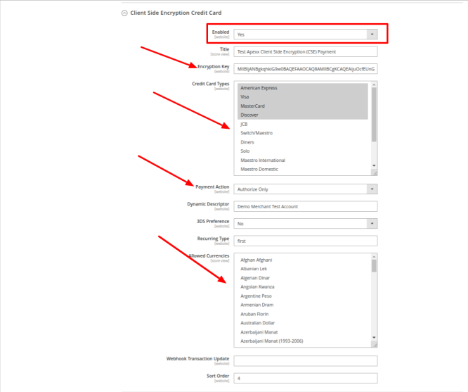**Payment Status Flow**

The Payment status flow for CSE is identical to Credit Card Direct Payment.

**AFTERPAY PAYMENT METHOD**

1. **Enables**: Enable or disable Afterpay using the Enable options.

2. **Title**:The name for this payment method that appears to customers during checkout.

3. **Payment Action**: Determines the action taken by Afterpay when a payment is processed. Options:

Authorize Only- Funds on the customer’s card are authorized, but not transferred from the customer’s account. An order is created in your store Admin. You can later capture the sale and create an invoice.

4. **Dynamic Descriptor**:A short reference/descriptor that will show up on the customers bank statement.

5. **Shopper Interaction**: Determines the point of sale of a customer. Default values: ecommerce

6. **Customer Type**: Type of the customer.Default values: Person

7. P**ayment Type**: Type of Payment. Default values: Invoice, Valid values:"Invoice" "Account" "Installment" "Consolidatedinvoice"

8. **Country Specific Account ID**: The ID of the account based on country. Identifies the Account ID that are accepted per country and currency combination for payments processed by Afterpay.

A record is saved for each country. Options:

Countrycode_Currencycode - Add Country code with Currency code like DE_EUR Account ID: Add account id

Add - Add a new line to allow account id for a different country and currency combination. Action - Deletes the record of allowed account id for the country.

9. **Webhook Transaction Update**: A webhook url that is called when a transaction is updated. Set it as below example.

Ex.https://domainname.com/rest/V1/ccdirect/webhookdata

**Payment Status Flow**

The Payment status flow for AfterPay is identical to Credit Card Direct Payment.

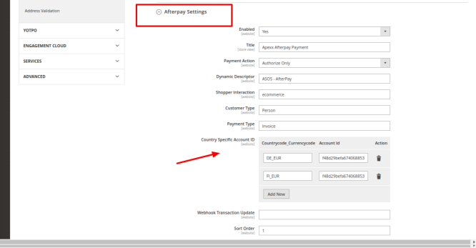10. **Sort Order:** A number that determines the order that Payment on Account appears when listed with other payment methods during checkout. Enter 0 to place it at the top of the list.

**APPLEPAY PAYMENT METHOD**

1. **Enables**: Enable or disable Applepay using the Enable options.

2. **Title**:The name for this payment method that appears to customers during checkout.

3. **Payment Action**: Determines the action taken by Applepay when a payment is processed. Options: Authorize Only- Funds on the customer’s card are authorized, but not transferred from the customer’s account. An order is created in your store Admin. You can later capture the sale and create an invoice.

Authorize and Capture - Funds on the customer’s card are authorized and captured by Applepay, and an order and invoice are created in your store Admin.

4.**Webhook Transaction Update**: A webhook url that is called when a transaction is updated. Set it as below example.

Ex.https://domainname.com/rest/V1/ccdirect/webhookdata

5. **Date of Birth**: Add date of birth

6. **Dynamic Descriptor**: A short reference/descriptor that will show up on the customers bank statement.

7. **Shopper Interaction**: Determines the point of sale of a customer. Default values: ecommerce

8. **3DS Preference**: Determines if a transaction must pass an additional verification process when the customer is enrolled in a program such as “Verified by VISA”. Options: Yes / No

9. **Recurring Type**:This field is to be used only when a transaction is part of a series of recurring transactions. If it's the initial transaction, set the value to 'first', and if it's not, set it to 'recurring'. This field must not be included in transactions that will not be part of a series of repeated transactions. (All values are written in lowercase letters). "Default values: first" "recurring" "oneclick"

10. **Sort Order**: A number that determines the order that Payment on Account appears when listed with other payment methods during checkout. Enter 0 to place it at the top of the list.

11. **Allowed Currencies**: If applicable, identifies the specific countries from which you accept payments processed by Applepay.

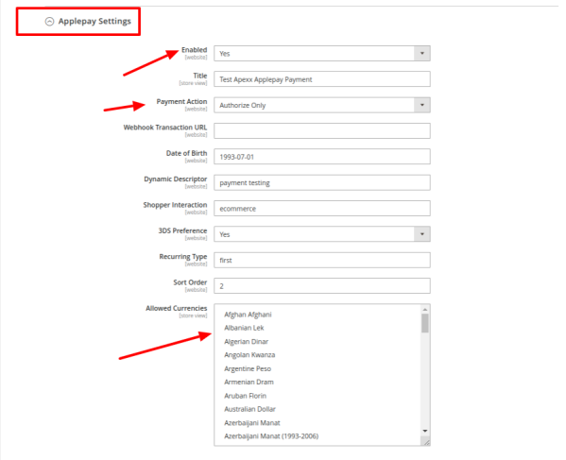**Payment Status Flow**

The Payment status flow for ApplePay is identical to Credit Card Direct Payment.

**PAYPAL PAYMENT METHOD**

1. **Enables**: Enable or disable Paypal using the Enable options.

2. **Title**:The name for this payment method that appears to customers during checkout.

3. **Payment Action**: Determines the action taken by Paypal when a payment is processed. Options:

Authorize Only- Funds on the customer’s card are authorized, but not transferred from the customer’s account. An order is created in your store Admin. You can later capture the sale and create an invoice.

Authorize and Capture - Funds on the customer’s card are authorized and captured by Paypal, and an order and invoice are created in your store Admin.

4. **Dynamic Descriptor**: A short reference/descriptor that will show up on the customers bank statement.

5. **Redirect URL**: The return url to which the customer is redirected after an transaction is processed.

6. **Recurring Type**:This field is to be used only when a transaction is part of a series of recurring transactions. If it's the initial transaction, set the value to 'first', and if it's not, set it to 'recurring'. This field must not be included in transactions that will not be part of a series of repeated transactions. (All values are written in lowercase letters). "Default values: first" "recurring" "oneclick"

7. **Shopper Interaction**: Determines the point of sale of a customer. Default values: ecommerce

8. **Brand Name**: The label that overrides the business name in the PayPal account on the PayPal site.

9. **Customer Paypal Id**: The customer's paypal ID. 10.**Paypal Tax Id**: The customer's tax ID

11. **Paypal Tax Id type**: The customer's tax ID type

12. **Customer Date of Birth**: The Customer date of birth 13.**Order Description**: The purchase description.

14. **Webhook Transaction Update**: A webhook url that is called when a transaction is updated. Set it as below example.

Ex.https://domainname.com/rest/V1/ccdirect/webhookdata

15. **Sort Order**: A number that determines the order that Payment on Account appears when listed with other payment methods during checkout. Enter 0 to place it at the top of the list.

16. **Allowed Currencies**: If applicable, identifies the specific countries from which you accept payments processed by Paypal.

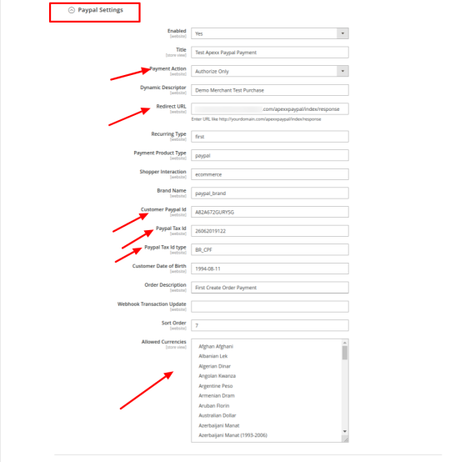

**GOOGLEPAY PAYMENT METHOD**

1. **Enables**: Enable or disable Googlepay using the Enable options.

2. **Title**:The name for this payment method that appears to customers during checkout.

3. **Payment Action**: Determines the action taken by Googlepay when a payment is processed. Options: Authorize Only- Funds on the customer’s card are authorized, but not transferred from the customer’s account. An order is created in your store Admin. You can later capture the sale and create an invoice.

Authorize and Capture - Funds on the customer’s card are authorized and captured by Googlepay, and an order and invoice are created in your store Admin.

4.**Webhook Transaction Update**: A webhook url that is called when a transaction is updated. Set it as below example.

Ex.https://domainname.com/rest/V1/ccdirect/webhookdata

5. **Date of Birth**: Add date of birth

6. **Dynamic Descriptor**: A short reference/descriptor that will show up on the customers bank statement.

7. **Shopper Interaction**: Determines the point of sale of a customer. Default values: ecommerce

8. **3DS Preference**: Determines if a transaction must pass an additional verification process when the customer is enrolled in a program such as “Verified by VISA”. Options: Yes / No

9. **Recurring Type**:This field is to be used only when a transaction is part of a series of recurring transactions. If it's the initial transaction, set the value to 'first', and if it's not, set it to 'recurring'. This field must not be included in transactions that will not be part of a series of repeated transactions. (All values are written in lowercase letters). "Default values: first" "recurring" "oneclick"

10. **Sort Order**: A number that determines the order that Payment on Account appears when listed with other payment methods during checkout. Enter 0 to place it at the top of the list.

11. **Allowed Currencies**: If applicable, identifies the specific countries from which you accept payments processed by Googlepay.

**Payment Status Flow**

The Payment status flow for GooglePay is identical to Credit Card Direct Payment.

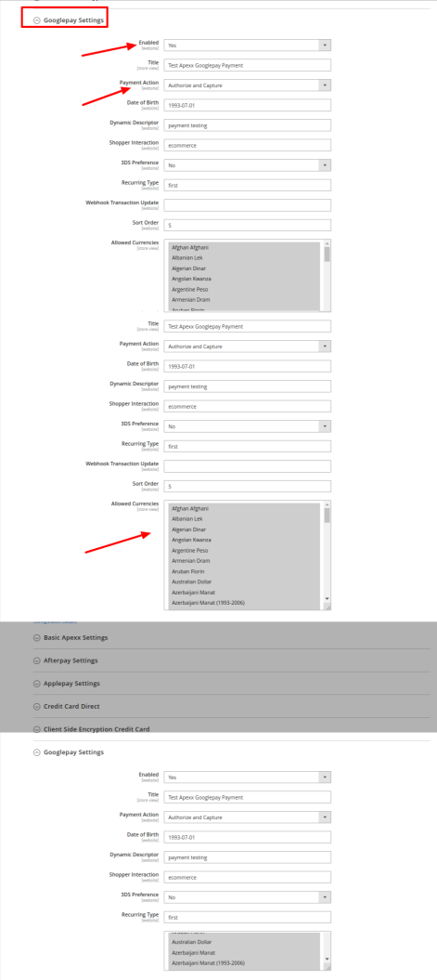

**HOSTED PAYMENT METHOD**

1. **Enables**: Enable or disable Hosted using the Enable options.

2. **Title**:The name for this payment method that appears to customers during checkout.

3. **Payment Action**: Determines the action taken by Hosted payments when a payment is processed. Options:

Authorize Only- Funds on the customer’s card are authorized, but not transferred from the customer’s account. An order is created in your store Admin. You can later capture the sale and create an invoice. Authorize and Capture - Funds on the customer’s card are authorized and captured by Hosted payments, and an order and invoice are created in your store Admin.

4. **Dynamic Descriptor**: A short reference/descriptor that will show up on the customers bank statement.

5. **Recurring Type**:This field is to be used only when a transaction is part of a series of recurring transactions. If it's the initial transaction, set the value to 'first', and if it's not, set it to 'recurring'. This field must not be included in transactions that will not be part of a series of repeated transactions. (All

values are written in lowercase letters). "Default values: first" "recurring" "oneclick"

6.**Webhook Transaction Update**: A webhook url that is called when a transaction is updated. Set it as below example.

Ex.https://domainname.com/rest/V1/ccdirect/webhookdata

7. **Iframe Height** : Define height of iframe on checkout page

8. **Iframe Width** : Define width of iframe on checkout page.

9. **Show Card Holder Name** : Make 'Yes' if want to show card holder name on iframe.

10. **Show Address** : Make 'Yes' if want to show card Address on iframe.

11. **Show Address Required** : Make 'Yes' if want to show card holder name on iframe.

12. **Sort Order**: A number that determines the order that Payment on Account appears when listed with other payment methods during checkout. Enter 0 to place it at the top of the list.

13. **Allowed Currencies**: If applicable, identifies the specific countries from which you accept payments processed by Hosted payments.

14. **3DS Setting:** Enable 3Ds Preferences if need to enable 3Ds for payment. Else keep it 'No'.

**Payment Status Flow**

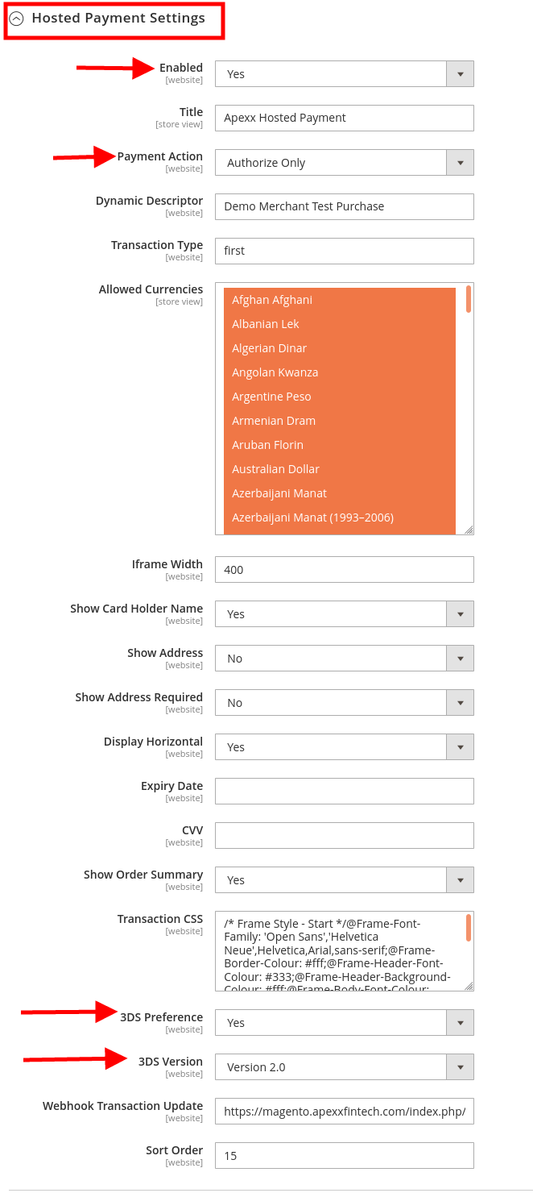

The Payment status flow for Hosted Payment is identical to Credit Card Direct Payment.

**Sinnifyd Configuration for Hosted Payment:**

We need some configuration required for Hosted Payment, insert sql query for webhook return value to map and save below fields-

Bin, Cvv, Avs, Last4, TransactionId, Exp Year & Exp Month.

**Signifyd module(Sql query) for Hosted Payment:**

Insert below sql query in database.

INSERT INTO core_config_data(path, value) VALUES('signifyd/general/async_payment_methods', 'hostedpayment_gateway');

Other payment method CC payment and CSE payment not required any webhook settings map all fields automatically.

**Signifyd Intallation:**

<https://github.com/signifyd/magento2>

<https://marketplace.magento.com/signifyd-module-connect.html>

If you still facing any issue filed mapping, please contact to Signifyd support they will provide patch “MAG-693__Cron_fix_for_async_payment_methods.patch”.

**Note:** If we used signifyd module then we need apply patch for it after intall signifyd module.

signifydupdate.patch