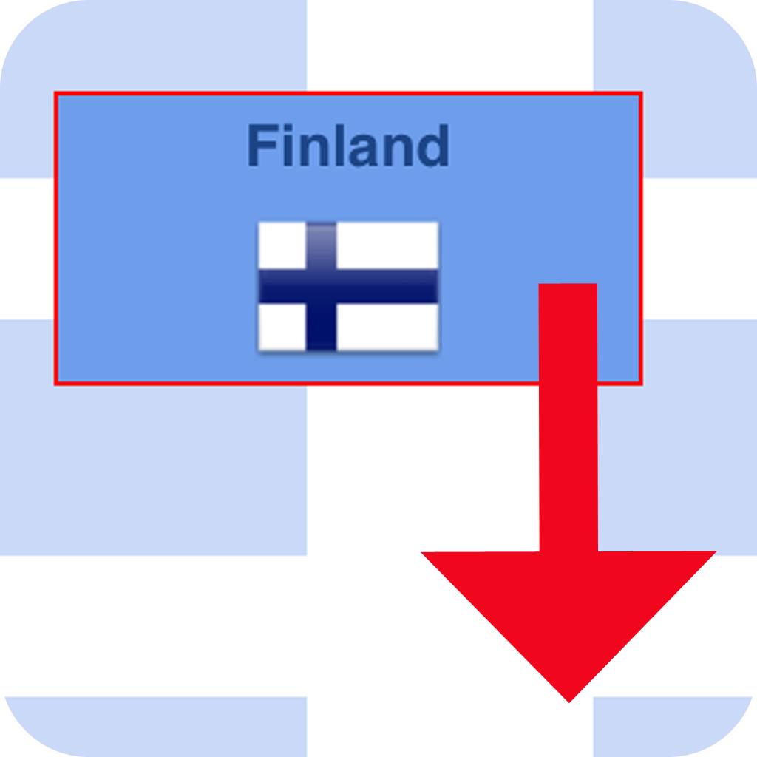

IOS Drag&Drop Framework
ArraSolta Manual


Prepared by: Ulrich Vormbrock
Prepared for: IOS developers
Date: 15.10.2015
Table of Contents
1 Prerequisites 3
2 Integrating ArraSolta into your project 3
3 Organizing Imports – PublicAPI.h 6
3.1 Generating a central PCH file 7
4. Creating Macros for ArraSolta Singletons 9
5. Programming with ArraSolta 11
5.1 View Controller 11
5.2 Main View containing the drag&drop functionality 12
5.2.1 Source Collection View 13
5.2.2 Target Collection View 13
5.3.3 UICollectionViewDataSource Protocol 13
5.3.4 UICollectionViewDelegateFlowLayout Protocol 15
5.3.5 Undo Button 16
5.4 Custom draggable View 16
5.4.1 Creating Subview Components 18
5.4.2 Populating Subview Components 19
6 Architecture of the ArraSolta Framework 21
7 ArraSolta API 23

1 Prerequisites

ArraSolta is written in Objective C, thus it's intended for Xcode projects written in Objective C.
In addition, ArraSolta is not based on storyboards, but on pure Objective C code. As ArraSolta works with auto layout, device rotation and varying screen sizes are not an issue.
The framework files of ArraSolta are shipped in three different versions:
- Device– release version for the iPhone and iPad (782 kB),
- Simulator – for running on simulator only (444 kB),
- Universal – for running both on simulator, both on physical device (1.2 MB).

Below please find the directory structure of the framework delivery:
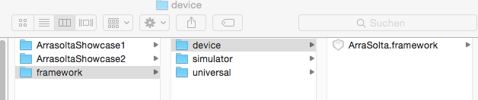
Both Xcode sample projects (ArraSoltaShowcase1 and ArrasoltaShowcase2 – delivered as a bonus with ArraSolta) use the universal version of this framework – thus you can run and test them both with the simulator, both with a physical device.
ArraSolta requires IOS 8.0 or above.

2 Integrating ArraSolta into your project

In order to become familiar with ArraSolta, we recommend that you run and test at least one of the sample Xcode projects which are delivered with ArraSolta. Nevertheless, if you want to integrate ArraSolta into your existing Xcode project, you should read the following explanations.
First make sure that you integrate this framework correctly into your Xcode project. We recommend that you first create a subfolder (using the Finder) which can be named Framework. Copy one of the three above-mentioned framework files into your new folder. As already mentioned, use the universal version at the beginning – you can change it later when you plan to perform a final upload to iTunes Connect.
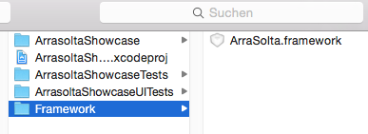
As next step, you need to inform Xcode about the new framework. Just go to Targets → Embedded Binaries → Add Other:
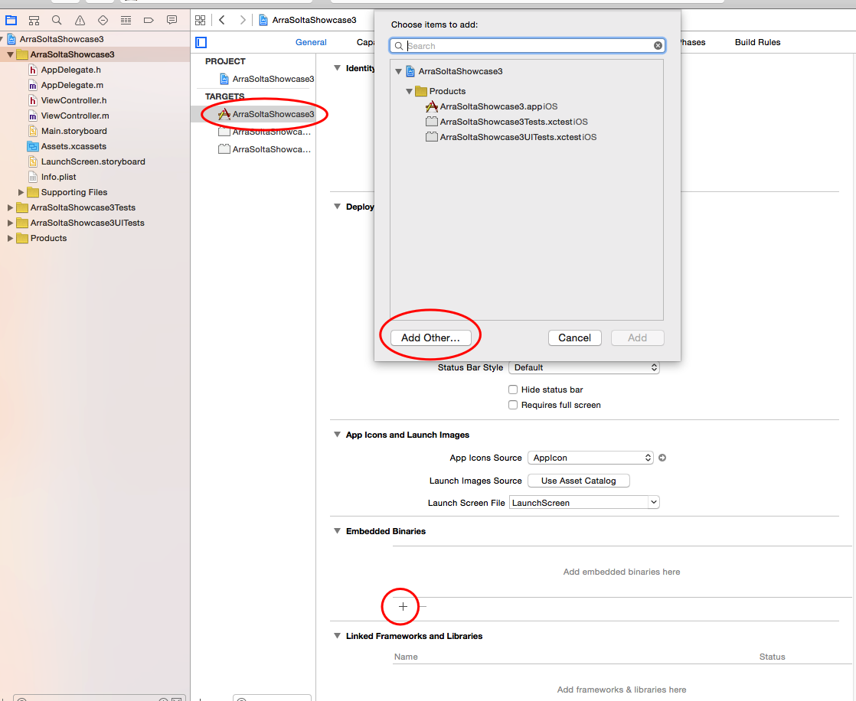
It's important that you choose Embedded Binaries and NOT Linked Framework and Libraries.
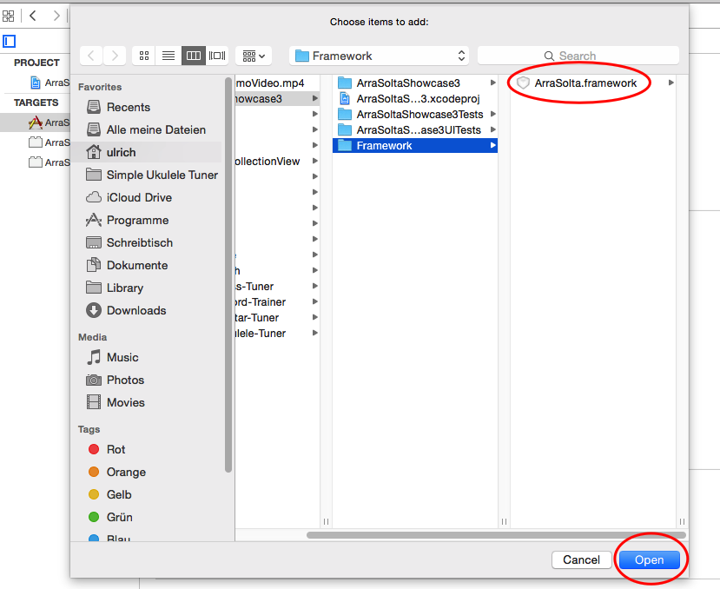
Now choose the ArraSolta.framework file from your subfolder (you created):

Please watch out that under Destination the Option Copy items if needed is enabled:
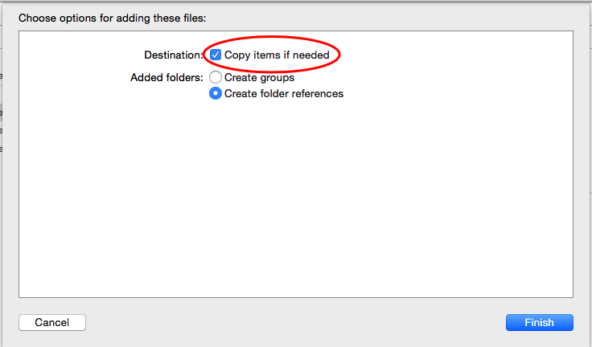

If you have successfully integrated ArraSolta into your project, you should see a screen like this:
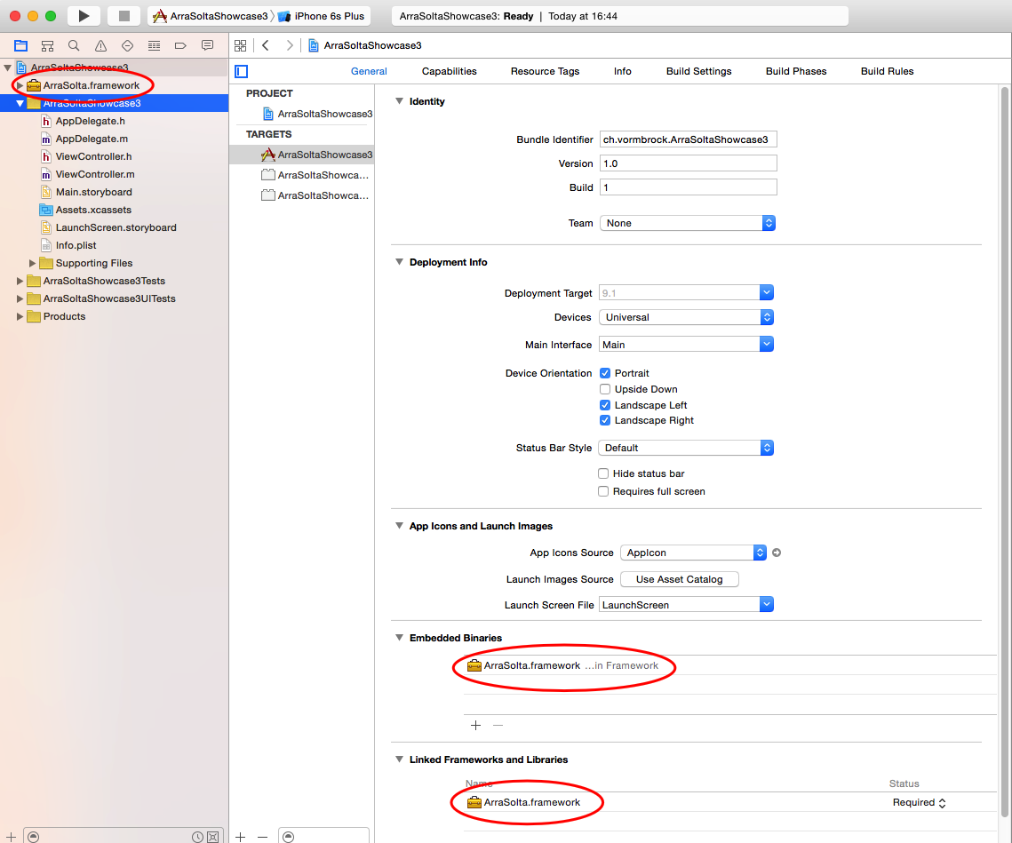
Now the integration part is done – now you need to perform an import of the API.

3 Organizing Imports – ArrasoltaAPI.h

This framework contains more than 20 classes – but you only need to import one master header file named ArrasoltaAPI.h - which in return contains further imports:

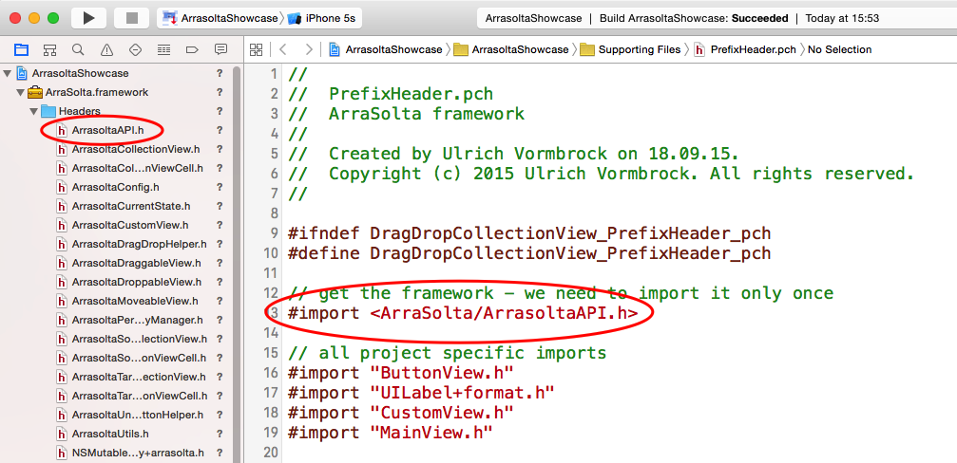
Put the following line of code in all files which deal with the ArraSolta framework, as in the View Controller, in the UIView containing the drag&drop functionalities and into your custom UIView which should be draggable and droppable:
#import <ArraSolta/ArrasoltaAPI.h>
In order to avoid naming conflicts, this framework uses the Arrasolta prefix in all its classes and also in the reuse identifiers of the collection view cells!
It's recommended to build your project in order to make sure that ArraSolta is correctly integrated!
Hint:
Instead of importing <ArraSolta/ArrasoltaAPI.h> into multiple files, you can also generate a central PCH file and import it once there.

3.1 Generating a central PCH file
Although it's not subject of this manual, we like to show you how to generate a PCH file. It will facilitate further implementation steps, as you'll see later.
Just right-click at one project file (best practice: right-click at the folder „Supporting Files“ if you want to have the PCH file there) and choose „Other“ and „PCH File“. By default, the PCH file will be named „PrefixHeader“. You can also choose another name for it – maybe in the case that you want to work with multiple PCH files.

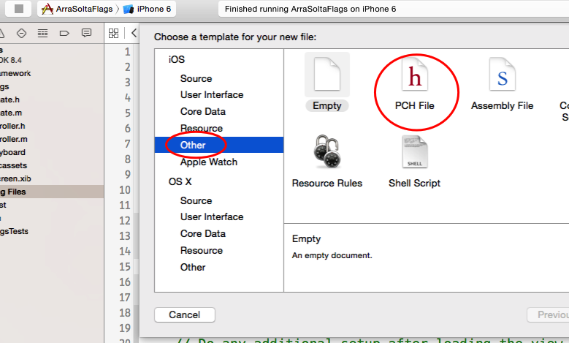

Unfortunately, Xcode doesn't add this file to the build settings automatically – you need to do it manually.
Just go to Build Settings and make a pre-search with the term prefix in order to find the option prefix header more easily. Now it's crucial that you change Precompile Prefix Header from NO to YES! Then enter the path and the name of the PCH file below into Prefix Header. That's the most error-prone part: make sure that you enter the project name (here: ) as well as the name and the extension of the PCH file, separated by a slash – thus something like this:
ArraSoltaShowcase3/PrefixHeader.pch
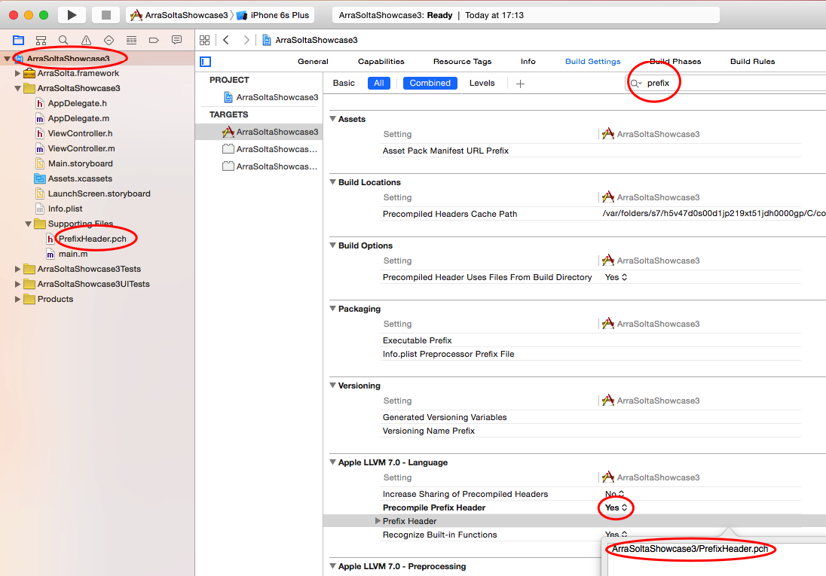

Make sure that your PCH file is correctly implemented - transfer your ArraSolta imports
#import <ArraSolta/ArrasoltaAPI.h>
from all files (Vie Controller and UIViews) to your PCH file and make a build. You should get no compile error!

4. Using ArraSolta Singletons Macros

This framework provides three different singletons which are open to the user. These are
- ArrasoltaConfig (all configurations concerning layout and drag&drop behaviour),
- ArrasoltaCurrentState (for tracking the drag&drop transaction state),
- ArrasoltaUndoButtonHelper (binding the undo/redo button to the framework).
The function of these singletons will be explained more in detail later!
Please remember:
As an IOS app only needs to satisfy the requirements of one user, all configurations can be passed to and from a singleton instance, as for example the line-spacing of a collection view or the width-height ratio of a draggable item (custom UIView).
A singleton is a design pattern which allows only one instance for a given class and which provides a global access point to such instance. Singletons are an easy and powerful way to share data between different parts of a project, without the need to pass objects manually from one class to another.
The macros (which are open to the user) are already defined in ArrasoltaAPI.h – thus you won't need to define them in your files:
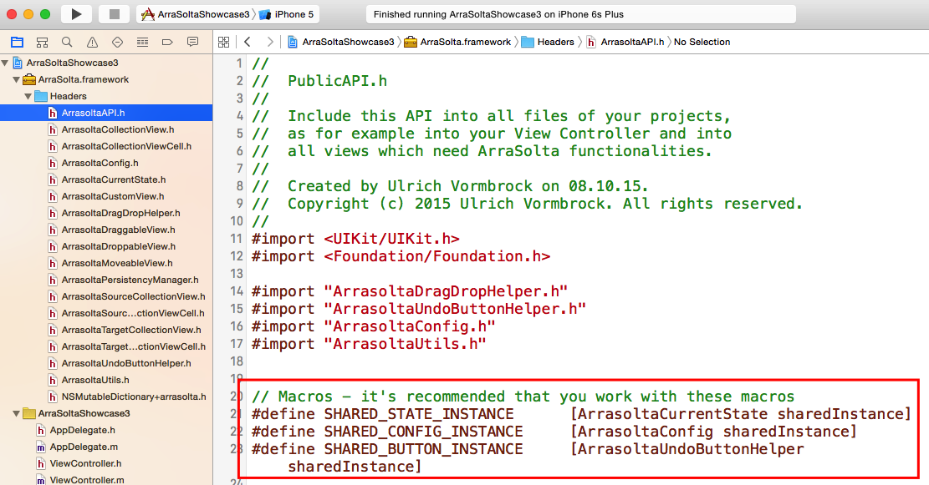
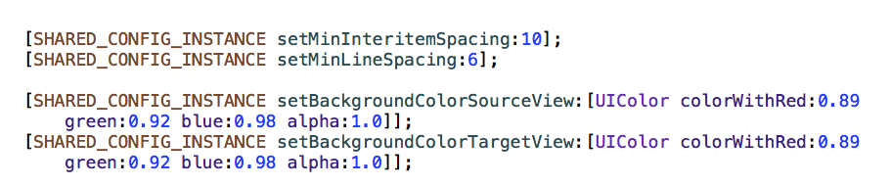
We recommend to use these macros (instead of redefining them) – see example:

5. Programming with ArraSolta

5.1 View Controller
The View Controller is the entry-point for the ArraSolta framework, as you perform all required configurations concerning
- the collection views (one for the source and another one for the target items),
- the draggable views (customizable UIViews which may contain further subviews) and
- the data source of the source collection view (mutable dictionary with all custom draggable views – properties must be set before adding those views to the dictionary!).
As precondition, your custom draggable UIView class must be created before! In the View Controller, you need to generate instances of your custom view, setting the properties and then adding all these instances to your Mutable Dictionary (which serves as data source).
When you look at the ArrasoltaConfig interface, you'll discover about 25 properties which can be set in the View Controller, as for example minInterimSpacing in conjunction with Collection Views:

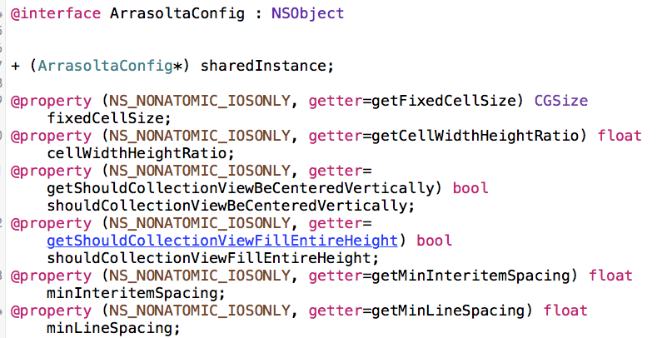
Below please find a possible implementation in the View Controller:
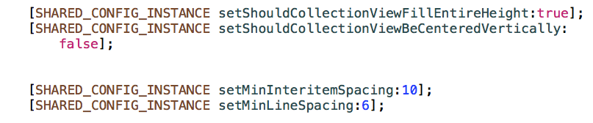
As mentioned before, you need to populate the Source Collection View with your custom (draggable/droppable) elements.
First you need to declare a Mutable Dictionary as private member – for example like this:
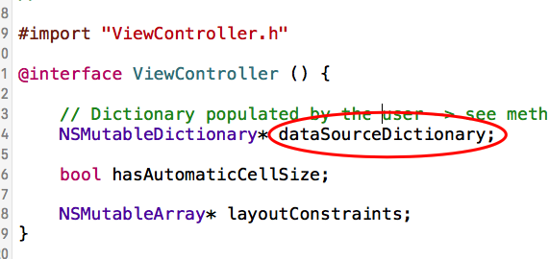
After instantiating the Mutable Dictionary (please don't forget!), you should first wrap all instances of your custom UIViews into ArrasoltaDraggableViews and then add all these wrapper instances to the newly created Mutable Dictionary – see the following example:
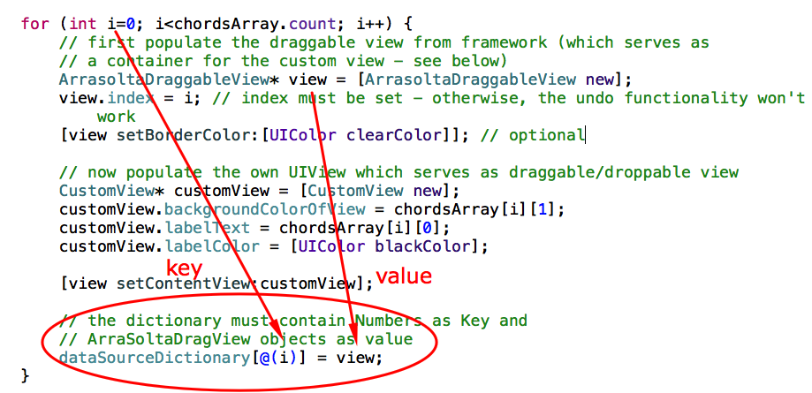
Important:
The Mutable Dictionary (as data source for the Source Collection View) must contain a NSNumber object (starting from 0) as key and an instance of ArrasoltaDraggableView as value. Warning: don't add your custom view directly to the Mutable Dictionary! You can learn more about the relation between the framework classes in the chapter 6 Architecture of the ArraSolta framework.
ArrasoltaDraggableView is part of the ArraSolta framework and serves as container for your custom draggable view. It can contain a border (width and colour) – for populating ArrasoltaDraggableView with your own custom view, you need to call the following method:
[view setContentView:customView];

5.2 Main View containing the drag&drop functionality
You need an UIView which contains the two collection views (source and target) and an optional undo/redo button.
This framework is shipped with two different sample projects – thus you can get a first insight how to program a view with drag and drop functionality.
As you can see in the sample projects, there is a huge amount of source code in the main view, as the following tasks should be done:
- Build all views (headline, undo/redo button, collection views) and add them to the main view,
- Fill the collection view's delegate methods with code (UICollectionViewDataSource and UICollectionViewDelegate),
- Setup the layout constraints, as we work with auto layout,
- Handle device rotation with the aid of NSNotificationCenter - UIDeviceOrientationDidChangeNotification.
We expect that you are familiar with auto layout – thus we explain the first two points only. Anyhow, you can see in the sample projects how step 3. and 4. can be done.
In the sample projects, we have put all methods into a single class (MainView), but in order to make your code more readable (“separation of concerns”), you can create a superclass of MainView and put all the code concerning layout constraints in it.
Now we explain step-by-step how to build the collection views and how to handle their delegates.

5.2.1 Source Collection View
The source collection view must be populated by a NSDictionary within the initialisation process initWithFrame. Remember that the source collection view must be filled! Let's have a look into one sample project:
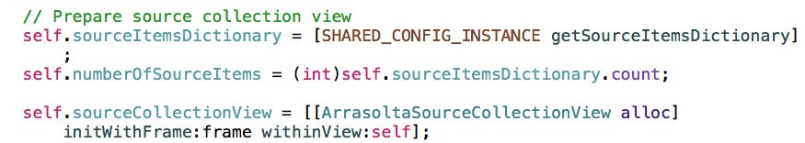
As you cans see, the dictionary (previously defined in the ViewController) is read from the ArrasoltaConfig singleton – see macro SHARED_CONFIG_INSTANCE. We also need the number of items which simply is the number of dictionary elements. The instantiation of the source collection view is easy: please use the class ArrasoltaSourceCollectionView and pass the current frame and the embedding view (=self) as arguments.

5.2.2 Target Collection View
Contrary to the source collection view, the target collection view doesn't need be populated at the beginning: it will be populated later when the user drags and drops elements into it. Anyhow, if you work with Core Data, you should populate the target collection view with the elements from the previous session. Let's see how to do:
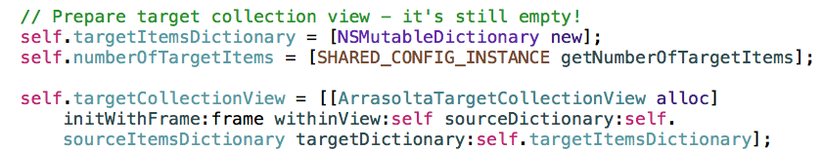
Contrary to the source collection view, the target collection view ArrasoltaTargetCollectionView is instantiated with two further arguments – namely with the source and with the target dictionary.
The number of items comes from ArrasoltaConfig: if source items are consumable, the framework sets it equal to the number of source items – if source items are not consumable, the value must be set in the View Controller. In the first case, it wouldn't make sense to set the number of target elements different than the number of source elements!

5.3.3 UICollectionViewDataSource Protocol
According to Apple's specification, all data source objects must at least implement the numberOfItemsInSection and cellForItemAtIndexPath methods! Lets start with the first one:
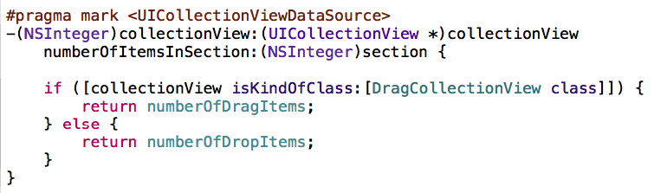
The implementation of numberOfItemsInSection is trivial: we check the correspondent class of the object “collectionView” (DragCollectionView and DropCollectionView) and return the number of items which in return represent the number of items in the correspondent data source object (dictionary).
The implementation of cellForItemAtIndexPath is a bit more complicated:
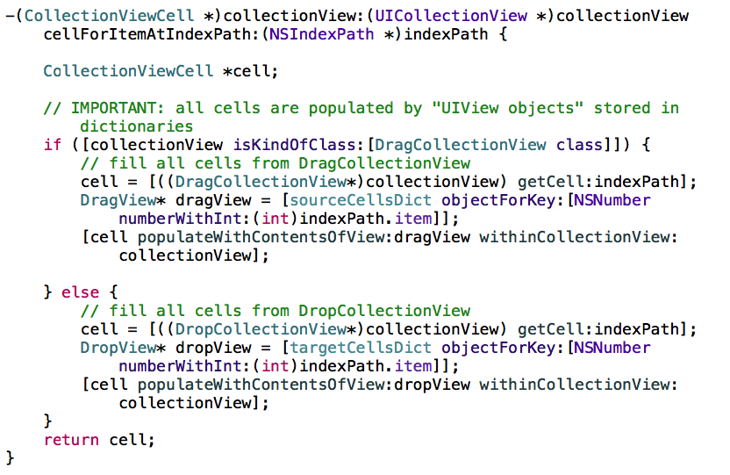
Analogous to numberOfItemsInSection, we first perform a class check in order to retrieve the cell of the right collection view (DragCollectionView or DropCollectionView). When this is done, we get the DragView (or the DropView) from the correspondent data source (dictionary). As you can see, the DragView is retrieved from the dictionary sourceCellsDict which in return is the result of our initialisation process within the ViewController. DropView – instead – comes from targetCellsDict which is populated dynamically in function of user interaction.
At last, we need to fill each cell with content – to do this, we simply call the method “populateWithContentsOfView” which belongs to the CollectionViewCell object.

Attention:
Please take into account that the cell is not an UICollectionViewCell, but a CollectionViewCell (which is part of this framework). If you set UICollectionViewCell instead, you get a compile error!
Note:
If you are familiar with collection views, you might wonder why we don't use a reuse identifier for the cells. Such reuse identifier exist for both collection views, but they are handled internally within the framework (see method “getCell” from DragCollectionView and DropCollectionView).

5.3.4 UICollectionViewDelegateFlowLayout Protocol
The UICollectionViewDelegateFlowLayout protocol provides methods which define the size of items and the spacing between items in the grid. Please note that we work with flow layout, which is a line-based braking layout: as soon as a line is full, a new line is created.
Let's start with the method “sizeForItemAtIndexPath”:
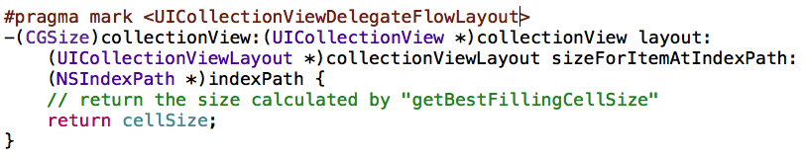
The implementation of this method is simple – we just return the cellSize which we have calculated previously:
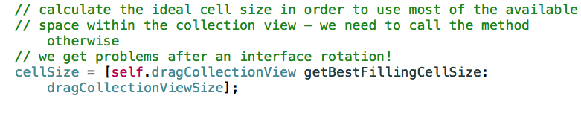
The class DragCollectionView provides a method named “getBestFillingCellSize” which takes as argument the size of the collection view. This method (taking into account of other parameters stored in the ConfigAPI singleton, as for example width-height ratio of a cell) calculates the ideal cell size so that the available space of the collection view is best filled.
The method “getBestFillingCellSize” must be called
- in the init method of the main view and
- in the notification method handling interface rotations.

The second UICollectionViewDelegateFlowLayout protocol method we use is “insetForSectionAtIndex”:
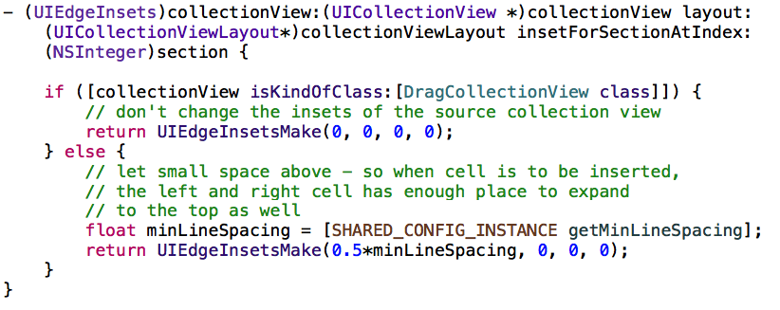
This method is not absolutely necessary, but it provides a small space above the cells of the target collection view: when a new cell is dragged between two cells, they get temporarily thinner, but expanded vertically – so they are not cut off at the top – see following screenshot:
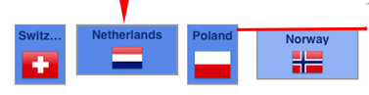
As you see, when for example “Netherlands” is dragged between Switzerland and Poland, both increase their height temporarily.

5.3.5 Undo Button
The implementation of the undo button is very simple: just create an UIButton as you normally do and bind it to the framework:
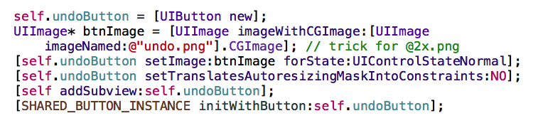
The framework will care about user interaction: as long as the target collection view contains elements, the undo button will stay active. Touching the undo button will bring back element per element to the source collection view. When the target collection view is empty, the button appears as deactivated (internally made by reducing the alpha value).

5.4 Custom draggable View
As already mentioned, this framework allows to define own views which can be dragged and dropped between two collection views. Thus you can do much more than only moving images or labels.
A custom draggable view may even contain further subviews. Lets study an example draggable view of the second sample project you got with this product:
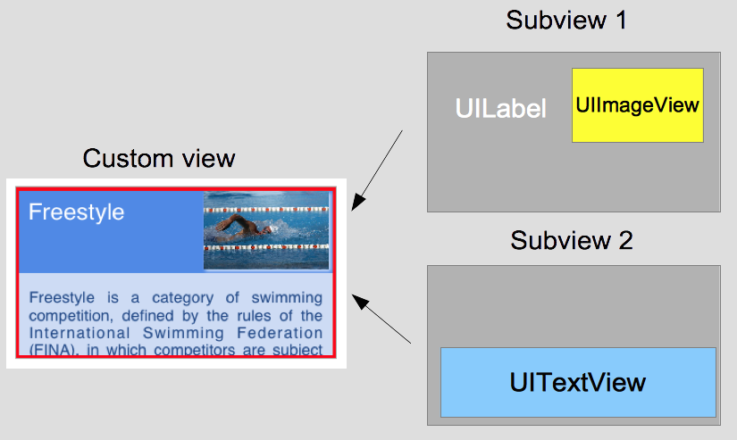
As you can see, the custom draggable view contains two subviews. Their sizes and positions are defined by layout constraints (auto layout). The first subview contains two further subviews, namely a label and an image view. The second subview contains a text view. Another strong point is that you can resize both the image, both the text view by touching them (toggling sizes). Such behaviour still exists after dragging and dropping such view into the target collection view.

Lets have a look at the public interface of such custom draggable view:
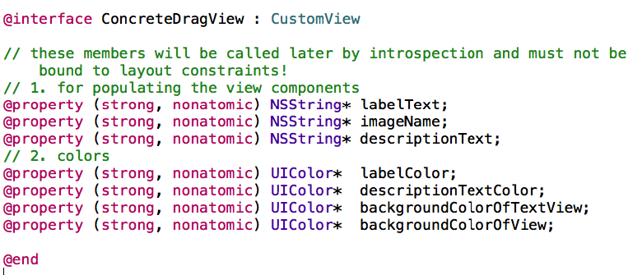
First of all, your custom draggable view should extend CustomView.
Probably, you expected that the view components themselves are declared in the public interface, something like this:
@property (strong, nonatomic) UIImageView* myImageView;
Don't do that!
The reason is that we need to make a copy of each view dropped into the target collection view. Such copy is made by introspection: the framework iterates over all public members (as for example labelText, imageName, descriptionText) and generates a copy of the custom view. As the view components themselves are bound to layout constraints, you would get an exception at runtime if you declared them in the public interface. Instead you should hide all components (with layout constraints) as private members!
Besides – as prerequisite for introspection, you should set the public member “concreteClassName” of CustomView in the init method of your custom draggable view:
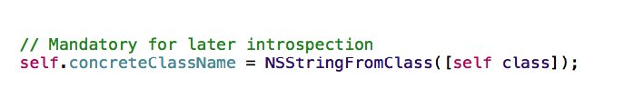
If you omit this line of code, the dropped cell will only appear as a dark grey box, missing all components you defined in your custom draggable view.

5.4.1 Creating Subview Components
As already mentioned, the subview components (UILabel, UIImageView, etc.) are marked as private members. You should instantiate them in the init method of your custom draggable view:
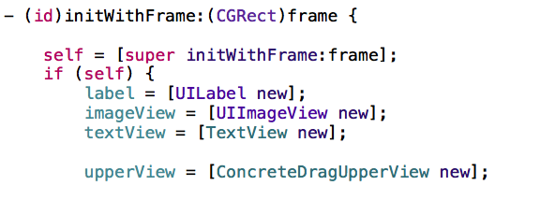
Of course you should add all those views to your custom view – something like:
[self addSubview:label];
[self addSubview:imageView];
…...
Besides, the layout constraints must be set!
In order to make the constraint upset work, you need to implement the following method into your custom draggable view:
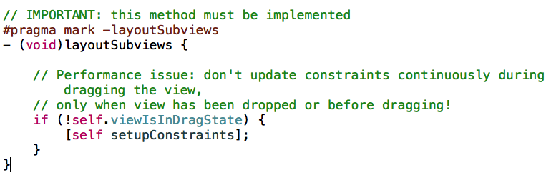
Don't call the method “setupConstraints” (or what else, dependent on your own method name) from the init method: if you do so, you'll get empty cells as at instantiation time, the size of your custom draggable view is still zero!
Please take into account that “layoutSubviews” is executed continuously while dragging your custom view. For the sake of performance, the framework (CustomView class) offers the attribute viewIsInDragState which is set to true as soon as a custom view is moving.

5.4.2 Populating Subview Components
In order to populate your subview components (for example an UILabel with formatted text or an UIImageView with a png file), you should generate getters and setters for your public (not private!) members:
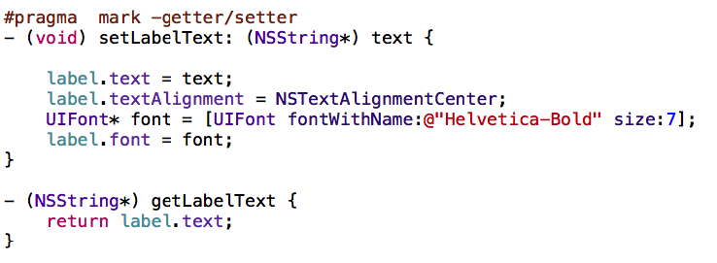
Just remember:
- labelText is a public member and used later for introspection:
@property (strong, nonatomic) NSString* labelText;
- label is an instance of UILabel and a private member of your custom view.
You populate label indirectly within the setter of the public labelText.
When you populate your image view, watch out for the image name which in the correspondent getter method can't be retrieved – UIImage has no method which returns the image name. Instead you should set the accessibility identifier of the image with your image name:

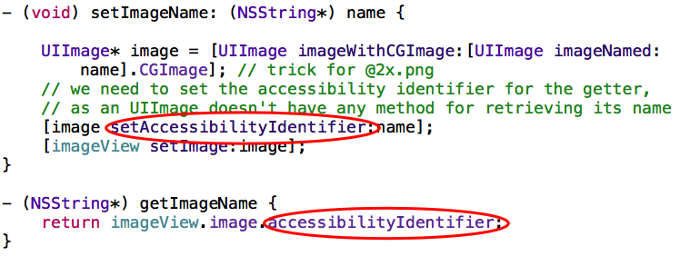
When you have programmed your custom draggable view, don't forget it to import it into the ViewController and populate the DragView (from the framework) with your custom view- something like:
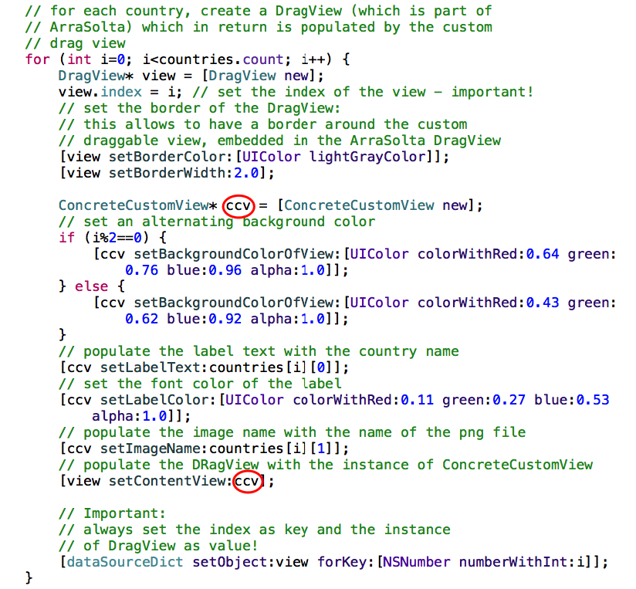

6 Architecture of the ArraSolta Framework
The following diagram provides an overview of the architecture and helps you to better understand the implementation details mentioned in the previous chapters:
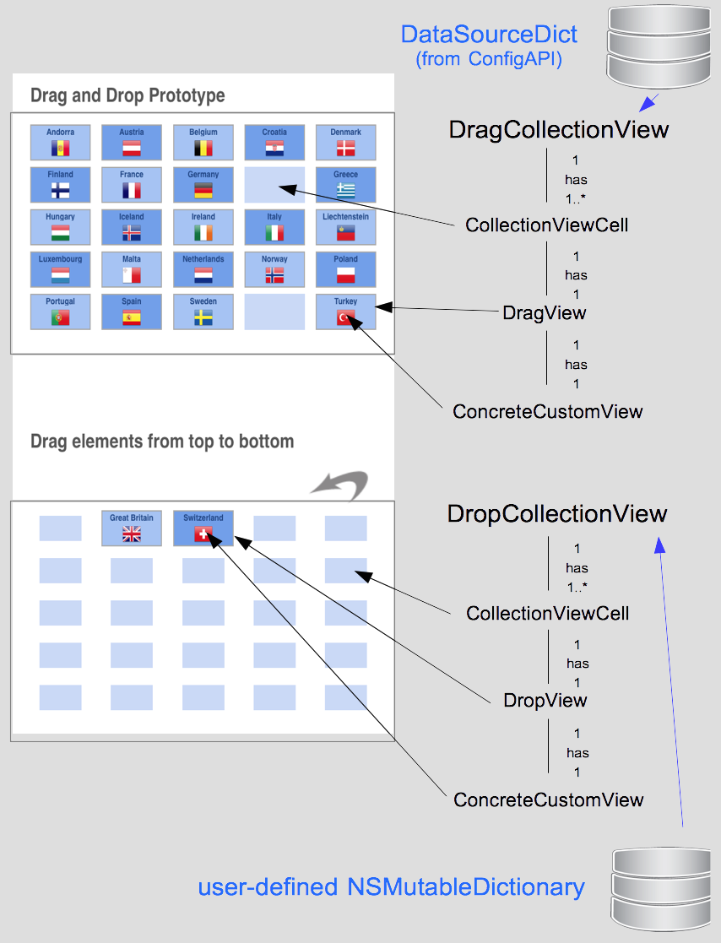

Each collection view is populated by a NSMutableDictionary (as data source). While DragCollectionView gets its data from a fixed mutable dictionary (see ConfigAPI – the singleton is populated earlier in the ViewController), DropCollectionView gets its data from a user-defined mutable dictionary, serving as a kind of stack: when the user removes an object from the target collection view, it will be removed from the user-defined dictionary as well.
Each collection view has at least one cell (CollectionViewCell). Each cell has a DragView (for DragCollectionView) or a DropView (for DropCollectionView). The DragView and DropView are part of this framework and are empty – only the background colour and the border width can be set.
A DragView or a DropView contains exactly one custom draggable view, which must extend the CustomView class. Here the user-defined elements (labels, images, etc.) come into play.
In order to get a better understanding about the difference between DragView und CustomView, let's have a look at the following screenshot:

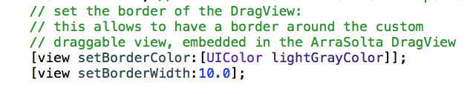
The border width of the DragView/DropView has been increased: the grey view is the DragView/DropView, the blue subview (with the flag and with the label on it) is the CustomView.

7 ArraSolta API

