Task 1: System Monitoring Setup
Install and configure htop or nmon to monitor CPU, memory, and processes, using df and du for disk usage tracking, and identifying resource-intensive processes. Proper logging of system metrics and clear documentation of the setup are essential.
- Updating of Ubuntu packages
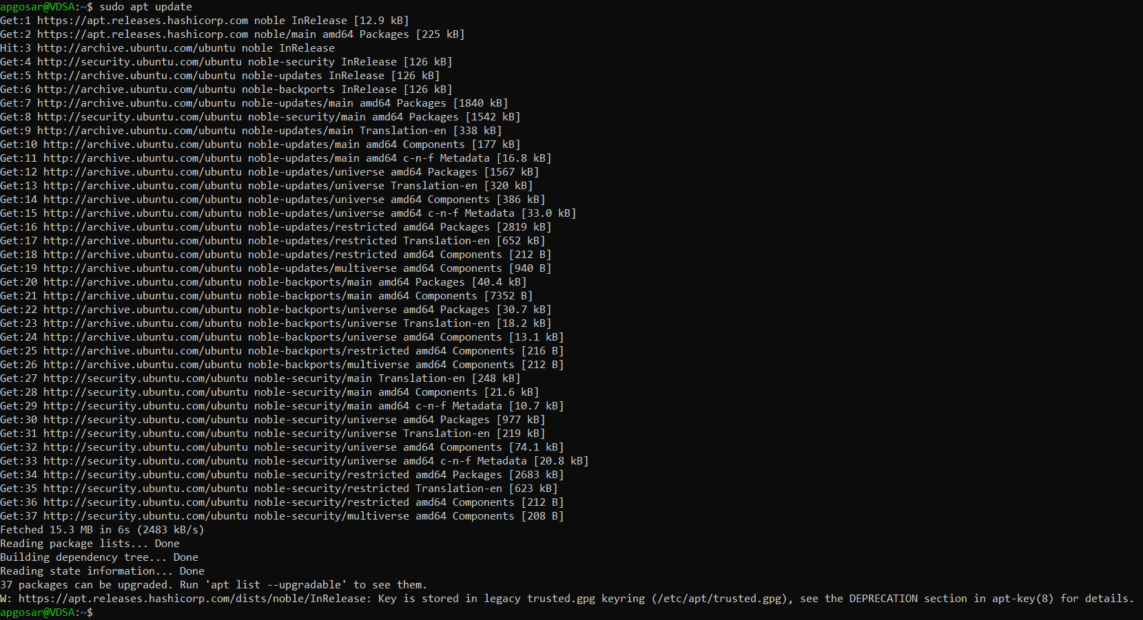
- Downloading and Installing htop and nmon
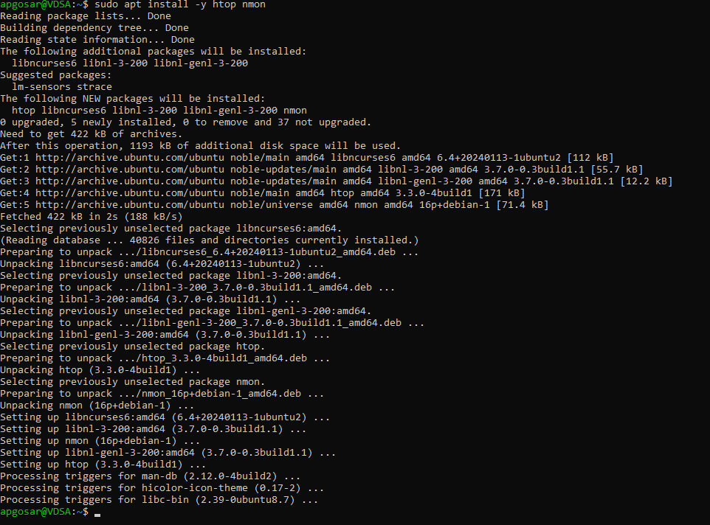
- Viewing top processes using htop
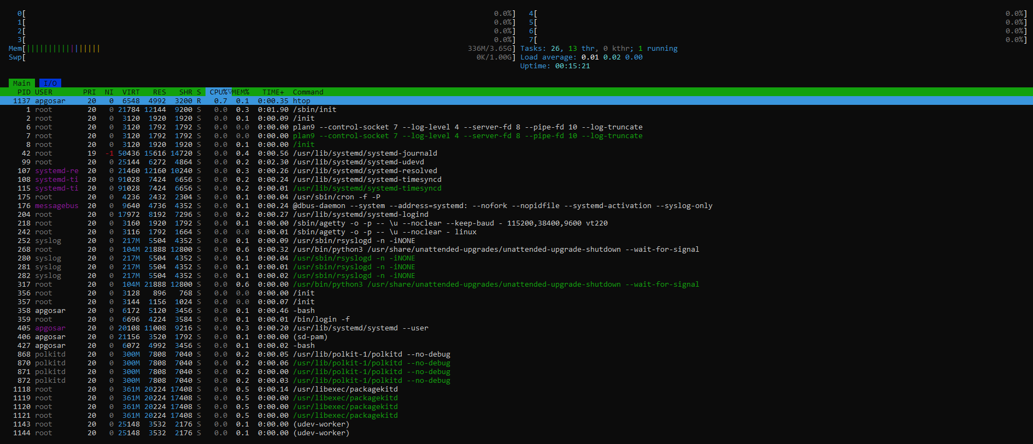

- Viewing nmon options
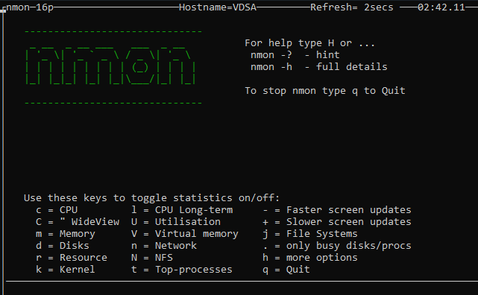
- Checking various metrics using nmon
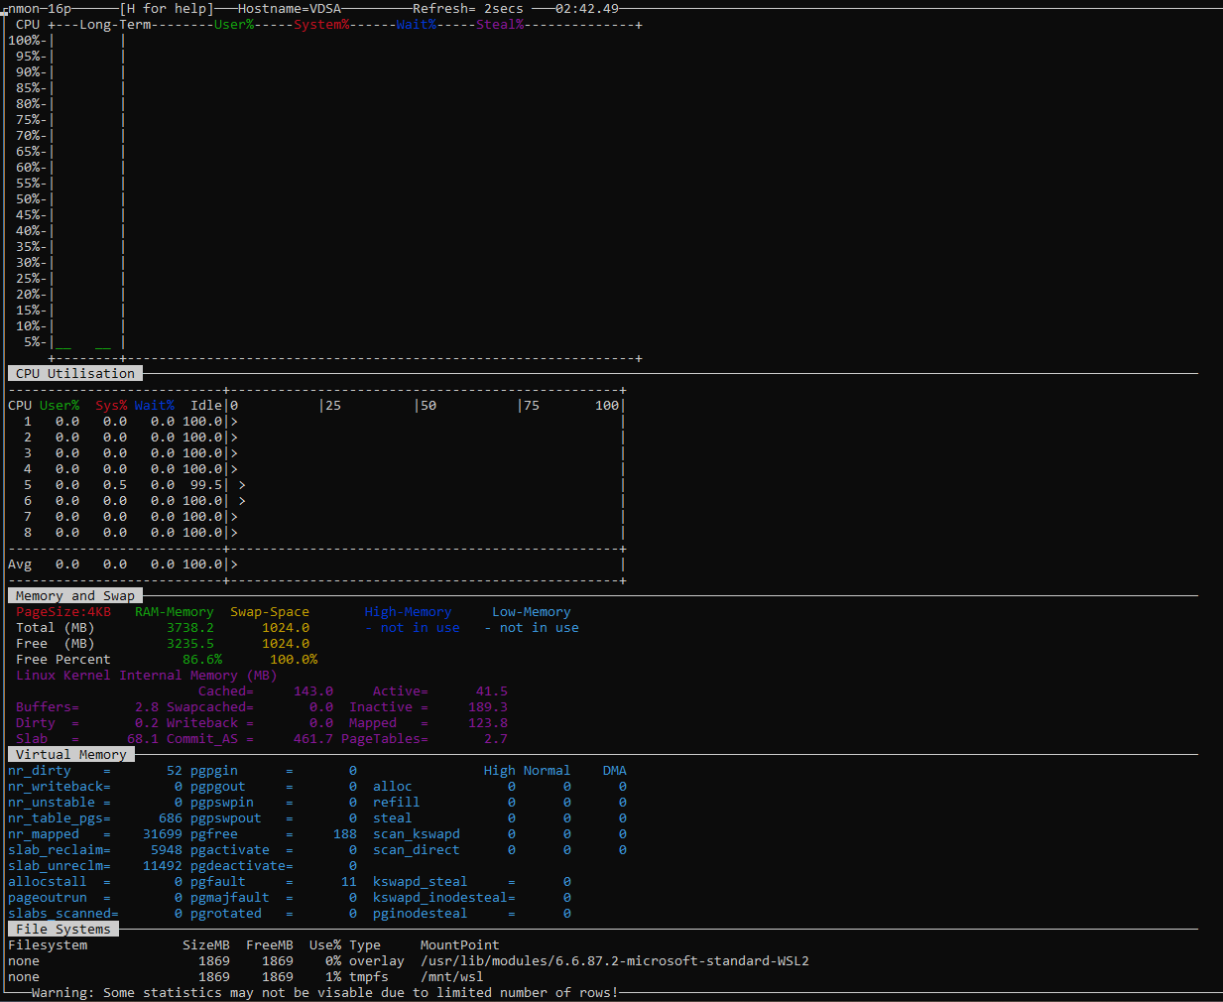
- Checking disk utilization
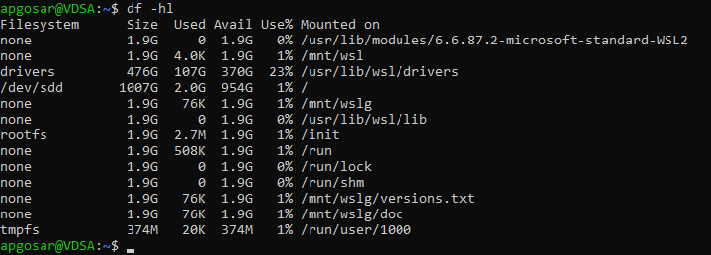
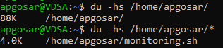
- Checking memory and CPU intensive processes
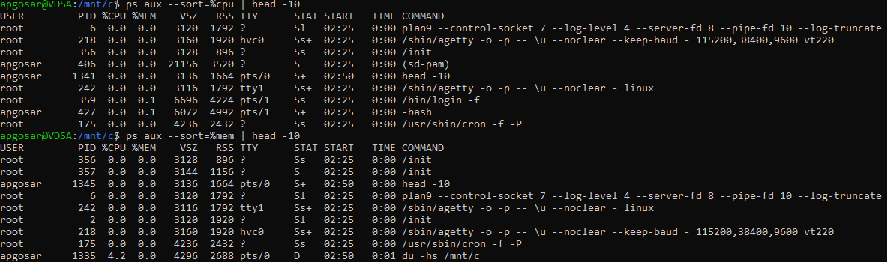
- Logging system metrics using bash sript
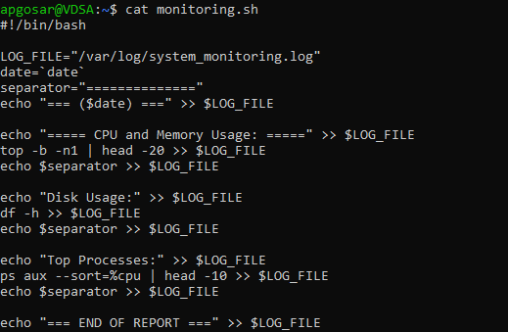
- Facing permission denied error since the created user does not have write permissions on /var/log
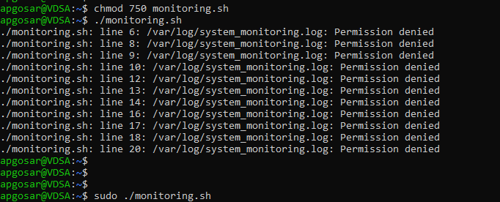
- Running script as root user (sudo) solves the problem. Here is the output:
