Task 3: Backup Configuration for Web Servers
Configure automated backups for Apache (/etc/httpd/, /var/www/html/) and Nginx (/etc/nginx/, /usr/share/nginx/html/), scheduling cron jobs to run every Tuesday at 12:00 AM, using the correct naming convention for backup files, and verifying backup integrity. Proper documentation and logs are necessary.
- Creating backup directory
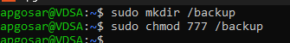
- Installing apache2 and nginx
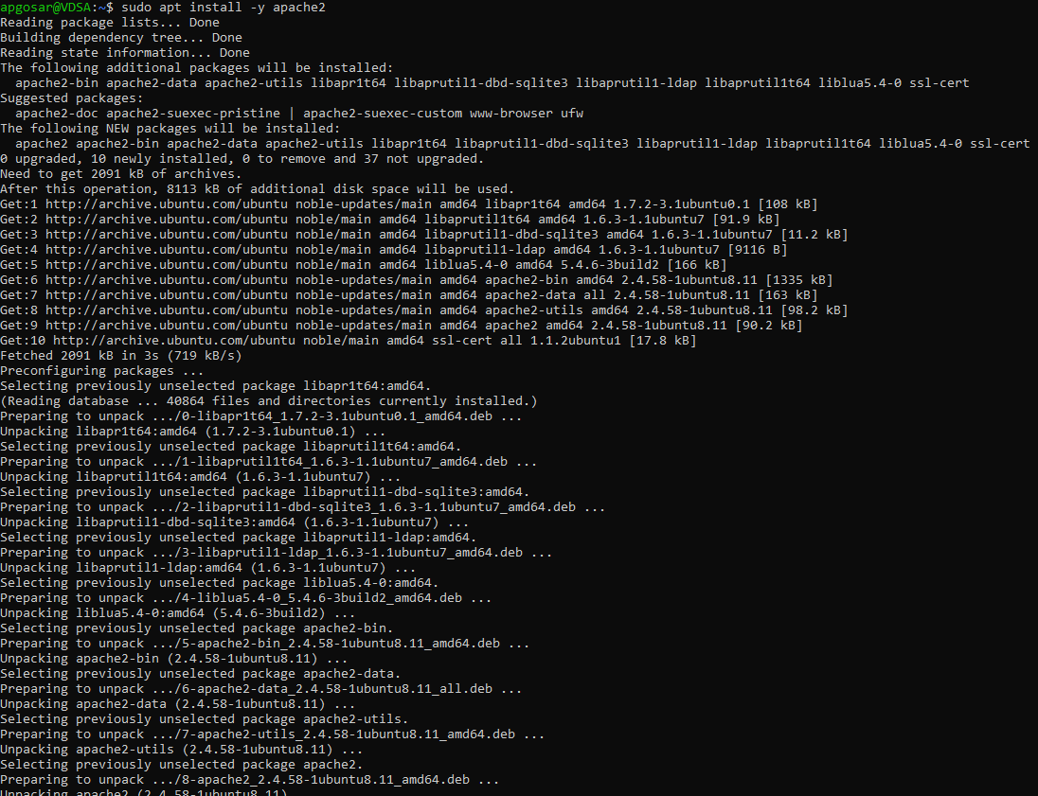
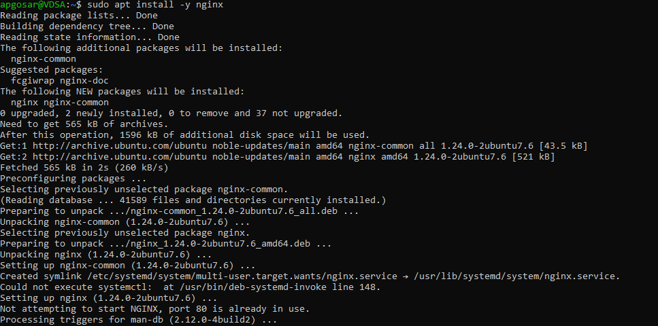
- Creating backup script for apache2
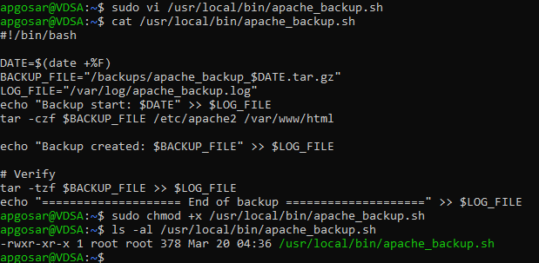

- Creating backup script for nginx
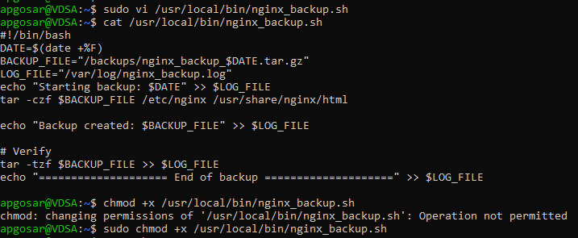
- Creating crontab entry
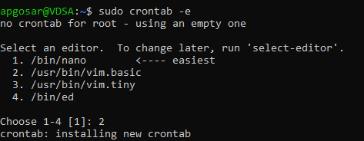

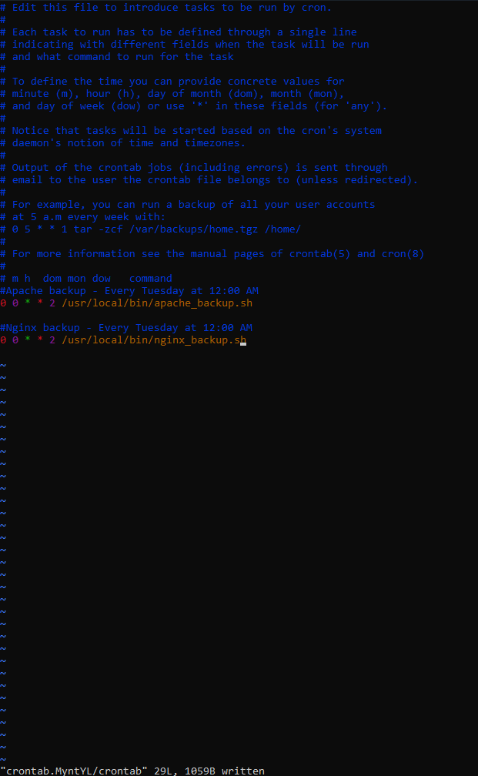
- Verifying crontab contents
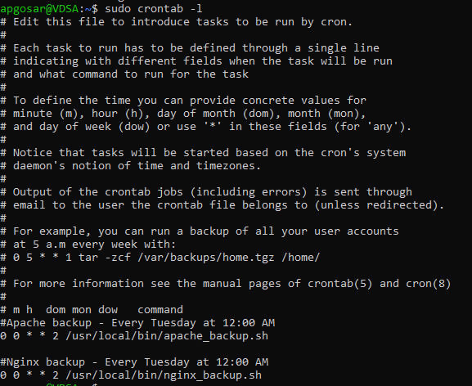
- Running the backup scripts manually to test and verifying backup getting created
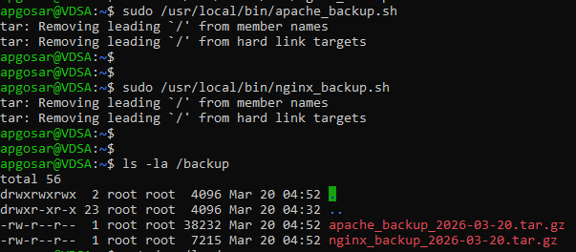

- Checking backup logs
