Task 2: User Management and Access Control
Evaluation includes creating user accounts for Sarah and Mike with secure passwords, setting up isolated directories with appropriate permissions, and enforcing a password policy with expiration and complexity. Detailed documentation of user management steps is required.
- Creating user accounts for Sarah and Mike with secure passwords
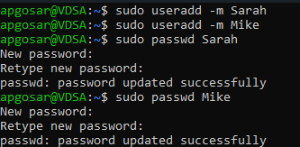
- Setting up isolated directories with appropriate permissions
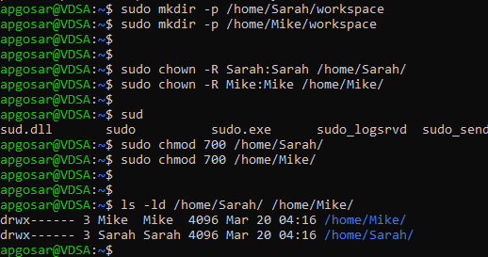

- Enforcing a password expiration policy
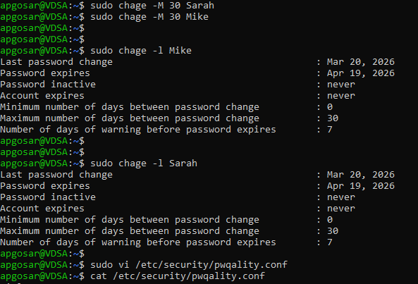
- Enforcing password complexity rules
