Analityk Jena sensors

Pedro J. Aphalo

2022-12-07

library(photobiologySensors)

## Loading required package: photobiology

## News at https://www.r4photobiology.info/

library(photobiologyLamps)  
library(photobiologyFilters)  
  
library(ggspectra)

## Loading required package: ggplot2

photon_as_default()

## Sensors on their own

Digitized from manual assuming that energy response is shown, and plotted as photon response normalized to the wavelength of maximum sensitivity.

autoplot(sensors.mspct[c("Analytik_Jena_UVX31", "Analytik_Jena_UVX36")],  
 facets = 1) +  
 ggtitle("Spectral photon response")

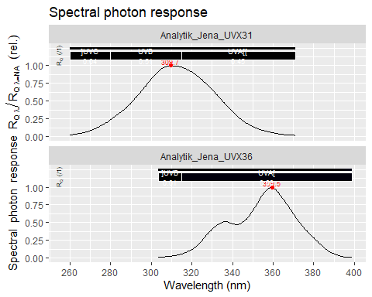

## Sensors in sunlight

By combining the sensor response with a photon irradiance spectrum of sunlight for mid morning in Helsinki, we see that UVX-36 might work with a sunlight especific calibration but the UVX-31 could be calibrated for an approximate measurement of UV-A but is useless for UV-B in sunlight.

autoplot(convolve_each(sensors.mspct[c("Analytik_Jena_UVX31", "Analytik_Jena_UVX36")], sun.spct),  
 facets = 1) +  
 ggtitle("Response to sunlight")

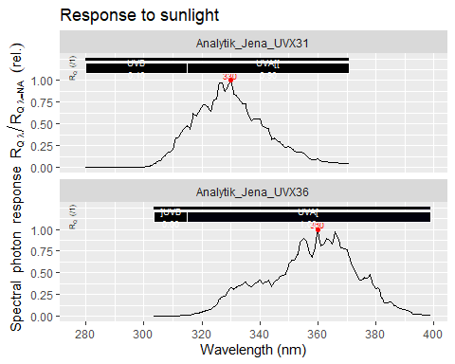

## Sensors with broad-band UV-B lamps

As we can expect that the spectrum of the radiation from the lamps varies little or not a all, the sensors could be calibrated to be useful. Anyway, they would require separate calibrations for bare lamps, lamps filtered with cellulose diacetate and lamps filtered with polyester.

autoplot(convolve_each(sensors.mspct[c("Analytik_Jena_UVX31", "Analytik_Jena_UVX36")],  
 lamps.mspct$Philips.FT.TL.40W.12.uv),  
 facets = 1) +  
 ggtitle("Response to Philips TL 12 (UV-B broad)")

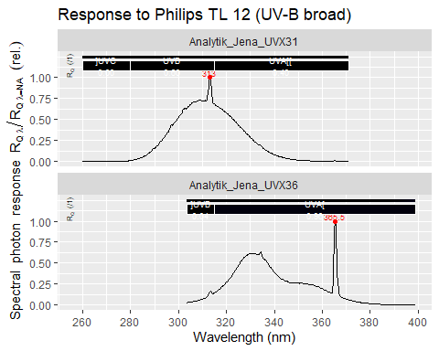

autoplot(convolve_each(sensors.mspct[c("Analytik_Jena_UVX31", "Analytik_Jena_UVX36")],  
 (lamps.mspct$Philips.FT.TL.40W.12.uv * filters.mspct$Courtaulds_CA_115um)),  
 facets = 1) +  
 ggtitle("Response to Philips TL 12 (UV-B broad) + acetate")

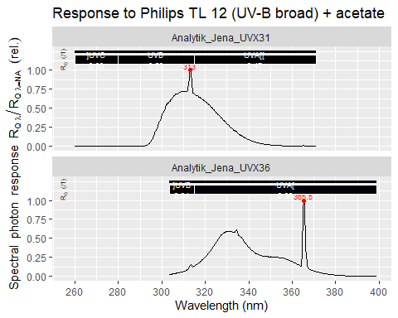

autoplot(convolve_each(sensors.mspct[c("Analytik_Jena_UVX31", "Analytik_Jena_UVX36")],  
 (lamps.mspct$Philips.FT.TL.40W.12.uv * polyester.spct)),  
 facets = 1) +  
 ggtitle("Response to Philips TL 12 (UV-B broad) + PET")

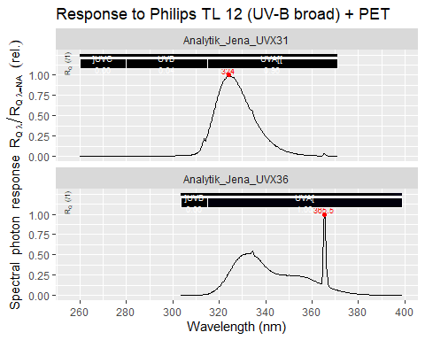

## Sensors with narrow-band UV-B lamps

As we can expect that the spectrum of the radiation from the lamps varies little or not a all, the sensors could be calibrated to be useful. Anyway, they would require separate calibrations for bare lamps and lamps filtered with polyester.

autoplot(convolve_each(sensors.mspct[c("Analytik_Jena_UVX31", "Analytik_Jena_UVX36")],  
 lamps.mspct$Philips.FT.TL.40W.01.uv),  
 facets = 1) +  
 ggtitle("Response to Philips TL 01 (UV-B narrow)")

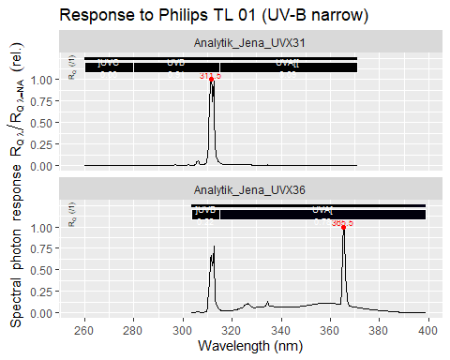

autoplot(convolve_each(sensors.mspct[c("Analytik_Jena_UVX31", "Analytik_Jena_UVX36")],  
 (lamps.mspct$Philips.FT.TL.40W.01.uv * filters.mspct$Courtaulds_CA_115um)),  
 facets = 1) +  
 ggtitle("Response to Philips TL 01 (UV-B narrow) + acetate")

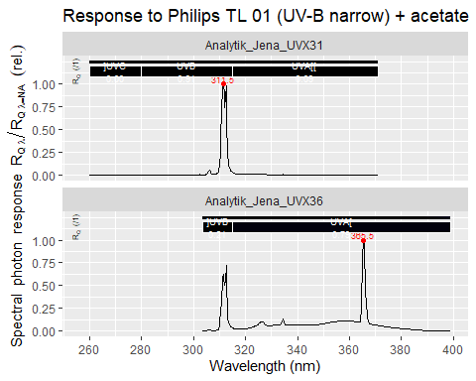

autoplot(convolve_each(sensors.mspct[c("Analytik_Jena_UVX31", "Analytik_Jena_UVX36")],  
 (lamps.mspct$Philips.FT.TL.40W.01.uv * polyester.spct)),  
 facets = 1) +  
 ggtitle("Response to Philips TL 01 (UV-B narrow) + PET")

