Strategic Decision Analysis for Aalto University's 10-Year Plan
Scenario-Based Recommendations for Long-Term Resilience and Excellence

Course: ISM-E1006 - Decision Analytics for Consulting
Group: F
Authors: Samuel Viitanen, Bui Minh Anh Pham, Zhanghu Zhao, Duy Hoang Khanh

Spring 2025
Date: 10.04.2025

1. Executive summary
This project aims to help Aalto University create a clear and practical 10-year strategic plan to handle future uncertainties and complexities. Working closely with Aalto's leadership, including the Vice Presidents, Deans, and Directors, the team identified strategic goals and made concrete recommendations for different future scenarios.
Three possible future scenarios were analyzed: Unlimited Growth Drivers (focusing on market-driven education and digital learning), Common Challenge Solvers (emphasizing collaborative approaches to solving societal problems), and Bastions of Knowledge (prioritizing traditional academic values and independence). Each scenario was assigned likelihood based on Aalto University's management team’s judgment.
The main goals for Aalto University were set as Academic Excellence & Integrity, Financial Sustainability & Autonomy, Global Relevance & Leadership, Societal Impact & Public Trust, and Innovation in Education & Research. Specific measurable indicators were defined for each goal to clearly assess progress.
Using scenario analysis and structured decision-making tools, the team evaluated potential actions. Here are the key recommendations:
- Strengthen partnerships with industry for applied research.
- Lead interdisciplinary research teams on global challenges.
- Improve interdisciplinary collaboration between faculties.
- Host international academic events to build Aalto's global presence.
- Increase open-access publication of research findings.
- Strengthen internal academic governance to maintain integrity.
- Broaden funding sources through corporate investment.
- Establish clear ethical guidelines to protect academic independence.
A sensitivity analysis showed these recommendations remain effective under various assumptions, which indicate reliability and broad applicability.
Implementing these actions will help Aalto University maintain its relevance and achieve long-term stability and excellence, no matter what the future may bring.

2. Introduction
Nowadays, universities face many uncertainties and challenges. Rapid technological advances, global crises, changes in funding, and shifting political priorities have made the environment increasingly complex. Aalto University, like other institutions, must navigate these challenges carefully and make strategic decisions to secure its future.
This project supports Aalto University's management team in preparing their 10-year strategic plan. We worked directly with members of the management team, including the Vice President for Strategy, Vice President for Education, Vice President for Research, Chief Financial Officer (CFO), Director of Strategic Planning, Director of Communications, and the Deans of the different Aalto's schools. The goal was to examine different strategic options and understand how well they support Aalto’s long-term goals under different future scenarios. These goals include academic excellence, financial stability, global relevance, societal impact, and innovation.
To manage complexity and uncertainty, we used decision analysis methods. These tools helped structure our assessment clearly and systematically. By doing so, we provided practical recommendations intended to stay relevant, regardless of how the future unfolds.

3. Scenarios
To deal with uncertainties, we created three potential scenarios for the year 2035. These were developed based on research, workshops, and discussions with Aalto University management. Each scenario describes a different way the future could develop, based on key factors like education policy, market conditions, technological change, and the role of universities in society.
Scenario 1: Unlimited Growth Drivers
In this scenario, education is increasingly driven by market needs and digital technology. Learning becomes flexible and is often delivered in short, practical modules rather than traditional degrees. Industry partnerships become critical, and universities must compete in a crowded, fast-paced education marketplace. Successful institutions in this scenario will be adaptable, market-oriented, and technologically advanced.
Scenario 2: Common Challenge Solvers
In this future, universities collaborate closely with governments and international organizations, particularly the European Union, to tackle global challenges like climate change, health crises, and ethical issues around technology. Funding depends heavily on how well universities contribute to these societal missions. Interdisciplinary research and education that promotes teamwork becomes highly valuable.
Scenario 3: Bastions of Knowledge
This scenario pictures universities focusing strongly on academic traditions and independence. Priorities include scientific integrity, deep research, and critical thinking, with less emphasis on commercialization. Public funding remains stable, allowing universities to remain somewhat separate from market pressures and political influences. Institutions prioritize rigorous scholarships and long-term research excel in this scenario.
Scenario Probabilities
To better understand these scenarios, we estimated their likelihood based on current trends and opinions of the Aalto management team:
- Unlimited Growth Drivers: 40%
- Common Challenge Solvers: 35%
- Bastions of Knowledge: 25%
We used these probabilities to weigh our strategic analyses. To ensure accuracy, we discussed potential biases that might influence our assessments, such as placing too much importance on recent events or favoring scenarios we personally prefer. Group discussions and structured approaches helped us minimize these biases.

4. Identification of objectives and attributes
Defining the Fundamental Objectives
First, we talked about what really matters to Aalto University in any future scenario. These “big goals” are the things we want the university to achieve no matter what happens. We decided on five main areas:
- Academic Excellence & Integrity: Keeping high academic standards.
- Financial Sustainability & Autonomy: Being financially strong and independent.
- Global Relevance & Leadership: Remaining as a respected international institution.
- Societal Impact & Public Trust: Helping solve societal challenges and maintaining public trust.
- Innovation in Education & Research: Adapting to new trends in learning and research
Breaking down the Fundamental Objectives to Instrumental Objectives:
Next, we broke these big goals into smaller, actionable steps that will help us achieve them. These steps are our “instrumental objectives”. For example, under Academic Excellence & Integrity, we came up with:

- Ensure Graduates Are Workforce-Ready: Making sure students are well-prepared for their careers.
- Preserve Research-Driven Education: Keeping a strong focus on research.
- Enhance Depth and Quality of Learning: Making sure the learning experience is thorough and meaningful.

We followed a similar process for the other fundamental objectives.
Choosing Attributes:
Finally, for each of these smaller goals, we identified specific, measurable attributes. These are indicators that let us know if we’re making progress. For example:

- Graduate Employability Rate tells us if our graduates are ready for the workforce.
- Research-to-Teaching Ratio shows how well we balance research with teaching.
- Student Satisfaction with Depth of Learning helps us see if the quality of education is high.

Each attribute was chosen because it can be clearly measured and directly linked to our fundamental objectives. Table 1 below illustrates the fundamental objectives, as well as their respective means objectives, and the attributes used to measure them.
Fundamental Objectives | Means Objective | Attributes
Academic Excellence & Integrity | Ensure Graduates Are Workforce-Ready | Graduate employability rate
 | Preserve Research-Driven Education | Research-to-teaching ratio
 | Enhance Depth and Quality of Learning | Student satisfaction with depth of learning
Financial Sustainability & Autonomy | Maintain a Balanced and Diverse Funding Model | Revenue diversification index
 | Ensure Financial Stability Over Time | Long-term funding growth rate
 | Safeguard Academic Independence | Academic independence index
Global Relevance & Leadership | Increase International Recognition | Global university rankings and reputation score
 | Expand Cross-Border Collaborations | Number of international partnerships
 | Enhance Student and Faculty Mobility | Faculty and student mobility rates
Societal Impact & Public Trust | Enhance Public Trust in Higher Education | Public trust in universities (survey-based)
 | Solve Grand Societal Challenges | Number of research projects addressing global challenges
 | Improve Communication & Public Engagement | Engagement in science communication
Innovation in Education & Research | Integrate Digital & Hybrid Learning Approaches | Adoption rate of new learning technologies
 | Redesign Curriculum for Future Skill Demands | Percentage of interdisciplinary programs
 | Strengthen Academia-Industry Collaboration | Industry collaboration rate in research and education
Table 1. Illustration of the fundamental objectives, their respective means objectives and the attributes used for measuring them
Our focus on fundamental objectives
The means objectives and their measurable attributes give us insight into the factors influencing the fundamental objectives. However, for the rest of our analysis, we will only focus on the fundamental objectives. This makes the analysis simpler and avoids trying to predict precise outcomes for every action. Fundamental objectives give us a high-level overview that still supports sound strategic planning. Moreover, this approach follows value-focused decision-making, where the main goals and values are clearly identified first (Keeney, 1994). Instead of just picking from existing choices, decision-makers systematically generate and evaluate options based on clearly articulated fundamental goals. This helps make sure that the final decisions align well with what truly matters to the organization (Keeney, 1994).

5. Generation and assessment of strategic action proposals
With the fundamental objectives in mind, we conducted a TOWS analysis with the Aalto management team for each scenario, where we discussed the university’s strengths and weaknesses, as well as the opportunities and threats they might face in these scenarios. The TOWS method is a strategic planning tool used to analyze a company's internal and external environment and develop actionable strategies (Weihrich, 1982). It is an advanced version of the SWOT analysis, taking the same four elements - Strengths, Weaknesses, Opportunities, and Threats - but goes further by systematically linking them to generate strategic options (Weihrich, 1982). The main questions driving our conversations with the team were the following:
- How can the university use its strengths to take advantage of opportunities?
- How can it use its strengths to prevent potential threats?
- How can it use opportunities to minimize its weaknesses?
- How can it mitigate potential dangers where weaknesses and threats intersect?
From the team’s answers, we realized that there were some overlapping or similar action proposals. Therefore, we performed some necessary cross-scenario proposal consolidation. The final list of action proposals consists of 14 proposals. Then we asked the team to evaluate each action proposal, within each potential future scenario, based on the fundamental objectives. The team used a simple qualitative scale of High Impact (H), Medium Impact (M), or Low Impact (L) for the evaluation process. For the sake of simplicity, this scale was accepted for generating ideas. The team also provided reasoning behind evaluating each action proposal based on the scale. Figure 1 shows an example of how the team evaluated the action proposal Develop custom learning platforms and expand lifelong learning programs in the UGD scenario with the reasoning behind it.
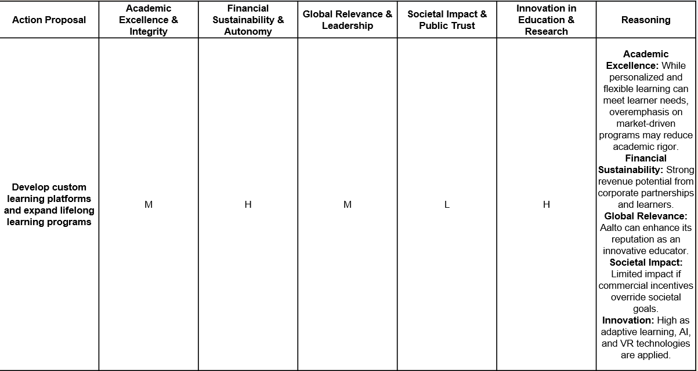
Figure 1. Example of the action proposal evaluating results in the scenario for the strategic action proposal Develop custom learning platforms and expand lifelong learning programs in the Unlimited Growth Drivers scenario
As a result of the generation process, the team has provided some key action proposals that are impactful across different scenarios. Develop Custom Learning Platforms and Expand Lifelong Learning is relevant in both Unlimited Growth Drivers and Common Challenge Solvers scenarios to meet industry needs and provide flexible learning opportunities. Strengthen Academic Safeguards and Governance provides robust internal policies to ensure research integrity, particularly when external partnerships grow. Positioning Aalto as an Ethical Leader is crucial in scenarios where partnerships with industry or the EU may risk academic independence. Leverage Diverse Funding Streams can ensure financial sustainability across all scenarios.

# | Action Proposal | Most favorable scenario | Description
1 | Develop custom learning platforms and expand lifelong learning programs | Unlimited Growth Drivers | Design and deploy proprietary learning platforms to serve non-traditional learners and corporate needs.
2 | Establish academic safeguards and strengthen faculty governance | Unlimited Growth Drivers | Ensure autonomy and academic rigor in research and education despite increasing commercialization.
3 | Promote applied research leadership through corporate partnerships | Unlimited Growth Drivers | Position Aalto as a leader in applied innovation by increasing research collaborations with industry.
4 | Leverage corporate investment and diversify revenue streams | Unlimited Growth Drivers | Expand financial base via private partnerships, international tuition, and philanthropic funding.
5 | Create ethical guidelines and implement academic oversight | Unlimited Growth Drivers | Uphold academic integrity with clear codes of conduct and oversight mechanisms for research.
6 | Lead large-scale research consortia and interdisciplinary initiatives | Common Challenge Solvers | Coordinate cross-border, interdisciplinary projects targeting societal issues.
7 | Influence EU policy and funding priorities | Common Challenge Solvers | Proactively shape regional science and innovation policy to align with Aalto’s strategic strengths.
8 | Enhance interdisciplinary collaboration in research and education | Common Challenge Solvers | Build structures to promote cross-faculty teaching and research to address complex challenges.
9 | Simplify grant management processes and improve research administration | Common Challenge Solvers | Reduce administrative burden and improve efficiency of externally funded research.
10 | Develop contingency funds to protect against funding fluctuations | Common Challenge Solvers | Create buffers for uncertain external funding cycles to maintain research continuity.
11 | Lead public science communication and expand outreach | Bastions of Knowledge | Increase media presence and outreach to enhance public understanding of science.
12 | Host global academic events and establish Aalto as a knowledge hub | Bastions of Knowledge | Attract scholars and thought leaders by hosting international conferences and symposiums.
13 | Expand open-access publishing and research dissemination | Bastions of Knowledge | Ensure global access to Aalto’s research through open-access policies and platforms.
14 | Strengthen public engagement through dialogues and outreach programs | Bastions of Knowledge | Build trust and relevance by involving the public in academic events and knowledge-sharing forums.
Table 2. The final 14 strategic action proposals, their descriptions, and their most favorable scenarios
From the team’s evaluation process, a few key insights stand out for the fundamental objectives:
- Academic Excellence & Integrity is consistently supported by actions that safeguard academic freedom and enhance research dissemination.
- Financial Sustainability & Autonomy benefits most from corporate partnerships in Unlimited Growth Drivers and EU funding strategies in Common Challenge Solvers.
- Global Relevance & Leadership is significantly boosted by cross-border partnerships and hosting international events.
- Societal Impact & Public Trust improves through active science communication and transparent academic practices.
- Innovation in Education & Research is most supported in scenarios that emphasize digital learning and interdisciplinary programs.

6. Elicitation of utility functions
In order to effectively evaluate the different action proposals in our model, we needed a way to assess the performance of a strategic action on each fundamental objective. Due to the large uncertainties associated with assessing future performances, we decided to come up with a simple, four-point assessment system, where performance was evaluated on the scale [Poor, Fair, Good, Excellent]. As we decided to use an additive multiattribute utility function to model the problem, we needed to verify that the different attributes (fundamental objectives in this case) were mutually preferentially independent (MPI) (Keeney, 1977) and additively independent (AI) (Abbas, 2018).
6.1. Verification of independence assumptions
Mutual Preferential Independence
To verify mutual preferential independence, we took each subset of two attributes and fixed the other three attributes at arbitrary levels. Then we asked the Aalto management team to choose between two choices that constituted a trade-off between the chosen two attributes. After they had made their choice, we changed the values of the three remaining attributes, while keeping the trade-off between the two chosen attributes the same. If the team still chose the same trade-off between the chosen two attributes, MPI was proven, as the trade-off preference did not change due to the change in the other three attributes. This was then done for each subset of attributes.
Example dialogue to verify MPI:
“Consultant:
Let’s look at a trade-off between Academic Excellence and Financial Sustainability.
In this first situation, assume that:
- Global Relevance & Leadership is “Fair”
- Societal Impact & Public Trust is “Poor”
- Innovation in Education & Research is “Good”
Now consider the following options:
- Option A: Academic Excellence is “Good”, Financial Sustainability is “Fair”
- Option B: Academic Excellence is “Fair”, Financial Sustainability is “Good”
Which would you prefer?
Decision Maker:
I would choose Option A. I lean slightly more toward academic strength in this case.
Consultant:
Now, let’s try a second scenario. This time, the other objectives are at different fixed levels:
- Global Relevance is “Excellent”
- Societal Impact is “Good”
- Innovation is “Fair”
Same two options as before:
- Option A: Academic Excellence is “Good”, Financial Sustainability is “Fair”
- Option B: Academic Excellence is “Fair”, Financial Sustainability is “Good”
Which one would you go for?
Decision Maker:
Still Option A. My judgment between the academic and financial side isn’t influenced by those changes.”
Additive Independence
To verify additive independence, we once again chose a subset of two attributes to be tested. We then constructed two lotteries with two possible outcomes, both with the probability 0.5. In both lotteries, one outcome has the best possible values for the two chosen attributes, while the other one has the worst possible values for the chosen attributes. The difference between the two lotteries lies in the remaining three attributes. In the other one there is a 0.5 probability of getting the best possible values and the worst possible values for all attributes (Lottery I in Figure 2), while the other lottery offers a more of a “mixed bag” for the attribute values (Lottery II in Figure 2). The AI is then verified by confirming that the decision-maker is indifferent between the two lotteries.

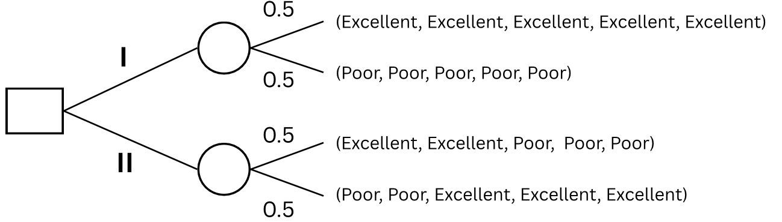
Figure 2. Example of the different lotteries used for verifying Additive Independence (AI)
6.2. Elicitation of utility functions
After successfully confirming the necessary independence assumptions, we elicited the utility functions for each of the fundamental objectives. We did this by giving the highest possible value, Excellent, a utility of 1, and the worst possible value, Poor, a utility of 0. We then elicited the utility for the value Fair by asking the Aalto management team to come up with a value p at which they would be indifferent between the following two lotteries shown in Figure 3:
- A degenerate lottery I with the certain outcome Fair
- A simple lottery II with the outcome Excellent with probability p, and the outcome Poor with probability 1-p
The utility for the value Good was elicited through the same method, but the outcome of the degenerate lottery was changed from Fair to Good, and the outcome Poor in the simple lottery was changed to Fair (see Figure 4).

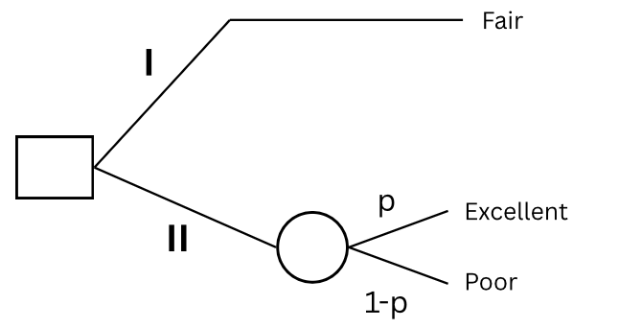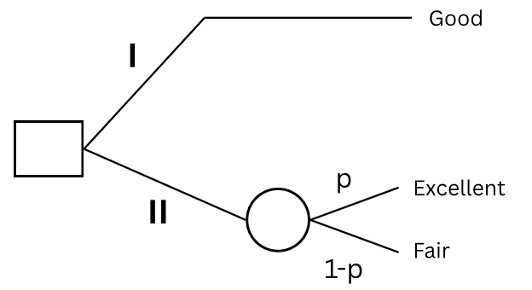
Figure 3. Lottery used for eliciting u(Fair) Figure 4. Lottery used for eliciting u(Good)
The given values for p were then used to calculate the utilities for the values Fair and Good using the following formulas:
u(Fair) = (1-p) × u(Poor) + p × u(Excellent) = (1-p) × 0 + p × 1
u(Good) = (1-p) × u(Fair) + p × u(Excellent) = (1-p) × u(Fair) + p × 1
This was then done for each of the fundamental objectives, to get the objective-specific utility functions. For example, for the fundamental objective Academic Excellence & Integrity the given p was 0.3 in the first lottery, and 0.65 in the second one. Therefore, the utilities for Fair and Good are:
u(Fair) = (1-0.3) × u(Poor) + 0.3 × u(Excellent) = (1-0.3) × 0 + 0.3 × 1 = 0.3
u(Good) = (1-0.65) × u(Fair) + 0.65 × u(Excellent) = (1-0.65) × 0.3 + 0.65 × 1 = 0.755
We repeated this process for each of the fundamental objectives and received the attribute-specific utilities shown in Table 3. These utility functions are also illustrated in Figures 4-8.
Fundamental Objective | Poor | Fair | Good | Excellent
Academic Excellence & Integrity | 0 | 0.3 | 0.755 | 1
Financial Sustainability & Autonomy | 0 | 0.4 | 0.82 | 1
Global Relevance & Leadership | 0 | 0.35 | 0.7725 | 1
Societal Impact & Public Trust | 0 | 0.45 | 0.8375 | 1
Innovation in Education & Research | 0 | 0.38 | 0.8584 | 1
Table 3. Normalized utilities for each fundamental objective at each performance level
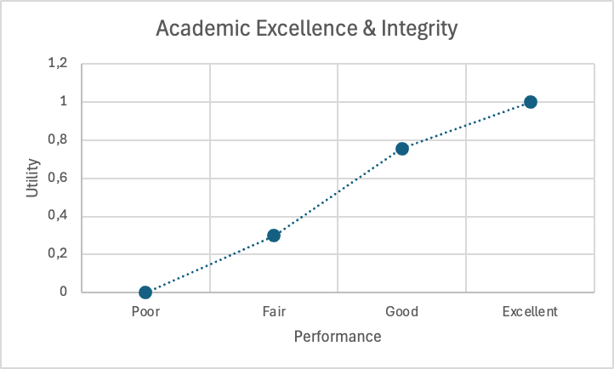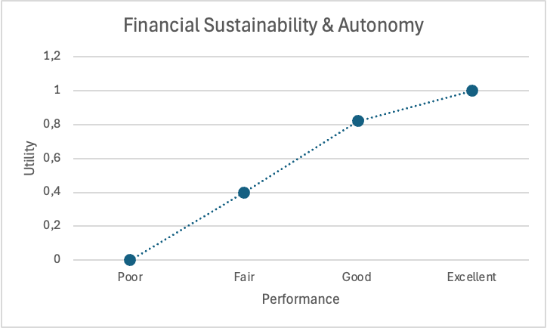
Figure 4. Illustrated utility function for Academic Figure 5. Illustrated utility function for Financial Excellence & Integrity Sustainability & Autonomy
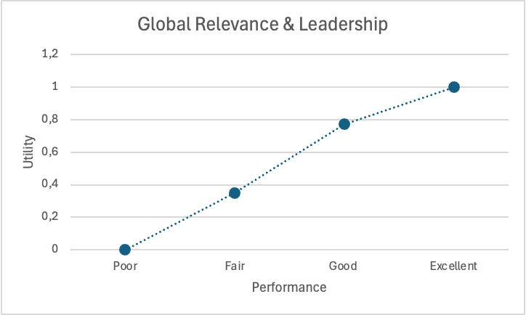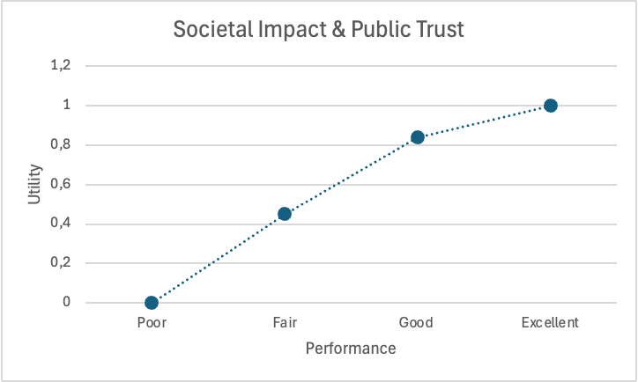
Figure 6. Illustrated utility function for Global Figure 7. Illustrated utility function for Societal Relevance & Leadership Impact & Public Trust
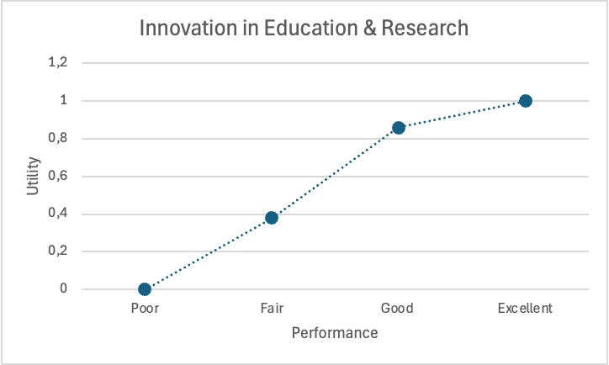
Figure 8. Illustrated utility function for Innovation in Education & Research

7. Elicitation of attribute weights
To elicit the weights of each attribute, we decided that the method should be SWING weighting. SWING weighting begins by imagining that all fundamental objectives are currently at their worst level (utility = 0) (Fischer, 1995). The decision-makers is then asked: “If we could improve only one of the objectives from its worst to its best (from utility 0 → 1), which one would have the greatest impact on the overall goal?” We can rank the improvements in order of importance and assign a score between 0 and 100 to each, based on how valuable that swing from 0 → 1 is relative to the most valuable one (which is given 100 points). These scores are then normalized to sum to 1. The SWING method is one of the most widely used methods for eliciting attribute weights (Fischer, 1995) and we also find it intuitive and easy to understand.
An example question would be: “Imagine that all five fundamental objectives are currently performing at the lowest possible level (i.e., ‘poor’ utility = 0). You are given the opportunity to bring just one of them up to the ‘excellent’ level (utility = 1). Which one would you choose? Now, suppose you could also improve a second one. Which would you pick next? And how valuable is that improvement compared to the first one?” Table 4 shows the SWING scores given by the Aalto management team, as well as the weights after normalization.

Fundamental Objective | SWING Score | Normalized Weight
Academic Excellence & Integrity | 100 | 100/248 ≈ 0.402
Financial Sustainability & Autonomy | 34 | 34/248 ≈ 0.138
Global Relevance & Leadership | 31 | 31/248 ≈ 0.126
Societal Impact & Public Trust | 40 | 40/248 ≈ 0.161
Innovation in Education & Research | 43 | 43/248 ≈ 0.173
Total | 248 | 1
Table 4. SWING scores and attribute weights given by the SWING weighting

8. Mathematical modelling
To begin our modelling, we asked the management team to assess the different strategic actions’ scenario-specific, attribute-specific utilities on the scale [Poor, Fair, Good, Excellent]. As a result, Figure 9 displays the utility for each action proposal on each attribute in each scenario. Based on attribute weights elicited in Section 7, we can obtain the actions’ scenario-specific utilities. Then with the scenario probabilities given in Section 3, we can assign one expected utility for each action proposal, which are shown in Figure 10. Our goal is to maximize the overall expected utility based on the decision variables and the action-specific expected utilities. The formula for this can be written as:
$$Maxmize \sum_{i=1 }^{14 }{u_{i}}x_{i}$$
Where $u_{i}$is the expected utility for each action proposal and $x_{i}$ is the decision variable indicating whether or not the action proposal is selected.
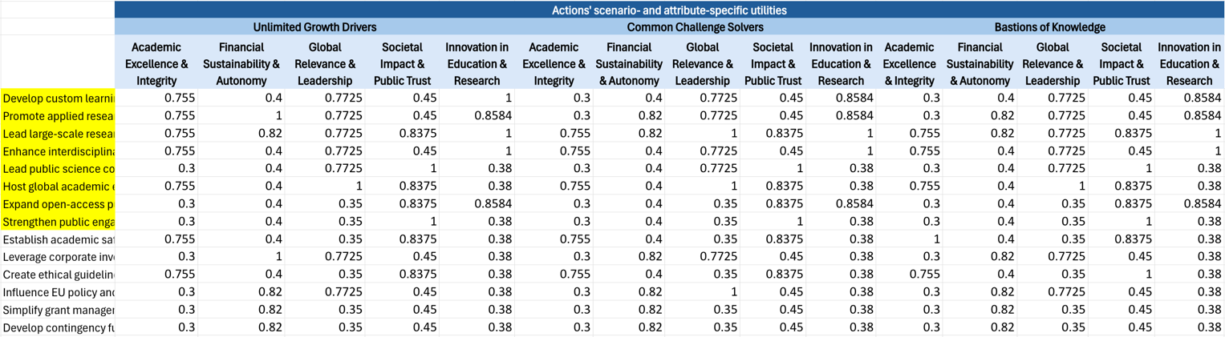Figure 9. Strategic actions’ scenario- and attribute-specific utilities
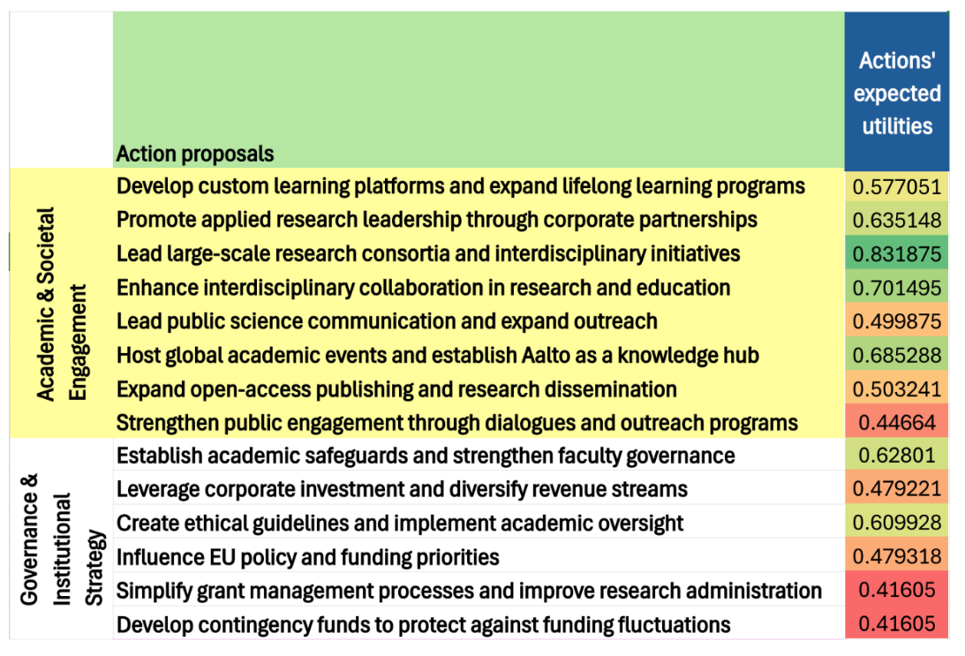
Figure 10. Expected utilities for the strategic action proposals

8.1. Model constraints
We then applied three types of constraints in the portfolio model - resource constraints, logical constraints, and balance constraints.
For resource constraints, we limit the number of selected actions to a maximum of n = 8. By capping the number of actions, we can make sure that the final decision recommendations are manageable and feasible to execute.
When it comes to logical constraints, we take account of relationships between specific actions. Some of the action proposals are independent, while others are incompatible due to conflicting goals or ways of implementation. Firstly, 'Develop contingency funds to protect against funding fluctuations' and 'Leverage corporate investment and diversify revenue streams' represent opposing financial strategies — the former emphasizes building internal reserves, while the latter focuses on external private funding. Therefore, these two actions cannot be selected together. Secondly, 'Establish academic safeguards and strengthen faculty governance' and 'Create ethical guidelines and implement academic oversight' are considered interdependent and should therefore be implemented together to enhance overall effectiveness. Thirdly, global events rely on strong interdisciplinary networks to deliver diverse academic content and attract broad participation. Therefore, 'Host global academic events and establish Aalto as a knowledge hub' would require 'Enhance interdisciplinary collaboration in research and education' to also be implemented.
In addition, the action proposals can be divided into two categories:
- Academic & Societal Engagement
- Governance & Institutional Strategy
The first eight action proposals shown in Figure 10 belong to Academic & Societal Engagement, while the latter six are categorized under Governance & Institutional Strategy. To ensure balance between the two categories, at least one-quarter of the selected actions must come from each category, and no more than five action proposals can be chosen from a single category. Under this division, the final portfolio will not be overly weighted to one area of focus.
The constraints are listed below:
Resource constraints:
- No more than n = 8 actions should be included in the final portfolio
Logical constraints:
- ‘Develop contingency funds’ and ‘Leverage corporate investment’ are mutually exclusive
- ‘Establish faculty governance’ and ‘Create ethical guidelines’ must be implemented together
- ‘Host global academic events’ requires ‘Expand interdisciplinary collaboration’
Balance constraints:
- Choose at least 25% of action proposals from each category
- No more than 5 action proposals may be selected from either category
The portfolio model can thus be written in the following mathematical format:
$$Maximize \sum_{ i=1}^{ 14}{u_{i}}x_{i}$$
s.t $\sum_{ i=1}^{ 14}{x_{i}} ≤ 8$
$$x_{10}+x_{14}≤1$$
$$x_{9}=x_{11}$$
$$x_{6}≤x_{4}$$
$$0.25⋅8≤\sum_{ i=1}^{ 8}{x_{i}}≤5$$
$$0.25⋅8≤\sum_{ i=9}^{ 14}{x_{i}}≤5$$
$$x_{i}∈\left\{0,1\right\}$$
Where $u_{i}$ is the expected utility for each action proposal and $x_{i}$ is the decision variable indicating whether the action proposal is selected or not.
8.2. Decision recommendations
Based on the objective function and constraints of the model, we can apply linear programming to solve this optimization problem. As a result, we obtained 8 action proposals in total (shown in Figure 11), with 5 coming from Academic & Societal Engagement, and the remaining 3 from Governance & Institutional Strategy. The decision recommendations are listed below:
Academic & Societal Engagement:
- Promote applied research leadership through corporate partnerships
- Lead large-scale research consortia and interdisciplinary initiatives
- Enhance interdisciplinary collaboration in research and education
- Host global academic events and establish Aalto as a knowledge hub
- Expand open-access publishing and research dissemination
Governance & Institutional Strategy:
- Establish academic safeguards and strengthen faculty governance
- Leverage corporate investment and diversify revenue streams
- Create ethical guidelines and implement academic oversight
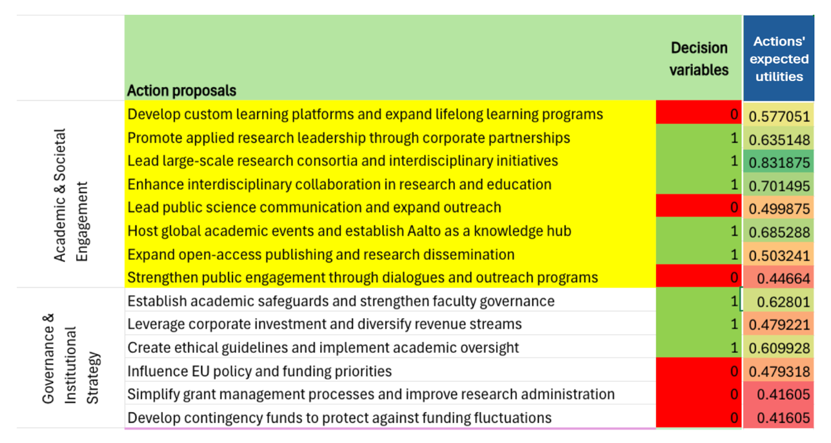
Figure 11. Decision recommendations. Actions chosen have the decision variable value of 1, while those not chosen have the decision variable value 0.
8.3. Sensitivity analysis
Sensitivity analysis can help us find out how variations in attribute weights and scenario probabilities can impact decision-making. To understand how different strategy priorities might impact recommendations, we vary attribute weights while maintaining the following rules:
- Each attribute weight must be at least 0.1
- The total of all weights must equal 1
Based on these constraints, we can define five extreme configurations (ExtW1 - ExtW5 in Table 5). These points represent the situation where the decision makers heavily prioritize some attributes while minimizing others, or as in the case of ExtW5, a scenario in which all attributes are prioritized equally. The extreme points for attribute weights are shown in Table 5.
Attribute weights | ExtW1 | ExtW2 | ExtW3 | ExtW4 | ExtW5
Academic Excellence & Integrity | 0.6 | 0.35 | 0.266 | 0.225 | 0.2
Financial Sustainability & Autonomy | 0.1 | 0.1 | 0.1 | 0.225 | 0.2
Global Relevance & Leadership | 0.1 | 0.1 | 0.1 | 0.1 | 0.2
Societal Impact & Public Trust | 0.1 | 0.1 | 0.267 | 0.225 | 0.2
Innovation in Education & Research | 0.1 | 0.35 | 0.267 | 0.225 | 0.2
Table 5. Extreme points for attribute weights
Similarly, for scenario probabilities, we define three extreme cases (ExtP1 to ExtP3), which represent different assumptions about how likely each future scenario is. The constraints for the scenario probabilities are:
- Each scenario probability must be at least 0.1
- The total of all probabilities must equal 1
These extreme points simulate different levels of probability regarding the future scenarios. The extreme points for scenario probabilities are shown in Table 6.
Scenario probabilities | ExtP1 | ExtP2 | ExtP3
Unlimited Growth Drivers | 0.8 | 0.45 | 0.334
Common Challenge Solvers | 0.1 | 0.45 | 0.333
Bastions of Knowledge | 0.1 | 0.1 | 0.333
Table 6. Extreme points for scenario probabilities
In addition to this, we also modify the resource constraint from eight to six, and then to four to better understand how variations in the action proposal budget may impact decision making. Accordingly, the balance constraint stating no more than five actions can be chosen from a single action category was also lowered to four and three, respectively. We then conducted sensitivity analyses for each of the three budget constraints
As illustrated in Figure 12, the decision variables are listed in the first column, with action proposals marked in green if they are selected in all scenarios, blue if selected in more than 10 scenarios, yellow if selected in some but fewer than 10 scenarios, and red if they are not chosen in any scenario. In this case, $x_{2}$, $x_{3}$, $x_{4}$, $x_{6}$, $x_{9}$, $x_{10}$, $x_{11}$ are marked in green, indicating that they are selected in all 15 scenarios and considered to be robust recommendations. When compared to decision recommendations derived from standard attribute weights and standard scenarios probabilities (shown in Section 8.2.), 7 out of 8 action proposals overlap. These common actions are $x_{2}$, $x_{3}$, $x_{4}$, $x_{6}$, $x_{9}$, $x_{11}$. The high level of agreement suggests strong consistency and confidence in these particular action choices across different modeling assumptions.
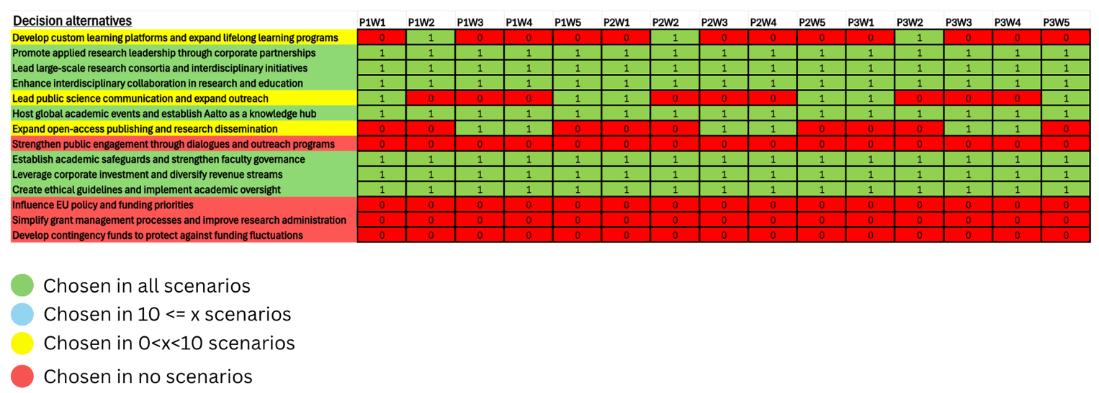Figure 12. Sensitivity analysis with a budget of 8 action proposals
We can apply the same analysis to a scenario where the budget allows for selecting only 6 action proposals. Figure 13 indicates the decision recommendations from both the original attribute weights and scenario probabilities (under ‘Given W and P’) and the sensitivity analysis. Using the same analysis method as before, we can find that 5 out of the 6 action proposals are chosen in every case. This strong overlap reinforces the reliability of these recommendations, even under tighter resources constraints.
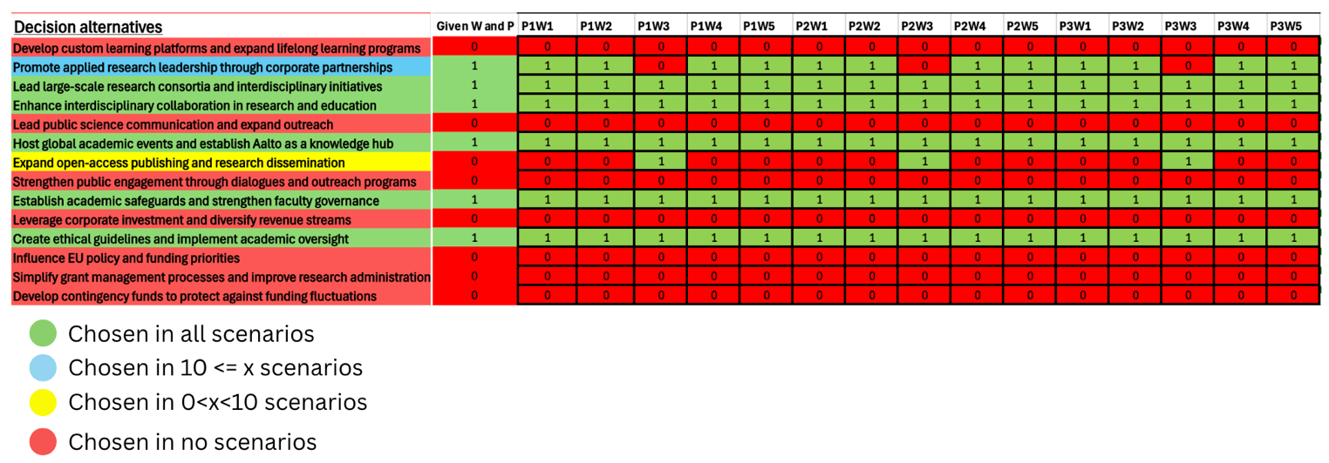Figure 13 Sensitivity analysis with a budget of 6 action proposals
Again, when it comes to a budget of 4 action proposals (shown in Figure 14), the recommendations generated using standard attribute weights and standard scenarios probabilities are quite robust. The two recommendations chosen in every scenario, ‘Lead large-scale research consortia and interdisciplinary initiatives’ and ‘Enhance interdisciplinary collaboration in research and education’ seem to be the most favored recommendations as they are chosen in every case, across all three sensitivity analyses. This is consistent with the fact that they have the highest expected utilities (see Figure 11).
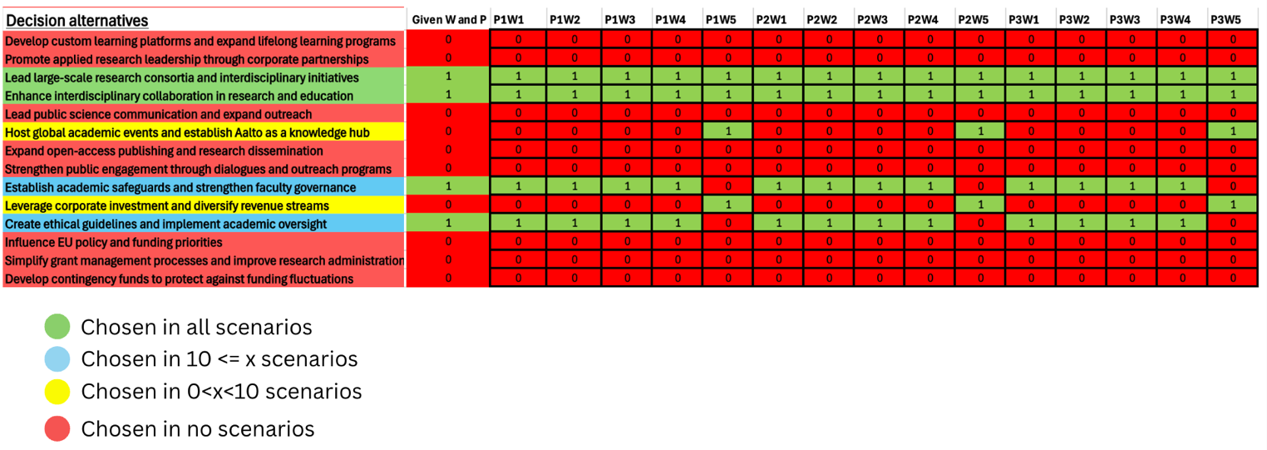Figure 14. Sensitivity analysis with a budget of 4 action proposals
The analysis across different budget scenarios (selecting 8, 6, or 4 actions) shows strong alignment between the recommendations generated using the standard approach and those identified through sensitivity analysis. All but ‘Expand open-access publishing and research dissemination’ of the original decision recommendations were unsusceptible to change in all cases of the sensitivity analysis at n=8. This consistent selection pattern suggests that our decision recommendations are robust to changes in assumptions, such as attribute weights and scenarios probabilities, or even constraints. Moreover, the sensitivity analyses with n=6 and n=4 provide useful insights into the decision recommendations and their robustness, particularly in cases where our original budget estimate was too high.

9. Discussion on the effects of biases on our analysis
There were some group aspects and behavioral biases that could have impacted our decision-making process. It is notable that our elicitation processes and discussions were carried in a group setting with Aalto management team. Expert groups from differing disciplines (such as the one used in this case), providing information from various perspectives usually enjoy greater information accuracy from error checking, as well as greater feeling of procedural fairness and satisfaction (Montibeller and von Winterfeldt, 2018). However, in some scenarios, group settings may accentuate individual biases (Kerr and Tindale, 2004).
Firstly, our elicitation of scenario probabilities might have suffered from the bias of anchoring, wherein a participant’s judgement is affected by answers given by the other participants, therefore “anchoring their answers to the answers of others (Montibeller and von Winterfeldt, 2015). This could have been alleviated with more careful management of the conversation by managing the order in which the participants gave their opinions, or by keeping the previous answers hidden or anonymized (Montibeller and von Winterfeldt, 2015). Another bias that could have affected the process is groupthink, where group members are too focused on achieving consensus, thereby compromising the accuracy of the results (Janis, 1982). However, the sensitivity analysis proved our model to be quite robust, producing similar results with differing probabilities, therefore diminishing the impact of any potential biases plaguing the probability elicitation process.
As for the utility elicitation processes, the lottery choice scenario could have suffered from the certainty effect, wherein a certain outcome is preferred to a gamble with a similar expected utility (Hershey and Schoemaker, 1985; Schoemaker and Hershey, 1992). Indeed, Montibeller and von Winterfeldt (2015) suggest that when using gambles for eliciting utility functions, the elicitor should avoid using sure outcomes (such as degenerate lotteries). However, we considered that this would increase the complexity of the process, introducing a higher workload and an increased risk for errors and therefore decided to use certainty-equivalent method regardless.
When it comes to the weight elicitation process, our use of SWING weighting could have introduced some range insensitivity bias into the process, where in the weights given are insensitive to the attribute ranges used (Fischer, 1992). We, however, consider the effect of this to be mitigated due to the similarity of the attribute ranges across attributes. Furthermore, we consider the effect biases commonly associated with weight elicitation processes, such as equalizing bias and proxy bias (Montibeller and von Winterfeldt, 2015), to be minimal due to the wide range of weights given, as well as the use of fundamental objectives in the weight elicitation process. Finally, the robustness of our model mitigates the effect of these potential biases.

10. Conclusions and discussion
We conducted this modelling project in collaboration with the Aalto Management team, their opinions and preferences serving as the basis for our analysis. We suggest that the Aalto Management team should seek to implement most, if not all, of the following strategic action proposals:
- Promote applied research leadership through corporate partnerships
- Lead large-scale research consortia and interdisciplinary initiatives
- Enhance interdisciplinary collaboration in research and education
- Host global academic events and establish Aalto as a knowledge hub
- Expand open-access publishing and research dissemination
- Establish academic safeguards and strengthen faculty governance
- Leverage corporate investment and diversify revenue streams
- Create ethical guidelines and implement academic oversight
Implementing these action proposals will help Aalto University in future-proofing their organizational strategy. However, this is not an exhaustive list of all possible effective strategic actions. Therefore, Aalto University should stay vigilant, identifying new opinions and threats as they arise. Furthermore, due to the ever-changing global landscape and rapid advancements in technology, it is prudent for Aalto to re-evaluate their 10-year strategy on a continual basis, or by the very least, yearly.
Our analysis is limited by the inexperience of the authors with the elicitation techniques, as well as the limited time offered with the Aalto Management, which favored simpler, more easy-to-understand techniques, as opposed to perhaps better, more complex techniques. The robustness of our model helped mitigate the effect of potential biases in the probability and weight elicitation processes. However, it is notable that our use of certainty equivalents in the utility elicitation process could have introduced some bias, especially through the certainty effect.

References:
Abbas, A.E. (2018) ‘Additive Preference Functions’, in Foundations of Multiattribute Utility. Cambridge University Press, pp. 126–160. Available at: https://doi.org/10.1017/9781316596739.013.
Fischer, G.W. (1992) ‘Range Sensivity of Attribute Weights in Multiattribute Value Models’, Organizational Behavior and Human Decision Processes, 62(3), pp. 252–256.
Hershey, J.C. and Schoemaker, P.J.H. (1985) ‘Probability versus Certainty Equivalence Methods in Utility Measurement: Are They Equivalent?’, Management Science, 10(31), pp. 1213–1231. Available at: https://about.jstor.org/terms.
Janis, I.L. (1982) Groupthink: psychological studies of policy decisions and fiascoes. Houghton Mifflin, Boston, MA.
Keeney, R.L. (1977) ‘The Art of Assessing Multiattribute Utility Functions’, ORGANIZATIONAL BEHAVIOR AND HUMAN PERFORMANCE, 19, pp. 267–310.
Keeney, R.L. (1994) ‘Creativity in Decision Making with Value-Focused Thinking’, Management Review; Summer, 35, p. 33.
Kerr, N.L. and Tindale, R.S. (2004) ‘Group performance and decision making’, Annual Review of Psychology, 55, pp. 623–655. Available at: https://doi.org/10.1146/annurev.psych.55.090902.142009.
Montibeller, G. and von Winterfeldt, D. (2015) ‘Cognitive and Motivational Biases in Decision and Risk Analysis’, Risk Analysis, 35(7), pp. 1230–1251. Available at: https://doi.org/10.1111/risa.12360.
Montibeller, G. and von Winterfeldt, D. (2018) ‘Individual and group biases in value and uncertainty judgments’, in International Series in Operations Research and Management Science. Springer New York LLC, pp. 377–392. Available at: https://doi.org/10.1007/978-3-319-65052-4_15.
Schoemaker, P.J.H. and Hershey, J.C. (1992) ‘Utility Measurement: Signal, Noise, and Bias’, Organizational Behavior and Human Decision Processes, 52(3), pp. 397–424.
Weihrich, H. (1982) ‘The TOWS Matrix A Tool for Situational Analysis’, Long Range Planning, 15(2), pp. 54–66.

