SIMATS ENGINEERING (SAVEETHA SCHOOL OF ENGINEERING)
Department of Computer Science and Engineering
CO2 ASSESSMENT TOOL 1 – Scenario-Based Requirement Analysis
Course Code | CSA10 / CSA1063 | Course Title | Software Engineering
CO Assessed | CO2 | Assessment | Assessment Tool 2 – Scenario-Based Requirement Analysis
Weightage | 20% | Total Marks | 25
CO2 Statement | Perform detailed requirements analysis, design scalable architectures, and prioritize features with a focus on cross-disciplinary skills
Student Name | Hariny A P | Reg. No. | 192511334
Date | 23-10-2026 | Duration | 60 minutes

Code of Conduct
I Hariny A P (192511334) (Name / Reg. No.) certify that this submission is my original work and that I have adhered to the guidelines specified for this assessment. I understand that any violation of academic integrity rules will result in disciplinary action.
Signature of the Student: Hariny A P (192511334)

Annexure A – Scenario-Based Requirement Analysis

Instructions to Students:
Each student will be assigned an individual software project problem statement. Analyze the given scenario and prepare a complete Software Requirement Analysis document by following the steps below.

Question

CHAOS ENGINEERING PLATFORM FOR DISTRIBUTED APPLICATION RESILIENCE

Based on the assigned problem statement, perform a Scenario-Based Requirement Analysis and prepare a Software Requirement Specification (SRS) document. Your analysis should include the following:
- 1. Study and Analyze the Scenario — Carefully understand the given problem statement; identify the business domain, stakeholders, existing challenges, and system objectives.
- 2. Identify Functional and Non-Functional Requirements — List
- all functional requirements and suitable quality requirements such as performance, security, reliability, usability, scalability, maintainability and availability.
- 3. Identify Actors and Use Cases — Identify primary and secondary actors, list major use cases and draw a UML use-case diagram.
- 4. Prepare the SRS — Include introduction, problem description, scope, functional and non-functional requirements, use-case descriptions, data requirements, external interface requirements and system features.
- 5. Identify Assumptions and Constraints — List assumptions and technical, operational, economic, legal and time-related constraints.
- 6. Validate Requirement Completeness and Consistency — Check stakeholder coverage, ambiguity, redundancy, inconsistency and missing requirements; suggest improvements.

1. Study and Analyse the Scenario

1.1 Scenario summary
Modern distributed applications are assembled from services, containers, databases, message queues, networks and external APIs. A user request may cross several of these components before a response is returned. A failure in one component can therefore affect other components, even when those components are healthy. Conventional functional tests commonly validate expected behaviour under planned conditions, but they may not reveal how the whole system behaves when dependencies fail, network latency increases, resources become scarce or several faults occur close together.
The proposed Chaos Engineering Platform enables engineering teams to conduct deliberate, bounded experiments that test resilience. An experiment states a hypothesis, identifies the target and fault, establishes a baseline, sets safety guardrails, injects a controlled failure, observes system behaviour and restores the environment. The platform must stop an experiment automatically when a risk threshold is breached and preserve evidence for later analysis.

1.2 Business domain
The business domain is site reliability engineering (SRE), distributed-systems testing, DevOps and application resilience. The platform is a testing and operational-readiness tool rather than a production workload itself. It supports teams that need repeatable evidence about fault tolerance, recovery behaviour and dependency weaknesses.

1.3 Existing challenges
- Failure scenarios are difficult to reproduce consistently in ordinary test environments.
- Teams may know that a service works in normal conditions but lack evidence about degraded dependencies.
- Manual fault simulation can be inconsistent, difficult to audit and unsafe without clear boundaries.
- Metrics, logs and traces may be spread across different monitoring tools, making cause-and-effect analysis difficult.
- An experiment that exceeds its intended scope can cause unacceptable impact unless automatic stop and rollback controls exist.
- Resilience findings may be recorded in ad hoc notes instead of a standard, comparable report.

1.4 Proposed solution
The platform provides an experiment catalogue, a definition and approval workflow, a safety controller, fault-injection adapters, an execution orchestrator, observability integration, an automatic termination mechanism and a report generator. Experiments are denied by default until their target, scope, permissions, time limit, rollback approach and stop conditions have been validated.

1.5 Business value and measurable outcomes

Outcome | Proposed indicator | Interpretation
Safer experimentation | Percentage of experiments with validated guardrails | Shows whether experiments satisfy safety prerequisites.
Faster recovery insight | Time from fault injection to detection and recovery | Measures how quickly the application detects and handles the fault.
Improved dependency awareness | Number of verified dependency failure paths | Shows where a failure can propagate across components.
Repeatability | Successful repeat runs with comparable conditions | Supports comparison across builds and environments.
Actionable evidence | Reports containing baseline, experiment and recovery data | Makes results useful for engineering decisions.

2. Problem Description and Business Context

2.1 Problem statement
Design and develop a Chaos Engineering Platform that safely introduces controlled failures into distributed applications and evaluates their resilience without causing unacceptable production impact. The platform shall support service failures, network delays, resource exhaustion, dependency failures and container termination. It shall define safety controls, collect observability data, terminate experiments when risk thresholds are exceeded, integrate with testing and CI/CD workflows, identify weak dependencies and failure-propagation paths, and generate evidence-based resilience reports.

2.2 Why conventional testing is insufficient
Functional testing checks whether a feature produces expected results for specified inputs. Load testing evaluates performance under workload. Chaos engineering complements these methods by deliberately changing a system condition—under controlled limits—to test a resilience hypothesis. For example, if a payment service becomes unavailable, the hypothesis might be that the application returns a graceful error and does not lose an order. The experiment is useful only if its scope is controlled and the result is observable.

2.3 Stakeholder needs

Stakeholder | Need | Platform response
SRE / reliability engineer | Run repeatable, measurable fault experiments | Experiment templates, schedules, monitoring and reports
Application developer | Understand failure behaviour and weak dependencies | Service-level results, traces and remediation evidence
Platform / DevOps engineer | Protect infrastructure and deployment pipelines | RBAC, target allowlists, quotas, timeouts and CI/CD gates
Approver / service owner | Review risk before execution | Approval workflow and experiment preview
Security administrator | Prevent unauthorised or excessive fault injection | Least-privilege access, audit records and credential controls
Engineering manager | Compare resilience over time | Standard indicators and historical reports

2.4 Project objectives
- Define and execute controlled resilience experiments with explicit hypotheses and expected outcomes.
- Simulate service, network, resource, dependency and container failures in approved targets.
- Enforce pre-flight validation, safety limits, automatic termination and restoration.
- Collect time-aligned metrics, logs and traces before, during and after an experiment.
- Support manual execution and CI/CD-triggered experiments with policy checks.
- Identify dependencies and failure-propagation paths from experiment evidence.
- Generate clear reports with findings, impact, recovery time and recommendations.

3. Scope of the System

3.1 In-scope functions
- User authentication and role-based access control.
- Experiment creation, editing, versioning, scheduling and approval.
- Fault templates for service termination, latency injection, bounded resource stress, dependency unavailability and container termination.
- Pre-flight checks for target identity, environment, permissions, quotas and rollback readiness.
- Configurable duration, blast-radius limit, health thresholds and abort conditions.
- Live experiment status, telemetry collection, alerts and an emergency stop.
- Cleanup and restoration after completion, failure or cancellation.
- Reports, experiment history, audit events and exportable evidence.
- CI/CD API or pipeline integration for approved automated experiments.

3.2 Out-of-scope functions
- Unrestricted production fault injection without approval or explicit guardrails.
- Replacing a full observability platform, log warehouse or distributed tracing backend.
- Automatically modifying application source code or deploying unreviewed fixes.
- Guaranteeing that an application will never fail; experiments provide evidence, not absolute proof.
- Running destructive tests against targets that have not been explicitly allowlisted.
- Managing every vendor-specific infrastructure type in the initial version.

3.3 Operating environment
The proposed platform is a web-based control plane with a browser dashboard and authenticated API. A worker/orchestrator executes experiments through narrowly scoped adapters. A target may be a test cluster, staging environment or a specifically approved production subset. The design assumes integration with existing metrics, logging and tracing services. Concrete vendor choices can be selected during implementation.

3.4 System boundary
The platform controls experiments and collects evidence; the target application continues to provide the business service. The platform must not assume ownership of the target’s normal deployment lifecycle. It interacts with identity services, CI/CD systems, telemetry backends and infrastructure APIs through documented interfaces and least-privilege credentials.

3.5 Proposed logical architecture

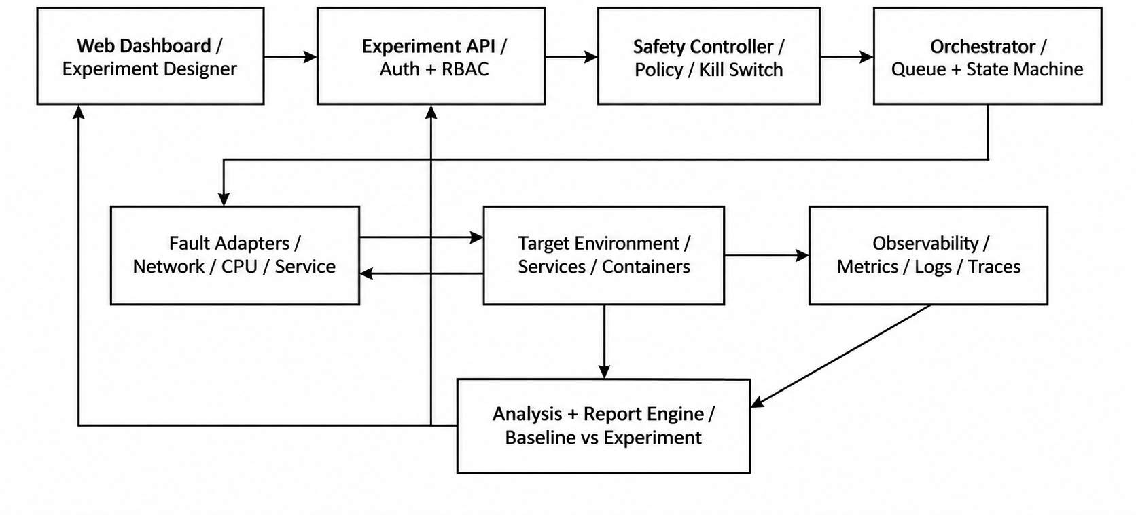

Figure 1. Proposed logical architecture of the Chaos Engineering Platform.
4. Stakeholders and Actors

Actor | Type | Responsibilities | Permissions / boundaries
Reliability Engineer | Primary | Define hypotheses, configure experiments, inspect telemetry and reports | Create and run within approved scopes; cannot bypass safety policy
Approver / Service Owner | Primary | Review risk, approve or reject experiment and confirm maintenance window | Approve within assigned service/environment
Platform Administrator | Primary | Manage users, roles, policies, target allowlists and integrations | Administrative actions are audited
CI/CD Pipeline | Secondary / system | Request eligible experiments after build or deployment stages | Uses service identity and approved pipeline policy
Observability Backend | External system | Provide metrics, logs and traces | Read access limited to configured telemetry
Target Infrastructure | External system | Receive fault actions and expose health state | Only approved resources and supported actions
Notification Service | External system | Deliver alerts for approval, abort and completion | Receives minimal event payloads
Auditor / Reviewer | Primary, read-only | Review experiment history, approvals and evidence | Cannot alter completed experiment records

4.1 Actor interaction principles

Actors must be authenticated and assigned explicit permissions. A person who defines an experiment should not automatically be able to approve a high-risk experiment if separation of duties is required by policy. CI/CD identities are scoped to permitted projects and environments. External systems are treated as dependencies: their availability and credentials must be checked before an experiment begins.

4.2 UML use-case diagram

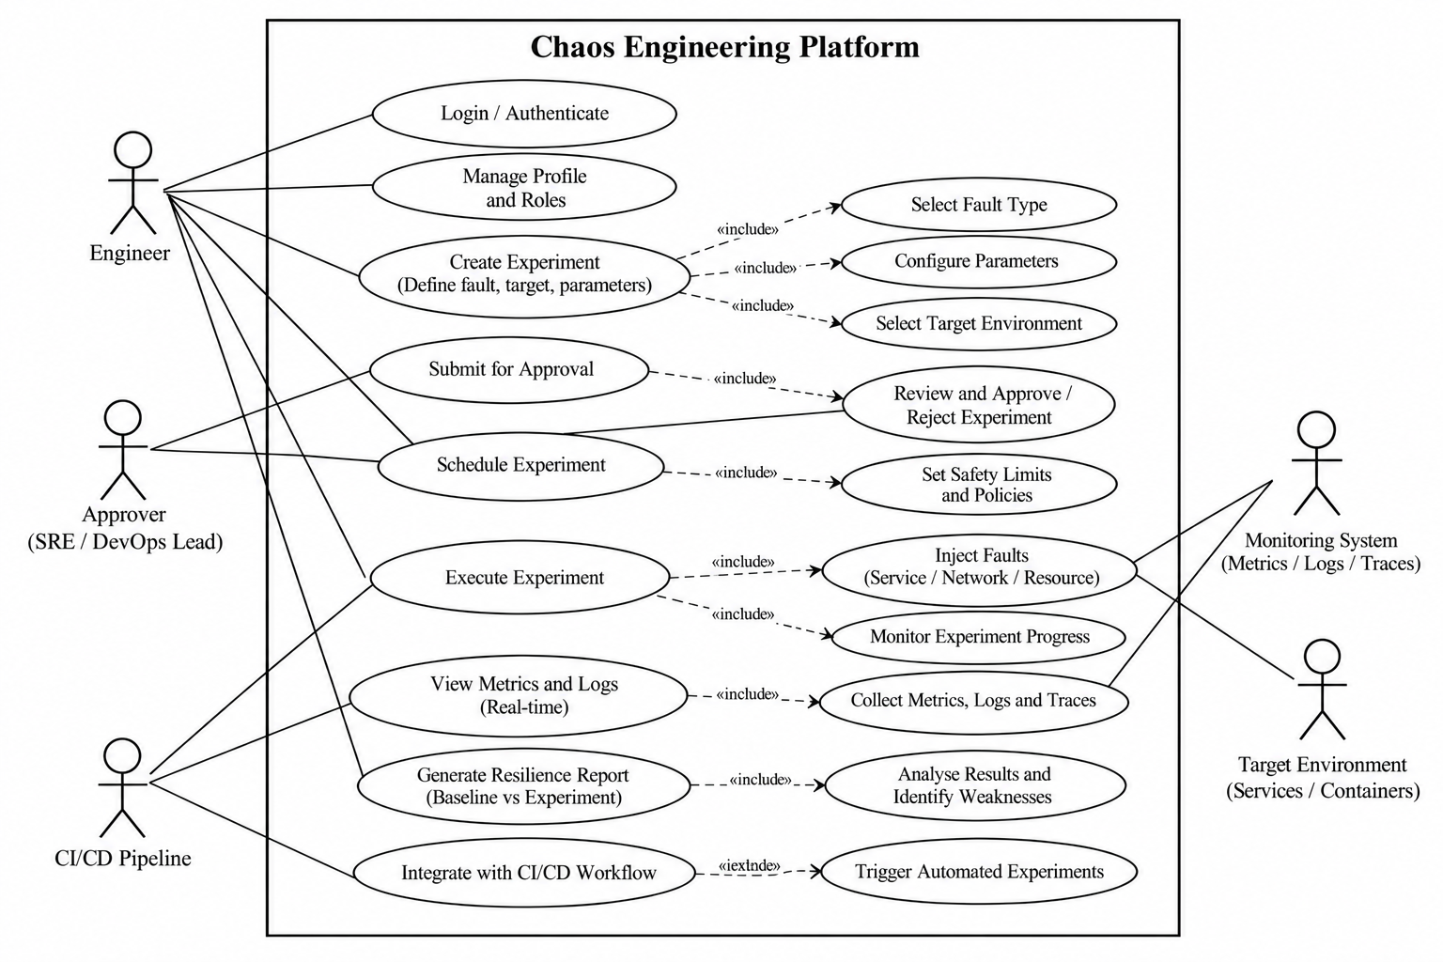

Figure 2. UML-style use-case model showing key platform functions and external actors.
The diagram presents the main interactions. The Engineer defines and executes an experiment, while the Approver authorises higher-risk activity. The CI/CD pipeline requests eligible runs. Monitoring and target systems exchange telemetry and fault actions with the platform. All experiment actions remain subject to the safety controller.

5. Functional Requirements
The following requirements are uniquely identified so they can be tested and traced to acceptance criteria. ‘Shall’ denotes a mandatory requirement for the proposed system.

ID | Requirement | Verification
FR-01 | The system shall authenticate users and service identities before permitting protected operations. | Authentication test
FR-02 | The system shall assign roles and enforce permissions for experiment creation, approval, execution, administration and read-only review. | Role-permission tests
FR-03 | The system shall allow an authorised user to create an experiment containing a name, purpose, hypothesis, target, fault type, duration, scope, expected outcome and owner. | Create/edit test
FR-04 | The system shall support versioned experiment templates and preserve the configuration used for each run. | Version-history test
FR-05 | The system shall support service failure, network delay, bounded resource exhaustion, dependency failure and container termination experiments where the target adapter supports them. | Adapter tests
FR-06 | The system shall require an explicit target allowlist and reject targets outside the permitted scope. | Negative target test
FR-07 | The system shall validate target health, permissions, telemetry availability, rollback capability and policy compliance before execution. | Pre-flight test
FR-08 | The system shall support configurable maximum duration, blast radius, resource limits and experiment concurrency. | Policy-boundary tests
FR-09 | The system shall require approval for experiments classified by policy as elevated risk. | Approval workflow test
FR-10 | The system shall provide scheduled and immediate execution modes subject to policy and approval. | Scheduling test
FR-11 | The system shall expose experiment lifecycle states: Draft, Pending Approval, Approved, Pre-check, Running, Aborting, Restoring, Completed, Failed and Cancelled. | State-transition test
FR-12 | The system shall collect configured metrics, logs and traces with timestamps correlated to the experiment window. | Telemetry correlation test
FR-13 | The system shall continuously evaluate configured health and risk thresholds during execution. | Threshold-trigger test
FR-14 | The system shall stop fault injection automatically when an abort threshold, maximum duration or policy violation is detected. | Automatic-abort test
FR-15 | The system shall provide an authorised emergency stop that initiates fault removal and restoration. | Kill-switch test
FR-16 | The system shall attempt cleanup and restoration after completion, failure, cancellation or abort. | Cleanup test
FR-17 | The system shall notify designated owners of approval requests, experiment start, aborts, restoration failures and completion. | Notification test

6. Non-Functional Requirements

ID / Quality | Requirement | Verification
NFR-01 Performance | For a configured deployment, dashboard status updates should appear within 5 seconds under normal operating load; experiment control actions must not wait for report generation. | Load and response-time test
NFR-02 Availability | The control plane should target 99.5% monthly availability for the initial deployment, excluding agreed maintenance; the exact service objective must be approved by the owner. | Availability monitoring
NFR-03 Reliability | Failure of the reporting component must not prevent an active safety controller from issuing a stop action. | Fault-isolation test
NFR-04 Safety | Every run must have a maximum duration and at least one explicit stop policy; the system shall fail closed if mandatory safety validation cannot complete. | Guardrail tests
NFR-05 Security | All protected actions shall require authenticated identity, least-privilege authorisation and encrypted transport. | Security review and penetration test
NFR-06 Auditability | The system shall record actor, timestamp, target, configuration version, decision and outcome for material actions. | Audit completeness test
NFR-07 Scalability | The design should support adding workers and adapters without changing the user-facing experiment model. | Scale-out test
NFR-08 Maintainability | Fault adapters and telemetry connectors should use documented interfaces and be independently testable. | Code review and adapter tests
NFR-09 Usability | An authorised engineer should be able to understand experiment state, current risk and abort reason from the dashboard without inspecting raw logs. | Usability walkthrough
NFR-10 Interoperability | The platform should integrate through documented APIs and common telemetry formats where supported by the target environment. | Integration tests
NFR-12 Data integrity | Experiment definitions, approvals and reports shall be linked to immutable version identifiers and timestamps. | Integrity verification
NFR-13 Recoverability | A failed run shall enter a restoration state and report whether each applied fault was removed successfully. | Recovery scenario test

6.1 Quantifiable resilience indicators

Indicator | Definition | Use
Detection time | Time from fault injection to detection by the target or monitoring system | Measures alerting and failure detection
Recovery time | Time from fault start to restoration of the defined healthy state | Measures recovery behaviour
Error-rate change | Experiment error rate minus baseline error rate, over equivalent windows | Quantifies service impact
Availability during experiment | Successful eligible requests divided by total eligible requests | Estimates user-visible availability
Abort response time | Time between guardrail breach detection and confirmed fault removal initiation | Measures safety-control responsiveness
Dependency impact count | Number of downstream components with measurable degradation linked to the experiment | Shows propagation breadth
Experiment repeatability | Degree to which repeated runs under comparable conditions produce comparable outcomes | Supports confidence in findings

7. Use-Case Descriptions

UC-01: Create an experiment
Field | Description
Primary actor | Reliability Engineer
Preconditions | User is authenticated; target environment and fault adapter are registered.
Trigger | Engineer selects Create Experiment.
Main flow | 1. Enter purpose and hypothesis. 2. Select target and fault type. 3. Configure duration, blast radius and guardrails. 4. Choose telemetry sources and expected outcome. 5. Save as Draft or submit for approval.
Alternative flows | If a required field is missing, the system identifies it and prevents submission. If the target is not allowlisted, the system rejects the configuration.
Postconditions | A versioned experiment definition is stored and available for validation.
Exceptions | API or database failure produces an error without falsely confirming that the definition was saved.

UC-02: Approve and execute an experiment
Field | Description
Primary actors | Reliability Engineer; Approver
Preconditions | Experiment definition is complete; required approval is granted; target is in scope.
Main flow | 1. Submit experiment. 2. Approver reviews target, fault, risk, duration and rollback plan. 3. System performs pre-flight checks. 4. Orchestrator starts the bounded fault. 5. Safety controller monitors guardrails. 6. Fault is removed at the planned end. 7. Results are finalised.
Alternative flows | Approver rejects the run; pre-flight check fails; target health is already degraded; a concurrent experiment holds a target lock.
Postconditions | The experiment is completed, cancelled or failed with a recorded reason and cleanup result.
Exceptions | If restoration fails, the platform raises a critical alert, records affected resources and continues permitted recovery actions.

UC-03: Automatic abort
Field | Description
Primary actor | Safety Controller (system actor)
Preconditions | Experiment is Running and safety telemetry is available.
Trigger | A configured threshold is exceeded, the maximum duration is reached, or a policy violation occurs.
Main flow | 1. Mark run Aborting. 2. Issue stop to fault adapter. 3. Verify fault removal. 4. Initiate restoration. 5. Alert owner. 6. Preserve telemetry and abort reason. 7. Mark run Failed or Aborted with recovery status.
Alternative flows | If telemetry is lost, the configured fail-safe policy stops or pauses fault injection. If the adapter does not acknowledge stop, escalate and notify the on-call owner.
Postconditions | No further fault injection is permitted for the run; cleanup and evidence status are recorded.

8. Software Requirement Specification (SRS)

8.1 Introduction
This SRS defines the externally observable behaviour, constraints and quality expectations for the proposed Chaos Engineering Platform for Distributed Application Resilience. It is intended for students, developers, testers, platform engineers, service owners and reviewers. The specification describes what the platform must do, not a commitment to a particular cloud vendor or implementation framework.

8.2 Purpose
The purpose is to provide a structured basis for design, implementation, verification and assessment. Each requirement uses a unique identifier and a testable statement. The SRS also defines the safety properties that are essential because the system deliberately introduces faults.

8.3 Product perspective
The platform is a control plane that coordinates experiment definitions, approvals, fault adapters, telemetry collection and reporting. It integrates with existing infrastructure and monitoring services rather than replacing them. The architecture separates the safety controller from optional reporting functions so a report outage cannot block a stop action.

8.4 Product functions
- Manage identities, roles, target allowlists and experiment policies.
- Define hypotheses and parameterised fault experiments.
- Validate risk controls and obtain required approvals.
- Execute bounded fault actions through adapters.
- Observe target health and enforce automated stop conditions.
- Restore the target, record outcome and notify responsible owners.
- Analyse baseline-versus-experiment behaviour and generate evidence-based reports.

8.5 User classes and characteristics
Reliability engineers are expected to understand service dependencies, monitoring signals and experiment hypotheses. Approvers need enough operational knowledge to assess blast radius and rollback readiness. Administrators manage access and policy. Auditors require read-only evidence. CI/CD integrations are non-human actors and must use service credentials rather than personal accounts.

8.6 Definitions
Term | Definition
Chaos experiment | A controlled test that introduces a defined fault to examine a resilience hypothesis.
Fault injection | The deliberate application of a bounded failure condition.
Blast radius | The set or proportion of resources that an experiment is permitted to affect.
Guardrail | A policy or threshold that limits risk and can stop an experiment.
Baseline | Reference observations captured before fault injection.
Abort | Early termination of fault injection in response to a stop condition.
Restoration | Removal of injected faults and verification of recovery.
Resilience indicator | A measurable signal such as error-rate change, detection time or recovery time.

9. Data Requirements

9.1 Core data entities
Entity | Key attributes | Purpose
User | user_id, identity_provider_id, role_ids, status | Authentication and authorisation
Target | target_id, environment, owner, allowlist_status, adapter_type | Defines eligible resources and boundaries
ExperimentDefinition | experiment_id, version, hypothesis, fault_type, parameters, guardrails | Versioned reusable experiment configuration
Approval | approval_id, experiment_version, approver_id, decision, timestamp, comments | Evidence of review and authorisation
ExperimentRun | run_id, experiment_version, target_id, state, start_time, end_time, outcome | Tracks a specific execution
TelemetryReference | run_id, source, time_window, query_or_link, completeness | Links metrics, logs and traces to a run
AuditEvent | event_id, actor, action, target, timestamp, result | Supports accountability and investigation
ResilienceReport | report_id, run_id, indicators, findings, limitations, recommendations | Summarises evidence and outcome
Dependency | source_service, dependent_service, evidence, confidence, observed_impact | Represents dependencies and failure propagation

9.2 Data validation rules
- Every experiment run must reference an existing, versioned experiment definition and an approved target.
- Duration, concurrency, resource stress and blast radius values must be within policy-defined ranges.
- An approval must identify the exact experiment version being approved; later edits invalidate that approval.
- All event timestamps must include a consistent time basis so telemetry can be aligned.
- Reports must distinguish measured values, configured thresholds, derived indicators and missing data.
- Secrets and raw credentials must never be stored in experiment descriptions or included in exported reports.
- Audit events must not be silently overwritten; corrections should be recorded as new events.

9.3 Retention and integrity
Retention periods depend on organisational policy and the sensitivity of telemetry. The platform should retain experiment configuration, approval decisions, outcomes and audit evidence for an approved period. Telemetry can be referenced in an external observability store rather than copied in full. If a source expires or becomes inaccessible, the report must disclose that limitation. Access to reports and exports must follow role permissions.

9.4 Data quality
The report engine must not infer a successful recovery solely from the end of the fault-injection command. It should require a defined health signal or explicit operator confirmation. Missing samples, clock skew, delayed metrics and incomplete traces must be disclosed. Comparisons should use reasonably comparable baseline and experiment windows and state any known confounding conditions.

10. External Interface Requirements

10.1 User interface
- The dashboard shall provide pages for experiment catalogue, editor, approval queue, live run, history, reports, integrations and administration.
- The experiment editor shall group target, fault, duration, hypothesis, expected outcome and safety settings in clearly labelled sections.
- The live run view shall show lifecycle state, elapsed time, fault status, key indicators, current guardrail status and stop control.
- Warnings and abort events shall be visually clear and also expressed in text; colour alone must not convey safety status.
- Forms shall validate required fields and explain rejected settings in actionable language.
- Destructive or high-risk actions shall require confirmation and be logged.

10.2 Software interfaces
Interface | Purpose | Requirements
Identity provider | Authenticate users and service identities | Use supported secure protocols; map identities to roles
Infrastructure / orchestrator API | Apply and remove supported faults | Use scoped credentials, timeouts, idempotent operations where possible
Metrics backend | Retrieve time-series health signals | Record query, time range, source and missing samples
Logging backend | Retrieve relevant structured events | Apply access controls and avoid secret exposure
Tracing backend | Inspect request paths and dependency spans | Correlate trace windows with run identifiers
CI/CD API | Request experiments after build or deployment | Authenticate service identity and enforce pipeline policy
Notification provider | Send approval and safety alerts | Retry safely; record delivery outcome

10.3 Communication and security interfaces
All remote control and data interfaces shall use authenticated, encrypted communication appropriate to the deployment. Credentials shall be stored in a secrets-management facility or equivalent protected configuration, not in source code. The system shall use timeouts, bounded retries and clear error states. A failed telemetry connection must not be interpreted as evidence that the target is healthy.

10.4 Hardware interfaces
No dedicated hardware is required by the proposed system. It operates on compute infrastructure capable of running the control plane, workers and storage. Resource requirements depend on experiment concurrency, telemetry volume and the size of the target environment.

11. System Features and Experiment Lifecycle

11.1 Feature A — Experiment design
The user records a testable hypothesis, such as: ‘If one replica of the catalogue service becomes unavailable, the remaining replicas will continue serving requests within the agreed error-rate threshold.’ The experiment definition includes a measurable success condition and a clear failure condition. A hypothesis must not simply say ‘the system should be resilient’; it should identify observable behaviour.

11.2 Feature B — Pre-flight safety checks
- Confirm the target is allowlisted and the user has permission.
- Confirm the target is healthy enough to run the experiment and capture a baseline.
- Check required telemetry is available and sufficiently fresh.
- Validate maximum duration, blast radius, resource limits and concurrency.
- Confirm rollback or fault-removal action is supported and credentials are valid.
- Verify the approval and maintenance-window requirements.
- Reject the run if a mandatory check fails; record the reason.

11.3 Feature C — Fault injection
Fault category | Example controlled action | Key safety considerations
Service failure | Stop or isolate one approved replica | Preserve minimum healthy capacity; verify restoration
Network delay | Add bounded latency to selected traffic | Limit endpoints, latency and duration; monitor timeout/error rate
Resource exhaustion | Apply a capped CPU or memory stressor | Set hard resource limits; avoid node-wide exhaustion
Dependency failure | Simulate a downstream API or queue being unavailable | Use test doubles or isolated routes where possible
Container termination | Terminate one selected container or replica | Respect replica minimums and orchestration policies

11.4 Feature D — Observability
The system captures a baseline before injection, observations during the fault, and a recovery window after removal. Metrics quantify service impact; logs explain events; traces show request paths and downstream calls. The run identifier should be attached to platform-generated events and, where possible, propagated to telemetry queries. Data collection must be limited to relevant time windows and authorised services.

11.5 Experiment lifecycle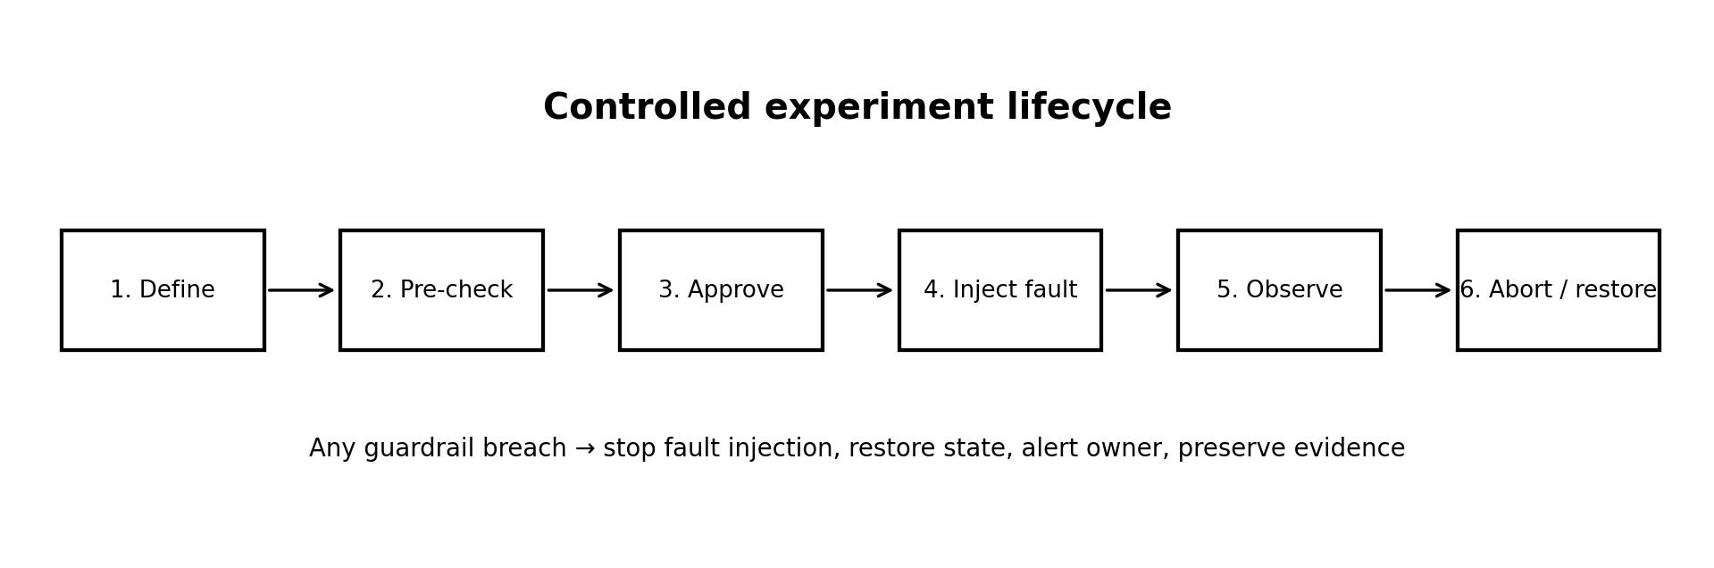
Figure 3. Lifecycle from experiment definition through safe execution and evidence preservation.

12. Assumptions and Constraints

12.1 Assumptions
- Target services expose sufficient health signals to determine whether they are functioning within an agreed range.
- Users and approvers understand the operational risks of the target environment.
- Required infrastructure APIs support at least one safe method to apply and remove each configured fault.
- An observability backend is available or can be configured before the first experiment.
- Targets are explicitly registered and owned by a responsible service team.
- Clock synchronisation is adequate to correlate experiment events and telemetry.
- Organisational policies define which environments and fault types require elevated approval.
- CI/CD pipelines can authenticate to the platform using a protected service identity.

12.2 Technical constraints
- Fault actions are limited to the capabilities of available adapters and infrastructure APIs.
- Network partitions, API outages or unavailable telemetry can reduce control and evidence quality.
- Resource-exhaustion experiments must be capped to avoid affecting unrelated workloads.
- High-cardinality telemetry and large traces may increase storage and query costs.
- External systems may not acknowledge stop or restoration commands immediately.

12.3 Operational constraints
- Experiments must respect approved windows, service ownership and change-management policies.
- Production experiments require explicit approval and a defined blast radius.
- An on-call owner and escalation path must be available for elevated-risk experiments.
- Concurrent experiments on the same target must be prevented unless a policy explicitly permits them.
- Experimenters must review results and remediate findings; the platform alone does not fix application weaknesses.

12.4 Economic constraints
The project should prioritise open interfaces and reuse existing monitoring and infrastructure tooling where possible. Costs include compute for the control plane and workers, telemetry storage, integration maintenance and engineering time. The initial implementation should focus on a small set of high-value adapters rather than attempting broad vendor coverage.

12.5 Legal, security and time constraints
The system must comply with the organisation’s access, privacy, data-retention and change-management policies. Experiments must not target third-party systems without permission. The academic implementation should be scoped to a local or isolated test environment and a demonstrable subset of fault types. A realistic implementation plan should prioritise identity, safety controller, one or two adapters, telemetry and report generation before broader integrations.

13. Requirement Validation and Traceability

13.1 Validation approach
Requirements are reviewed for correctness, completeness, consistency, feasibility, verifiability, traceability and lack of ambiguity. Stakeholder walkthroughs check that the system supports the intended workflows. Table-top scenarios test whether abort and restoration behaviour is clear before code is written. Prototype and integration tests then verify that the requirements can be implemented.

13.2 Completeness and consistency checklist
Validation check | Review question | Expected evidence
Completeness | Are all scenario objectives represented by requirements? | Traceability matrix covers fault types, safety, telemetry, CI/CD, dependencies and reporting
Consistency | Do any requirements contradict each other? | A stop policy takes precedence over continuing an experiment
Unambiguity | Can a tester interpret each requirement in one way? | Unique IDs, measurable conditions and defined states
Feasibility | Can the requirement be implemented with available interfaces? | Adapter capability review and prototype
Verifiability | Can objective evidence show pass or fail? | Test cases, event logs and recorded metrics
Traceability | Can each requirement be linked to a stakeholder need and test? | Requirement ID linked to test case and report
Safety | Does each experiment have bounded scope and a stop path? | Pre-flight checklist, kill-switch and cleanup test
Data integrity | Are results and limitations preserved honestly? | Versioned definitions, timestamps and audit trail

13.3 Traceability matrix
Scenario objective | Requirement IDs | Verification evidence
Controlled experiment definition | FR-03, FR-04, FR-10, FR-11 | Experiment creation, version and state-transition tests
Realistic fault simulation | FR-05, FR-06, FR-08 | Adapter tests in isolated target
Safety limits and auto-stop | FR-07, FR-08, FR-13, FR-14, FR-15, FR-16 | Threshold breach, timeout, kill-switch and restoration tests
Observability | FR-12, FR-21; NFR-16 | Baseline/run/recovery telemetry correlation
CI/CD integration | FR-20, FR-23 | Authenticated pipeline-trigger test
Dependency analysis | FR-22 | Known dependency failure scenario and evidence review
Resilience reports | FR-18, FR-25, FR-26 | Report completeness and export tests
Security and accountability | FR-01, FR-02, FR-19; NFR-05, NFR-06 | RBAC, audit and security tests

14. Risk Analysis and Safety Controls
Risk | Potential impact | Preventive control | Response
Wrong target selected | Unexpected service disruption | Target allowlist, clear environment labels, confirmation | Abort, restore, notify owner, preserve audit evidence
Guardrail threshold too permissive | Excessive user-visible errors | Policy defaults, review, bounded blast radius | Stop fault, escalate, revise policy
Telemetry unavailable | Unsafe or inconclusive experiment | Pre-flight freshness check and fail-safe policy | Pause/abort and mark evidence incomplete
Fault adapter fails to stop | Injected failure persists | Timeouts, idempotent stop, independent watchdog where possible | Escalate immediately; execute approved manual recovery
Credentials compromised | Unauthorised experiments | Least privilege, rotation, secret storage, audit alerts | Revoke credentials and investigate
Concurrent experiments conflict | Combined unexpected impact | Target locks and concurrency limits | Block new run; stop conflicting run if policy dictates
Report overstates causal result | Incorrect engineering decisions | Evidence links, confidence and limitations fields | Correct through versioned addendum
CI/CD misconfiguration | Fault triggered at wrong stage | Pipeline identity scope, environment gates and dry run | Reject request and alert pipeline owner

14.1 Safety policy precedence
Safety and target policy take precedence over experiment convenience. A user or pipeline must not override a mandatory safety rule. If the safety controller cannot verify a required condition, the system should not begin the experiment; if the condition is lost during execution, the configured fail-safe action should be taken. Stop and cleanup actions should be prioritised over analytics and report generation.

14.2 Minimum guardrails for every run
- Explicit allowlisted target and owner.
- Maximum duration and a hard execution timeout.
- Defined blast radius and resource caps.
- Pre-experiment baseline and required health signals.
- At least one health-based abort condition plus manual stop capability.
- Supported cleanup action and a restoration verification method.
- Approval where required by risk policy.
- Audit trail and notification recipient.

15. Acceptance Criteria and Test Strategy

15.1 Acceptance criteria
ID | Acceptance criterion | Pass condition
AC-01 | Unauthorised user attempts to start an experiment | Request is denied and the attempt is audited.
AC-02 | Experiment references a target outside the allowlist | Pre-flight validation rejects it before fault injection.
AC-03 | A required health signal is unavailable before start | Experiment does not start; missing prerequisite is reported.
AC-04 | A health threshold is exceeded during a run | Fault stop is initiated, run enters Aborting, and owner is alerted.
AC-05 | Maximum duration is reached | No additional fault action is issued and cleanup begins.
AC-06 | Experiment finishes normally | Fault is removed and recovery status is recorded.
AC-07 | Adapter does not acknowledge stop | Run is marked as requiring escalation; the platform does not claim success.
AC-08 | Report is generated | Report includes configuration version, hypothesis, baseline, timeline, impact, restoration and limitations.
AC-09 | CI/CD triggers an experiment | Only an authenticated, policy-compliant request is accepted.
AC-10 | Two conflicting runs target the same protected resource | The second run is blocked by concurrency policy.
AC-11 | An experiment is edited after approval | The old approval cannot authorise the changed version.
AC-12 | Telemetry contains gaps | Report labels missing data and avoids unsupported conclusions.

15.2 Test levels
- Unit testing: validate parameter bounds, policy evaluation, lifecycle transitions and report calculations.
- Adapter testing: verify each fault can be applied and removed in an isolated environment.
- Integration testing: validate identity, target APIs, telemetry queries, notifications and CI/CD calls.
- System testing: execute end-to-end experiments including approval, monitoring, abort, restoration and reporting.
- Security testing: test role boundaries, service credentials, input validation, secret handling and audit integrity.
- Recovery testing: simulate worker loss, telemetry loss, adapter timeout and restoration failure.
- Usability testing: ask representative users to configure an experiment and identify its current risk state.

16. Conclusion
The proposed Chaos Engineering Platform addresses a practical resilience challenge in distributed applications: normal functional tests do not fully demonstrate how a system behaves when infrastructure and dependencies fail. The platform makes experiments repeatable by combining explicit hypotheses, versioned definitions, approval, bounded fault injection, observability, automatic termination, restoration and evidence-based reporting.
The requirements emphasise safety as a core system property rather than an optional feature. Target allowlists, least-privilege access, pre-flight checks, duration limits, blast-radius controls, an emergency stop and honest reporting of incomplete recovery are essential. The SRS also makes the scenario’s objectives traceable to functional requirements, non-functional quality expectations and acceptance tests.

References
[1] N. R. S. (NIST). (2022). Security and privacy controls for information systems and organizations (NIST Special Publication 800-53, Revision 5). National Institute of Standards and Technology. https://doi.org/10.6028/NIST.SP.800-53r5
[2] ISO/IEC/IEEE. (2018). ISO/IEC/IEEE 29148:2018 Systems and software engineering—Life cycle processes—Requirements engineering. International Organization for Standardization.
[3] Basiri, A., Behnam, N., de Rooij, R., Hochstein, L., Koselek, M., Reynolds, J., & Rosenthal, C. (2016). Chaos engineering. IEEE Software, 33(3), 35–41. https://doi.org/10.1109/MS.2016.60
[4] Rosenthal, C., & Jones, N. (2020). Chaos engineering: System resiliency in practice. O’Reilly Media.
[5] Google Cloud. (n.d.). Chaos engineering. Google Cloud Architecture Center. https://cloud.google.com/architecture/chaos-engineering
[6] Kubernetes. (n.d.). Kubernetes documentation. https://kubernetes.io/docs/
[7] OpenTelemetry. (n.d.). Documentation. https://opentelemetry.io/docs/
[8] Newman, S. (2021). Building microservices: Designing fine-grained systems (2nd ed.). O’Reilly Media.
[9] Beyer, B., Jones, C., Petoff, J., & Murphy, N. R. (Eds.). (2016). Site reliability engineering: How Google runs production systems. O’Reilly Media.

Rubrics for Calculation
Criteria | Excellent (4 Marks) | Good (3 Marks) | Satisfactory (2 Marks) | Needs Improvement (1 Mark)
Scenario Understanding and Problem Analysis (30%) | Thorough understanding of the scenario, stakeholders, objectives and business context with clear analysis. | Good understanding with minor omissions. | Basic understanding with limited analysis. | Poor understanding; major aspects missing or incorrect.
Functional and Non-Functional Requirement Identification (25%) | Comprehensive, accurate and well-classified functional and non-functional requirements. | Most requirements identified with minor classification errors. | Only basic requirements; several omissions. | Requirements incomplete, inaccurate or poorly classified.
Actor Identification and Use Case Modelling (20%) | All relevant actors and use cases; complete, accurate UML diagram. | Most actors and use cases; minor diagram errors. | Limited actors/use cases; partially correct diagram. | Actors/use cases missing or incorrect; diagram absent or inaccurate.
SRS Documentation (15%) | Well-structured, complete, professional SRS containing all required sections. | Organised with minor omissions or formatting issues. | Essential sections with limited detail. | Incomplete, poorly organised or missing essential components.
Assumptions, Constraints and Requirement Validation (10%) | Realistic assumptions and constraints; validates completeness, consistency and ambiguity with justification. | Most assumptions and constraints identified; adequate validation. | Limited assumptions/constraints; superficial validation. | Assumptions, constraints and validation missing or incorrect.

Assessment Marks
Criteria | Mark
Scenario Understanding and Problem Analysis (30%) | /5
Functional and Non-Functional Requirement Identification (25%) | /5
Actor Identification and Use Case Modelling (20%) | /5
Software Requirement Specification (SRS) Documentation (15%) | /5
Assumptions, Constraints and Requirement Validation (10%) | /5
TOTAL | /25

