G-UNIT CAKES
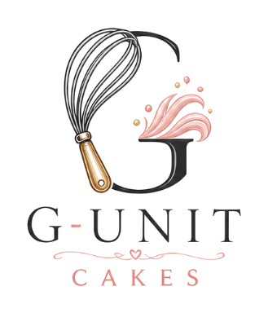
Brand Identity
Visual identity, voice, packaging, and digital guidance
BRAND ESSENCE
Celebration, made personal.

VERSION 1.0 / JULY 2026

01 / G-UNIT CAKES

Brand core
  - The strategic centre that keeps every cake, message, package, and customer interaction recognisably G-Unit Cakes.
A warm, elegant cake studio built around personal celebration.
BRAND PROMISE
Every order should feel thoughtfully designed, carefully made, clearly communicated, and joyful to receive.

Foundation
Mission  To bake memorable cakes and sweet details that make every celebration feel personal. | Vision  To become a trusted local cake studio known for thoughtful design, generous flavour, and warm service.
Positioning  A custom cake studio for people who want a celebration piece that looks considered, tastes generous, and feels made specifically for their moment. | Tagline  Made for your moment.

Personality
- Elegant, not formal. Polished enough for a milestone, welcoming enough for every day.
- Warm, not overly familiar. Personal care without forced intimacy.
- Creative, not chaotic. Expressive design guided by clear choices.
- Confident, not boastful. Calm expertise that helps customers decide.
- Reliable, not transactional. Organised service from first enquiry to handover.

02 / G-UNIT CAKES

Audience and message
  - Speak first to the meaning of the occasion, then to design, flavour, and a clear ordering experience.
Beautifully considered cakes, baked for the moments worth celebrating.

Who we serve
Celebration customers  Birthdays, graduations, baby showers, anniversaries, weddings, and personal milestones. | Thoughtful gift buyers  People sending a cake, dessert box, cupcakes, or cookies to make someone feel seen.
Event partners  Planners and hosts who need a dependable centrepiece that fits the wider event. | Small businesses  Teams ordering branded treats, thank-you gifts, launches, or client celebrations.

Message pillars
- Personal by design. Every order begins with the occasion, taste, and visual references.
- Beautiful and delicious. The finish creates a strong first impression without compromising flavour.
- Clear from enquiry to collection. Ordering feels welcoming, organised, and dependable.
- Thoughtful in every detail. Decoration, finishing, packaging, and handover feel connected.

Preferred calls to action
USE DIRECT LANGUAGE
Start your custom order / Tell us about your celebration / Check availability / Order on WhatsApp

03 / G-UNIT CAKES

Voice and tone
  - The brand sounds like a skilled baker who is warm, calm, creative, and easy to order from.
Warm  Use genuine care and hospitality. Acknowledge the occasion. | Celebratory  Bring energy to the moment without filling every line with exclamation marks.
Clear  Make dates, portions, pricing, and next steps easy to understand. | Confident  Guide customers with calm expertise and useful recommendations.
Personal  Sound like a real baker speaking to a real customer. | Concise  Use short sentences and specific details.

Writing pattern
- Start with the customer's occasion or desired outcome.
- Add one appetising or visual detail.
- State the useful information clearly.
- End with one simple next step.

Social caption example
CAPTION
Soft coral piping, hand-finished details, and a centre made for celebrating. Planning something special? Tell us the date, servings, flavours, and the look you love.

Enquiry reply example
Thank you for thinking of G-Unit Cakes for your celebration. Please send your event date, number of servings, preferred flavours, and any inspiration images. We will confirm availability and guide you through the next step.

04 / G-UNIT CAKES

Primary logo
  - The whisk-shaped G is the recognisable heart of the identity. The full lockup is the default brand signature.

Anatomy and meaning
Whisk  Craft, movement, and handmade baking. | Letter G  Immediate recognition and ownership of the name.
Frosting flourish  Celebration, decoration, and expressive cake design. | Heart detail  Care, warmth, and personal service.
Gold handle  A crafted, warm, quality accent. | Serif wordmark  A refined visual tone with a timeless feel.
DEFAULT CHOICE
Use the full-colour primary logo on white, ivory, blush, or another pale, quiet background.

05 / G-UNIT CAKES

Logo use
  - Protect the mark with enough space, enough size, and a background that keeps every detail legible.

Clear space
Keep clear space around the logo equal to the height of the word CAKES. No text, border, image, or package edge should enter this zone.

Minimum size
Digital - full logo  140 px wide minimum | Digital - symbol  40 px wide minimum
Print - full logo  38 mm wide minimum | Print - symbol  12 mm wide minimum

Never
- Stretch, compress, rotate, crop, or rearrange the logo.
- Change individual logo colours or add unapproved colours.
- Add shadows, bevels, glows, outlines, transparency, or gradients.
- Place the logo over busy cake photography without a quiet field.
- Use the detailed full logo below the minimum size.
PRODUCTION NOTE
The screenshot-matched SVG embeds cleaned raster artwork. Before signage, embroidery, foil stamping, laser cutting, or large-format print, approve a fully path-traced vector master.

06 / G-UNIT CAKES

Colour palette
  - A light, appetite-led system: quiet ivory fields, strong charcoal structure, coral warmth, and restrained gold detail.
 | Signature Coral  #EE8D83 | 238, 141, 131 | Frosting, highlights, social accents
 | Charcoal  #1F1D1D | 31, 29, 29 | Wordmark, body text, premium contrast
 | Ivory  #FFFDF9 | 255, 253, 249 | Primary background
 | Deep Coral  #C86D65 | 200, 109, 101 | Links, buttons, accessible emphasis
 | Soft Blush  #F9D8D4 | 249, 216, 212 | Packaging and gentle background panels
 | Whisk Gold  #B98642 | 185, 134, 66 | Small premium accents
 | Kraft  #B8895F | 184, 137, 95 | Natural packaging and texture

Recommended balance
Use ivory or white for most of the field, charcoal for structure and readability, coral as the main emotional accent, and gold sparingly. Kraft and blush support packaging and photography.
ACCESSIBILITY
Use charcoal for normal text. Deep coral can be used for larger headings and controls; test every text/background pairing to WCAG AA before launch.

07 / G-UNIT CAKES

Typography
  - Pair a graceful editorial serif with a direct, modern sans serif. The contrast mirrors decorated craft and dependable service.
Cormorant Garamond
Preferred display face / Medium or Semibold / Headings, quotes, campaign moments
Manrope
Preferred body face / Regular or Medium / Website, forms, captions, order information

Reliable fallbacks
Display  Georgia, Times New Roman, serif | Body  Arial, Helvetica, sans-serif

Type rules
- Use sentence case for headings and calls to action.
- Reserve all caps for short labels only.
- Use body text at 16 px minimum in digital applications.
- Keep letter spacing at 0 for headings and body copy.
- Do not use more than two font families in one design.
- Keep line length comfortable: roughly 55 to 75 characters.
SIMPLE HIERARCHY
Elegant display headline / Clear supporting line / Direct action in the sans serif

08 / G-UNIT CAKES

Visual language
  - The cake remains the hero. Brand details provide recognition, order, and warmth around it.

Photography
- Light. Use bright natural light and keep frosting colours accurate.
- Subject. Show the real cake clearly before atmospheric details.
- Variety. Mix complete cake portraits, close piping details, slices, and hands at work.
- Surface. Prefer ivory, blush, stone, pale wood, charcoal, or natural kraft.
- Edit. Keep the result warm, soft, and true to the product.

Composition
Quiet space  Leave room for short copy without covering the cake. | Product clarity  Use straight-on or gentle three-quarter views for hero images.
Purposeful crop  Use close detail crops deliberately; never clip the cake accidentally. | Relevant props  Use only a few props tied to flavour, occasion, or making.

Graphic devices
RECOGNISABLE DETAILS
Fine coral rules and flourishes / Small heart motif / Circular logo seals / Ivory fields / Blush or coral package bands

09 / G-UNIT CAKES

Packaging system
  - A flexible family of white, blush, kraft, ivory, and coral materials that feels coherent at every order size.
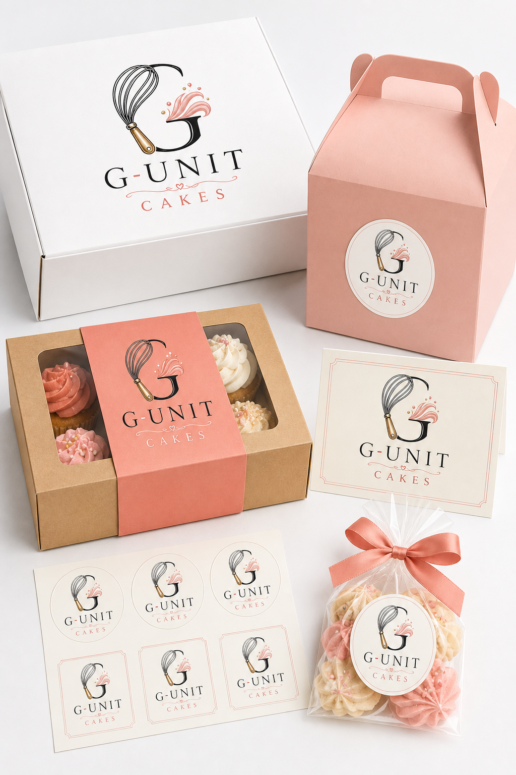
Cake box / handled box / cupcake sleeve / thank-you card / labels / treat bag

10 / G-UNIT CAKES

Brand applications
  - Use the same visual cues at the moments customers see, carry, photograph, gift, and share the product.
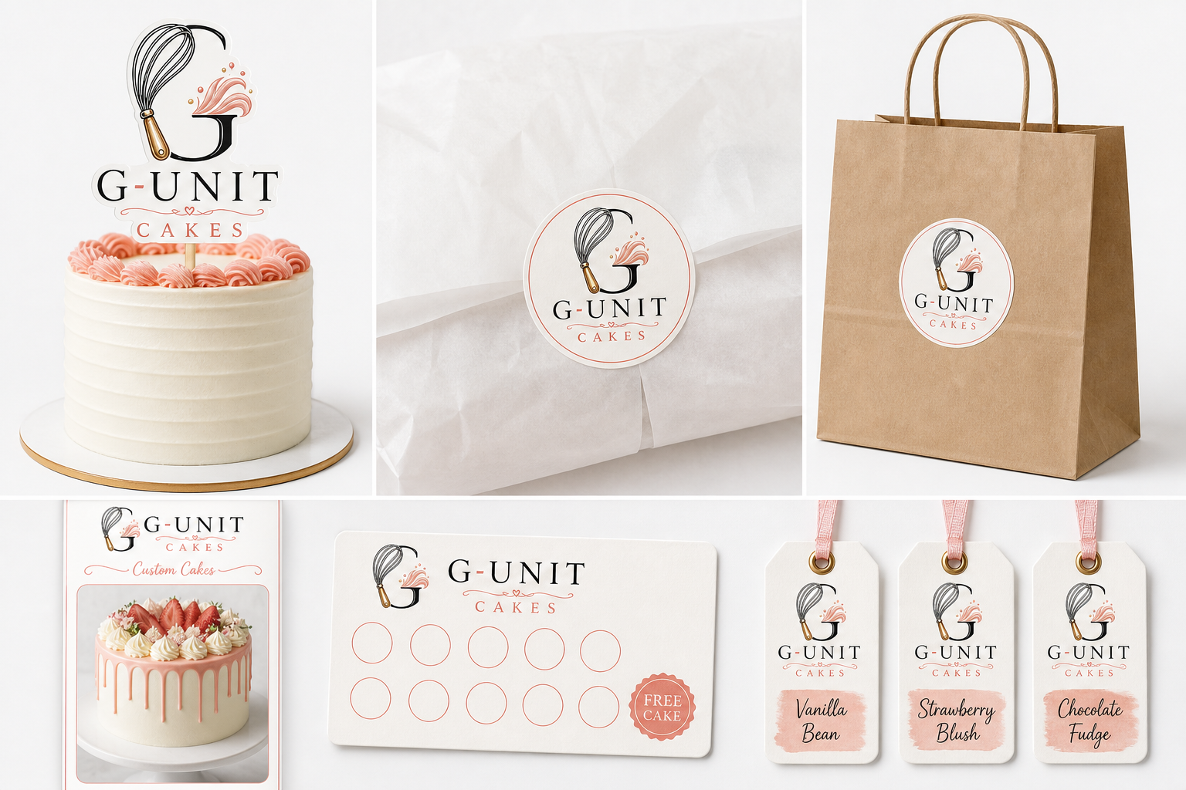
APPLICATION PRINCIPLE
Use one confident logo placement, one clear message, and enough quiet space for the cake or product to remain the focus.

11 / G-UNIT CAKES

Digital and social
  - Digital touchpoints should make discovery appetising and ordering reassuringly simple.

Website
- Use the full logo in the header and a simplified symbol for the favicon.
- Lead with clear cake photography and a direct custom-order action.
- Collect event date, servings, flavour, style, budget, delivery or collection, and inspiration images.
- Keep Instagram, WhatsApp, and TikTok links as placeholders until the final accounts are supplied.

Social formats
Feed posts  4:5 portrait. Keep text overlays short and inside safe margins. | Stories and video  9:16. Start with the finished cake or a strong making moment.
Profile image  Use the circular G/whisk seal once a clean symbol-only asset is approved. | Content rhythm  Alternate finished cakes, details, process, customer moments, and ordering prompts.

WhatsApp ordering
ORDER SUMMARY
Design / servings / flavour / price / payment status / collection or delivery / final date and time

Confirm availability before detailed decoration discussions, then keep the final agreed details together in one clear message.

12 / G-UNIT CAKES

Asset control
  - Consistent files and approvals protect the identity as the bakery grows.

Current logo assets
Asset | File
Screenshot-matched SVG | g-unit-cakes-logo-from-screenshot.svg
Transparent PNG | g-unit-cakes-logo-from-screenshot.png
Editable vector recreation | g-unit-cakes-logo.svg
High-resolution PNG | g-unit-cakes-logo.png

Naming convention
FILE PATTERN
g-unit-cakes-[asset]-[variant]-[colour]-[size].[ext]

Example: g-unit-cakes-logo-stacked-full-colour-2000px.png

Approval checklist
- Correct logo version, colour, clear space, and minimum size.
- Approved typefaces and palette.
- Cake is clear, accurate, and appetising.
- Copy sounds warm, clear, and celebratory.
- Order details, prices, dates, and contact links are correct.
- Final artwork is proofed in its actual format before publishing or printing.

