LLDD FE - Master and Config
SBP Mall - ระบบประกันรายได้ | Low Level Design Document

แนวทางการใช้เอกสาร
หัวข้อ | คำอธิบาย
วัตถุประสงค์ | ใช้เป็นรายละเอียดระดับพัฒนาสำหรับออกแบบ ลงมือพัฒนา ตรวจทาน และทดสอบขอบเขตที่ระบุในฉบับนี้
ลำดับการอ่าน | เริ่มจาก Overview และ Scope จากนั้นตรวจ Field/Validation, Implementation, Contract, Processing Flow, Acceptance Criteria และ Test Checklist ตามลำดับ
ผลลัพธ์ที่คาดหวัง | ผู้อ่านสามารถระบุ input, ขั้นตอนประมวลผล, output, เงื่อนไขผิดพลาด และหลักฐานการทดสอบได้จากเนื้อหาในฉบับเดียว

คำว่า Input, Progress และ Output ในเอกสารนี้หมายถึงข้อมูลตั้งต้น ลำดับการทำงาน และผลลัพธ์ที่ตรวจสอบได้ของขอบเขตที่กำลังพัฒนา

1. Overview
รายการ | รายละเอียด
Track | FE
Estimate | 30 ชั่วโมง
Owner | Peerakorn <Pete> Sakunkaewphithak
Objective | สร้างหน้าจอผู้ปฏิบัติงาน ปัจจัยภายนอก สิทธิ์เมนู และตั้งค่าระบบ

Common contract reference: ทุกหัวข้อ API/FE ต้องยึด LLDD-BE-API-Common-Contracts.pdf และ LLDD-FE-Integration-Contracts.pdf สำหรับ error/auth/format/pagination/action/RBAC ก่อนลงรายละเอียดเฉพาะหน้าหรือเฉพาะ endpoint

2. Screen / Functional Scope
- Operator master
- External factor master
- Menu permission
- System/Global Config (SCR-11)
- CRUD modal
- Audit/reason

3. Screenshot Reference
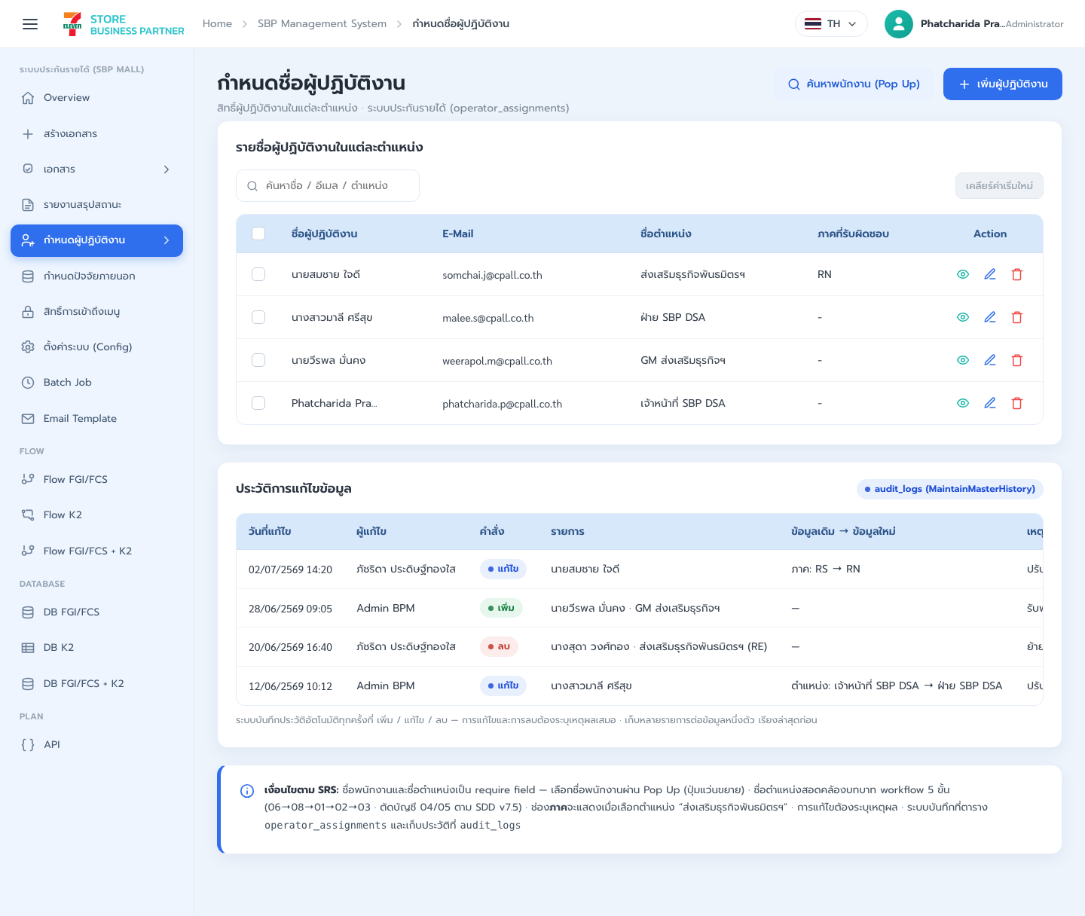
รูปที่ 1: Screenshot: k2-operators-01.png
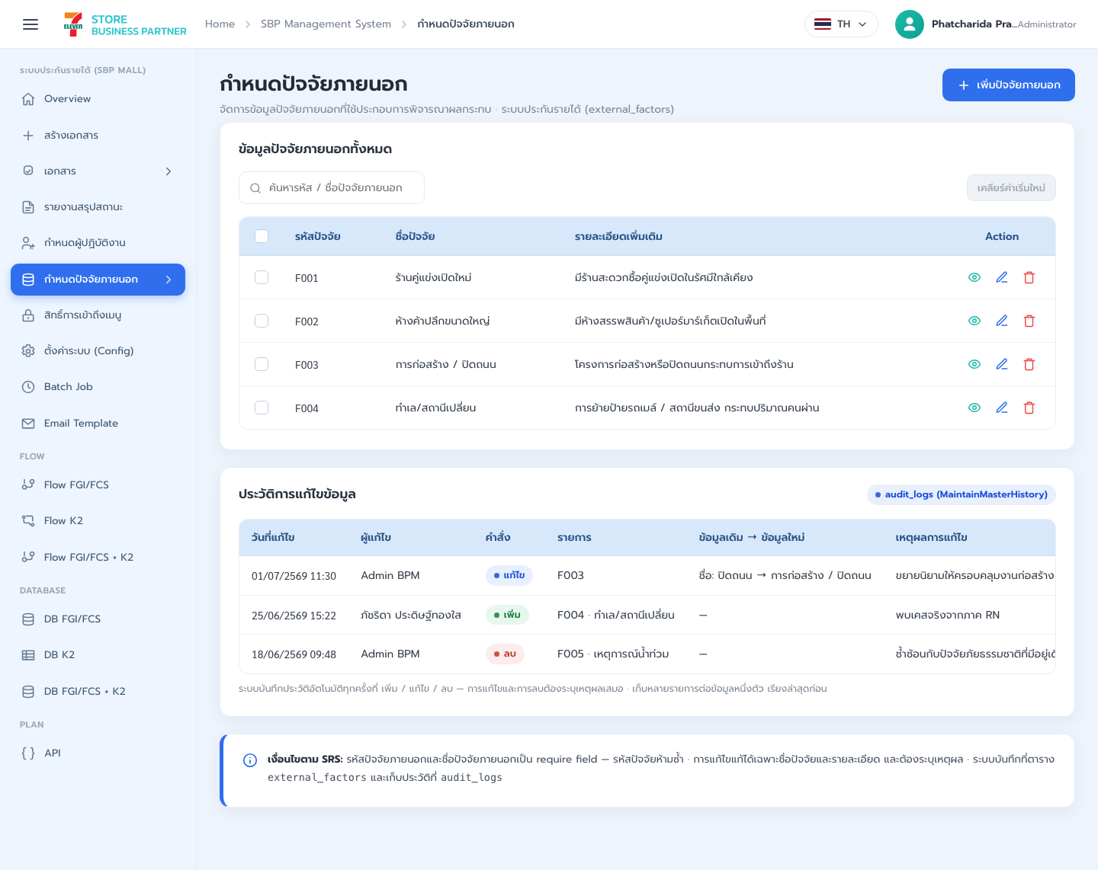
รูปที่ 2: Screenshot: k2-factors-01.png
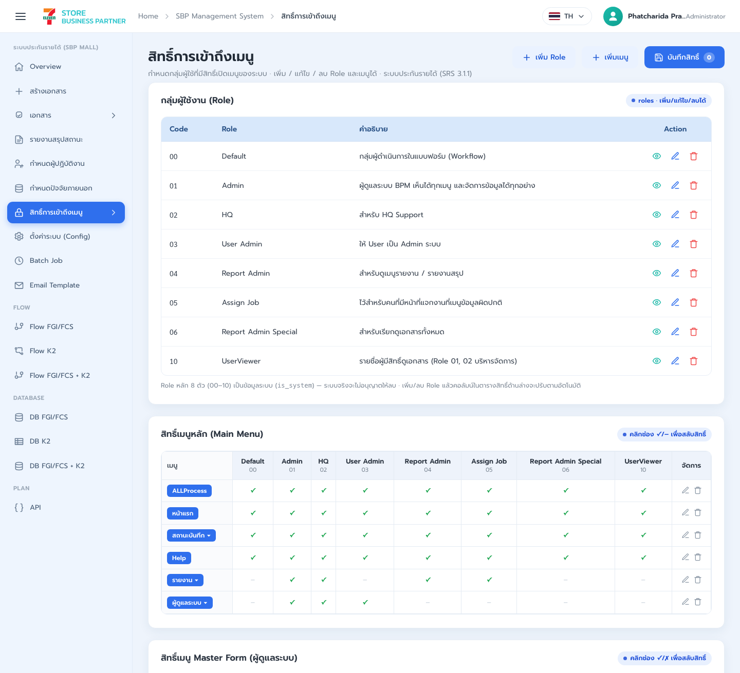
รูปที่ 3: Screenshot: k2-permissions-01.png
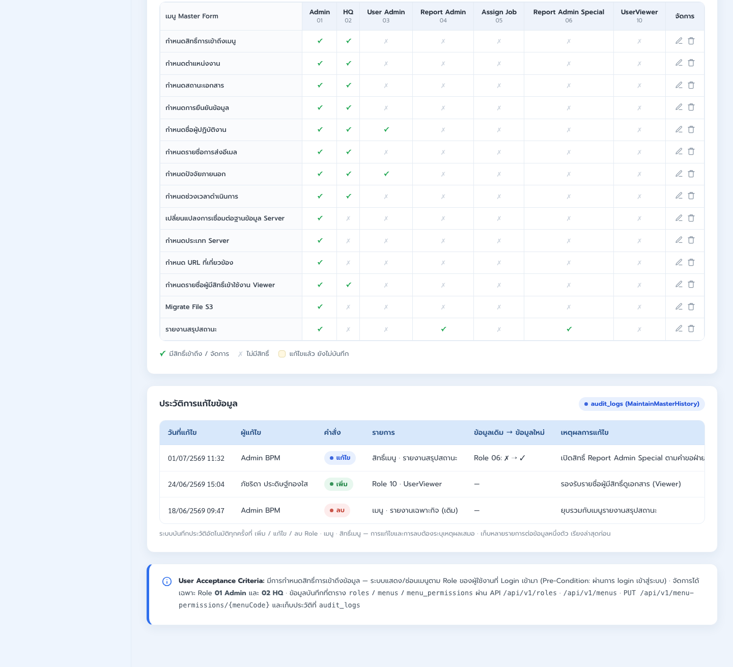
รูปที่ 4: Screenshot: k2-permissions-02.png
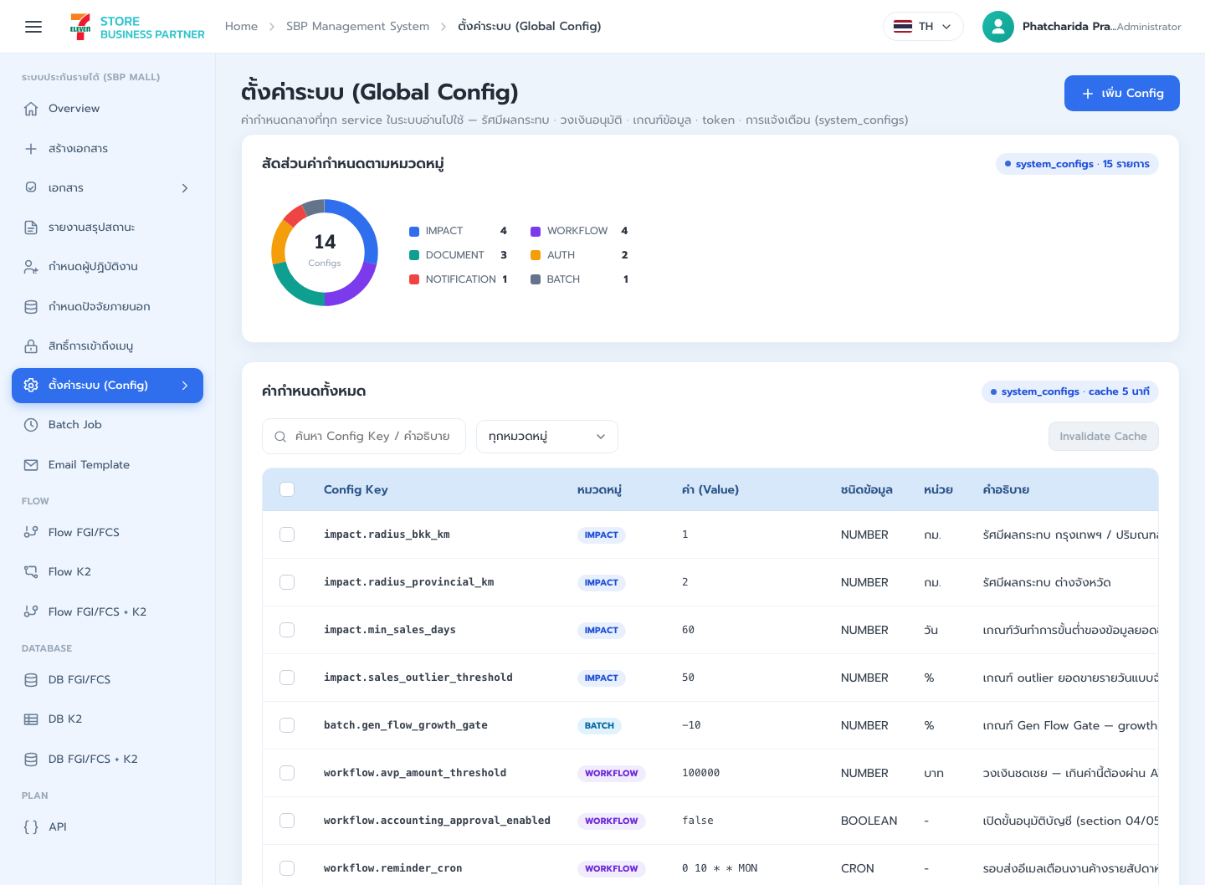
รูปที่ 5: Screenshot: system-config-01.png
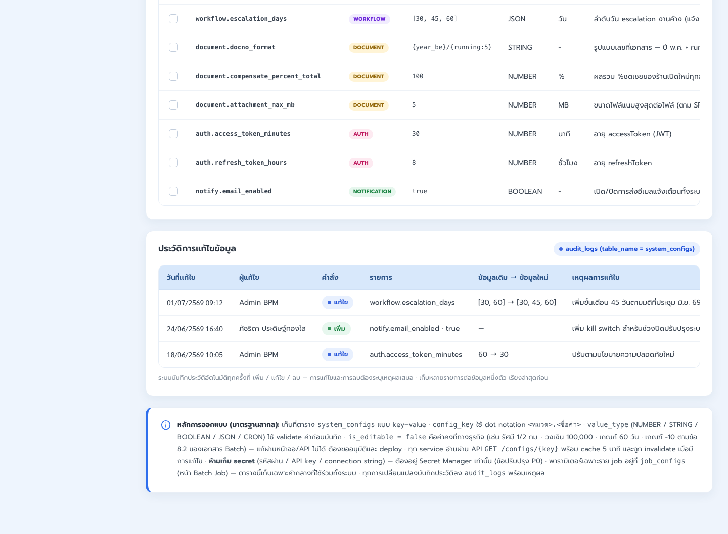
รูปที่ 6: Screenshot: system-config-02.png

4. Implementation Flow Diagram (Reference)
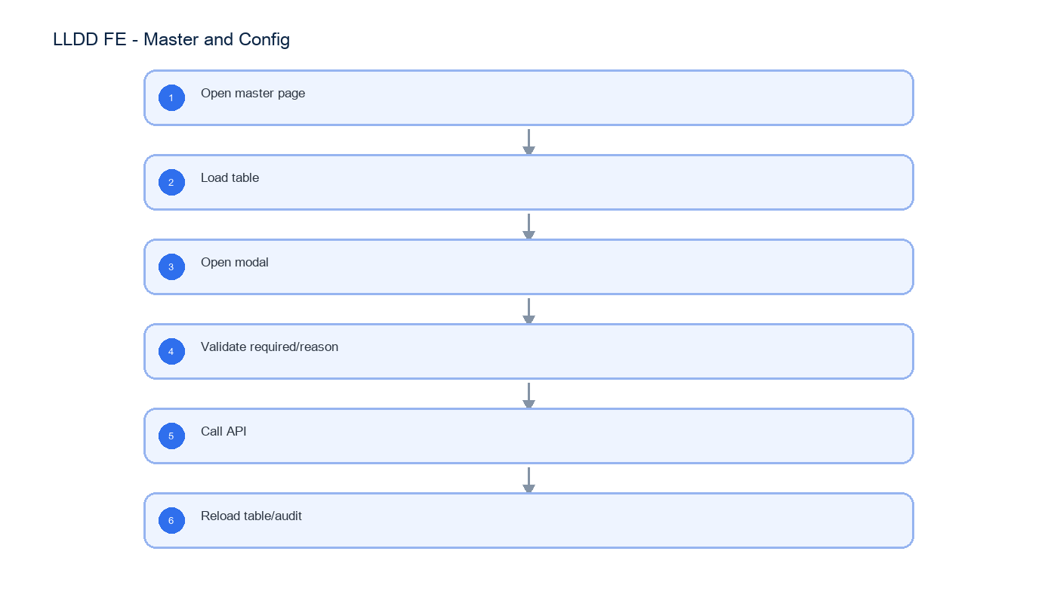
รูปที่ 7: Implementation flow reference: LLDD FE - Master and Config

5. Field, Format, and Validation
Field / UI | Format | Validation | Behavior
employeeName | string | required | เลือกจาก popup/search
position | dropdown | required | เลือกตำแหน่ง
factorCode | string | required unique | ห้ามซ้ำ
reason | text | required on edit/delete | บันทึก audit
configValue | string/number/boolean | validate by type | ห้ามแก้ is_editable=false

5.1 Screen Boundary and Route Matrix
หัวข้อนี้ประกอบด้วย 4 หน้าจออิสระ แต่ละหน้ามี route, state, validation และ endpoint ของตนเอง ห้าม implement เป็น form/table เดียวที่สลับชนิดข้อมูลด้วยเงื่อนไขใน component เดียว
Screen | Route / Component | Primary model | Main operations
SCR-08 ผู้ปฏิบัติงาน | /admin/operators / OperatorAssignmentPage | OperatorAssignment | search employee, list, add, edit, deactivate, audit reason
SCR-09 ปัจจัยภายนอก | /admin/external-factors / ExternalFactorPage | ExternalFactor | list, add, edit, delete, duplicate-code guard
SCR-10 สิทธิ์เมนู | /admin/menu-permissions / MenuPermissionPage | MenuPermissionMatrix | load roles/menus, toggle canView, save per menu, refresh guard
SCR-11 ตั้งค่าระบบ | /admin/system-config / SystemConfigPage | SystemConfig | list, typed editor, immutable-key guard, audit reason

5.2 SCR-08 Operator Assignment
Field | Type | Required / Rule | UI behavior
id | integer | response only | row key
employeeId | string | required; selected from employee search | store employee id, not display name
employeeName | string | read-only | filled from selected employee
positionCode | enum 06|08|01|02|03 | required | workflow position selector
zoneCode | string | null | optional by position | preserve leading zero if numeric-looking
active | boolean | required | deactivation requires reason
reason | string | required for create/update/deactivate | audit dialog before submit

5.3 SCR-09 External Factor
Field | Type | Required / Rule | UI behavior
factorCode | string | required; unique; immutable after create | uppercase and trim before submit
factorName | string | required; 1..200 chars | Thai UTF-8 supported
description | string | null | optional; max 1000 chars | multiline editor
active | boolean | required | inactive rows remain visible under filter
reason | string | required for mutation | include in request and audit

5.4 SCR-10 Menu Permission Matrix
Field | Type | Required / Rule | UI behavior
menuCode | string | required; row key | one menu per row
menuName | string | response only | Thai display label
permissions[].roleCode | string | required | one column per role
permissions[].canView | boolean | required | toggle; dirty state tracked per menu
reason | string | required on save | save one menu row atomically

5.5 SCR-11 System Config
Field | Type | Required / Rule | UI behavior
key | string | required; unique; immutable | configuration key
value | string | number | boolean | required; validate by valueType | typed control, never secret input
valueType | enum STRING|INTEGER|DECIMAL|BOOLEAN|URL | required | drives editor and validation
editable | boolean | response only | false disables edit/delete
description | string | required | explain runtime impact
reason | string | required for mutation | audit dialog before submit

5.6 Screen-level Acceptance
- แต่ละ SCR มี route/component/state แยกและสามารถ test/release แยกกันได้
- mutation ทุกหน้าส่ง reason และ refresh เฉพาะ resource ที่เปลี่ยน
- SCR-08 ไม่รับ employeeName ที่พิมพ์เองแทน employeeId จากผลค้นหา
- SCR-09 กัน factorCode ซ้ำทั้ง client response handling และ BE error
- SCR-10 rollback toggle เมื่อ save ล้มเหลวและคง dirty indication
- SCR-11 ไม่ render secret value และห้ามแก้ record ที่ editable=false

5.1 Input / Progress / Output Contract
Stage | Contract for implementation
Input | GET /api/v1/operators; POST /api/v1/operators; PUT /api/v1/operators/{id}
Progress | Open master page; Load table; Open modal; Validate required/reason
Output | Rendered UI state or normalized API response with status/message and audit-ready trace reference.

5.90 Master and Config Component Contract
ID | Component / Scope | Single responsibility | Definition of done
C01 | Operator master | โหลด/ค้นหา/เพิ่ม/แก้/ปิด operator โดยเลือก employee จาก employee search | duplicate/invalid employee ถูก block และ mutation สำเร็จ refresh row/audit
C02 | External factor master | จัดการ factor CRUD รวม DELETE เฉพาะรายการที่ไม่ถูกใช้งานและต้องมี reason | factorCode ซ้ำไม่ได้, conflict แสดงข้อความ และ deleted row หายหลัง refresh
C03 | Menu permission | render role x menu matrix จาก canAccess และบันทึก permission ราย menu | toggle optimistic ได้เฉพาะเมื่อ rollback on error และค่าหลัง reload ตรงฐานข้อมูล
C04 | System/Global Config (SCR-11) | render config ตาม valueType/unit/isEditable และกัน secret/locked config จากการแก้ | type/range validation ผ่านและ isEditable=false ไม่มี enabled mutation control
C05 | CRUD modal | ใช้ modal mode ADD/EDIT/DELETE แยก initial values, validation และ confirm copy | เปลี่ยน mode ไม่ทิ้ง stale field และปุ่ม submit กัน double request
C06 | Audit/reason | บังคับ reason สำหรับ mutation และแสดง auditId/updatedBy/updatedAt หลังบันทึก | mutation ที่ไม่มี reason ไม่ออก request และ evidence trace กลับ audit log ได้

5.91 Master and Config API Adapter Map
Endpoint | Typed adapter purpose | Invoked by
GET /api/v1/operators | SCR-08 list/filter ผู้ปฏิบัติงาน | Add/Edit/Delete (modal action)
POST /api/v1/operators | SCR-08 เพิ่มผู้ปฏิบัติงาน | Search employee (แว่นขยาย)
PUT /api/v1/operators/{id} | SCR-08 แก้ไข/ปิดใช้งานผู้ปฏิบัติงาน | Save permission (toggle permission)
GET /api/v1/employees/search | SCR-08 popup ค้นหาพนักงาน | Search employee (แว่นขยาย)
GET /api/v1/factors | SCR-09 list/filter ปัจจัยภายนอก | Search employee (แว่นขยาย)
POST /api/v1/factors | SCR-09 เพิ่มปัจจัยภายนอก | Save permission (toggle permission)
PUT /api/v1/factors/{code} | SCR-09 แก้ไขปัจจัยภายนอก | Add/Edit/Delete (modal action)
DELETE /api/v1/factors/{code} | SCR-09 ลบปัจจัยภายนอกที่ไม่ถูกใช้งาน | Search employee (แว่นขยาย)
GET /api/v1/menu-permissions | อ่าน matrix สิทธิ์เมนูทุก role | Save permission (toggle permission)
PUT /api/v1/menu-permissions/{menuCode} | บันทึกสิทธิ์เมนูรายเมนู | Save permission (toggle permission)
GET /api/v1/configs | SCR-11 list ค่าระบบ | Search employee (แว่นขยาย)
POST /api/v1/configs | SCR-11 เพิ่มค่าระบบที่ไม่ใช่ secret | Save permission (toggle permission)
PUT /api/v1/configs/{key} | SCR-11 แก้ค่าระบบที่ editable=true | Add/Edit/Delete (modal action)

5.92 Master and Config Interaction State Machine
Action | Trigger | API / State transition | Expected visible result
Add/Edit/Delete | modal action | POST/PUT/DELETE master API | update table + audit
Search employee | แว่นขยาย | GET /api/v1/employees/search | select employee
Save permission | toggle permission | PUT /api/v1/menu-permissions/{menuCode} | save matrix

5.93 Master and Config Feature Failure Checks
Case | Feature-specific scenario | Expected evidence
FE-01 | add operator | แก้ master ต้องมี reason
FE-02 | edit factor without reason | factorCode ซ้ำไม่ได้
FE-03 | duplicate factor | permission toggle save ได้
FE-04 | save permission | config type validate
FE-05 | edit locked config | แก้ master ต้องมี reason

6. Button / User Action Mapping
Action | Trigger | API / Service | Expected Result
Add/Edit/Delete | modal action | POST/PUT/DELETE master API | update table + audit
Search employee | แว่นขยาย | GET /api/v1/employees/search | select employee
Save permission | toggle permission | PUT /api/v1/menu-permissions/{menuCode} | save matrix

7. API Contract

GET /api/v1/operators
SCR-08 list/filter ผู้ปฏิบัติงาน
Query Params
{
"q": "สมชาย",
"positionCode": "06",
"active": true,
"page": 1,
"size": 20
}

Request Field Schema
Field | Type | Required | Constraint / Meaning
q | string | No | UTF-8; use value domain described by endpoint purpose
positionCode | string | No | UTF-8; use value domain described by endpoint purpose
active | boolean | No | UTF-8; use value domain described by endpoint purpose
page | integer | No | >= 1; default 1
size | integer | No | 1..100; default 20

Response
{
"page": 1,
"size": 20,
"total": 1,
"items": [
{
"id": 1,
"employeeId": "E001",
"employeeName": "สมชาย ใจดี",
"positionCode": "06",
"zoneCode": "01",
"active": true,
"updatedAt": "2026-07-22T10:00:00+07:00"
}
]
}

Response Field Schema
Field | Type | Required | Constraint / Meaning
page | integer | Yes | >= 1; default 1
size | integer | Yes | 1..100; default 20
total | integer | Yes | UTF-8; use value domain described by endpoint purpose
items | array<object> | Yes | JSON array; element type shown in Type column
items[].id | integer | Yes | UTF-8; use value domain described by endpoint purpose
items[].employeeId | string | Yes | UTF-8; use value domain described by endpoint purpose
items[].employeeName | string | Yes | UTF-8; use value domain described by endpoint purpose
items[].positionCode | string | Yes | UTF-8; use value domain described by endpoint purpose
items[].zoneCode | string | Yes | UTF-8; use value domain described by endpoint purpose
items[].active | boolean | Yes | UTF-8; use value domain described by endpoint purpose
items[].updatedAt | string | Yes | ISO-8601 ค.ศ.; nullable only when type includes null

POST /api/v1/operators
SCR-08 เพิ่มผู้ปฏิบัติงาน
Request
{
"employeeId": "E001",
"positionCode": "06",
"zoneCode": "01",
"active": true,
"reason": "เพิ่มผู้รับผิดชอบ"
}

Request Field Schema
Field | Type | Required | Constraint / Meaning
employeeId | string | Yes | UTF-8; use value domain described by endpoint purpose
positionCode | string | Yes | UTF-8; use value domain described by endpoint purpose
zoneCode | string | Yes | UTF-8; use value domain described by endpoint purpose
active | boolean | Yes | UTF-8; use value domain described by endpoint purpose
reason | string | Yes | trimmed UTF-8 Thai text; required by operation/business rule

Response
{
"id": 1,
"message": "saved",
"auditId": 901
}

Response Field Schema
Field | Type | Required | Constraint / Meaning
id | integer | Yes | UTF-8; use value domain described by endpoint purpose
message | string | Yes | UTF-8; use value domain described by endpoint purpose
auditId | integer | Yes | UTF-8; use value domain described by endpoint purpose

PUT /api/v1/operators/{id}
SCR-08 แก้ไข/ปิดใช้งานผู้ปฏิบัติงาน
Request
{
"positionCode": "08",
"zoneCode": "01",
"active": true,
"reason": "ย้ายหน้าที่"
}

Request Field Schema
Field | Type | Required | Constraint / Meaning
positionCode | string | Yes | UTF-8; use value domain described by endpoint purpose
zoneCode | string | Yes | UTF-8; use value domain described by endpoint purpose
active | boolean | Yes | UTF-8; use value domain described by endpoint purpose
reason | string | Yes | trimmed UTF-8 Thai text; required by operation/business rule

Response
{
"id": 1,
"message": "saved",
"auditId": 902
}

Response Field Schema
Field | Type | Required | Constraint / Meaning
id | integer | Yes | UTF-8; use value domain described by endpoint purpose
message | string | Yes | UTF-8; use value domain described by endpoint purpose
auditId | integer | Yes | UTF-8; use value domain described by endpoint purpose

GET /api/v1/employees/search
SCR-08 popup ค้นหาพนักงาน
Query Params
{
"q": "E001",
"page": 1,
"size": 20
}

Request Field Schema
Field | Type | Required | Constraint / Meaning
q | string | No | UTF-8; use value domain described by endpoint purpose
page | integer | No | >= 1; default 1
size | integer | No | 1..100; default 20

Response
{
"page": 1,
"size": 20,
"total": 1,
"items": [
{
"employeeId": "E001",
"employeeName": "สมชาย ใจดี",
"email": "somchai@example.test",
"active": true
}
]
}

Response Field Schema
Field | Type | Required | Constraint / Meaning
page | integer | Yes | >= 1; default 1
size | integer | Yes | 1..100; default 20
total | integer | Yes | UTF-8; use value domain described by endpoint purpose
items | array<object> | Yes | JSON array; element type shown in Type column
items[].employeeId | string | Yes | UTF-8; use value domain described by endpoint purpose
items[].employeeName | string | Yes | UTF-8; use value domain described by endpoint purpose
items[].email | string | Yes | UTF-8; use value domain described by endpoint purpose
items[].active | boolean | Yes | UTF-8; use value domain described by endpoint purpose

GET /api/v1/factors
SCR-09 list/filter ปัจจัยภายนอก
Query Params
{
"q": "ถนน",
"active": true,
"page": 1,
"size": 20
}

Request Field Schema
Field | Type | Required | Constraint / Meaning
q | string | No | UTF-8; use value domain described by endpoint purpose
active | boolean | No | UTF-8; use value domain described by endpoint purpose
page | integer | No | >= 1; default 1
size | integer | No | 1..100; default 20

Response
{
"page": 1,
"size": 20,
"total": 1,
"items": [
{
"factorCode": "F001",
"factorName": "ก่อสร้างถนน",
"description": "ผลกระทบจากการก่อสร้าง",
"active": true,
"updatedAt": "2026-07-22T10:00:00+07:00"
}
]
}

Response Field Schema
Field | Type | Required | Constraint / Meaning
page | integer | Yes | >= 1; default 1
size | integer | Yes | 1..100; default 20
total | integer | Yes | UTF-8; use value domain described by endpoint purpose
items | array<object> | Yes | JSON array; element type shown in Type column
items[].factorCode | string | Yes | UTF-8; use value domain described by endpoint purpose
items[].factorName | string | Yes | UTF-8; use value domain described by endpoint purpose
items[].description | string | Yes | UTF-8; use value domain described by endpoint purpose
items[].active | boolean | Yes | UTF-8; use value domain described by endpoint purpose
items[].updatedAt | string | Yes | ISO-8601 ค.ศ.; nullable only when type includes null

POST /api/v1/factors
SCR-09 เพิ่มปัจจัยภายนอก
Request
{
"factorCode": "F001",
"factorName": "ก่อสร้างถนน",
"description": "ผลกระทบจากการก่อสร้าง",
"active": true,
"reason": "เพิ่ม master"
}

Request Field Schema
Field | Type | Required | Constraint / Meaning
factorCode | string | Yes | UTF-8; use value domain described by endpoint purpose
factorName | string | Yes | UTF-8; use value domain described by endpoint purpose
description | string | Yes | UTF-8; use value domain described by endpoint purpose
active | boolean | Yes | UTF-8; use value domain described by endpoint purpose
reason | string | Yes | trimmed UTF-8 Thai text; required by operation/business rule

Response
{
"factorCode": "F001",
"message": "saved",
"auditId": 903
}

Response Field Schema
Field | Type | Required | Constraint / Meaning
factorCode | string | Yes | UTF-8; use value domain described by endpoint purpose
message | string | Yes | UTF-8; use value domain described by endpoint purpose
auditId | integer | Yes | UTF-8; use value domain described by endpoint purpose

PUT /api/v1/factors/{code}
SCR-09 แก้ไขปัจจัยภายนอก
Request
{
"factorName": "ก่อสร้างถนนระยะยาว",
"description": "กระทบการเข้าร้าน",
"active": true,
"reason": "ปรับคำอธิบาย"
}

Request Field Schema
Field | Type | Required | Constraint / Meaning
factorName | string | Yes | UTF-8; use value domain described by endpoint purpose
description | string | Yes | UTF-8; use value domain described by endpoint purpose
active | boolean | Yes | UTF-8; use value domain described by endpoint purpose
reason | string | Yes | trimmed UTF-8 Thai text; required by operation/business rule

Response
{
"factorCode": "F001",
"message": "saved",
"auditId": 904
}

Response Field Schema
Field | Type | Required | Constraint / Meaning
factorCode | string | Yes | UTF-8; use value domain described by endpoint purpose
message | string | Yes | UTF-8; use value domain described by endpoint purpose
auditId | integer | Yes | UTF-8; use value domain described by endpoint purpose

DELETE /api/v1/factors/{code}
SCR-09 ลบปัจจัยภายนอกที่ไม่ถูกใช้งาน
Request
{
"reason": "ยกเลิกค่า master"
}

Request Field Schema
Field | Type | Required | Constraint / Meaning
reason | string | Yes | trimmed UTF-8 Thai text; required by operation/business rule

Response
{
"factorCode": "F001",
"deleted": true,
"auditId": 907
}

Response Field Schema
Field | Type | Required | Constraint / Meaning
factorCode | string | Yes | UTF-8; use value domain described by endpoint purpose
deleted | boolean | Yes | UTF-8; use value domain described by endpoint purpose
auditId | integer | Yes | UTF-8; use value domain described by endpoint purpose

GET /api/v1/menu-permissions
อ่าน matrix สิทธิ์เมนูทุก role
Query Params
{
"roleCode": "04"
}

Request Field Schema
Field | Type | Required | Constraint / Meaning
roleCode | string | No | canonical code; do not replace with display label

Response
{
"items": [
{
"menuCode": "k2-report",
"roleCode": "04",
"canView": true
}
]
}

Response Field Schema
Field | Type | Required | Constraint / Meaning
items | array<object> | Yes | JSON array; element type shown in Type column
items[].menuCode | string | Yes | UTF-8; use value domain described by endpoint purpose
items[].roleCode | string | Yes | canonical code; do not replace with display label
items[].canView | boolean | Yes | UTF-8; use value domain described by endpoint purpose

PUT /api/v1/menu-permissions/{menuCode}
บันทึกสิทธิ์เมนูรายเมนู
Request
{
"roleCode": "04",
"canView": true,
"reason": "ปรับสิทธิ์รายงาน"
}

Request Field Schema
Field | Type | Required | Constraint / Meaning
roleCode | string | Yes | canonical code; do not replace with display label
canView | boolean | Yes | UTF-8; use value domain described by endpoint purpose
reason | string | Yes | trimmed UTF-8 Thai text; required by operation/business rule

Response
{
"message": "saved"
}

Response Field Schema
Field | Type | Required | Constraint / Meaning
message | string | Yes | UTF-8; use value domain described by endpoint purpose

GET /api/v1/configs
SCR-11 list ค่าระบบ
Query Params
{
"q": "ATTACHMENT",
"page": 1,
"size": 20
}

Request Field Schema
Field | Type | Required | Constraint / Meaning
q | string | No | UTF-8; use value domain described by endpoint purpose
page | integer | No | >= 1; default 1
size | integer | No | 1..100; default 20

Response
{
"page": 1,
"size": 20,
"total": 1,
"items": [
{
"key": "MAX_ATTACHMENT_MB",
"value": 5,
"valueType": "INTEGER",
"editable": false,
"description": "ขนาดไฟล์แนบสูงสุด",
"updatedAt": "2026-07-22T10:00:00+07:00"
}
]
}

Response Field Schema
Field | Type | Required | Constraint / Meaning
page | integer | Yes | >= 1; default 1
size | integer | Yes | 1..100; default 20
total | integer | Yes | UTF-8; use value domain described by endpoint purpose
items | array<object> | Yes | JSON array; element type shown in Type column
items[].key | string | Yes | UTF-8; use value domain described by endpoint purpose
items[].value | integer | Yes | UTF-8; use value domain described by endpoint purpose
items[].valueType | string | Yes | UTF-8; use value domain described by endpoint purpose
items[].editable | boolean | Yes | UTF-8; use value domain described by endpoint purpose
items[].description | string | Yes | UTF-8; use value domain described by endpoint purpose
items[].updatedAt | string | Yes | ISO-8601 ค.ศ.; nullable only when type includes null

POST /api/v1/configs
SCR-11 เพิ่มค่าระบบที่ไม่ใช่ secret
Request
{
"key": "REPORT_PAGE_SIZE",
"value": 20,
"valueType": "INTEGER",
"description": "จำนวนแถวเริ่มต้น",
"reason": "เพิ่มค่า report"
}

Request Field Schema
Field | Type | Required | Constraint / Meaning
key | string | Yes | UTF-8; use value domain described by endpoint purpose
value | integer | Yes | UTF-8; use value domain described by endpoint purpose
valueType | string | Yes | UTF-8; use value domain described by endpoint purpose
description | string | Yes | UTF-8; use value domain described by endpoint purpose
reason | string | Yes | trimmed UTF-8 Thai text; required by operation/business rule

Response
{
"key": "REPORT_PAGE_SIZE",
"message": "saved",
"auditId": 905
}

Response Field Schema
Field | Type | Required | Constraint / Meaning
key | string | Yes | UTF-8; use value domain described by endpoint purpose
message | string | Yes | UTF-8; use value domain described by endpoint purpose
auditId | integer | Yes | UTF-8; use value domain described by endpoint purpose

PUT /api/v1/configs/{key}
SCR-11 แก้ค่าระบบที่ editable=true
Request
{
"value": 50,
"reason": "เพิ่มจำนวนแถว"
}

Request Field Schema
Field | Type | Required | Constraint / Meaning
value | integer | Yes | UTF-8; use value domain described by endpoint purpose
reason | string | Yes | trimmed UTF-8 Thai text; required by operation/business rule

Response
{
"key": "REPORT_PAGE_SIZE",
"value": 50,
"valueType": "INTEGER",
"editable": true,
"message": "saved",
"auditId": 906
}

Response Field Schema
Field | Type | Required | Constraint / Meaning
key | string | Yes | UTF-8; use value domain described by endpoint purpose
value | integer | Yes | UTF-8; use value domain described by endpoint purpose
valueType | string | Yes | UTF-8; use value domain described by endpoint purpose
editable | boolean | Yes | UTF-8; use value domain described by endpoint purpose
message | string | Yes | UTF-8; use value domain described by endpoint purpose
auditId | integer | Yes | UTF-8; use value domain described by endpoint purpose

9. Processing Flow
Step | Description
1 | Open master page
2 | Load table
3 | Open modal
4 | Validate required/reason
5 | Call API
6 | Reload table/audit

10. Acceptance Criteria
- แก้ master ต้องมี reason
- factorCode ซ้ำไม่ได้
- permission toggle save ได้
- config type validate

11. Developer Test Checklist
No | Test
1 | add operator
2 | edit factor without reason
3 | duplicate factor
4 | save permission
5 | edit locked config

