Adamaoua - Countdown Analysis

| **District** | **Population** | **Live Births** |
| --- | --- | --- |
| Bankim | 125,044 | 5,090 |
| Banyo | 172,457 | 7,019 |
| Belel | 53,387 | 2,173 |
| Dang | 93,039 | 3,787 |
| Djohong | 85,827 | 3,493 |
| Meiganga | 179,082 | 7,290 |
| Ngaoundal | 99,087 | 4,033 |
| Ngaoundere Rural | 118,948 | 4,842 |
| Ngaoundere Urbain | 388,865 | 15,829 |
| Tibati | 116,673 | 4,750 |
| Tignere | 130,191 | 5,300 |

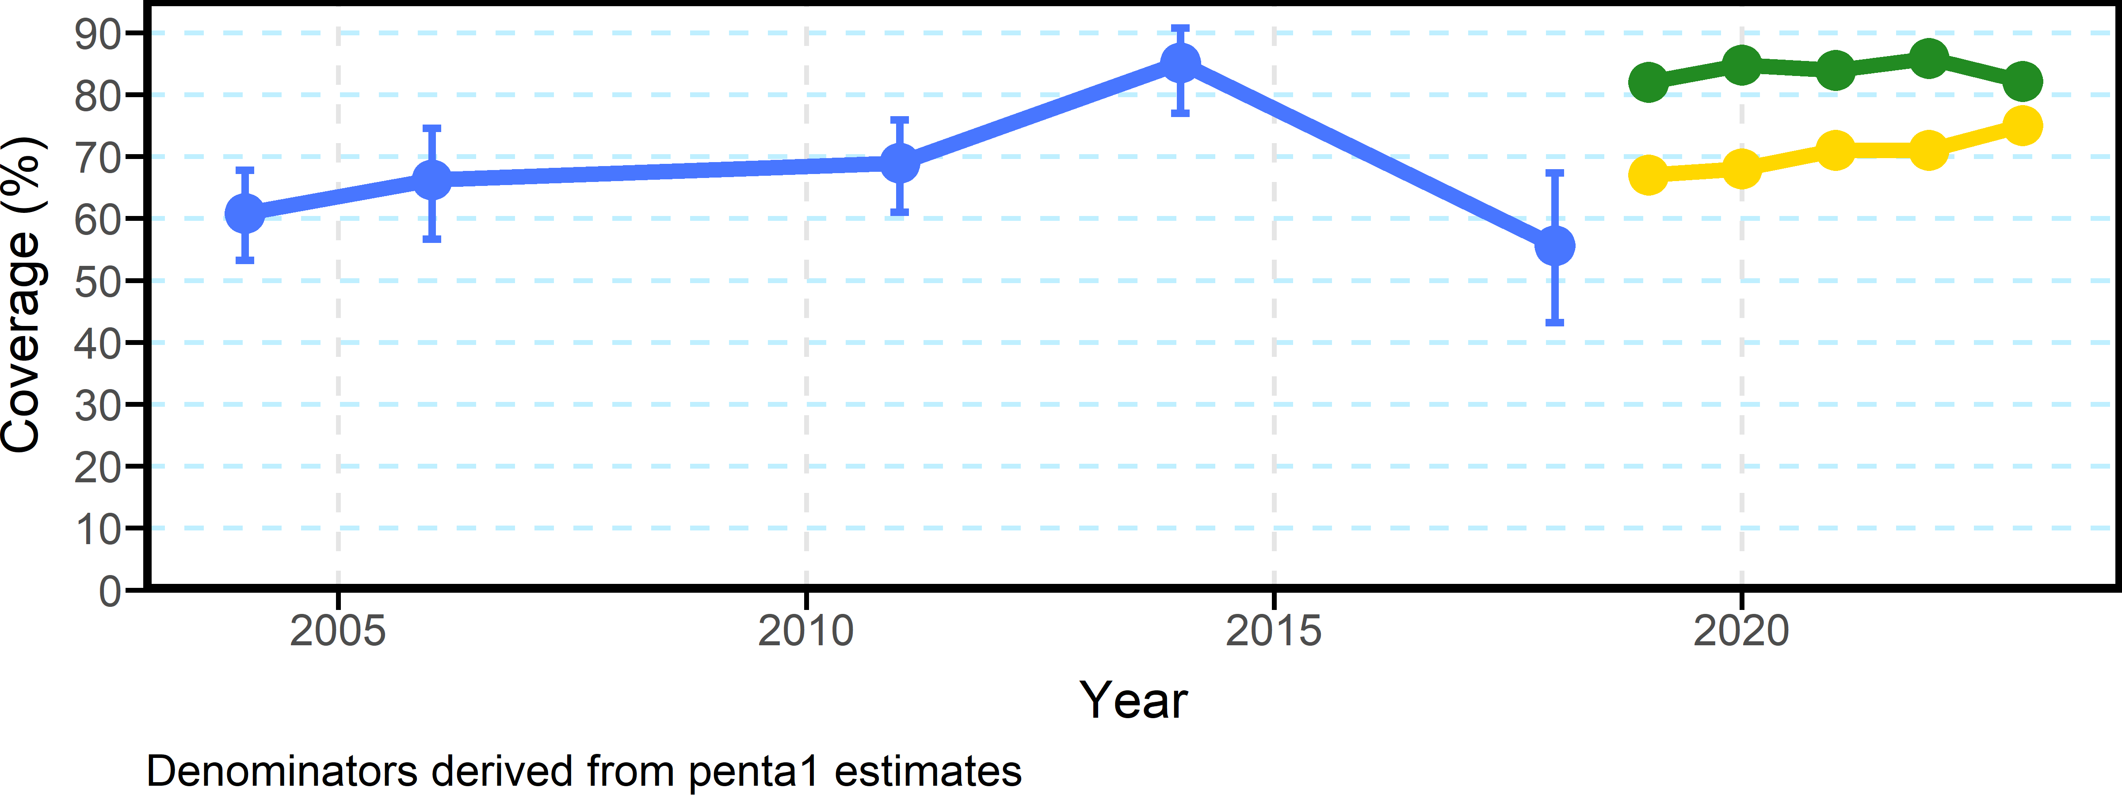

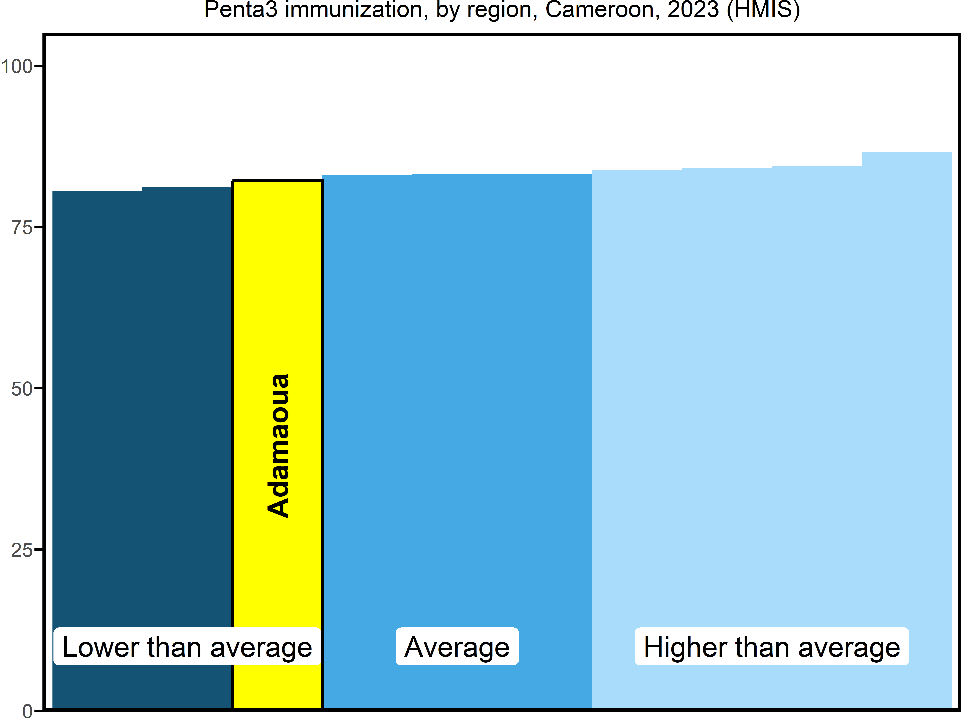

| **district** | **2019** | **2020** | **2021** | **2022** | **2023** |
| --- | --- | --- | --- | --- | --- |
| Bankim | 81 | 84 | 85 | 83 | 78 |
| Banyo | 82 | 87 | 85 | 84 | 85 |
| Belel | 74 | 88 | 80 | 82 | 74 |
| Dang | 80 | 86 | 88 | 89 | 79 |
| Djohong | 82 | 86 | 79 | 86 | 81 |
| Meiganga | 85 | 85 | 84 | 84 | 83 |
| Ngaoundal | 82 | 83 | 84 | 87 | 81 |
| Ngaoundere Rural | 81 | 79 | 87 | 86 | 84 |
| Ngaoundere Urbain | 81 | 84 | 83 | 88 | 84 |
| Tibati | 84 | 90 | 85 | 86 | 81 |
| Tignere | 84 | 83 | 82 | 87 | 81 |

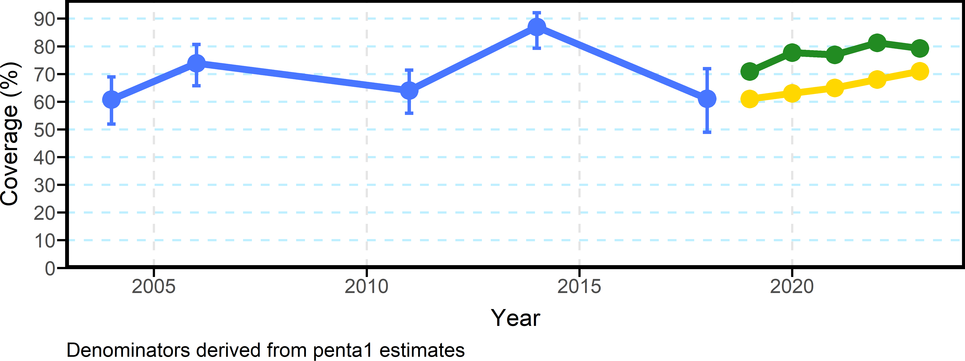

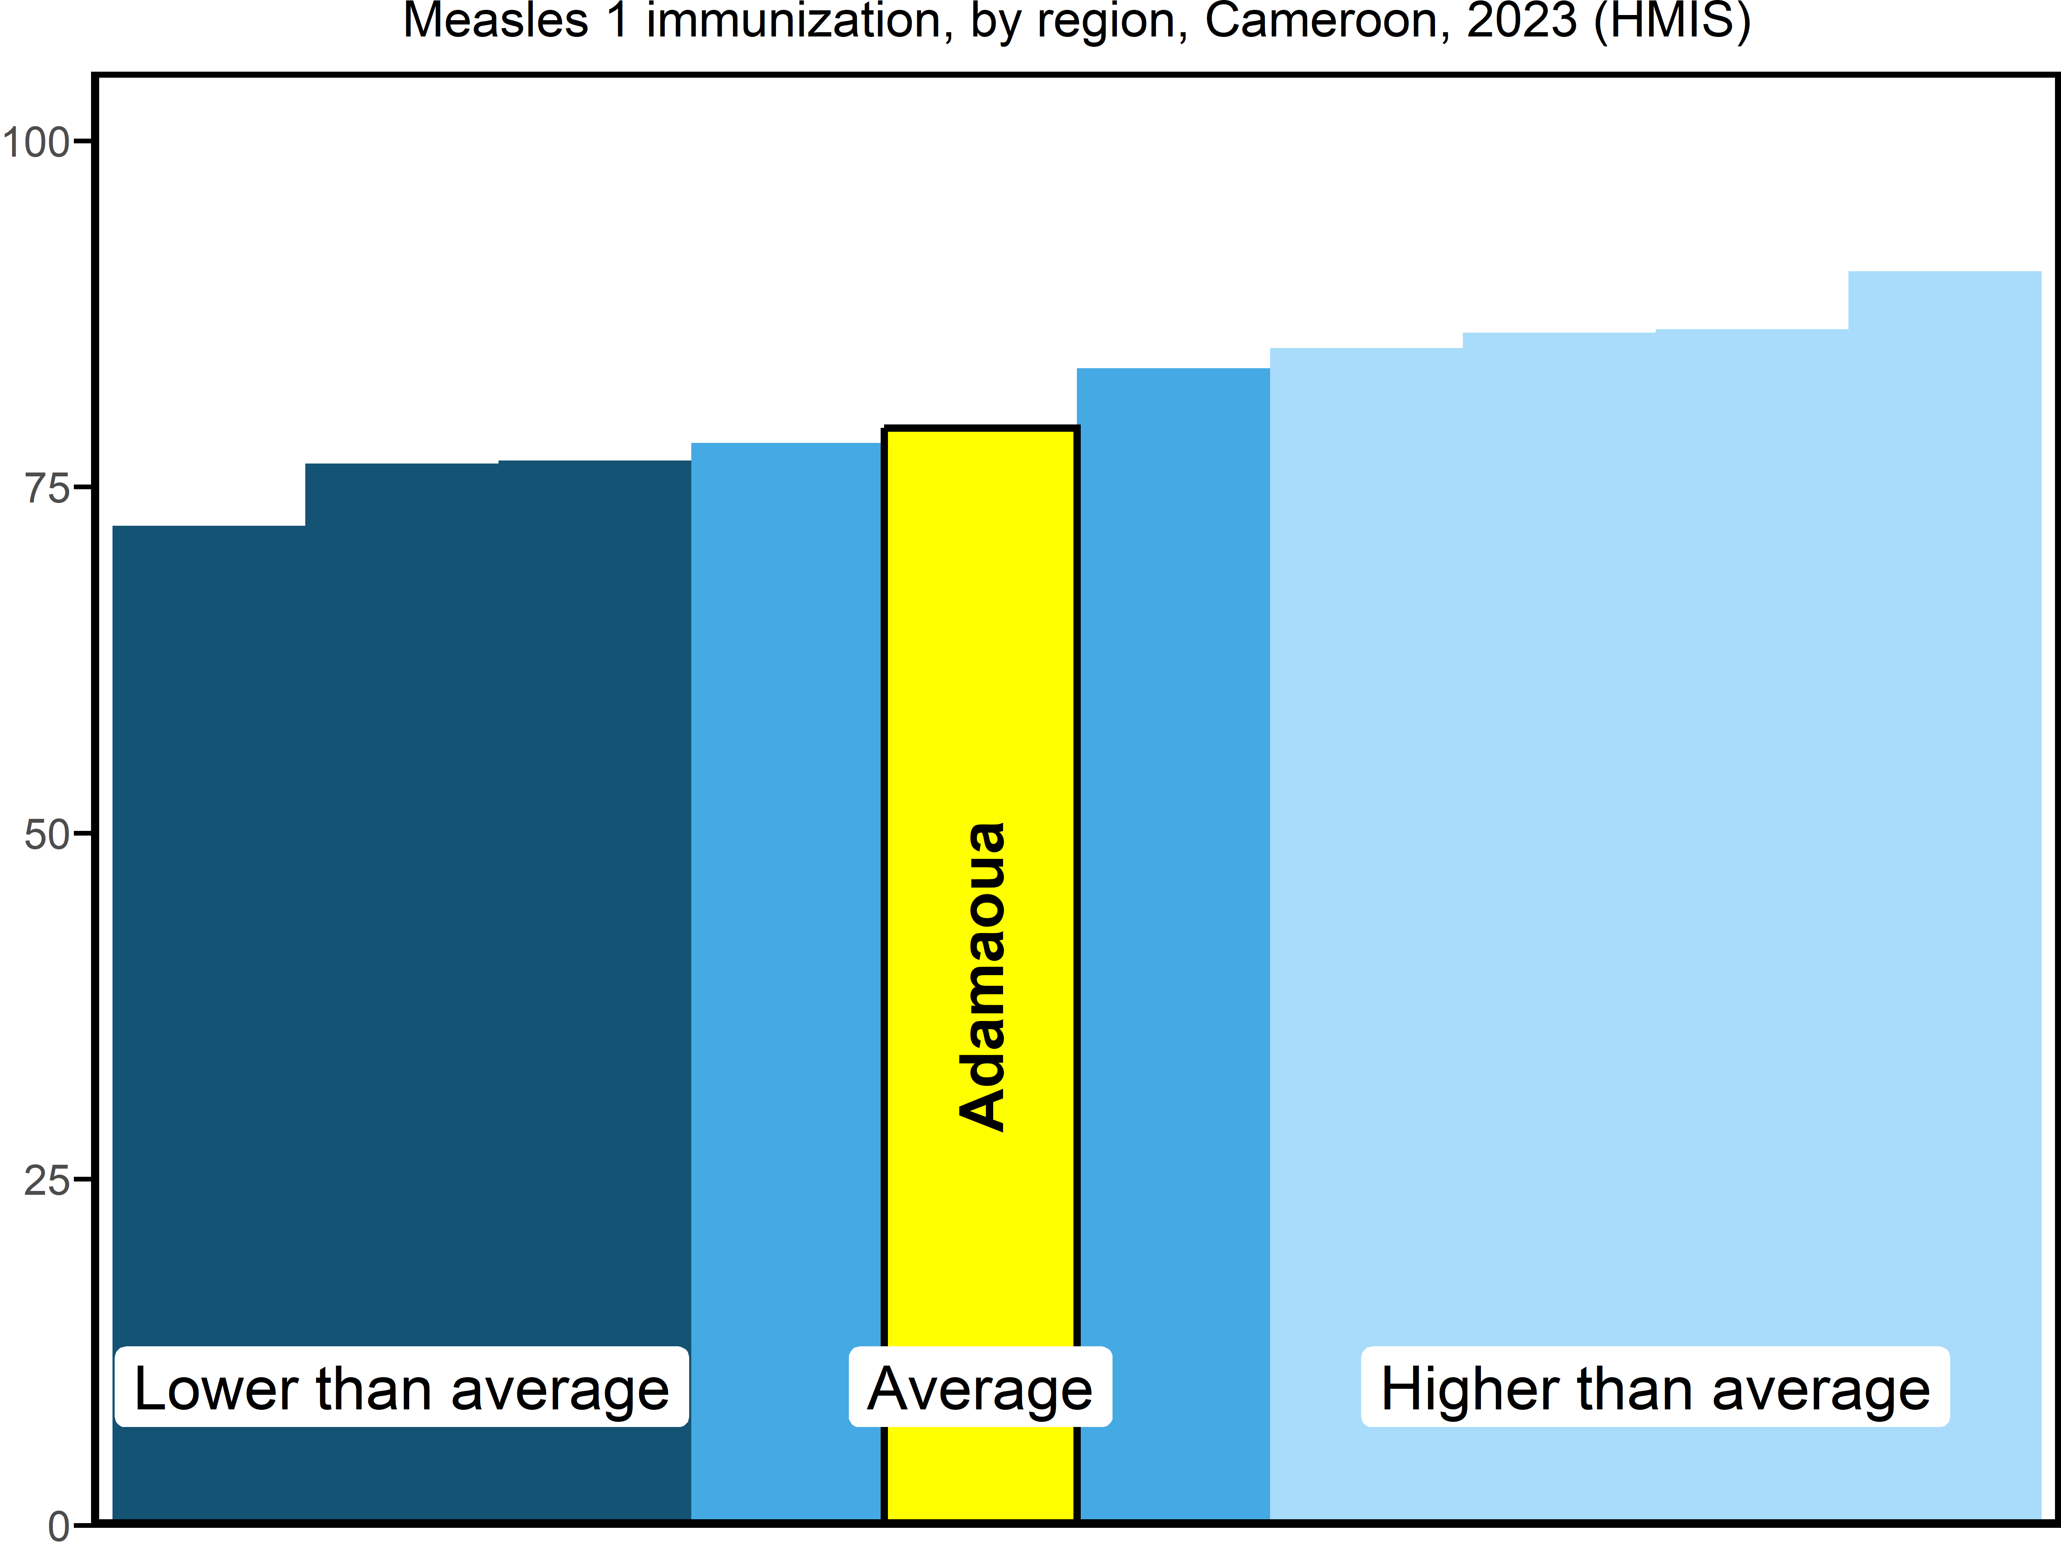

| **district** | **2019** | **2020** | **2021** | **2022** | **2023** | **2004** | **2006** | **2011** | **2014** | **2018** |
| --- | --- | --- | --- | --- | --- | --- | --- | --- | --- | --- |
| Bankim | 78 | 78 | 75 | 79 | 71 |  |  |  |  |  |
| Banyo | 74 | 82 | 84 | 88 | 80 |  |  |  |  |  |
| Belel | 72 | 76 | 78 | 78 | 78 |  |  |  |  |  |
| Dang | 70 | 81 | 71 | 75 | 78 |  |  |  |  |  |
| Djohong | 53 | 79 | 70 | 73 | 71 |  |  |  |  |  |
| Meiganga | 72 | 73 | 72 | 81 | 88 |  |  |  |  |  |
| Ngaoundal | 74 | 77 | 78 | 90 | 85 |  |  |  |  |  |
| Ngaoundere Rural | 69 | 69 | 78 | 82 | 78 |  |  |  |  |  |
| Ngaoundere Urbain | 70 | 78 | 80 | 82 | 75 |  |  |  |  |  |
| Tibati | 75 | 88 | 80 | 83 | 90 |  |  |  |  |  |
| Tignere | 72 | 75 | 70 | 74 | 82 |  |  |  |  |  |