Senegal - Countdown Analysis

## Health Facility Data Quality

### Summary reported immunization health facility data DHIS2

| **no** | **Data Quality Metrics** | **2019** | **2020** | **2021** | **2022** | **2023** |
| --- | --- | --- | --- | --- | --- | --- |
| **type: 1. Completeness of monthly facility reporting (Immunization)** | | | | | | |
| 1a | % of expected monthly reports | 99 | 99 | 99 | 100 | 100 |
| 1b | % of districts with complete report >= 90% | 97 | 98 | 99 | 99 | 100 |
| 1c | % of districts with no missing values | 100 | 100 | 100 | 100 | 100 |
| **type: 2. Extreme outliers (Common Vaccine antigens)** | | | | | | |
| 2a | % of values not extreme outliers | 98 | 99 | 96 | 95 | 73 |
| 2b | % of districts with no extreme outliers | 79 | 87 | 77 | 67 | 39 |
| **type: 3. Consistency of annual reporting** | | | | | | |
| 3f | % district with anc1/penta1 in expected | 18 | 34 | 26 | 29 | 76 |
| 3g | % district with penta1/penta3 in expected | 95 | 95 | 95 | 100 | 92 |
| **4** | **Annual data quality score** | **84** | **87** | **85** | **84** | **83** |

## Equity Analysis

### Wealth an urban-rural inequity for Penta 3 Coverage

#### Wealth Status

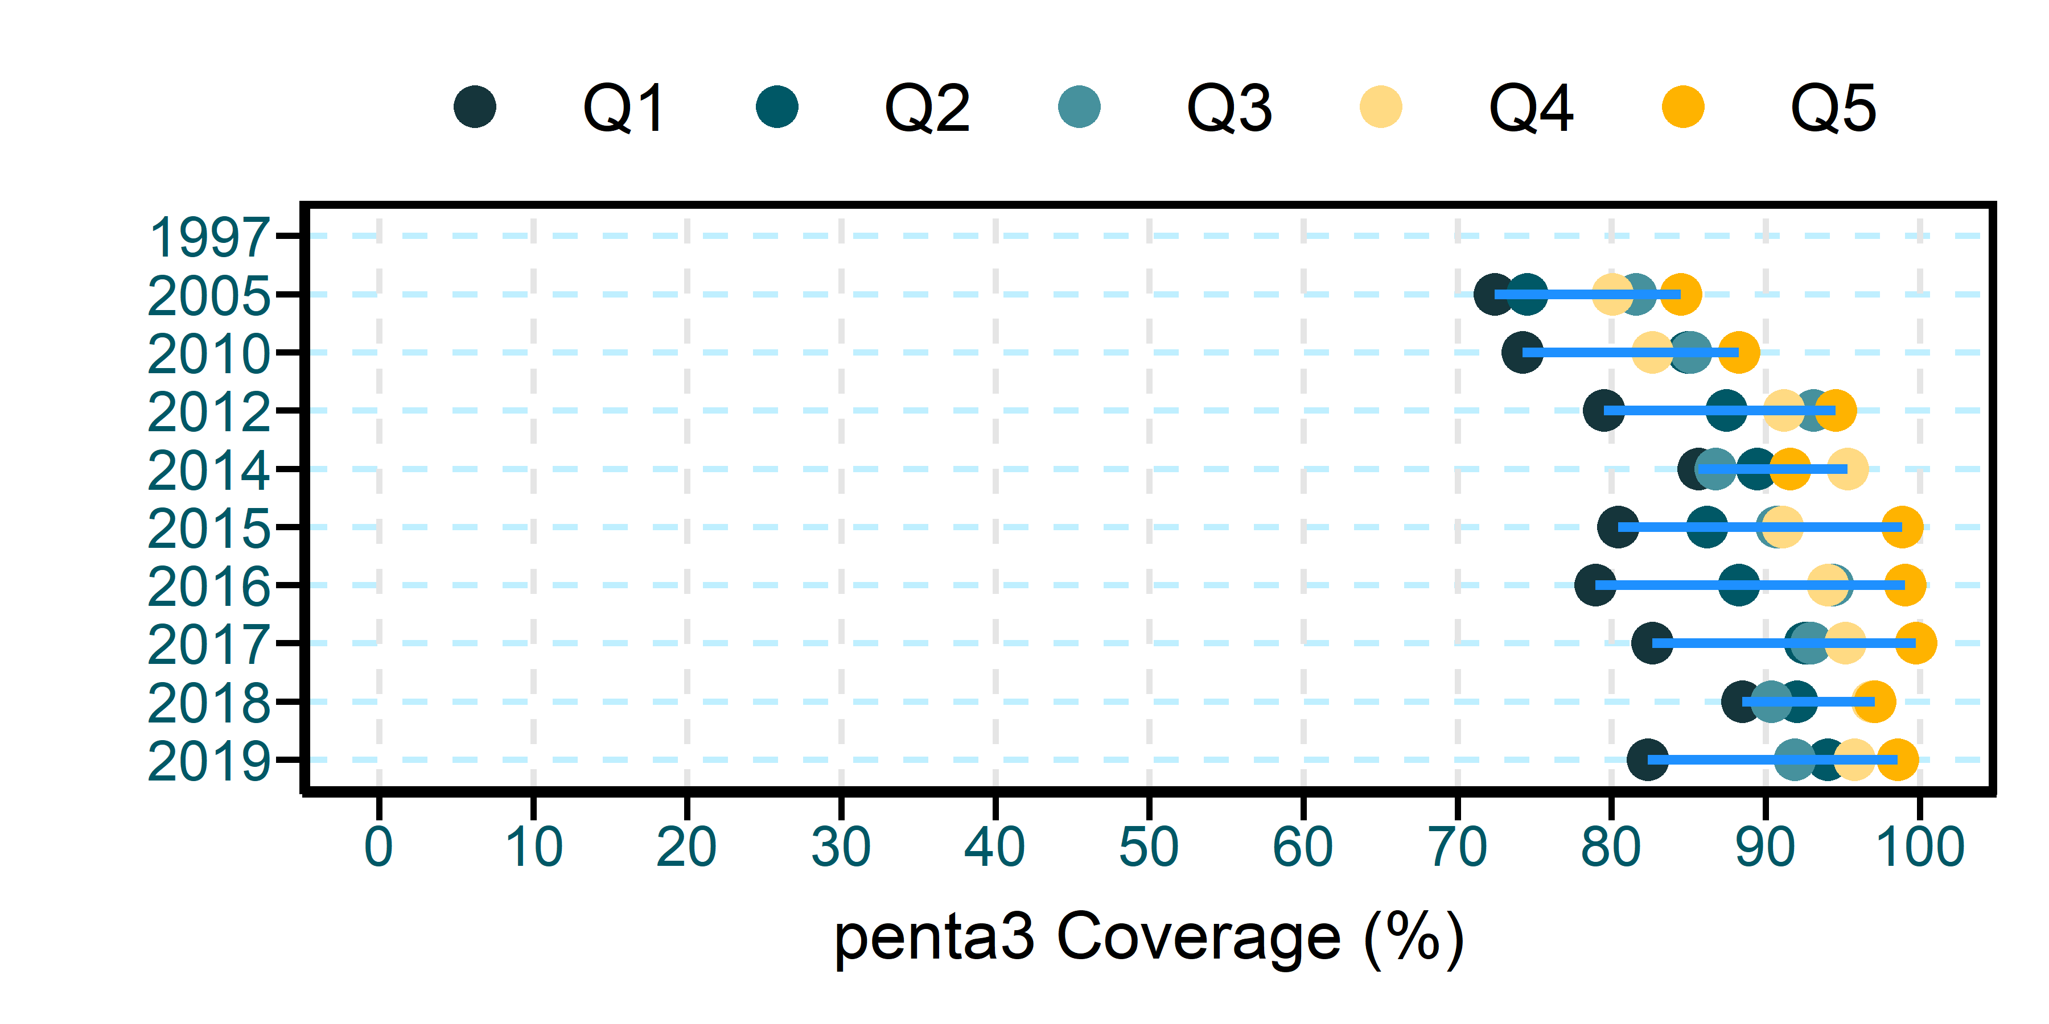

#### Residence

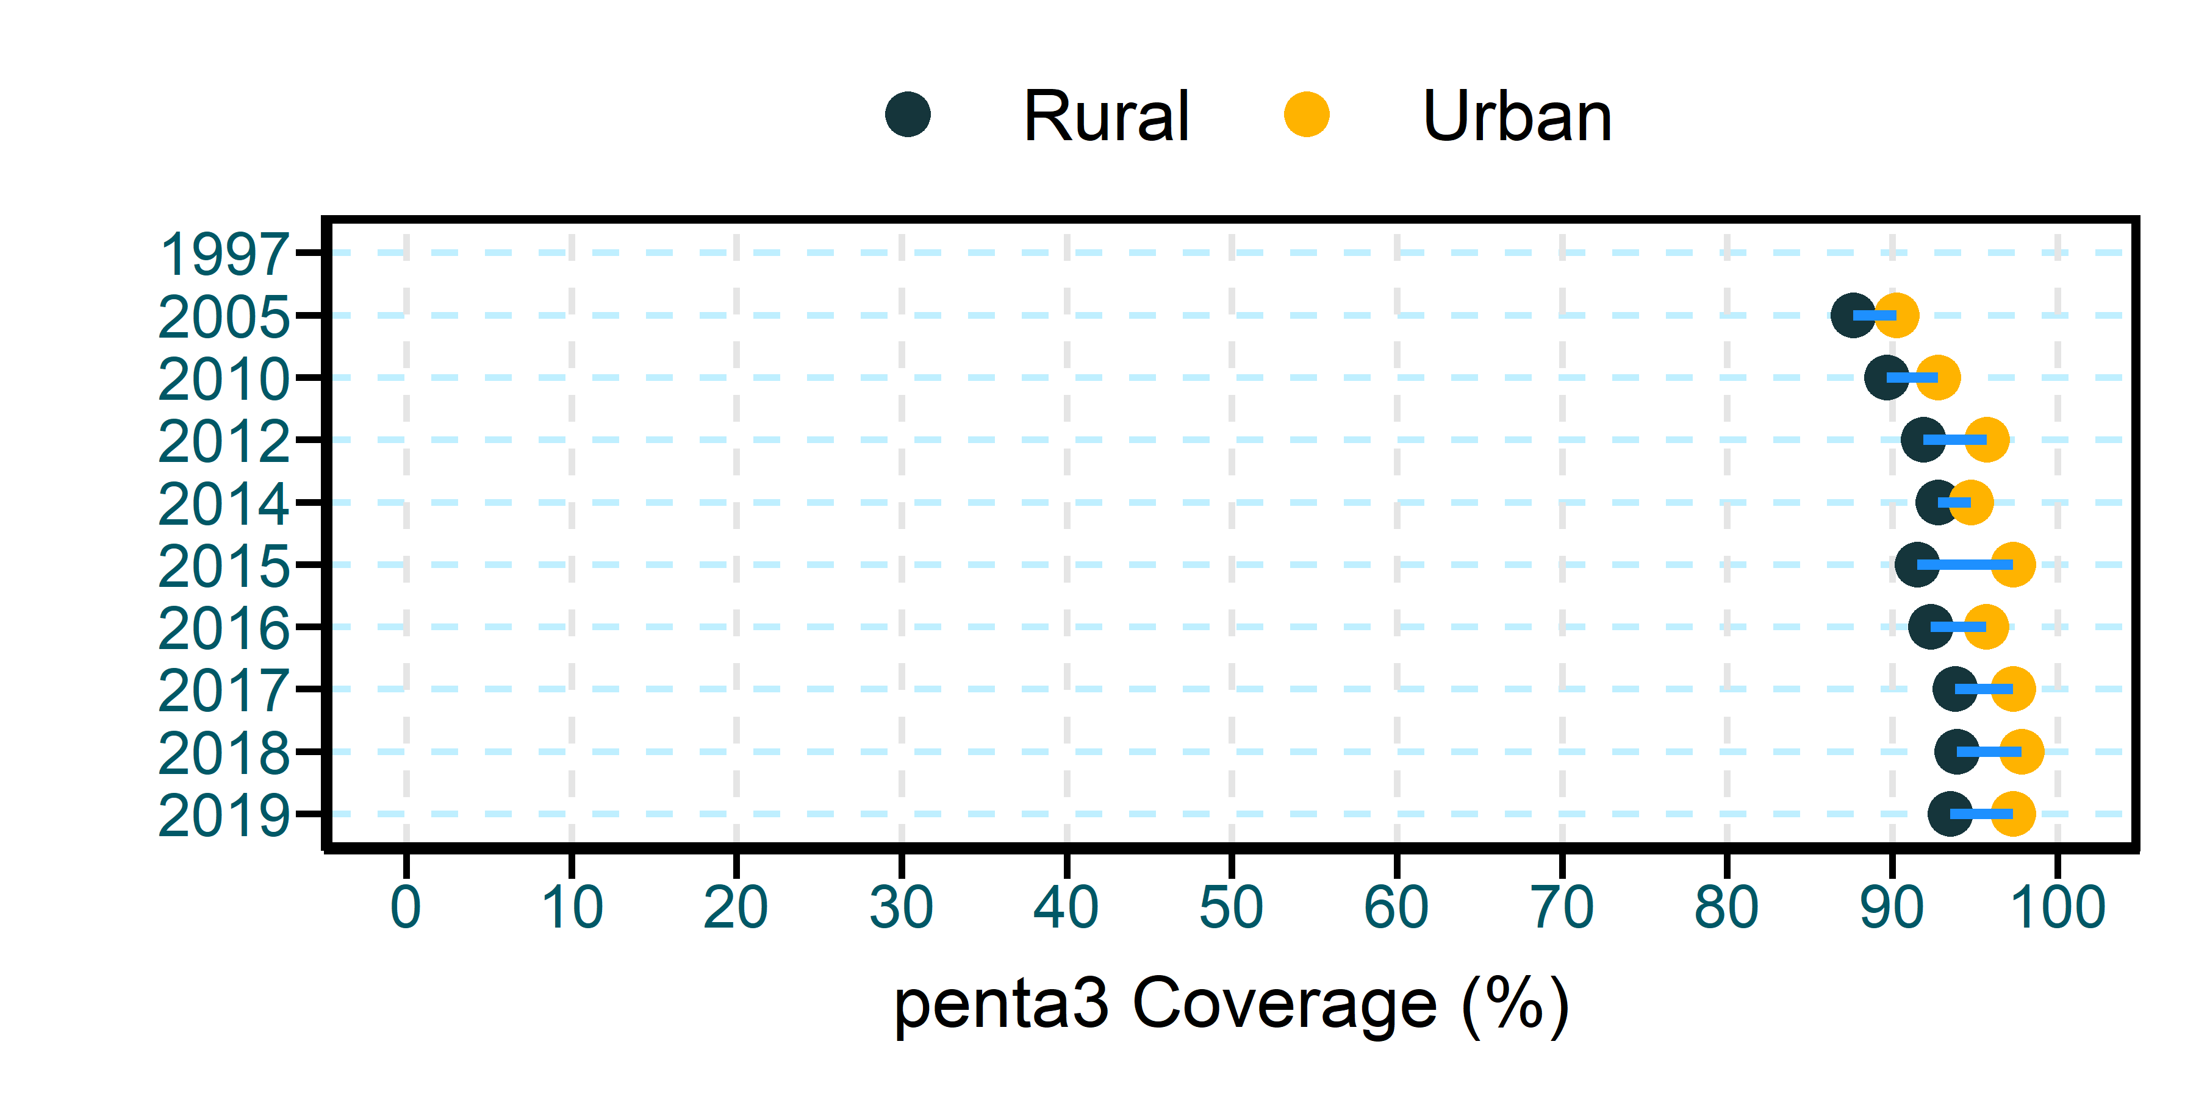

##### DQA scores greater or equal to 90% are highlighted in green indicating good data quality, scores of 80-90% in yellow and less than 70% in red indicator poor data quality

## National immunization Coverage trends

### 2019 – 2023 trend in immunization coverage, first dose of measles, third dose of pentavalent vaccines and pentavalent dropout rates

#### Measles 1

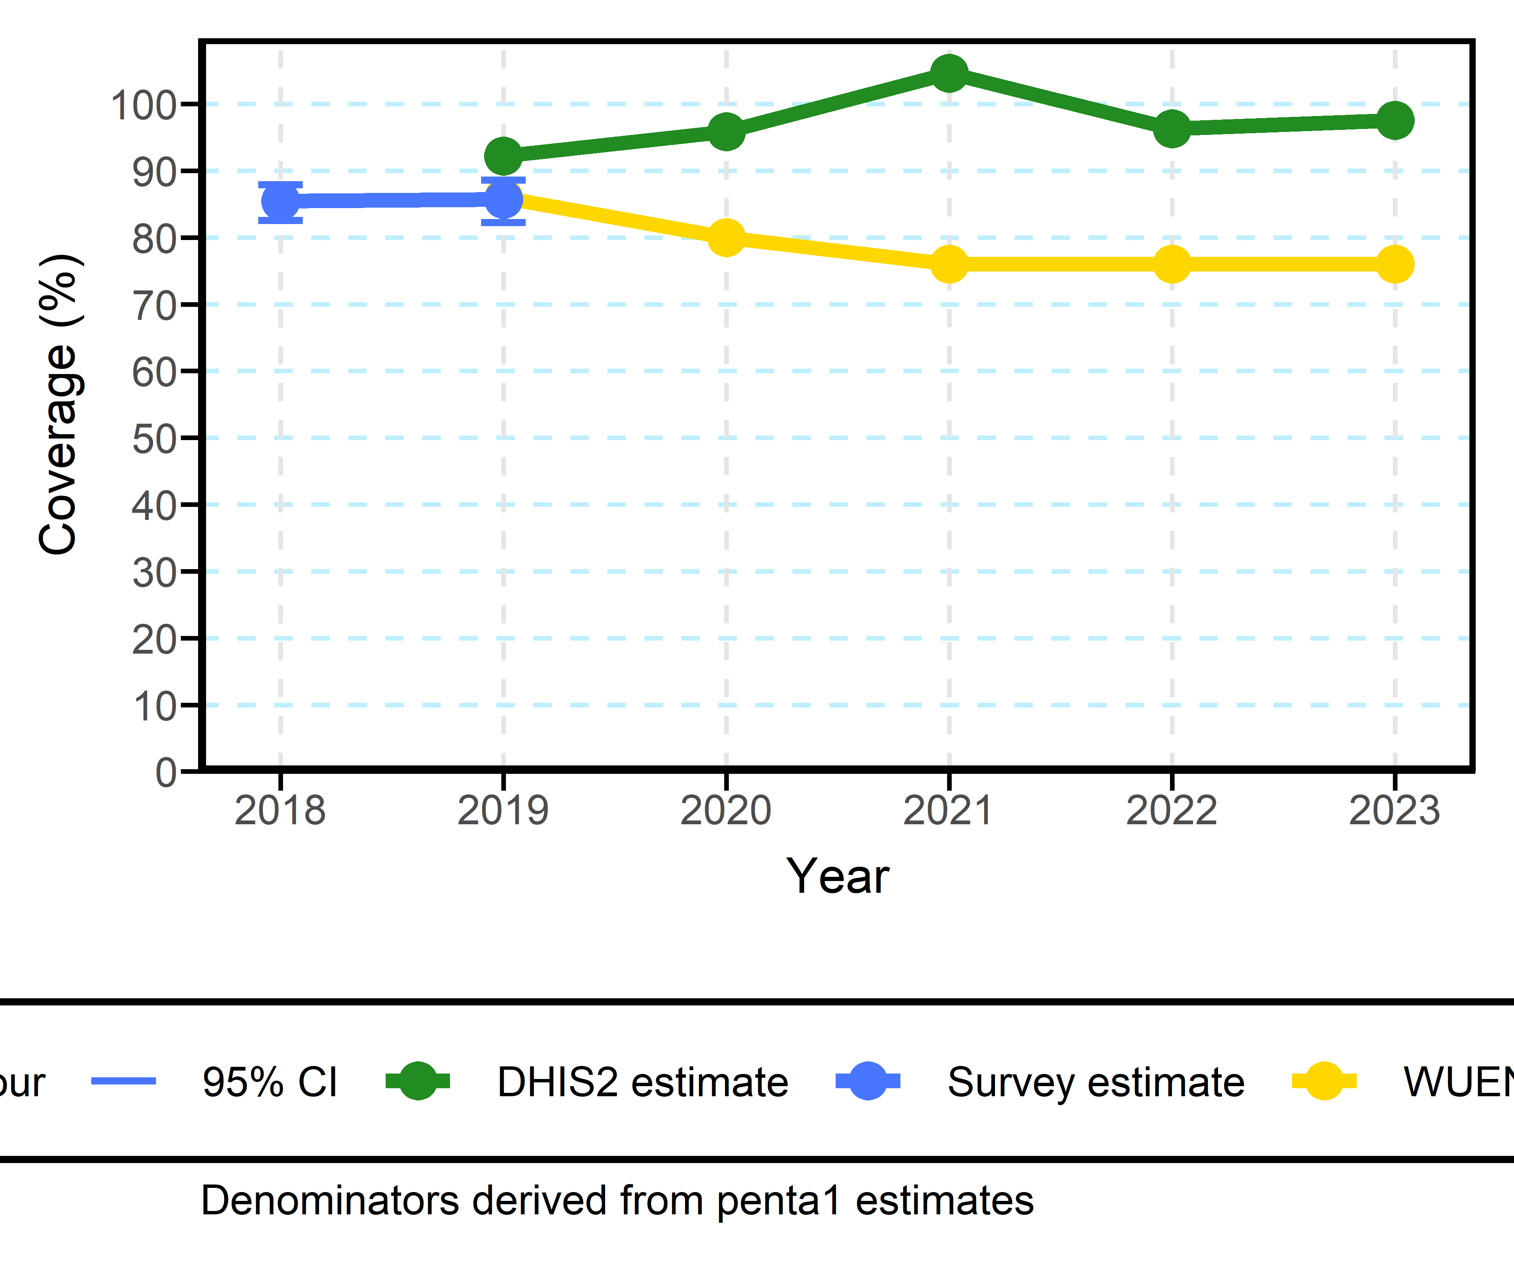

#### Penta 3

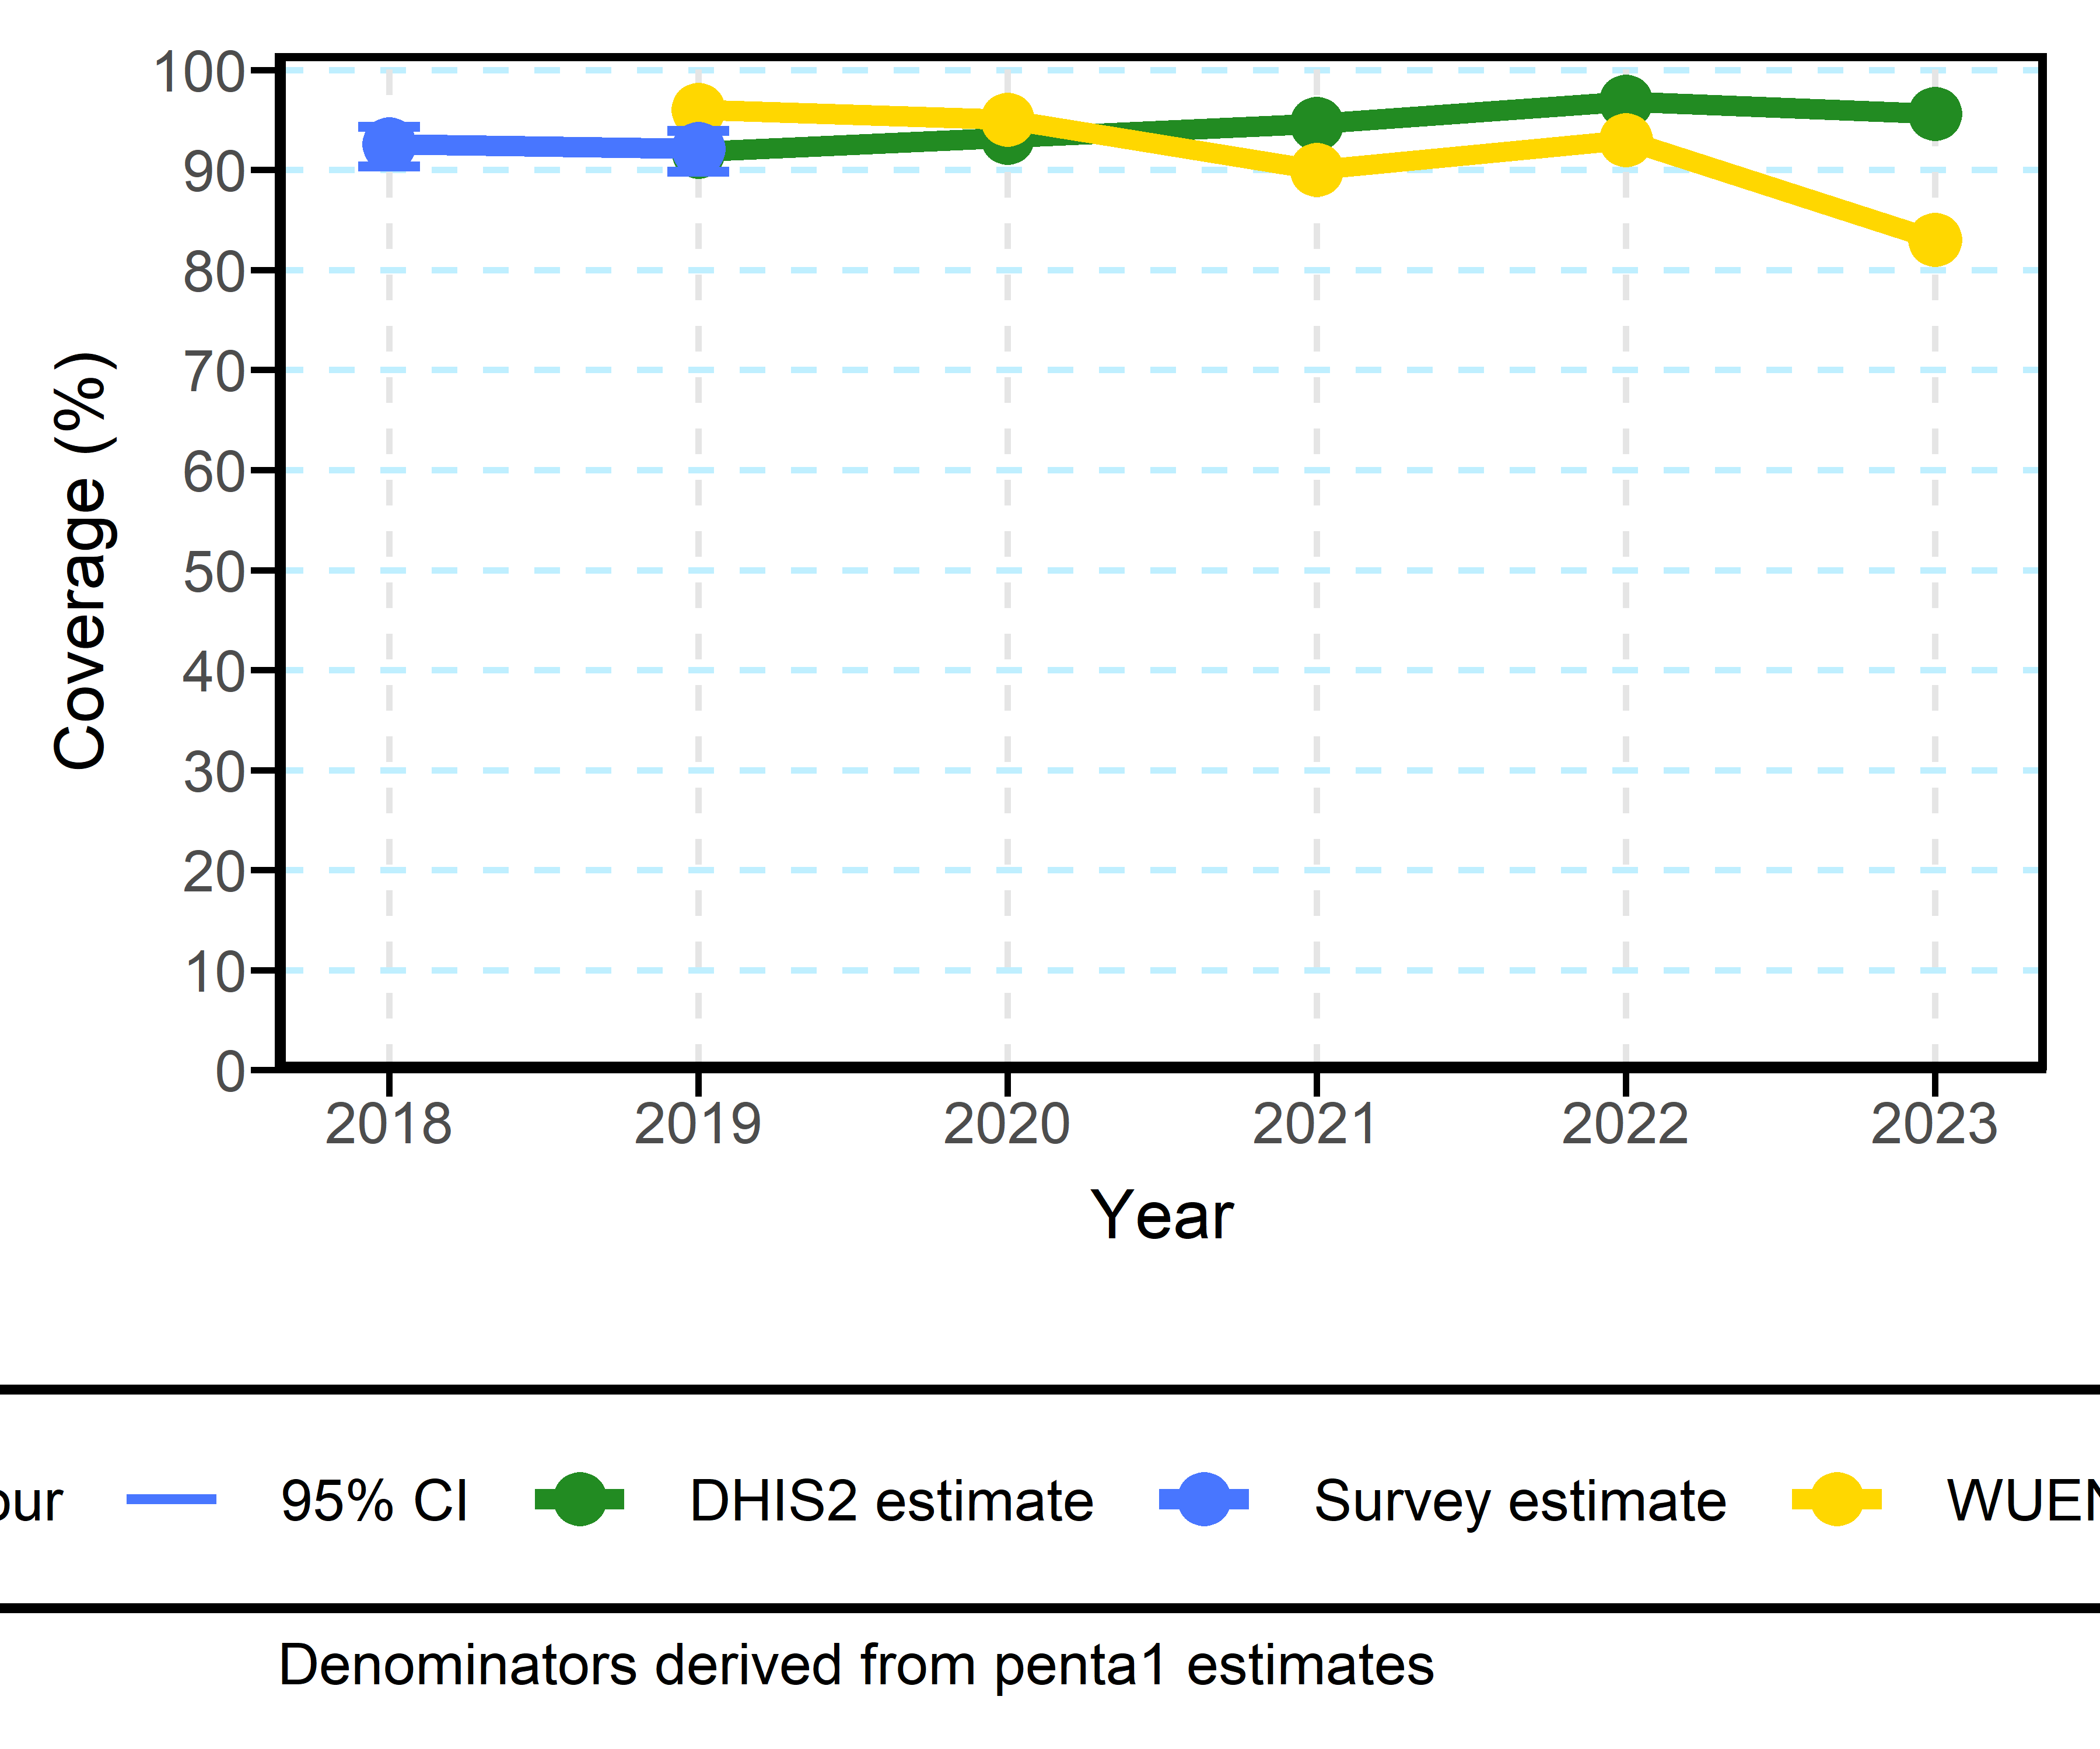

#### Penta1 to Penta3 Dropout

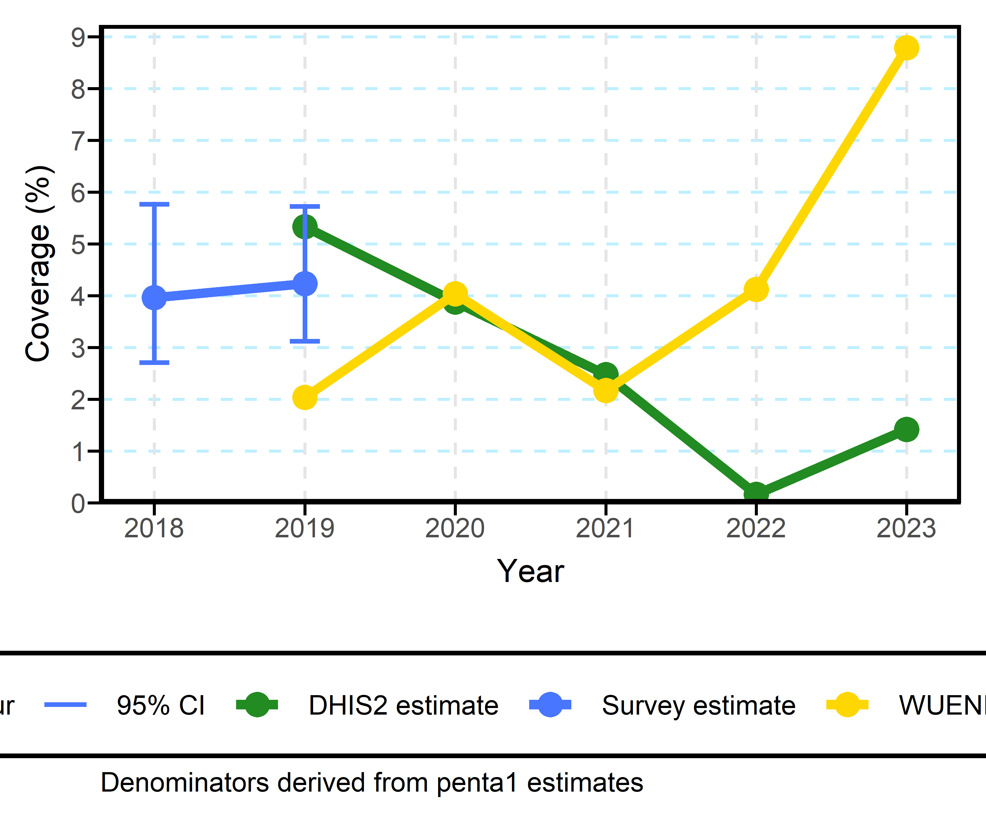

## Admin Level 1 Vaccination Coverage Map

### Subnational vaccination coverage 2019 & 2023 (measles1, penta3, dropout penta1_3)

#### Measles 1

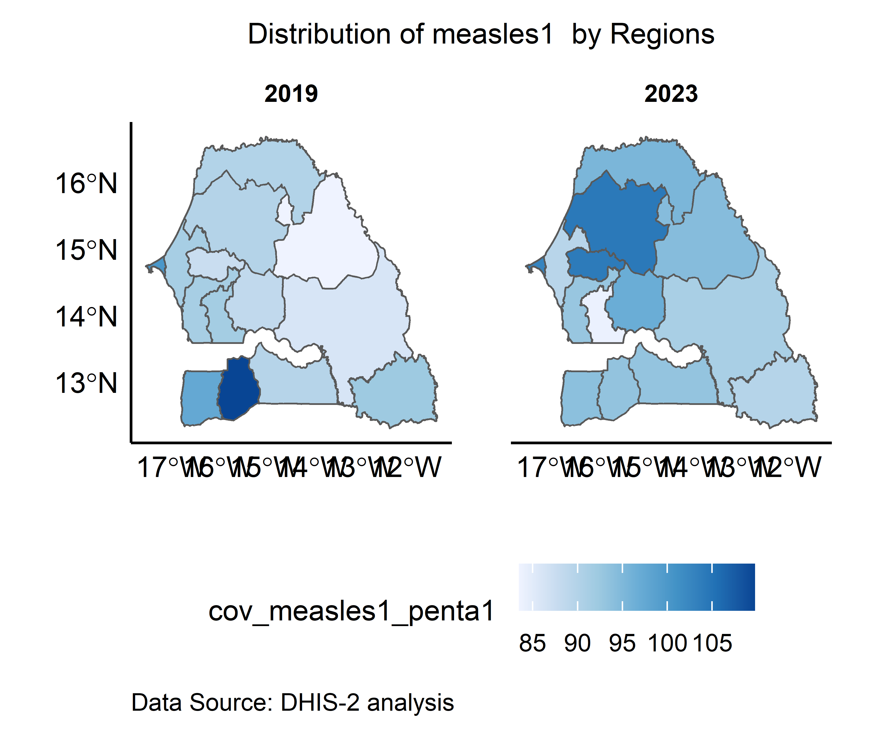

#### Penta 3

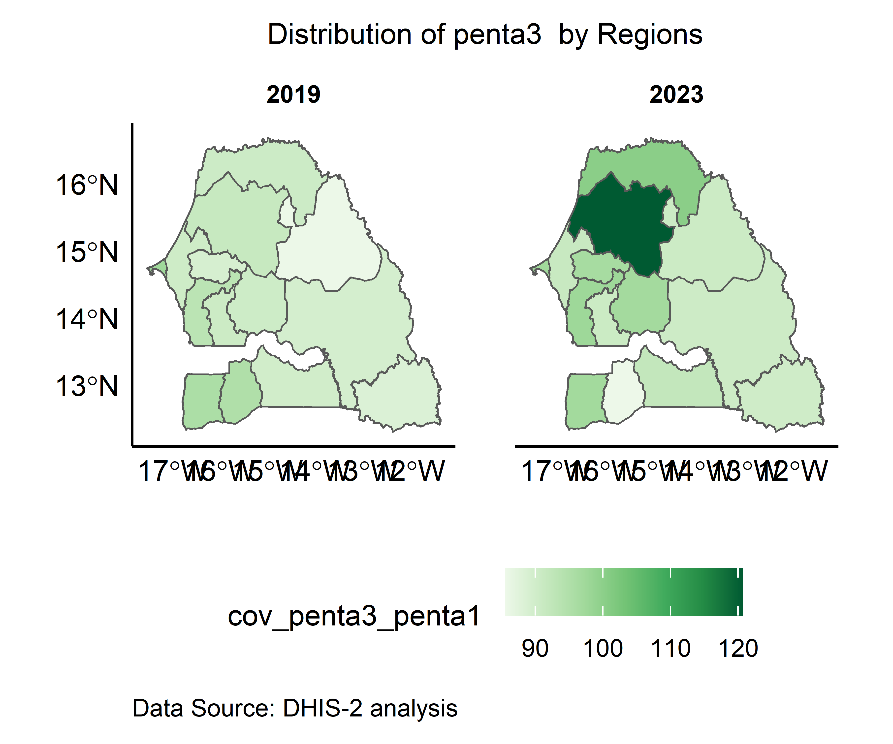

#### Penta1 to Penta3 Dropout

