CAM 2025 Analysis Guide

Table of contents

# Introduction to Countdown to 2030

## Overview of the Countdown to 2030 (The Countdown)

The Countdown to 2030 for Women’s, Children’s and Adolescents’ Health (The Countdown) initiative is a global collaboration involving academics from national, regional, and international institutions, UN agencies, the World Bank, and civil society organizations. The initiative tracks progress in Reproductive, Maternal, Newborn, Child, and Adolescent Health and Nutrition (RMNCAH+N), fostering advocacy and accountability through rigorous data analysis.

**Key objectives include:**

* Strengthening country-led data analysis and monitoring
* Fostering innovation and evidence generation through multi-country collaboration
* Enhancing global measurement and monitoring Improving policy and program communication

For more on Countdown to 2030 initiative, visit: [The Countdown website](https://www.countdown2030.org/about)

## About the cd2030.rmncah R Package

The cd2030.rmncah R package and Shiny App were developed to support evidence generation and analysis of RMNCAH indicators.

Key features include: User-friendly interface for data management and analysis Tools for visualization and statistical summarization Automated report generation

# General Introduction to CD2030 CAM Approach

## General Introduction to CD2030 CAM Approach

The CD2030 for Women’s, Children’s and Adolescents’ Health, GFF, UNICEF, WHO, WAHO and other partners are collaborating to strengthen country-led progress and performance reviews, such as annual health sector reviews and midterm reviews of investment cases. This guidebook is for Countdown country analytical teams to develop a set of national and subnational estimates for key RMNCAH-N indicators, including equity, using five-year time series of routine data and survey results.

Much attention is paid to obtaining a clean data set with the necessary corrections and adjustments for known biases. Service coverage and equity, maternal and perinatal mortality, and health service utilization and systems performance are the main subjects, with a focus on monitoring national and subnational targets, as well as global targets. The figure below shows the general overview of the CAM approach 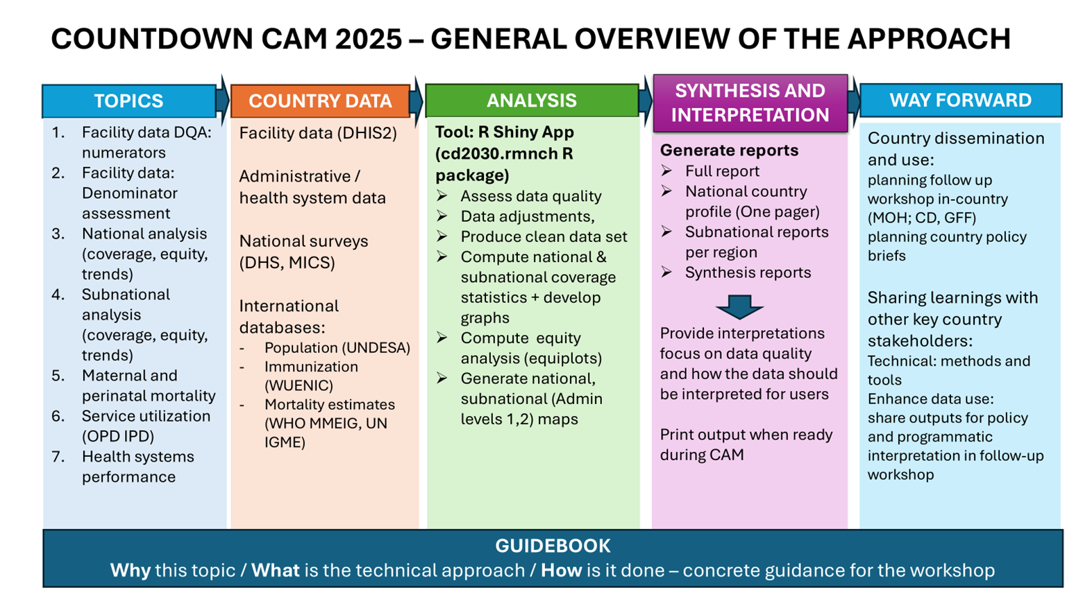

## Organization of the Guidebook

This guidebook is organized into seven sections, each focusing on a specific area of data analysis related to reproductive, maternal, newborn, child and adolescent health and nutrition (RMNCAH-N). The guidebook provides a comprehensive approach to analyzing routine health data and survey results, with an emphasis on data quality, coverage, equity, and health systems performance. The seven data analysis sections in this guidebook are:

1. Section 1: Health facility data quality assessment
2. Section 2: National  Analyses (Coverage & Equity)
3. Section 3: Subnational analysis (Coverage & Inequality)
4. Section 4: Maternal mortality, stillbirths and neonatal mortality
5. Section5: Curative health services utilization for sick children
6. Section 6: Health systems progress and performance
7. Section 7: Planning ahead for data use

These sections are designed to be used in a modular way, allowing countries to select the topics that are most relevant to their context and data availability.

Each section has:

* **Why/Rationale -** the scientific basis for the analysis;
* **Approach**- a step-by-step guide on how to conduct the analysis; and the
* **Implementation -** the use of the R Shiny App for data visualization and interpretation.

## Data Sources

The Countdown CAM approach uses a variety of data sources, including:

* **Health facility data**: Routine health data collected from health facilities, including service coverage, health systems performance, and health service utilization.
* **Surveys**: Nationally representative surveys, such as the Demographic and Health Surveys (DHS) and Multiple Indicator Cluster Surveys (MICS), which provide data on health indicators, equity, and health service utilization.
* **Administrative data**: Data collected by government agencies, such as vital registration systems and health management information systems (HMIS), which provide information on health outcomes and service delivery.
* **Other data sources**: Other relevant data sources, such as census data, population estimates, and health financing data, which provide additional context for the analysis.

## Expected outputs

* **Full country report** (national/subnational) (.pdf, .doc files)
* **Synthesis/poster reports** (.pdf, .doc files)
* **Country analytical reproducible files** (.rds files)
* **Adjusted and or summarized data files** (.csv. .dta, xlsx files)

Country analytical reproducible files (.rds files) are the final output of the analysis, which can be used for further analysis and visualization. These files contain the cleaned and processed data, country specific analysis parameters as well as the results of the analysis, including coverage, equity, and health systems performance indicators.

# Getting started

Initially, Countdown2030 analyses were conducted using Stata. These scripts have now been translated into R to support the development and deployment of a Shiny-based dashboard.

We extend our appreciation to the team that compiled the original Stata codebase.

## Installing R and RStudio

To begin working in R, it is necessary to install both R and RStudio. R is the underlying programming language, while RStudio provides a user-friendly interface that simplifies the development and execution of R scripts. Both are freely available and widely supported across platforms. > **Note**: R and RStudio are not the same. R is the programming language, while RStudio is an integrated development environment (IDE) that makes working with R easier. >To ensure smooth installation and functionality, it is recommended to install **R** first, followed by **RStudio**. This order is important as RStudio relies on R to function properly.

### Download and Install R (Step 1)

R is distributed via The [Comprehensive R Archive Network (CRAN)](https://cran.r-project.org/). Select your operating system from the homepage: Windows, Mac, or Linux.

#### Windows

1. Navigate to ***Download R for Windows*** and select the “base” option.
2. Click the first link (e.g., “Download R x.x.x for Windows”) to download the installer.
3. Run the installer and follow the prompts. ***Administrator privileges may be required***.
4. R will be installed in your system’s Program Files, with a shortcut added to the Start menu.

#### Mac

1. Click ***Download R for Mac*** on the CRAN homepage.
2. Download the latest release package and run the installer.
3. The default installation settings are typically sufficient. You may be prompted to enter your system password.

**R is not a graphical software application but a programming environment. It is best used in conjunction with RStudio, which provides a consistent and user-friendly interface across operating systems.**

### Install RStudio (Step 2)

RStudio is an integrated development environment (IDE) designed for R. It features a script editor, console, graphics viewer, and additional tools for package management, debugging, and file organization.

Download RStudio from [Posit Website](https://posit.co/downloads/)

**Do I still need to download R?** Even if you use RStudio, you’ll still need to download R to your computer. RStudio helps you use the version of R that lives on your computer, but it doesn’t come with a version of R on its own.

After installation, launch RStudio and begin interacting with R through its console and script windows. 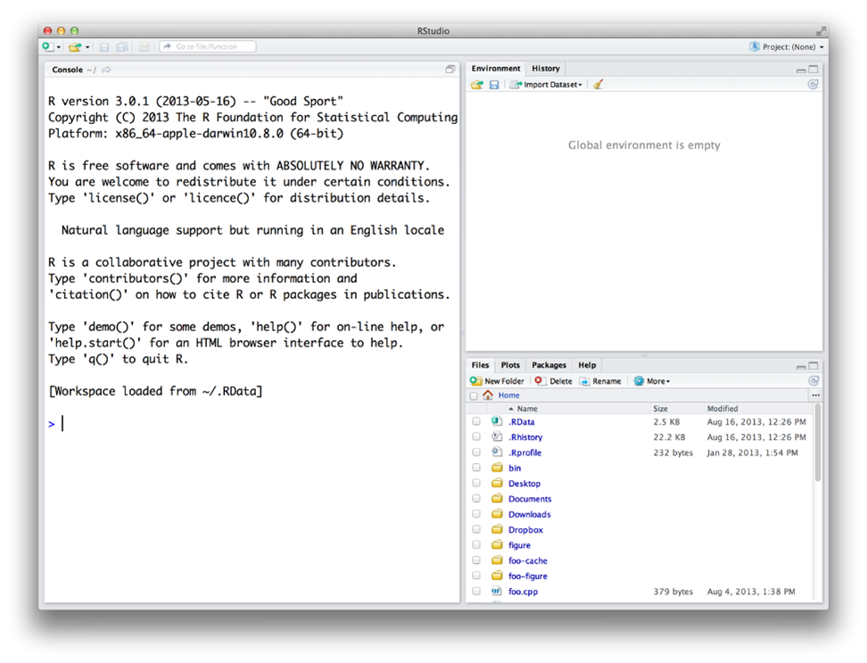

## Installing the Countdown2030 RMNCAH Application

After installing R and RStudio, you may proceed with installing the Countdown2030 RMNCAH application, which is hosted on GitHub under the repository [cd2030.rnncah](https://github.com/aphrcwaro/cd2030.rmncah). The application is implemented as an R package and supports interactive dashboard generation via Shiny.

### Installation via R Console

**Stable Version**

devtools::install_github("aphrcwaro/cd2030.rmncah@v1.0.0")

**Development Version**

devtools::install_github("aphrcwaro/cd2030.rmncah")

### Launching the Application

library(cd2030.rmncah)  
dashboard()

The Shiny dashboard will launch automatically in your default web browser.

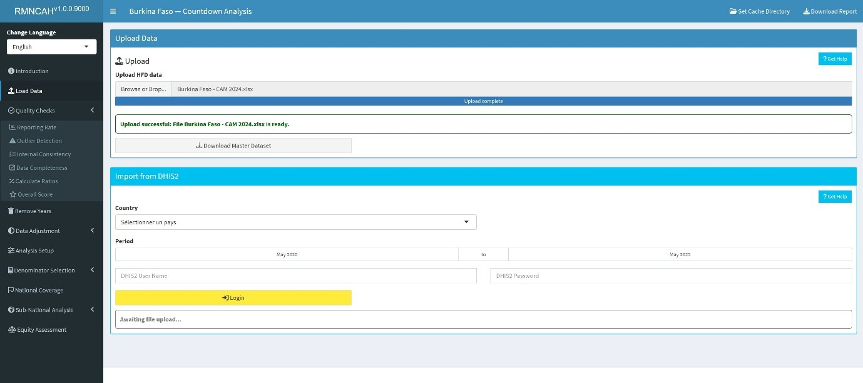

### Alternative Installation via GitHub Desktop or Git or direct download

Advanced users with GitHub accounts may prefer to clone the repository directly. This method allows for:

* Version control
* Contribution to the codebase
* Inspection of the package structure
* Once cloned, open the .Rproj file in RStudio to set the working directory.

| Github | Local Folder |
| --- | --- |
|  |  |

To install and run:

devtools::install()  
  
library(cd2030.rmncah)  
dashboard()

### RTools for Windows

To compile packages from source, especially development versions, RTools must be installed. Ensure compatibility with your installed R version:

* **R 4.2.0** → Rtools42
* **R 4.4.0** → Rtools44
* **R 4.5.0** → Rtools45

RTools can be downloaded from [CRAN](https://cran.r-project.org/bin/windows/Rtools/)

## Data requirements

### Datasets required

To run the analysis efficiently, each country team will require to have a folder containing the following datasets:

1. Health facility data (.xlsx file)
2. UN Estimates
3. Survey data
4. UN mortality data
5. FPET data These datasets will be provided to the country teams by the Countdown2030 team prior to the workshop.

### Country specific analysis parameters

The following parameters will be required to run the analysis see

# Loading Health facility data

This section explains how to structure and upload data into the app, ensuring compatibility with the **Countdown Health facility data format**

Please note that should you update your data during the workshop, ensure it is in the correct format before uploading to avoid errors.

## **Supported File Formats**

The app supports uploading the following file types:

* .xls, .xlsx (Excel files)- The raw health facility dataset in the **Countdown format**
* .dta (Stata files) - Master dataset downloaded from the app after validation/adjustment
* .rds (R Cached datafile) - The file containing the preloaded dataset, user adjustments and analysis parameters that has been > saved in the Cache directory. This will be the last saved file.

## **How to Upload Data**

**Step 1: Prepare Your data file**

Ensure your data is cleaned and structured according to the **The Countdown Health facility data format** by:

* Using the provided **HFD Standardized Template** to format your data > correctly.
* Saving the file in a supported format: .xls, .xlsx, .dta, or .rds.

Step 2: Upload the File

1. Navigate to the **Upload Data** section of the app.
2. **Drag and drop** your file into the upload box, or click **Browse** > to select it manually in your directory.
3. For subsequent re-uploads (after the initial uploading of the .xls, > .xlsx, .dta files and saving your progress in .rds file using the > Cache Directory button), do not reupload the .xls, .xlsx, .dta but > the saved .rds file if you want to retain any changes made in your > analytical files
4. The app will validate your file against the **Countdown format**.
   * If successful, a confirmation message will appear: *“Upload > successful: Your file is ready for analysis.”*
   * If errors are detected, an error message will indicate the > issue.

## **Common Errors and How to Fix Them**

| **Error Message** | **Cause** | **Solution** |
| --- | --- | --- |
| “Unsupported file format” | File type not supported | Save your file as .xls, .xlsx, .dta, or .rds. |
| “The following required columns are missing from the data: opv1” | Missing essential columns in the data | Add the missing column(s) to your dataset and ensure their values are valid. |
| “The following sheets are missing: Service_data_1, Service_data_2, Service_data_3, Reporting_completeness, Population_data, Admin_data” | Missing one or more required sheets in the file | Add the missing sheets to your file and ensure they conform to the template. |
| “Sheet Service_data_3 is empty” | The sheet exists but contains no data | Populate the sheet with valid data or remove the empty sheet. |
| “Key Columns”month” missing in Service_data_3” | A key column district, year, or month, is missing from the specified sheet | Add the missing column(s) to the sheet and ensure the data is structured correctly. |
| “Column name month must not be duplicated. Use .name_repair to specify repair.” | Duplicate column names in the dataset | Ensure all column names are unique. Rename or remove duplicate columns. |

***Note****: If a key column (district, year, or month) is missing data in a row, that row will be excluded from the resulting dataset.*

## **Tips for a Successful Upload**

* Always use the latest **The Countdown Health facility data format** > template to structure your data.
* Double-check column names, formats, and content before uploading.
* Save your file in a supported format and ensure it is UTF-8 encoded

# Numerator Assessment

## Numerators Assessment

### Rationale: Scientific basis for the analysis

Routinely reported health facility data are an important data source for health indicators at facility and population level. The data are reported by health facilities on events such as immunizations given, or live births attended. As with any data, quality is an issue. Data needs to be checked to consider completeness of reporting by health facilities, identify extreme outliers and internal consistency. A standard reporting method for data quality allows assessment of progress over time.

### Approach: Description of analytical steps

The analysis of the monthly data by district for 2019-2024 is used to assess annual data quality using the following standard indicators:

## Implementation: Conducting analysis in the Shiny App

The various data quality aspects ( ***Reporting completeness***, ***Outlier detection***,***Internal Consistency*** ***Data completeness***, ***Ratios calculation***, ***Overall quality score***) are are assessed in the **Data quality** section of the Shiny App. 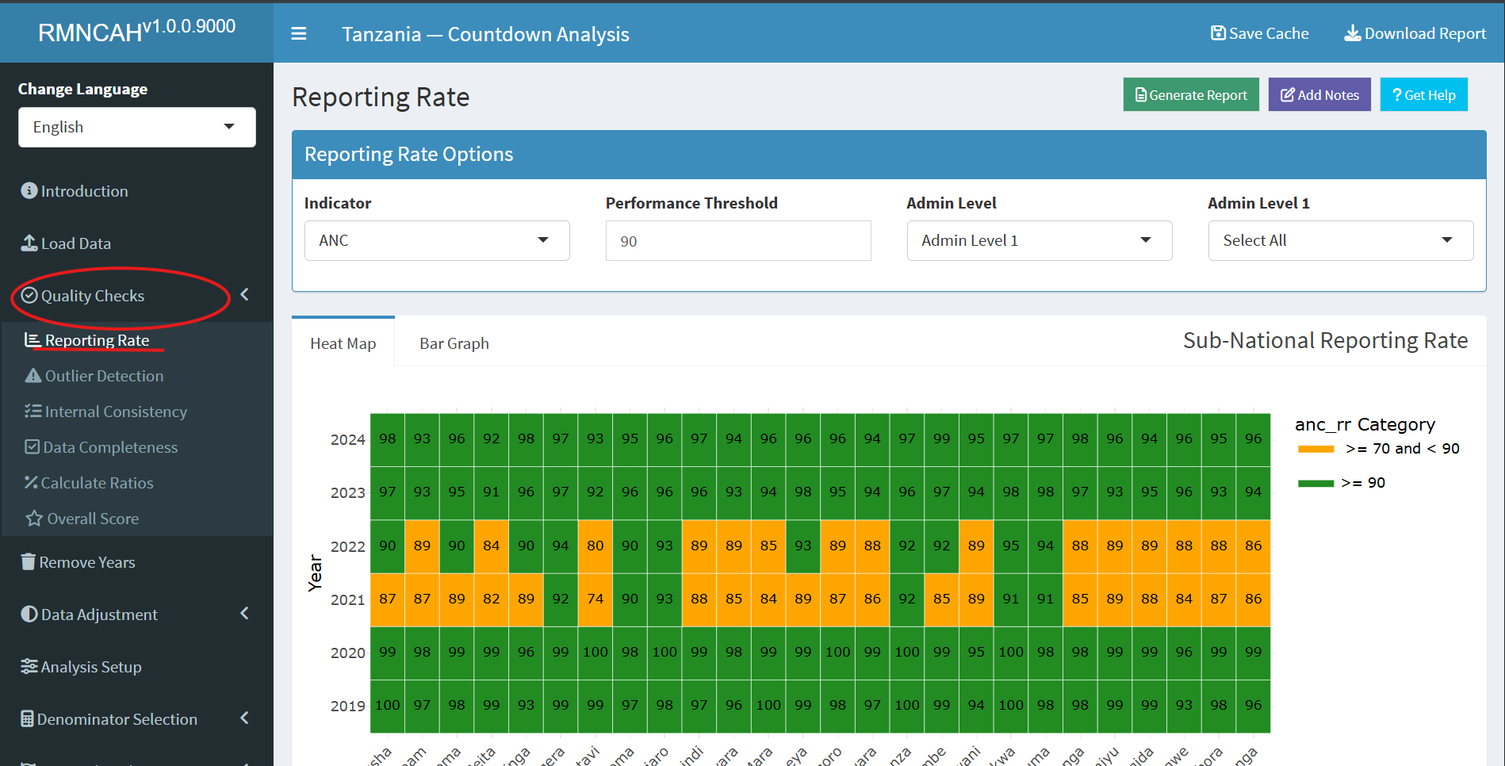 The app will automatically compute the overall data quality score based on the metrics described above. The app will also produce a report with the results of the data quality assessment, including the numerators and denominators for each indicator, as well as the overall data quality score. []

There is often an inconsistency between antenatal and immunization data, even though we can argue that the two should be consistent. To examine the association between ANC1 and penta1 is particularly informative. To compute and interpret indicators 3a and 3b the following considerations need to be made:

***ANC1 to penta1 ratio***

We can compute an expected ratio ANC1 to penta1 based on assumptions about mortality between early to mid pregnancy and early infancy and survey data on coverage of ANC1 and penta1 in the population:

* Consider the mortality between the first ANC visit and the first pentavalent vaccination.

Assuming that ANC1 takes place at about 20 weeks or 4-5 months of pregnancy and penta1 at 6-8 weeks postpartum, we assume a pregnancy loss (abortion) after the ANC1 visit of 3%, a stillbirth rate of 2%, a twinning rate of 1.5% and neonatal mortality rate before the penta1 of 3% then the difference between the numbers of ANC1 and penta1 should be: 1 – 0.03 – 0.02 + 0.015 – 0.03 = 0.935. This corresponds with a ANC1 to penta1 ratio of 1/0.935 = 1.07.

* Actual population coverage of ANC1 and penta1 will also need to be considered, using the surveys.

The expected ratio (the number of ANC1/ number of penta1 in facilities) is 1.07 * (ANC1 coverage in the survey/penta1 coverage in the survey).

If coverage for ANC1 and penta1 are the same, then the ratio is 1.07 (1.07 * 1/1). But if, for example, the last survey shows that ANC1 coverage was 90% and penta1 coverage was 95%, then the expected ratio becomes 1.07 * (.90/.95) = 1.01.

* For the national ANC1 to penta1 ratio a range of plus or minus 0.05 outside this computed ratio is considered acceptable. If the ratio is outside this range, this should be flagged, and possible explanations discussed.

***Penta1 to penta3 ratio***

We can compute an expected penta1 to penta3 ratio based on the most recent survey:

* The main factor determining the penta1 to penta3 ratio, which are recommended at 6 and at 14 weeks of age, is the actual drop-out rate between penta1 and penta3, as mortality plays a limited role.
* Population coverage rates from the latest survey are used to determine the expected penta1 to penta3 ratio in the facility data. For instance, if penta1 coverage is 95% and penta3 coverage is 85%, we expect that ratio to be 0.95/0.85 = 1.12.
* Also, here a range of plus or minus 0.05 is considered acceptable for the assessment of the facility data.

**Report:**

Points to consider for the interpretation

* Is there a data quality pattern by year for which there is an > explanation? (include the explanation)
* Are there certain regions or other subnational units that are > particularly problematic?
* Are there certain reporting forms or services (e.g., antenatal care, > labour and delivery, immunization) that are problematic?
* Is there good consistency between reported numbers of ANC1 and > penta1?

The Figure below produced in the ShinyApp shows the ratios for all six years (2019-2024) and the expected value. It will be important to reflect on large differences (e.g., more than 0.10 or 10%.).

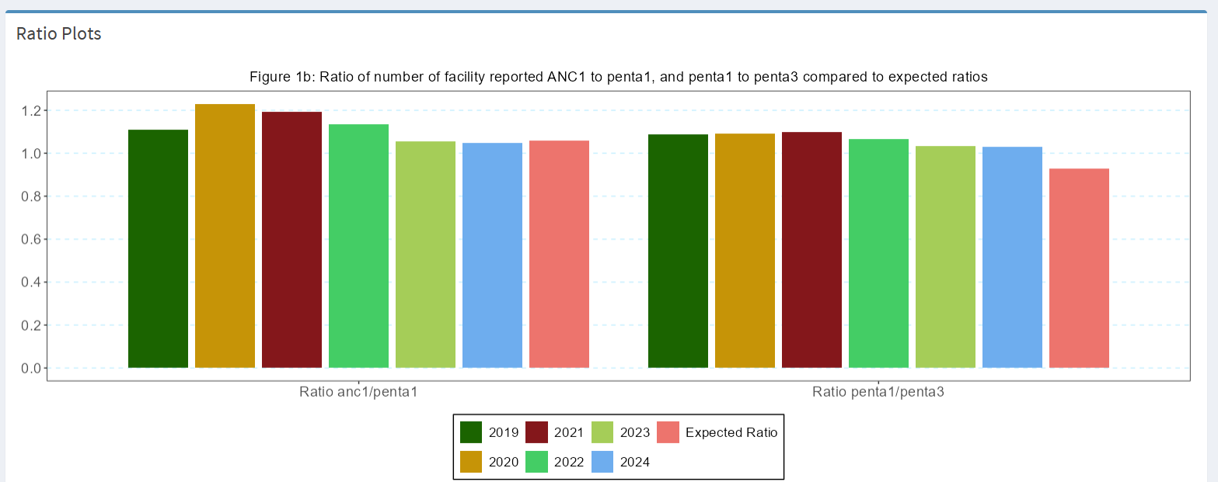

## Table 1: Health facility data quality assessment: numerators

| Indicator | Numerator | Denominator | Interpretation |
| --- | --- | --- | --- |
|  | **Completeness of monthly facility reporting** |  |  |
| Statistics for 1a and 1b are based on the mean of 4 reporting forms (ANC, delivery, immunization, OPD) |  |  |  |
| 1a | % of expected monthly facility reports (national) | Number of monthly facility reports received | Reporting rates over 90% are good; changes in reporting completeness over time affect trend analysis. |
| 1b | % of districts with completeness of facility reporting >= 90% | Number of districts with at least 90% monthly reporting completeness in a year | Can be used to identify districts with low reporting rates in multiple years. |
| 1c | % of districts with no missing monthly values in a year for any of the 4 forms | Number of districts with no missing values for any of the 4 forms in a year | Additional indicator; not used to compute the overall data quality score. |
| 2 | **Extreme outliers** |  |  |

The statistics for 2a and 2b are based on the mean of outliers in ANC, delivery, PNC, vaccination, OPD and IPD indicators. *Note: Number of indicators included in the mean may vary according to countries* | | | |2a |% of monthly values that are not extreme outliers¹ (national) |Total number of monthly values (usually 12 × number of years to be analyzed) |At least 99% of monthly data are expected *not* to be an extreme outlier; consider reasons. | |2b |% of districts with no extreme outliers in a year |Total number of districts |At least 90% of districts should have no extreme outliers at all; consider reasons. | |3 |**Consistency of annual reporting** | | | |3a |ANC1 to penta1 ratio in the reported data (national) |Number of ANC1 reported |National ratio within an expected range (1.05 to 1.10 if survey coverage for ANC1 and penta1 are the same). | |3b |Penta1 to penta3 ratio in the reported data (national) |Number of penta1 reported |National ratio within an expected range, based on the survey results. | |3c |% of districts with ANC1-penta1 ratio between 1.0 and 1.5 |Number of districts with ratios within the expected range |For districts, there is more variation in the ratio: a wider range is considered. | |3d |% of districts with penta1-penta3 ratio between 1.0 and 1.5 |Number of districts within the expected range |For districts, there is more variation in the ratio: a wider range is considered. | |4 |**Summary of performance** Annual data quality score (mean 1a, 1b, 2a, 2b, 3c, 3d) | | |

¹ An extreme outlier is defined as a monthly value that is 5 times the median absolute deviation (MAD) from the monthly median value for a particular year.

# Numerator Adjustments

## Numerator adjustments

### Rationale: Scientific basis for the analysis

The completeness of reporting may affect the analysis, especially if completeness is low or varies between years. Extreme outliers, such as an accidental extra zero in a number, can have a large impact, especially on subnational numbers. Following the assessments, several steps are necessary to obtain a clean data set for analysis. This implies adjusting for incomplete reporting and correcting for extreme outliers.

### Approach: Description of analytical steps

If we do not consider reporting completeness that means we assume all non-reporting facilities provided zero services, which is not likely to be true. Adjustments depend on how much services (e.g., pregnancy care, vaccinations) were provided at non-reporting facilities compared to those that reported. The adjustment factor k - defined as the ratio of the volume of services provided by non-reporting facilities to the volume of services provided by reporting facilities - is used to adjust the reported numbers for incomplete reporting.

## Adjusting the Numerator Using Completeness and Facility Reporting Ratio

To account for incomplete reporting, the reported number of events can be adjusted using the following formula:

**Where:** - ( N_{} ): Total number of events adjusted for incomplete reporting - ( N_{} ): Number of events reported  
- ( c ): Reporting completeness (e.g., proportion of facilities that reported)  
- ( k ): Adjustment factor to account for lower service volume in non-reporting facilities

As a default value, we use k=0.25, which means the non-reporting facilities provided services but only at a volume which was a quarter of the reporting health facilities. The factor k can be different for different services. For instance, if private facility reporting is poor but they are in the national system and they provide a considerable number of deliveries, k maybe greater than 0.25 or even as high as 1.0.

The following k-values are used depending on the reporting used to adjust the reported numbers for incomplete reporting:

* ***k=0*** - No services in non-reporting facilities (default k-value)
* ***k=0.25 -*** Some services, but much lower than reporting facilities
* ***k=0.50 -*** Half the rate compared to reporting facilities
* ***k=0.75 -*** Nearly as much as reporting facilities
* ***k= 1.0*** - Same rate of services as reporting facilities

If the facility reporting rate is below 75%, it becomes more difficult to impute district data. Therefore, no adjustments are made if reporting is lower than 75%. In that case, further analysis to determine coverage with the facility data is not considered sufficiently reliable.

Extreme outliers, as defined in the previous section, will be corrected by imputing the median monthly value of the same year. The table summarizes the adjustments.

**Table 2: Summary of adjustments made to the raw health facility data in preparation of a clean data set for the endline analysis**

| **Problem** | **Action** | **Adjustment** |
| --- | --- | --- |
| Low reporting rates: identifying low rates that were adjusted | If below 75% (default), data were imputed | Median monthly value for the district year was imputed for the month with low reporting |
| Incomplete reporting by districts, variable over time, affecting trend assessment | If reporting rates were >=75% and <= 100% default), an assumption was made about the volume of services provided by the non-reporting facilities | Adjustment factor k value was used to adjust for incomplete reporting k default value 0.25 (replace if different value used; state if used for all reporting forms or different k factors between forms) |
| Extreme outliers can greatly affect coverage trend assessments | If a monthly value was greater or smaller than 5 times the median absolute deviation (MAD) from district monthly median value, an adjustment was made | Extreme monthly outliers are corrected and given the district median value for the same year |
| Missing values | If there is a missing value, data were imputed | District median monthly value for the year was imputed for the month with missing value |

### Implementation: Conducting analysis in the Shiny App

* The outputs for this analysis can be obtained through the **Data adjustment** section of the Shiny App
* 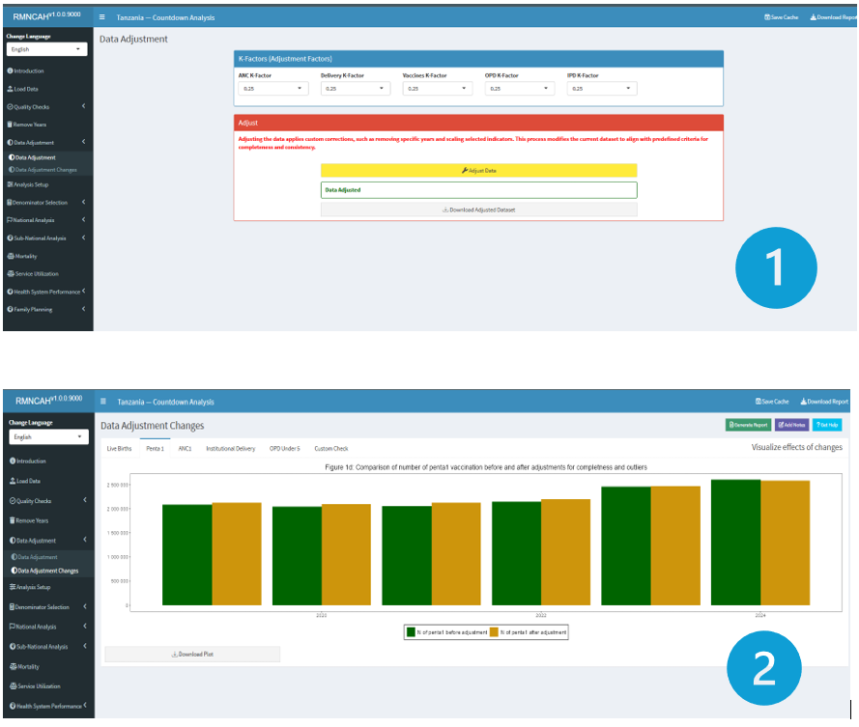

**Note:**

The ***Remove Years*** section before this, allows you to remove any years with no data or whose data has been determined to be not fit for analysis by the country team due to quality issues).

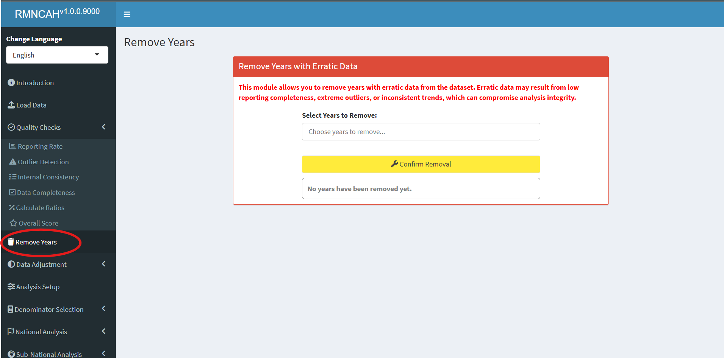

* This Section produces a master adjusted dataset (.dta) ready for analysis and plots for different indicators showing data adjustment changes.

**Report**

* The interpretation should include the selected adjustment factor (factor k) that was used to adjust for incomplete reporting (if necessary, by service). If the default factor is used, then report this and explain what this means for the reader.
* Report the percent change that the adjustment made in reported numbers of institutional deliveries and in penta1 (average of the 6-year period); you may want to highlight the year with the greatest impact of the adjustment if there is one; interpret if the impact of the adjustment on coverage rates is large or small; Make the same description and interpretations for penta1 vaccinations.

# Denominator Assessment and selection

## Rationale: Scientific basis for the analysis

Service coverage is defined as the population who received the service divided by the population who need the services (also referred to as target population). The numerators of coverage statistics (e.g., number of live births in health facilities) are derived from the health facility data and need to be adjusted as shown in the previous section. The denominator of the coverage statistics (e.g., number of live births in the population) needs to be estimated for national and sub-national levels (regions/provinces and districts).

## Approach: Description of analytical steps

The objective of the health facility denominator analysis is twofold. First, we assess the quality of the population projections in DHIS2 by comparison with the UN projections and the internal consistency. Then, we assess the performance of multiple denominators options for the computation of population-based service coverage indicators from the health facility data. This should lead to a final decision on denominators that are used for the analyses of population-based coverage indicators based on health facility data.

Each indicator has its own denominator, as shown in the table below.

**Table 3: Selected indicators with numerators and denominators**

| **Indicators** | **Numerator** | **Denominator** |
| --- | --- | --- |
| **SERVICE UTILIZATION** |  |  |
| Outpatient visits, children under 5, per year (N) | N of OPD visits for under-5 | Total mid-year population under 5 |
| Inpatient admissions, children under 5, per year (N) | N of admissions for under-5 | Total mid-year population under 5 |
| **PREVENTIVE INTERVENTIONS** |  |  |
| % of pregnant women with 4 antenatal care visits | N of women with ANC 4th visit | Total N of pregnant women in the whole population |
| % of live births in health facilities | N of live births in health facilities | Total N of live births in the whole population |
| % of infants receiving 3 doses of pentavalent vaccine | N of infants receiving 3 doses | N of infants eligible for 3 doses of the vaccine |
| **CURATIVE INTERVENTIONS** |  |  |
| % of children under 5 with malaria who receive ACT | N of children under 5 with malaria receiving ACT | Total N of children who had malaria in the last year |
| % of deliveries that were by C-section (population) | N of C-sections reported | Total N of deliveries in the population |
| % of deliveries that were by C-section (institutional) | N of C-sections reported | Total N of deliveries in health facilities |
| **MORTALITY** |  |  |
| Institutional maternal mortality ratio | N of maternal deaths in health facilities | Total number of live births in health facilities |
| Stillbirth rate | N of stillbirths in health facilities | Total N of births in health facilities |
| Neonatal mortality before discharge | N of neonatal deaths before discharge (after birth) | Total N of live births in the health facilities |
| **FAMILY PLANNING (FP)** |  |  |
| Ratio FP visits to women of reproductive age | N of FP new and revisits | Total N of women 15-49 years |
| Estimated modern use of contraceptives | Couple years of protection | Total N of women 15-49 years |
| FP coverage (demand satisfied) | N of women using modern methods | Total N of women in need of FP |

In the first part, we assess the **quality of the DHIS2 population projections** at national level:

* **Check the internal consistency of the DHIS2 population growth over time:**
  + Compute the population growth rate:
  + Compute the crude birth rate (CBR), defined as the number of live births per 1,000 population.
  + Expect both growth rate and CBR to be consistent over time (e.g., less than 2 per 1,000 difference between years).
* **Compare the population data in DHIS2 with the UN population projections at the national level:**
  + Differences may occur, but large discrepancies suggest issues with DHIS2 population projections.
  + The comparison is done for four indicators. Abnormal values are flagged:
    - **Population size:**  
      A relative difference between DHIS2 and UN-projected population size greater than 5% indicates a data quality issue.
    - **Population growth during 2023–2024:**  
      Annual growth is computed using the natural logarithm:
    - A difference greater than 0.3% (absolute) between DHIS2 and UN estimates is concerning.
    - **Crude birth rate (CBR):**  
      Defined as:
    - A difference greater than 5 per 1,000 population compared to the UN estimate suggests a data quality issue.
    - **Crude death rate (CDR):**  
      Defined as:
    - (both expressed per 1,000 population). A **negative CDR** or a **CDR < 5 per 1,000** indicates inconsistency and potential data problems.

The second part is to select the best performing denominator for population coverage estimates with facility data. First, we compare the results for different denominators at the national level.

For the national level, we evaluate 4 denominator methods. The first two are projection methods (DHIS2 estimate and UN estimate), and the additional two are facility data- based methods ( ***ANC1-derived*** and ***penta1-derived*** denominators).

**Note**

* For the sub-national level, no UN projections are available, so we will use 3 methods only.

The maternal and newborn health denominators are closely related and can be computed from each other by making assumptions.

Starting with pregnancies, the number of live births is closely associated with the number of pregnancies, which are usually identified within the health system at the first antenatal visit which in most countries is around 4-5 months of pregnancy (according to the surveys). Country specific values are preferred where available and can be obtained from the [WHO website](https://data.unicef.org/topic/child-survival/neonatal-mortality/). The default assumptions are as follows:

* Pregnancy loss between 4 and 7 months (28 weeks of pregnancy): 3%.
* Stillbirths or pregnancy loss between 28 weeks and birth: 2%.
* Twinning rate: 1.5%. These first three steps give the number of live births computed from pregnancies.
* Neonatal mortality: 3% (or 30 per 1,000 live births).
* Post neonatal mortality (between 1-11 months): 2.4% (or 24 per 1,000 live births).

The selection of the best performing denominator method is based on a comparison of the performance of the DHIS2 projection and facility-data derived methods for two indicators: ***institutional live births*** and ***penta3***. The gold standard is the population coverage rates from a recent survey, for a year as close as possible. The absolute difference between survey and facility-based coverage at national and sub-national levels is used to select the best performing indicator. (This can also be expressed as the number of standard errors from the survey value but this requires including the standard errors from the surveys – the results will be the same).

### Facility data derived denominators

The basic idea is that if the coverage of an indicator is high (e.g., over 90%), then the number of events reported by health facilities has to be close to the target population. In other words, the denominators or target population can be derived from the numbers in DHIS2. The best candidate indicators for this approach are ANC1 and DPT/penta1 (BCG also possible in some countries if re-vaccinations are recorded separately).

This approach requires the following:

A recent population-based survey is used to obtain an estimate of population level coverage of ANC1 or penta1. For example, ANC1 coverage is 95% of pregnant women.

The DHIS2 data on the number of ANC1 and penta1 visits need to be considered complete and accurate (after adjustments / cleaning the data). For example, 100,000 ANC1 visits were reported.

If this is the case, then we only need to add the percentage that has not used the services (according to the survey results) to get the target population. For example, if ANC1 coverage from survey is 95% and the number of ANC1 visits from DHIS2 for the year is 100,000, the total number of pregnant women is:

The same approach can be used for DPT1 or penta1. The survey coverage is the percent of children 12-23 months who received DPT1/penta1, the facility data are the number of infants who received DPT1/penta1 vaccination. For example, if survey coverage is 92%, and there were 100,000 vaccinations given, then the

The number of live births can be obtained from ANC1 and DPT1 by making assumptions about pregnancy loss (abortion after the first ANC visit, stillbirths), twinning rates, and neonatal mortality. These steps are shown in the Figure below. ![] (images/1-dqa_denom_adjustment.png)

**An example of ANC1:**

* Above we computed 105,263 pregnant women in the population
* at 3% abortion, this implies 105,263 * (1-.0.03) = 102,454 deliveries
* at 1.5% twinning rate this implies 102,454 / (1-(0.015/2)) = 103,229 births
* at 2% stillbirth rate this implies 103,229 * (1-0.02) = 101,164 live births
* at 3% neonatal mortality this implies 101,164 * (1-0.03) = 98,129 children eligible for DPT1/penta1.

## Implementation: Conducting analysis in the Shiny App

Shiny App

To get outputs for this analysis first, one need to set up their analysis by inputting key information at the **Analysis Set up** section in the Shiny App.

The parameters required are as shown in the figure below and they are:

1. **National mortality rates - based on the most recent survey** 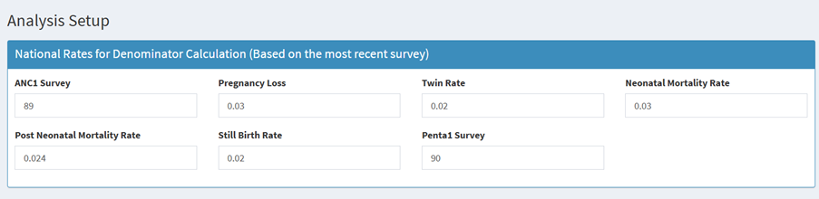
   * **ANC1 Survey -**
   * **Pregnancy loss -**
   * **Twin rate -**
   * **Neonatal mortality rate -**
   * **Post neonatal mortality rate -**
   * **Stillbirth rate -**
   * **Penta1 survey -**
2. **Survey coverage based percentages (based on the most recent survey)** 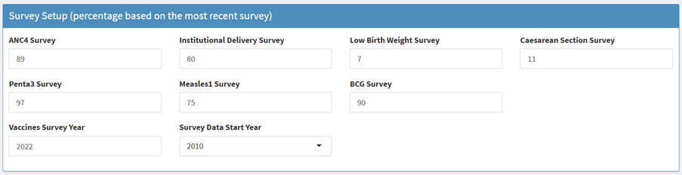
   * ANC4 Survey -
   * Institutional delivery survey -
   * Lowbirth weight survey -
   * Caesarean section survey -
   * Penta3 survey -
   * Measles1 survey -
   * BCG survey -
   * Vaccines survey year -
   * Vaccine data start year -
3. **Survey datasets**

* In addition to setting these parameters, you will be required to upload the following survey datasets (in addition to the health facility data loaded at the beginning of the analysis session).
* 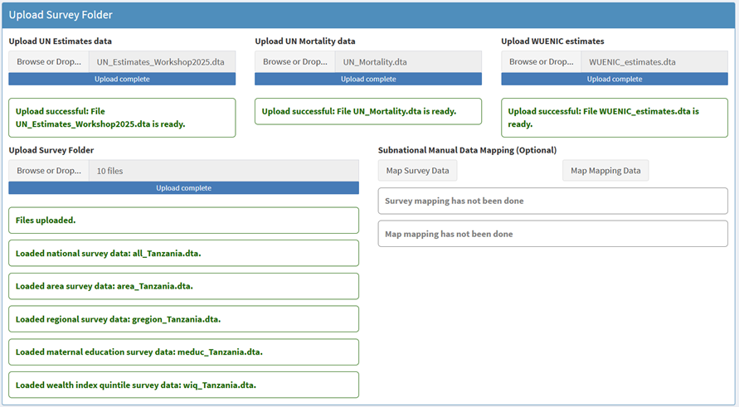
  + UN Estimates data
  + UN Mortality data
  + WUENIC estimates data
  + Survey data (uploaded as a folder)

The first part is to assess the accuracy and consistency of the projected population numbers in the DHIS-2 by comparing them to external sources. The second part is to compare results from the different methods - both at the national and sub-national levels.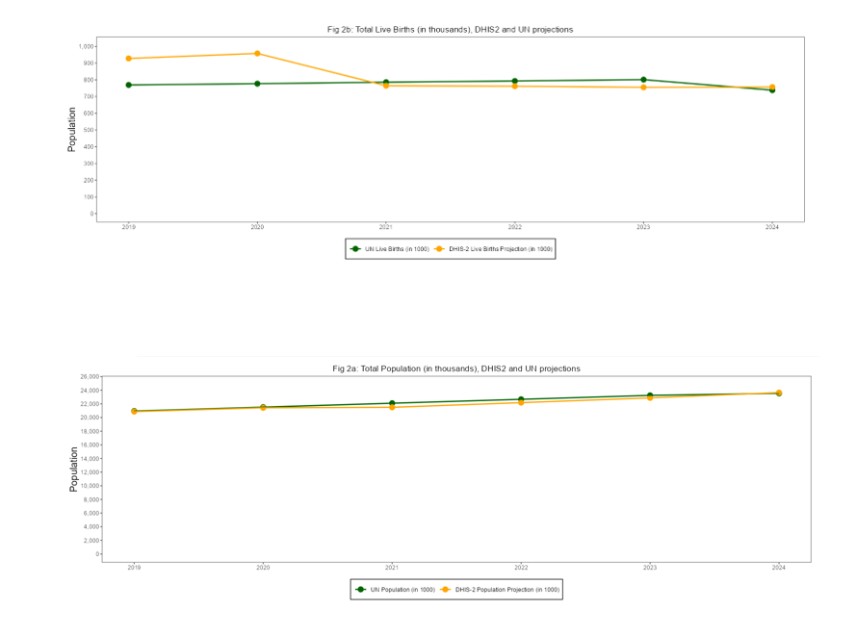

The final step is to select the best performing denominator for the coverage analyses with health facility data. The results on the national gap and the median sub-national gap should be taken into account to make that choice.

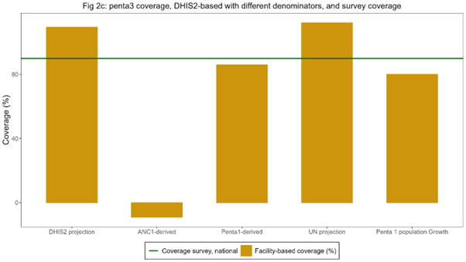

The best methods have the smallest gaps with the survey results. Ideally, one method is selected but it is also possible to select one denominator method for the MNH coverage indicators (ANC, delivery, PNC) and another method for the immunization coverage analyses. It will be important to clearly state the chosen denominator method in all tables.

The interpretation should focus on the extent to which the DHIS2 projections are considered robust which is the case when:

* The DHIS2 total population projection is consistent over time with regular population growth
* The DHIS2 total live birth projection is consistent over time (regular trend)
* The projected numbers of total population and live births are close to the UN population projection
* The DHIS2 population projections are consistent with UN estimates for crude birth rate and crude death rate.

The interpretation should describe, based on the graphs:

* Which denominator methods performed best at the national level for the two indicators?
* Which denominator performed best at the sub-national level for the two indicators?
* What selection is made for the indicators in the coverage analyses?

# National Coverage

## National coverage of interventions

### Rationale, Approach and implementation

**Rationale: Scientific basis for the analysis**

Coverage of interventions is a critical and direct output of health systems. Regular tracking of coverage at national and subnational levels has become the mainstay of monitoring progress in national health plans and international initiatives. Reproductive, maternal, newborn, child and adolescent health indicators with targets are the most common indicators of national health plans and global monitoring. Both health facility data and household surveys can provide coverage statistics, and an integrated analytical approach is desirable.

**Approach: Description of analytical steps**

Many coverage indicators can be estimated in both surveys and from health facility data. Both are critical pieces of information and need to be considered in conjunction with each other. The Table below lists the indicators, for antenatal and delivery care and child immunization, considered in the health facility data analysis in the workshop, including the variable names (in R) in the first column.

| **Name (in R)** | **Indicator title** | **Survey d enomin ator** | **Facility data den ominator** |
| --- | --- | --- | --- |
| **Antenatal care** |  |  |  |
| anc1 | Antenatal care at least one or more visits among all pregnant women (%) | Women aged 15-49 years with a live birth in the last 2 years | Estimated live births as d enominator |
| anc_1 trimester | Antenatal care 1+ visits in 1st trimester of pregnancy among all pregnant women (%) |  |  |
| anc4 | Antenatal care 4+ visits among all pregnant women (%) |  |  |
| ipt2  ipt3 | Intermittent preventive therapy for malaria - 2nd dose / 3rd dose during pregnancy among all pregnant women (%) |  |  |
| ifa90 | Iron folic acid supplementation given (90 days supply) during pregnancy among all pregnant women (%) |  |  |
| hiv_test | HIV test conducted among pregnant women (%) | Not available (in some survey re ports) |  |
| syph ilis_test | Syphilis test conducted among pregnant women (%) |  |  |
| **Delivery** **care** |  |  |  |
| instd eliveries | Institutional live births among all live births | Live births in the last 2 years | Estimated live births as de nominator. |
| sba | Skilled birth attendance |  |  |
| lo w_bweight | Low birth weight (below 2500 grams) among all live births |  |  |
| csection | C-section among all live births |  |  |
| pnc48h | Postnatal care within 48 hours |  |  |
| **Immunization** |  |  |  |
| bcg | BCG vaccination to infants | Children 12-23 months | N of surviving infants (beyond neonatal period) |
| penta1 | Penta vaccine - 1st dose to infants | Children 12-23 months |  |
| penta3 | Penta vaccine - 3rd dose to infants | Children 12-23 months |  |
| measles1 | Measles vaccine - 1st dose (to infants) | Children 12-23 months | N of surviving infants (beyond postNN period) |
| measles2 | Measles vaccine - 1st dose (older children) | Children 24-35 months | N of surviving infants (beyond po stneonatal period) (or age 1) |

The facility data can be used to generate annual coverage estimates, using the dataset for 2019-2024, through the Shiny App developed. These coverage results should be compared and interpreted alongside the results from recent surveys. The analysis results will include both coverage estimates.

**Implementation: Conducting analysis in the Shiny App**

### Antenatal care (ANC)

Most countries have at least one ANC indicator with a target in the national plan. The global ENAP/EPMM coverage targets for 2025 are: globally, at least 90% of pregnant women with 4 or more ANC care visits, and 90% of countries with at least 70% coverage. There are several ANC indicators that capture:

* *contact with health services* during pregnancy (ANC 1st visit, ANC 4 or more visits, ANC first visit in first trimester). ANC1 is often considered an indicator of basic access to health services. It is high in most countries, and in many instances, the numbers of ANC1 visits in the routine health facility data can provide a better denominator for the ANC and delivery indicators than population projections (see section 2 on denominators).
* *contents of services* provided (intermittent preventive therapy (IPT2 or IPT3) against malaria, HIV testing, syphilis testing and iron-folic acid (IFA) supplementation (at least 90 tablets given to the pregnant woman)). Some countries will not have policies for all of these diagnostic or therapeutic interventions during pregnancy (e.g., no IPT if no malaria risk).

For most indicators, the surveys also provide coverage estimates for the national level, with 95% confidence intervals. For most coverage indicators the data refer to a period before the survey: e.g., institutional birth coverage for the live births in the two years preceding the survey. This means that the midpoint of the coverage estimate lies one year before the survey.

An example of two graphs for ANC, based on facility and survey data, is shown below, showing both good concordance between the facility-based and survey results for coverage of ANC first visit in the first trimester and poor concordance in case of ANC4 visits. In the latter case, it is evident that ANC4 is overreported in the facility data as coverage is much higher than the survey and unlikely to be high (over 90% during 2021-23 and even 101% in 2023). Poor recording and reporting of ANC 4th visits in the DHIS2 data is likely the main cause.

Sometimes, an indicator may reach an unlikely high coverage at the national level, say over 125%. This may be because the data quality of the numerator of the coverage indicator is poor, the denominator is wrong, or the intervention is given and recorded more than once during pregnancy. An example is IFA supplementation. In that case, the computation of coverage is not useful. It is better to express it differently. For instance, if coverage is 200%, it is better to compute the average number of courses of 90 IFA tablets that a pregnant woman received (in this case 2.0 per pregnant woman in the population).[1]

![] (images/2-national-anc-cov.png)

### Delivery care

All countries have at least one delivery care indicator with a target in the national plan. The global ENAP/EPMM coverage target for 2025 is at least 90% global average coverage, and 90% of countries at least 80% coverage of skilled birth attendance (SBA). For postnatal care (PNC) within 2 days the global coverage target is 80% and the 90% of countries with at least 60% coverage.

*Institutional (live) birth coverage and SBA* are closely related, as almost all deliveries with a skilled attendant occur in health facilities. From the analytical point of view, institutional birth coverage is preferred because it is a more objective measure and avoids issues with the definition of what constitutes skilled birth. SBA is often preferred from the health care perspective, as it includes an element of quality: obviously, an institutional delivery without skilled attendance is not desirable, and in some countries home SBA may be part of the health care delivery strategy. attendance. Either indicator works well to capture delivery care.

*Caesarean section* is a live saving intervention and an important indicator. A general rule of thumb is, put forward by WHO, that in a population the need for Caesarean section is in the range of 10-15% of all deliveries. If the Caesarean section rate is below 10%, that means that there is unmet need. If the Caesarean section rate is over 10-15%, that implies that there most likely overuse of Caesarean section. It may however also imply that there is still unmet need among certain population groups (e.g. the poorest women or rural women) in combination with overuse in other subgroups of the population (such as urban and richer women).

*Postnatal care (PNC) within 48 hours* is provided to the mother/women and newborn. Country systems may have different ways of recording the type of PNC and also surveys are known to have data issues with PNC for the mother or the baby.[2] Some countries use multiple definitions of timing of the PNC visit (e.g., within the first week).

*Low birthweight* is a critical indicator of neonatal health. It is most meaningful if the distinction between prematurity and small-for-gestational age is made, but most facility reporting systems and most surveys do not have such data. All babies are supposed to have been weighed right after birth and the percent of newborns weighing less than 2500 grams is usually reported in the DHIS2 system. As general guidance for the interpretation of the data, low birthweight prevalence in sub-Saharan Africa was estimated at 13.9% (95% credibility interval: 12.4-15.7%) for 2020.[3]

### Immunization

Immunization coverage indicators are included in virtually every country’s health sector monitoring plan. A general target is at least 90% coverage for essential vaccines given in childhood and adolescence.

For the national coverage analyses, the focus is on BCG, first and third doses of penta/DTP (penta1 or DTP1 and penta3 or DTP3), and first and second doses of measles vaccine, often given in combination with rubella vaccine. *BCG and penta/DTP vaccinations* are recommended to be given at birth (BCG), 6 weeks (penta1) and 14 weeks (penta3). For facility data, the number of vaccinations given to infants is used and the denominator is the number of eligible children in the population, which is approximated as live births minus neonatal deaths. Survey data generally provide vaccination coverage among children 12-23 months (may also include the age at which the vaccination was given – mostly before the first birthday).[4]

The first dose of measles vaccine is generally recommended at age 9 months. For the facility data, the recording and reporting usually separate measles given to children under 1 year and children 1 year and older, though the quality of recording and reporting for the age group may vary (there may be a tendency to record measles vaccinations after 12 months as given to infants). Here, we use children who have survived the first year of life (live births minus neonatal deaths minus postneonatal deaths) as the denominator for measuring vaccination coverage. The second dose of measles uses children aged 24-35 months as denominator. This can be estimated as live births minus neonatal deaths = 2* postneonatal deaths).

WHO and UNICEF work with countries to produce annual estimates of immunization coverage based on all data sources. The national estimates, called WUENIC, are published and available for 2020-2024. These time trends are included in the Stata outputs, to compare the 2019-2023 annual estimates of the facility data produced in the workshop and the survey results.

### Family planning

The family planning coverage estimates are derived from a collaboration of the Countdown with Track20. Track20 has developed an advanced estimation tool called Family Planning Estimation Tool (FPET) which focuses on three indicators: modern contraceptive use, unmet need for modern contraceptives and demand satisfied with modern methods. The three indicators are closely related since demand is satisfied (this is the true coverage indicator) = use of modern contraceptives / (unmet need + use of modern contraceptives).

FPET uses statistical modelling that incorporates all available data from surveys and may also use estimates obtained from facility data if the quality is sufficient.[5] FPET allows for various types of survey data to be integrated into the estimates and fits a line that pulls from the trends. This utilizes the strength of multiple data points and minimizes the risk of comparing different surveys.

# National Inequality

National Inequality

# national-global-coverage

# Global targets for coverage of health services

# national-subnational-mapping

# National and subnational mapping of health service coverage

# national-equity-assessment

# National Equity Assessment

# subnational-coverage

# Subnational Coverage

# Sub-national Inequality

# subnational-global-coverage

# Subnational Global coverage targets

# maternal-mortality

# Maternal Mortality

# Section 5: Curative health services utilization for sick children

# Section5: Curative health services utilization for sick children

# Health systems inputs

# Health systems inputs

# health-systems-outputs

# Health systems outputs

# Private sector analyses

# Private Sector Analyses

# Planning Ahead

# Planning Ahead

1. Surveys can provide coverage of IFA supplementation, as here the unit of data analysis is individual pregnant women.
2. Amouzou A, Hazel E, Vaz L, Sanni Y, Moran A. Discordance in postnatal care between mothers and newborns: Measurement artifact or missed opportunity? J Glob Health. 2020 Jun;10(1):010505.
3. Okwaraji YB, et al. National, regional, and global estimates of low birthweight in 2020, with trends from 2000: a systematic analysis. Lancet. 2024 Mar 16;403(10431):1071-1080.
4. Therefore, the survey data on immunization roughly refer to the program performance in the year before the survey
5. https://www.track20.org/pages/data_analysis/publications/methodological/family_planning_estimation_tool.php