Country Analysis Meeting (CAM) 2025 - Analysis Guide

Table of contents

# Introduction to Countdown to 2030

### Overview of the Countdown to 2030 (The Countdown)

The Countdown to 2030 for Women’s, Children’s and Adolescents’ Health (The Countdown) initiative is a global collaboration involving academics from national, regional, and international institutions, UN agencies, the World Bank, and civil society organizations. The initiative tracks progress in Reproductive, Maternal, Newborn, Child, and Adolescent Health and Nutrition (RMNCAH+N), fostering advocacy and accountability through rigorous data analysis.

**Key objectives include:**

* Strengthening country-led data analysis and monitoring
* Fostering innovation and evidence generation through multi-country collaboration
* Enhancing global measurement and monitoring Improving policy and program communication

For more on Countdown to 2030 initiative, visit: [The Countdown website](https://www.countdown2030.org/about)

### About the cd2030.rmncah R Package

The cd2030.rmncah R package and Shiny App were developed to support evidence generation and analysis of RMNCAH indicators.

Key features include: User-friendly interface for data management and analysis Tools for visualization and statistical summarization Automated report generation

### Acknowledgments

The Countdown acknowledges and appreciates the contribution of the following individual in developing the Stata codes that form the backbone of the cd2030.rmncah R package and Shiny App:

# General Introduction to CD2030 CAM Approach

## General Introduction to CD2030 CAM Approach

The CD2030 for Women’s, Children’s and Adolescents’ Health, GFF, UNICEF, WHO, WAHO and other partners are collaborating to strengthen country-led progress and performance reviews, such as annual health sector reviews and midterm reviews of investment cases. This guidebook is for Countdown country analytical teams to develop a set of national and subnational estimates for key RMNCAH-N indicators, including equity, using five-year time series of routine data and survey results.

Much attention is paid to obtaining a clean data set with the necessary corrections and adjustments for known biases. Service coverage and equity, maternal and perinatal mortality, and health service utilization and systems performance are the main subjects, with a focus on monitoring national and subnational targets, as well as global targets. The figure below shows the general overview of the CAM approach 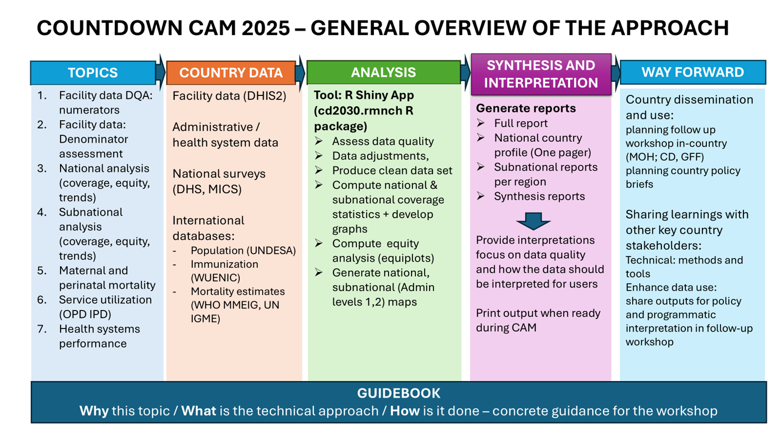

## Organization of the Guidebook

This guidebook is organized into seven sections, each focusing on a specific area of data analysis related to reproductive, maternal, newborn, child and adolescent health and nutrition (RMNCAH-N). The guidebook provides a comprehensive approach to analyzing routine health data and survey results, with an emphasis on data quality, coverage, equity, and health systems performance. The seven data analysis sections in this guidebook are:

1. Section 1: Health facility data quality assessment
2. Section 2: National  Analyses (Coverage & Equity)
3. Section 3: Subnational analysis (Coverage & Inequality)
4. Section 4: Maternal mortality, stillbirths and neonatal mortality
5. Section5: Curative health services utilization for sick children
6. Section 6: Health systems progress and performance
7. Section 7: Planning ahead for data use

These sections are designed to be used in a modular way, allowing countries to select the topics that are most relevant to their context and data availability.

Each section has:

* **Why/Rationale -** the scientific basis for the analysis;
* **Approach**- a step-by-step guide on how to conduct the analysis; and the
* **Implementation -** the use of the R Shiny App for data visualization and interpretation.

## Data Sources

The Countdown CAM approach uses a variety of data sources, including:

* **Health facility data**: Routine health data collected from health facilities, including service coverage, health systems performance, and health service utilization.
* **Surveys**: Nationally representative surveys, such as the Demographic and Health Surveys (DHS) and Multiple Indicator Cluster Surveys (MICS), which provide data on health indicators, equity, and health service utilization.
* **Administrative data**: Data collected by government agencies, such as vital registration systems and health management information systems (HMIS), which provide information on health outcomes and service delivery.
* **Other data sources**: Other relevant data sources, such as census data, population estimates, and health financing data, which provide additional context for the analysis.

## Expected outputs

* **Synthesis/poster reports** (.pdf, .doc files)
* **Full country report** (national/sub-national) (.pdf, .doc files) - to be downloaded in sections from the Shiny App and compiled into a full report with analysis outputs and interpretations.
* **Country analytical reproducible files** (.rds files)
* **Adjusted and or summarized data files** (.csv. .dta, xlsx files)

Country analytical reproducible files (.rds files) are the final output of the analysis, which can be used for further analysis and visualization. These files contain the cleaned and processed data, country specific analysis parameters as well as the results of the analysis, including coverage, equity, and health systems performance indicators.

# Getting started

Initially, Countdown2030 analyses were conducted using Stata. These scripts have now been translated into R to support the development and deployment of a Shiny-based dashboard.

We extend our appreciation to the team that compiled the original Stata codebase.

## Installing R and RStudio

To begin working in R, it is necessary to install both R and RStudio. R is the underlying programming language, while RStudio provides a user-friendly interface that simplifies the development and execution of R scripts. Both are freely available and widely supported across platforms. > **Note**: R and RStudio are not the same. R is the programming language, while RStudio is an integrated development environment (IDE) that makes working with R easier. >To ensure smooth installation and functionality, it is recommended to install **R** first, followed by **RStudio**. This order is important as RStudio relies on R to function properly.

### Download and Install R (Step 1)

R is distributed via The [Comprehensive R Archive Network (CRAN)](https://cran.r-project.org/). Select your operating system from the homepage: Windows, Mac, or Linux.

#### Windows

1. Navigate to ***Download R for Windows*** and select the “base” option.
2. Click the first link (e.g., “Download R x.x.x for Windows”) to download the installer.
3. Run the installer and follow the prompts. ***Administrator privileges may be required***.
4. R will be installed in your system’s Program Files, with a shortcut added to the Start menu.

#### Mac

1. Click ***Download R for Mac*** on the CRAN homepage.
2. Download the latest release package and run the installer.
3. The default installation settings are typically sufficient. You may be prompted to enter your system password.

**R is not a graphical software application but a programming environment. It is best used in conjunction with RStudio, which provides a consistent and user-friendly interface across operating systems.**

### Install RStudio (Step 2)

RStudio is an integrated development environment (IDE) designed for R. It features a script editor, console, graphics viewer, and additional tools for package management, debugging, and file organization.

Download RStudio from [Posit Website](https://posit.co/downloads/)

**Do I still need to download R?** Even if you use RStudio, you’ll still need to download R to your computer. RStudio helps you use the version of R that lives on your computer, but it doesn’t come with a version of R on its own.

After installation, launch RStudio and begin interacting with R through its console and script windows. 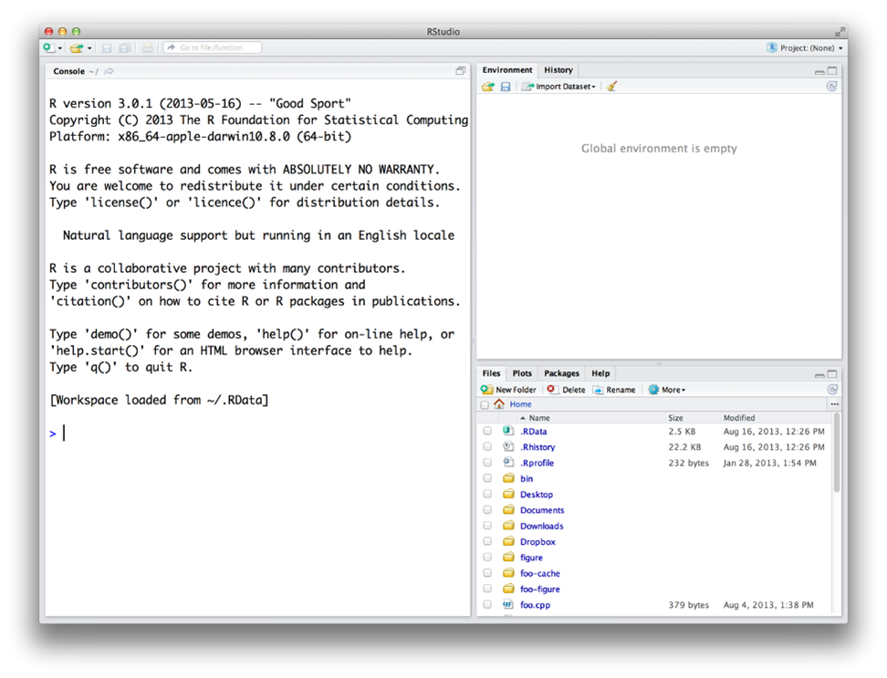

## Installing the Countdown2030 RMNCAH Application

After installing R and RStudio, you may proceed with installing the Countdown2030 RMNCAH application, which is hosted on GitHub under the repository [cd2030.rnncah](https://github.com/aphrcwaro/cd2030.rmncah). The application is implemented as an R package and supports interactive dashboard generation via Shiny.

### Installation via R Console

**Stable Version**

devtools::install_github("aphrcwaro/cd2030.rmncah@v1.0.0")

**Development Version**

devtools::install_github("aphrcwaro/cd2030.rmncah")

### Launching the Application

library(cd2030.rmncah)  
dashboard()

The Shiny dashboard will launch automatically in your default web browser.

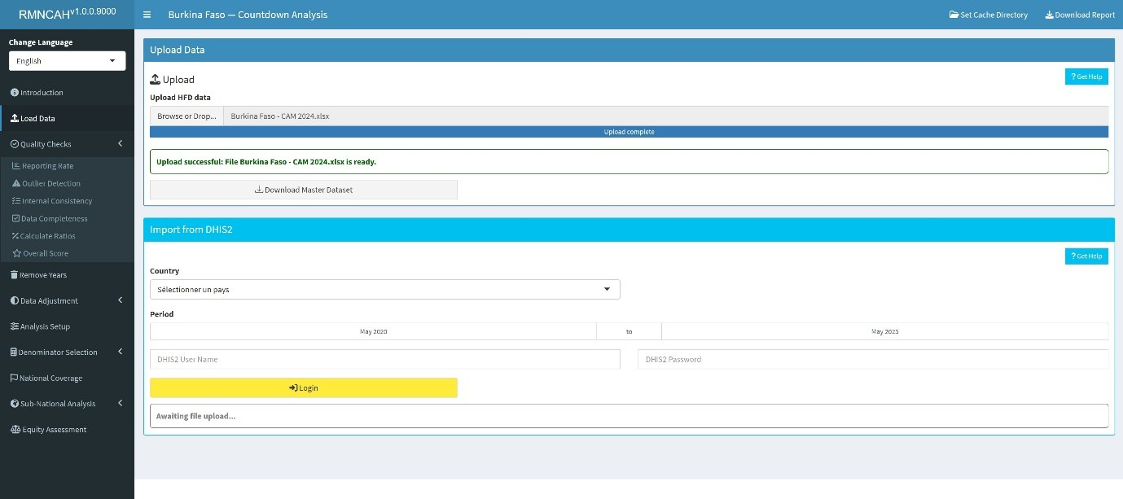

### Alternative Installation via GitHub Desktop or Git or direct download

Advanced users with GitHub accounts may prefer to clone the repository directly. This method allows for:

* Version control
* Contribution to the codebase
* Inspection of the package structure
* Once cloned, open the .Rproj file in RStudio to set the working directory.

| Github | Local Folder |
| --- | --- |
|  |  |

To install and run:

devtools::install()  
  
library(cd2030.rmncah)  
dashboard()

### RTools for Windows

To compile packages from source, especially development versions, RTools must be installed. Ensure compatibility with your installed R version:

* **R 4.2.0** → Rtools42
* **R 4.4.0** → Rtools44
* **R 4.5.0** → Rtools45

RTools can be downloaded from [CRAN](https://cran.r-project.org/bin/windows/Rtools/)

## Data requirements

### Datasets required

To run the analysis efficiently, each country team will require to have a folder containing the following datasets:

1. Health facility data (.xlsx file)
2. UN Estimates
3. Survey data
4. UN mortality data
5. FPET data These datasets will be provided to the country teams by the Countdown2030 team prior to the workshop.

### Country specific analysis parameters

The following parameters will be required to run the analysis see

# Loading Health facility data

This section explains how to structure and upload data into the app, ensuring compatibility with the **Countdown Health facility data format**

Please note that should you update your data during the workshop, ensure it is in the correct format before uploading to avoid errors.

## **Supported File Formats**

The app supports uploading the following file types:

* .xls, .xlsx (Excel files)- The raw health facility dataset in the **Countdown format**
* .dta (Stata files) - Master dataset downloaded from the app after validation/adjustment
* .rds (R Cached datafile) - The file containing the preloaded dataset, user adjustments and analysis parameters that has been > saved in the Cache directory. This will be the last saved file.

## **How to Upload Data**

**Step 1: Prepare Your data file**

Ensure your data is cleaned and structured according to the **The Countdown Health facility data format** by:

* Using the provided **HFD Standardized Template** to format your data > correctly.
* Saving the file in a supported format: .xls, .xlsx, .dta, or .rds.

Step 2: Upload the File

1. Navigate to the **Upload Data** section of the app.
2. **Drag and drop** your file into the upload box, or click **Browse** > to select it manually in your directory.
3. For subsequent re-uploads (after the initial uploading of the .xls, > .xlsx, .dta files and saving your progress in .rds file using the > Cache Directory button), do not reupload the .xls, .xlsx, .dta but > the saved .rds file if you want to retain any changes made in your > analytical files
4. The app will validate your file against the **Countdown format**.
   * If successful, a confirmation message will appear: *“Upload > successful: Your file is ready for analysis.”*
   * If errors are detected, an error message will indicate the > issue.

## **Common Errors and How to Fix Them**

| **Error Message** | **Cause** | **Solution** |
| --- | --- | --- |
| “Unsupported file format” | File type not supported | Save your file as .xls, .xlsx, .dta, or .rds. |
| “The following required columns are missing from the data: opv1” | Missing essential columns in the data | Add the missing column(s) to your dataset and ensure their values are valid. |
| “The following sheets are missing: Service_data_1, Service_data_2, Service_data_3, Reporting_completeness, Population_data, Admin_data” | Missing one or more required sheets in the file | Add the missing sheets to your file and ensure they conform to the template. |
| “Sheet Service_data_3 is empty” | The sheet exists but contains no data | Populate the sheet with valid data or remove the empty sheet. |
| “Key Columns”month” missing in Service_data_3” | A key column district, year, or month, is missing from the specified sheet | Add the missing column(s) to the sheet and ensure the data is structured correctly. |
| “Column name month must not be duplicated. Use .name_repair to specify repair.” | Duplicate column names in the dataset | Ensure all column names are unique. Rename or remove duplicate columns. |

***Note****: If a key column (district, year, or month) is missing data in a row, that row will be excluded from the resulting dataset.*

## **Tips for a Successful Upload**

* Always use the latest **The Countdown Health facility data format** > template to structure your data.
* Double-check column names, formats, and content before uploading.
* Save your file in a supported format and ensure it is UTF-8 encoded

# Numerator Assessment

## Numerators Assessment

### Rationale: Scientific basis for the analysis

Routinely reported health facility data are an important data source for health indicators at facility and population level. The data are reported by health facilities on events such as immunizations given, or live births attended. As with any data, quality is an issue. Data needs to be checked to consider completeness of reporting by health facilities, identify extreme outliers and internal consistency. A standard reporting method for data quality allows assessment of progress over time.

### Approach: Description of analytical steps

The analysis of the monthly data by district for 2019-2024 is used to assess annual data quality using the following standard indicators:

## Implementation: Conducting analysis in the Shiny App

The various data quality aspects ( ***Reporting completeness***, ***Outlier detection***,***Internal Consistency*** ***Data completeness***, ***Ratios calculation***, ***Overall quality score***) are are assessed in the **Data quality** section of the Shiny App. 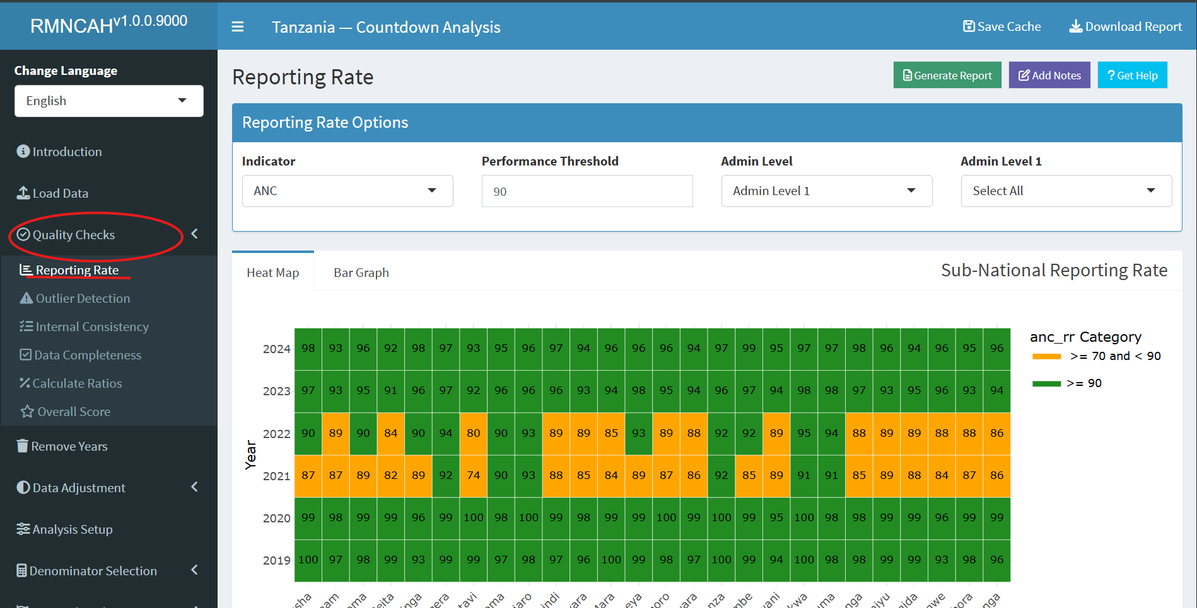 The app will automatically compute the overall data quality score based on the metrics described above. The app will also produce a report with the results of the data quality assessment, including the numerators and denominators for each indicator, as well as the overall data quality score. []

There is often an inconsistency between antenatal and immunization data, even though we can argue that the two should be consistent. To examine the association between ANC1 and penta1 is particularly informative. To compute and interpret indicators 3a and 3b the following considerations need to be made:

***ANC1 to penta1 ratio***

We can compute an expected ratio ANC1 to penta1 based on assumptions about mortality between early to mid pregnancy and early infancy and survey data on coverage of ANC1 and penta1 in the population:

* Consider the mortality between the first ANC visit and the first pentavalent vaccination.

Assuming that ANC1 takes place at about 20 weeks or 4-5 months of pregnancy and penta1 at 6-8 weeks postpartum, we assume a pregnancy loss (abortion) after the ANC1 visit of 3%, a stillbirth rate of 2%, a twinning rate of 1.5% and neonatal mortality rate before the penta1 of 3% then the difference between the numbers of ANC1 and penta1 should be: 1 – 0.03 – 0.02 + 0.015 – 0.03 = 0.935. This corresponds with a ANC1 to penta1 ratio of 1/0.935 = 1.07.

* Actual population coverage of ANC1 and penta1 will also need to be considered, using the surveys.

The expected ratio (the number of ANC1/ number of penta1 in facilities) is 1.07 * (ANC1 coverage in the survey/penta1 coverage in the survey).

If coverage for ANC1 and penta1 are the same, then the ratio is 1.07 (1.07 * 1/1). But if, for example, the last survey shows that ANC1 coverage was 90% and penta1 coverage was 95%, then the expected ratio becomes 1.07 * (.90/.95) = 1.01.

* For the national ANC1 to penta1 ratio a range of plus or minus 0.05 outside this computed ratio is considered acceptable. If the ratio is outside this range, this should be flagged, and possible explanations discussed.

***Penta1 to penta3 ratio***

We can compute an expected penta1 to penta3 ratio based on the most recent survey:

* The main factor determining the penta1 to penta3 ratio, which are recommended at 6 and at 14 weeks of age, is the actual drop-out rate between penta1 and penta3, as mortality plays a limited role.
* Population coverage rates from the latest survey are used to determine the expected penta1 to penta3 ratio in the facility data. For instance, if penta1 coverage is 95% and penta3 coverage is 85%, we expect that ratio to be 0.95/0.85 = 1.12.
* Also, here a range of plus or minus 0.05 is considered acceptable for the assessment of the facility data.

**Report:**

Points to consider for the interpretation

* Is there a data quality pattern by year for which there is an > explanation? (include the explanation)
* Are there certain regions or other subnational units that are > particularly problematic?
* Are there certain reporting forms or services (e.g., antenatal care, > labour and delivery, immunization) that are problematic?
* Is there good consistency between reported numbers of ANC1 and > penta1?

The Figure below produced in the ShinyApp shows the ratios for all six years (2019-2024) and the expected value. It will be important to reflect on large differences (e.g., more than 0.10 or 10%.).

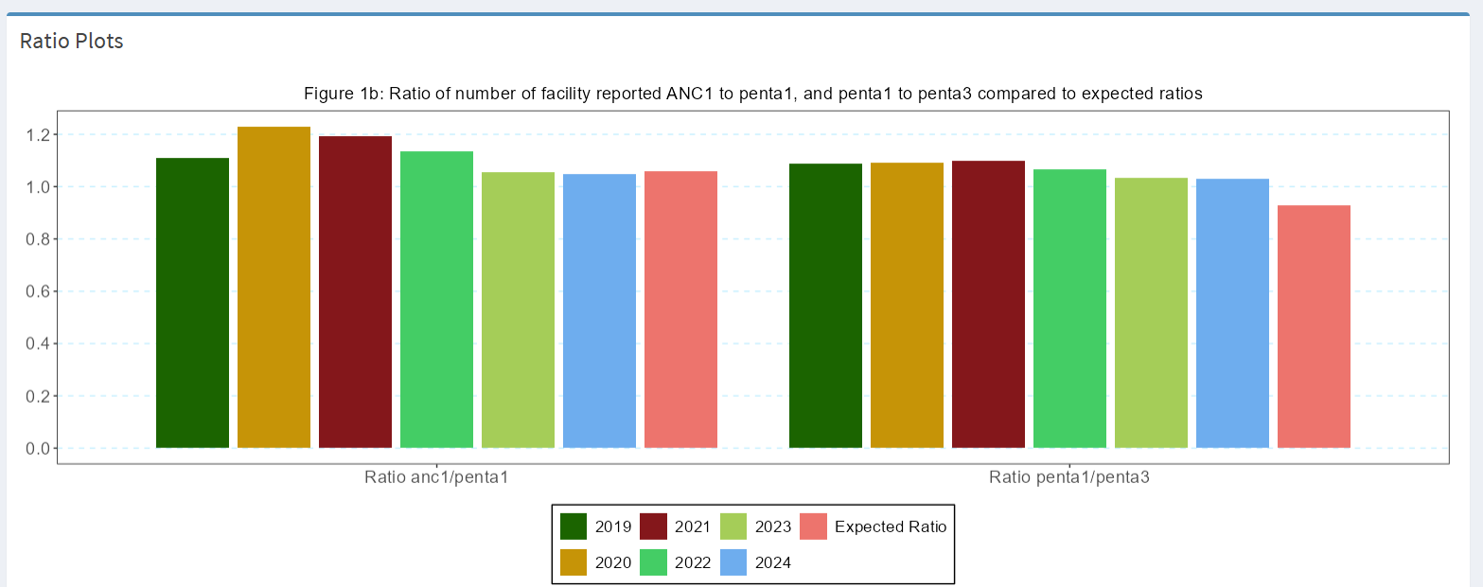

## Table 1: Health facility data quality assessment: numerators

| Indicator | Numerator | Denominator | Interpretation |
| --- | --- | --- | --- |
|  | **Completeness of monthly facility reporting** |  |  |
| Statistics for 1a and 1b are based on the mean of 4 reporting forms (ANC, delivery, immunization, OPD) |  |  |  |
| 1a | % of expected monthly facility reports (national) | Number of monthly facility reports received | Reporting rates over 90% are good; changes in reporting completeness over time affect trend analysis. |
| 1b | % of districts with completeness of facility reporting >= 90% | Number of districts with at least 90% monthly reporting completeness in a year | Can be used to identify districts with low reporting rates in multiple years. |
| 1c | % of districts with no missing monthly values in a year for any of the 4 forms | Number of districts with no missing values for any of the 4 forms in a year | Additional indicator; not used to compute the overall data quality score. |
| 2 | **Extreme outliers** |  |  |

The statistics for 2a and 2b are based on the mean of outliers in ANC, delivery, PNC, vaccination, OPD and IPD indicators. *Note: Number of indicators included in the mean may vary according to countries* | | | |2a |% of monthly values that are not extreme outliers¹ (national) |Total number of monthly values (usually 12 × number of years to be analyzed) |At least 99% of monthly data are expected *not* to be an extreme outlier; consider reasons. | |2b |% of districts with no extreme outliers in a year |Total number of districts |At least 90% of districts should have no extreme outliers at all; consider reasons. | |3 |**Consistency of annual reporting** | | | |3a |ANC1 to penta1 ratio in the reported data (national) |Number of ANC1 reported |National ratio within an expected range (1.05 to 1.10 if survey coverage for ANC1 and penta1 are the same). | |3b |Penta1 to penta3 ratio in the reported data (national) |Number of penta1 reported |National ratio within an expected range, based on the survey results. | |3c |% of districts with ANC1-penta1 ratio between 1.0 and 1.5 |Number of districts with ratios within the expected range |For districts, there is more variation in the ratio: a wider range is considered. | |3d |% of districts with penta1-penta3 ratio between 1.0 and 1.5 |Number of districts within the expected range |For districts, there is more variation in the ratio: a wider range is considered. | |4 |**Summary of performance** Annual data quality score (mean 1a, 1b, 2a, 2b, 3c, 3d) | | |

¹ An extreme outlier is defined as a monthly value that is 5 times the median absolute deviation (MAD) from the monthly median value for a particular year.

# Numerator Adjustments

## Numerator adjustments

### Rationale: Scientific basis for the analysis

The completeness of reporting may affect the analysis, especially if completeness is low or varies between years. Extreme outliers, such as an accidental extra zero in a number, can have a large impact, especially on subnational numbers. Following the assessments, several steps are necessary to obtain a clean data set for analysis. This implies adjusting for incomplete reporting and correcting for extreme outliers.

### Approach: Description of analytical steps

If we do not consider reporting completeness that means we assume all non-reporting facilities provided zero services, which is not likely to be true. Adjustments depend on how much services (e.g., pregnancy care, vaccinations) were provided at non-reporting facilities compared to those that reported. The adjustment factor k - defined as the ratio of the volume of services provided by non-reporting facilities to the volume of services provided by reporting facilities - is used to adjust the reported numbers for incomplete reporting.

## Adjusting the Numerator Using Completeness and Facility Reporting Ratio

To account for incomplete reporting, the reported number of events can be adjusted using the following formula:

**Where:** - ( N_{} ): Total number of events adjusted for incomplete reporting - ( N_{} ): Number of events reported  
- ( c ): Reporting completeness (e.g., proportion of facilities that reported)  
- ( k ): Adjustment factor to account for lower service volume in non-reporting facilities

As a default value, we use k=0.25, which means the non-reporting facilities provided services but only at a volume which was a quarter of the reporting health facilities. The factor k can be different for different services. For instance, if private facility reporting is poor but they are in the national system and they provide a considerable number of deliveries, k maybe greater than 0.25 or even as high as 1.0.

The following k-values are used depending on the reporting used to adjust the reported numbers for incomplete reporting:

* ***k=0*** - No services in non-reporting facilities (default k-value)
* ***k=0.25 -*** Some services, but much lower than reporting facilities
* ***k=0.50 -*** Half the rate compared to reporting facilities
* ***k=0.75 -*** Nearly as much as reporting facilities
* ***k= 1.0*** - Same rate of services as reporting facilities

If the facility reporting rate is below 75%, it becomes more difficult to impute district data. Therefore, no adjustments are made if reporting is lower than 75%. In that case, further analysis to determine coverage with the facility data is not considered sufficiently reliable.

Extreme outliers, as defined in the previous section, will be corrected by imputing the median monthly value of the same year. The table summarizes the adjustments.

**Table 2: Summary of adjustments made to the raw health facility data in preparation of a clean data set for the endline analysis**

| **Problem** | **Action** | **Adjustment** |
| --- | --- | --- |
| Low reporting rates: identifying low rates that were adjusted | If below 75% (default), data were imputed | Median monthly value for the district year was imputed for the month with low reporting |
| Incomplete reporting by districts, variable over time, affecting trend assessment | If reporting rates were >=75% and <= 100% default), an assumption was made about the volume of services provided by the non-reporting facilities | Adjustment factor k value was used to adjust for incomplete reporting k default value 0.25 (replace if different value used; state if used for all reporting forms or different k factors between forms) |
| Extreme outliers can greatly affect coverage trend assessments | If a monthly value was greater or smaller than 5 times the median absolute deviation (MAD) from district monthly median value, an adjustment was made | Extreme monthly outliers are corrected and given the district median value for the same year |
| Missing values | If there is a missing value, data were imputed | District median monthly value for the year was imputed for the month with missing value |

### Implementation: Conducting analysis in the Shiny App

* The outputs for this analysis can be obtained through the **Data adjustment** section of the Shiny App
* 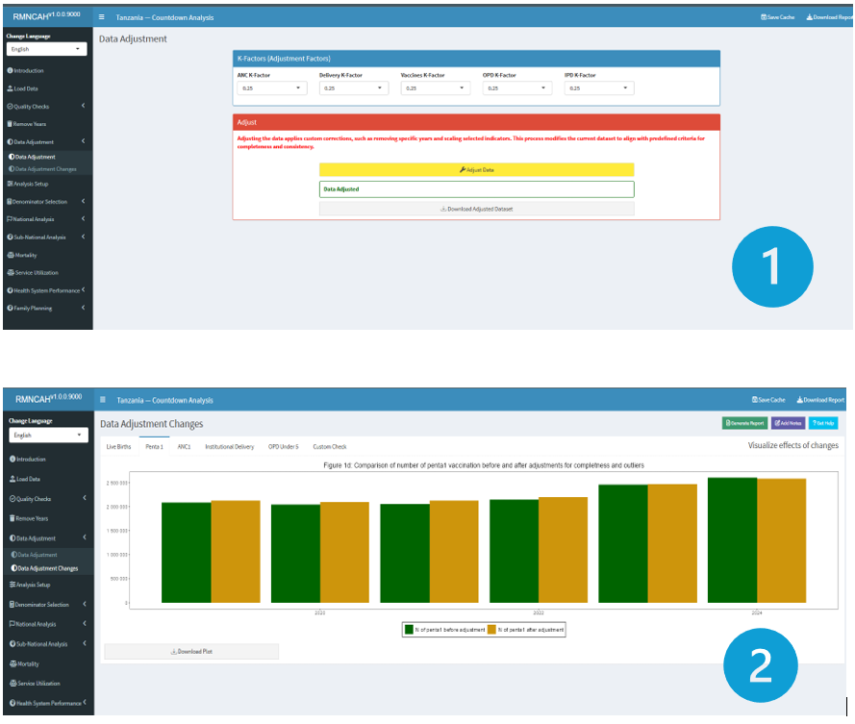

**Note:**

The ***Remove Years*** section before this, allows you to remove any years with no data or whose data has been determined to be not fit for analysis by the country team due to quality issues).

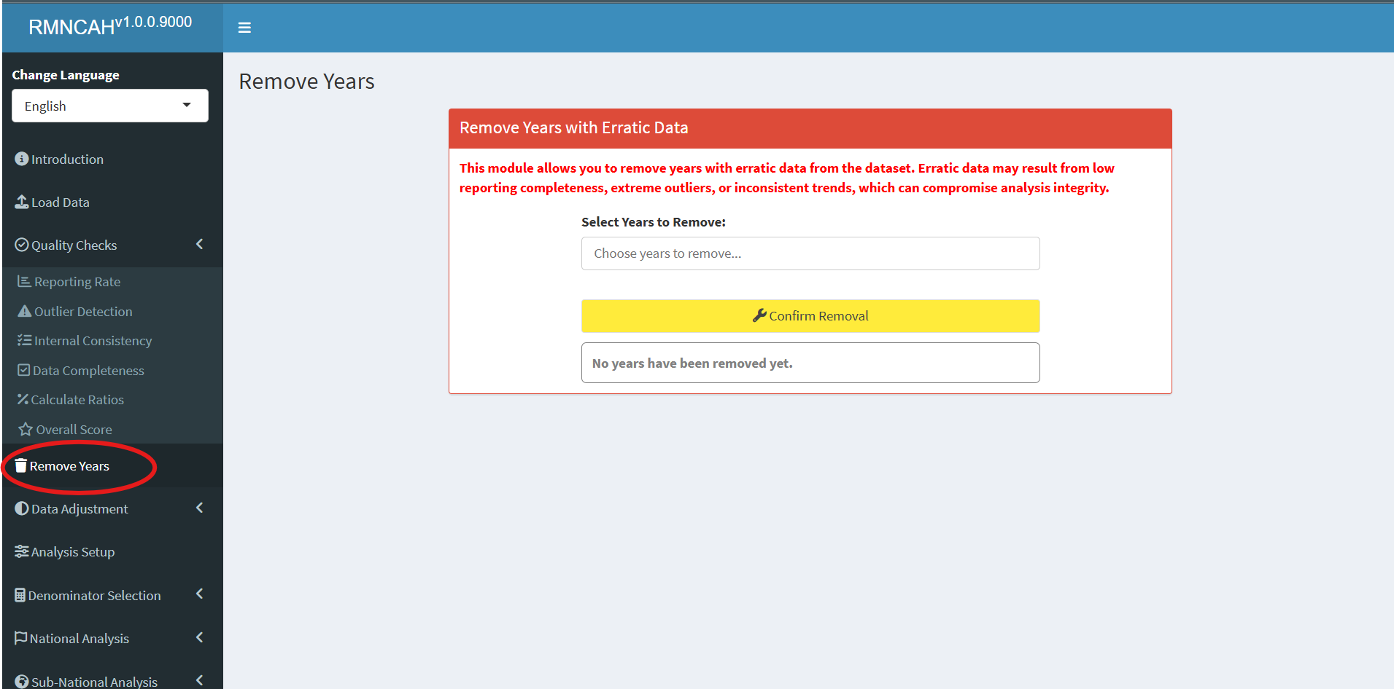

* This Section produces a master adjusted dataset (.dta) ready for analysis and plots for different indicators showing data adjustment changes.

**Report**

* The interpretation should include the selected adjustment factor (factor k) that was used to adjust for incomplete reporting (if necessary, by service). If the default factor is used, then report this and explain what this means for the reader.
* Report the percent change that the adjustment made in reported numbers of institutional deliveries and in penta1 (average of the 6-year period); you may want to highlight the year with the greatest impact of the adjustment if there is one; interpret if the impact of the adjustment on coverage rates is large or small; Make the same description and interpretations for penta1 vaccinations.

# Denominator Assessment and selection

## Rationale: Scientific basis for the analysis

Service coverage is defined as the population who received the service divided by the population who need the services (also referred to as target population). The numerators of coverage statistics (e.g., number of live births in health facilities) are derived from the health facility data and need to be adjusted as shown in the previous section. The denominator of the coverage statistics (e.g., number of live births in the population) needs to be estimated for national and sub-national levels (regions/provinces and districts).

## Approach: Description of analytical steps

The objective of the health facility denominator analysis is twofold. First, we assess the quality of the population projections in DHIS2 by comparison with the UN projections and the internal consistency. Then, we assess the performance of multiple denominators options for the computation of population-based service coverage indicators from the health facility data. This should lead to a final decision on denominators that are used for the analyses of population-based coverage indicators based on health facility data.

Each indicator has its own denominator, as shown in the table below.

**Table 3: Selected indicators with numerators and denominators**

<<<<<<< HEAD | **Indicators** | **Numerator** | **Denominator** | |:————————|:———————-|:———————–| | **SERVICE UTILIZATION** | | | | Outpatient visits, children under 5, per year (N) | N of OPD visits for under-5 | Total mid-year population under 5 | | Inpatient admissions, children under 5, per year (N) | N of admissions for under-5 | Total mid-year population under 5 | | **PREVENTIVE INTERVENTIONS** | | | | % of pregnant women with 4 antenatal care visits | N of women with ANC 4th visit | Total N of pregnant women in the whole population | | % of live births in health facilities | N of live births in health facilities | Total N of live births in the whole population | | % of infants receiving 3 doses of pentavalent vaccine | N of infants receiving 3 doses | N of infants eligible for 3 doses of the vaccine | | **CURATIVE INTERVENTIONS** | | | | % of children under 5 with malaria who receive ACT | N of children under 5 with malaria receiving ACT | Total N of children who had malaria in the last year | | % of deliveries that were by C-section (population) | N of C-sections reported | Total N of deliveries in the population | | % of deliveries that were by C-section (institutional) | N of C-sections reported | Total N of deliveries in health facilities | | **MORTALITY** | | | | Institutional maternal mortality ratio | N of maternal deaths in health facilities | Total number of live births in health facilities | | Stillbirth rate | N of stillbirths in health facilities | Total N of births in health facilities | | Neonatal mortality before discharge | N of neonatal deaths before discharge (after birth) | Total N of live births in the health facilities | | **FAMILY PLANNING (FP)** | | | | Ratio FP visits to women of reproductive age | N of FP new and revisits | Total N of women 15-49 years | | Estimated modern use of contraceptives | Couple years of protection | Total N of women 15-49 years | | FP coverage (demand satisfied) | N of women using modern methods | Total N of women in need of FP | ======= | **Indicators** | **Numerator** | **Denominator** | |:———————–|:———————–|:———————–| | **SERVICE UTILIZATION** | | | | Outpatient visits, children under 5, per year (N) | N of OPD visits for under-5 | Total mid-year population under 5 | | Inpatient admissions, children under 5, per year (N) | N of admissions for under-5 | Total mid-year population under 5 | | **PREVENTIVE INTERVENTIONS** | | | | % of pregnant women with 4 antenatal care visits | N of women with ANC 4th visit | Total N of pregnant women in the whole population | | % of live births in health facilities | N of live births in health facilities | Total N of live births in the whole population | | % of infants receiving 3 doses of pentavalent vaccine | N of infants receiving 3 doses | N of infants eligible for 3 doses of the vaccine | | **CURATIVE INTERVENTIONS** | | | | % of children under 5 with malaria who receive ACT | N of children under 5 with malaria receiving ACT | Total N of children who had malaria in the last year | | % of deliveries that were by C-section (population) | N of C-sections reported | Total N of deliveries in the population | | % of deliveries that were by C-section (institutional) | N of C-sections reported | Total N of deliveries in health facilities | | **MORTALITY** | | | | Institutional maternal mortality ratio | N of maternal deaths in health facilities | Total number of live births in health facilities | | Stillbirth rate | N of stillbirths in health facilities | Total N of births in health facilities | | Neonatal mortality before discharge | N of neonatal deaths before discharge (after birth) | Total N of live births in the health facilities | | **FAMILY PLANNING (FP)** | | | | Ratio FP visits to women of reproductive age | N of FP new and revisits | Total N of women 15-49 years | | Estimated modern use of contraceptives | Couple years of protection | Total N of women 15-49 years | | FP coverage (demand satisfied) | N of women using modern methods | Total N of women in need of FP | >>>>>>> 3ca019758b7b0acf9b278b3763a67c4e63921073

In the first part, we assess the **quality of the DHIS2 population projections** at national level:

* **Check the internal consistency of the DHIS2 population growth over time:**
  + Compute the population growth rate:
  + Compute the crude birth rate (CBR), defined as the number of live births per 1,000 population.
  + Expect both growth rate and CBR to be consistent over time (e.g., less than 2 per 1,000 difference between years).
* **Compare the population data in DHIS2 with the UN population projections at the national level:**
  + Differences may occur, but large discrepancies suggest issues with DHIS2 population projections.
  + The comparison is done for four indicators. Abnormal values are flagged:
    - **Population size:**  
      A relative difference between DHIS2 and UN-projected population size greater than 5% indicates a data quality issue.
    - **Population growth during 2023–2024:**  
      Annual growth is computed using the natural logarithm:
    - A difference greater than 0.3% (absolute) between DHIS2 and UN estimates is concerning.
    - **Crude birth rate (CBR):**  
      Defined as:
    - A difference greater than 5 per 1,000 population compared to the UN estimate suggests a data quality issue.
    - **Crude death rate (CDR):**  
      Defined as:
    - (both expressed per 1,000 population). A **negative CDR** or a **CDR < 5 per 1,000** indicates inconsistency and potential data problems.

The second part is to select the best performing denominator for population coverage estimates with facility data. First, we compare the results for different denominators at the national level.

For the national level, we evaluate 4 denominator methods. The first two are projection methods (DHIS2 estimate and UN estimate), and the additional two are facility data- based methods ( ***ANC1-derived*** and ***penta1-derived*** denominators).

**Note**

* For the sub-national level, no UN projections are available, so we will use 3 methods only.

The maternal and newborn health denominators are closely related and can be computed from each other by making assumptions.

Starting with pregnancies, the number of live births is closely associated with the number of pregnancies, which are usually identified within the health system at the first antenatal visit which in most countries is around 4-5 months of pregnancy (according to the surveys). Country specific values are preferred where available and can be obtained from the [WHO website](https://data.unicef.org/topic/child-survival/neonatal-mortality/). The default assumptions are as follows:

* Pregnancy loss between 4 and 7 months (28 weeks of pregnancy): 3%.
* Stillbirths or pregnancy loss between 28 weeks and birth: 2%.
* Twinning rate: 1.5%. These first three steps give the number of live births computed from pregnancies.
* Neonatal mortality: 3% (or 30 per 1,000 live births).
* Post neonatal mortality (between 1-11 months): 2.4% (or 24 per 1,000 live births).

The selection of the best performing denominator method is based on a comparison of the performance of the DHIS2 projection and facility-data derived methods for two indicators: ***institutional live births*** and ***penta3***. The gold standard is the population coverage rates from a recent survey, for a year as close as possible. The absolute difference between survey and facility-based coverage at national and sub-national levels is used to select the best performing indicator. (This can also be expressed as the number of standard errors from the survey value but this requires including the standard errors from the surveys – the results will be the same).

### Facility data derived denominators

The basic idea is that if the coverage of an indicator is high (e.g., over 90%), then the number of events reported by health facilities has to be close to the target population. In other words, the denominators or target population can be derived from the numbers in DHIS2. The best candidate indicators for this approach are ANC1 and DPT/penta1 (BCG also possible in some countries if re-vaccinations are recorded separately).

This approach requires the following:

A recent population-based survey is used to obtain an estimate of population level coverage of ANC1 or penta1. For example, ANC1 coverage is 95% of pregnant women.

The DHIS2 data on the number of ANC1 and penta1 visits need to be considered complete and accurate (after adjustments / cleaning the data). For example, 100,000 ANC1 visits were reported.

If this is the case, then we only need to add the percentage that has not used the services (according to the survey results) to get the target population. For example, if ANC1 coverage from survey is 95% and the number of ANC1 visits from DHIS2 for the year is 100,000, the total number of pregnant women is:

The same approach can be used for DPT1 or penta1. The survey coverage is the percent of children 12-23 months who received DPT1/penta1, the facility data are the number of infants who received DPT1/penta1 vaccination. For example, if survey coverage is 92%, and there were 100,000 vaccinations given, then the

The number of live births can be obtained from ANC1 and DPT1 by making assumptions about pregnancy loss (abortion after the first ANC visit, stillbirths), twinning rates, and neonatal mortality. These steps are shown in the Figure below. ![] (images/1-dqa_denom_adjustment.png)

**An example of ANC1:**

* Above we computed 105,263 pregnant women in the population
* at 3% abortion, this implies 105,263 * (1-.0.03) = 102,454 deliveries
* at 1.5% twinning rate this implies 102,454 / (1-(0.015/2)) = 103,229 births
* at 2% stillbirth rate this implies 103,229 * (1-0.02) = 101,164 live births
* at 3% neonatal mortality this implies 101,164 * (1-0.03) = 98,129 children eligible for DPT1/penta1.

## Implementation: Conducting analysis in the Shiny App

**Shiny App**

To get outputs for this analysis first, one need to set up their analysis by inputting key information at the **Analysis Set up** section in the Shiny App.

The parameters required are as shown in the figure below and they are:

1. **National mortality rates - based on the most recent survey** 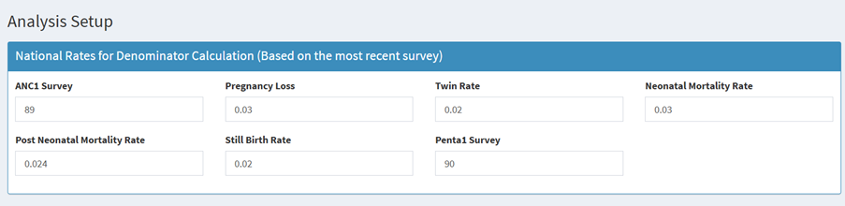

<<<<<<< HEAD - **ANC1 Survey -** This refers to the surveys collecting data on ANC services. The surveys are part of demographic studies to monitor and evaluate coverage, quality and equity of MNH services. - **Pregnancy loss -** refers to the death of an embryo or fetus before birth. It can occur at different stages of pregnancy and is broadly categorized based on gestational age and clinical features. - **Twin rate -** refers to the number of twin births per 1,000 total births - **Neonatal mortality rate -** The number of deaths during the first 28 days of life per 1,000 live births in a given year or period. - **Post neonatal mortality rate -** The number of deaths of infants aged 1 month (28 days) to 11 months per 1,000 live births in a given year or period. - **Stillbirth rate -** The number of babies born with no signs of life at or after 28 weeks of gestation per 1,000 total births (live births + stillbirths). - **Penta1 survey -** type of coverage survey that assesses how many children received first dose of pentavalent vaccine. ======= - **ANC1 Survey - The coverage percentage** - **Pregnancy loss -** - **Twin rate -** - **Neonatal mortality rate -** - **Post neonatal mortality rate -** - **Stillbirth rate -** - **Penta1 survey -** >>>>>>> 3ca019758b7b0acf9b278b3763a67c4e63921073

1. **Survey coverage based percentages (based on the most recent survey)** 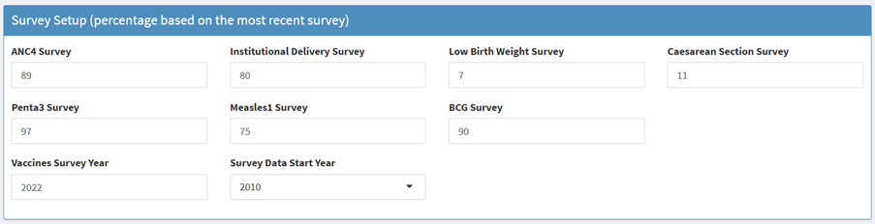
   * ANC4 Survey -
   * Institutional delivery survey - type of survey that collects data on where women gave birth, specifically whether the delivery took place in a health facility or outside
   * Lowbirth weight survey - type of survey that is used to estimate the proportion of newborns with a birth weight of <2.5g.
   * Caesarean section survey - this is a type of survey that collects data on proportion of live births delivered by caesarean section, usually within a specified period
   * Penta3 survey - type of coverage survey that assesses how many children received third dose of pentavalent vaccine.
   * Measles1 survey - type of coverage survey that assesses how many children received first dose of measles vaccine.
   * BCG survey - type of coverage survey that assesses how many children received bacillus calmette-Guerin vaccine.
   * Vaccines survey year - refers to the specific calendar year during which data on vaccination coverage was collected in a survey.
   * Vaccine data start year - refers to the earliest year which vaccination data was collected.
2. **Survey datasets**

* In addition to setting these parameters, you will be required to upload the following survey datasets (in addition to the health facility data loaded at the beginning of the analysis session).
* 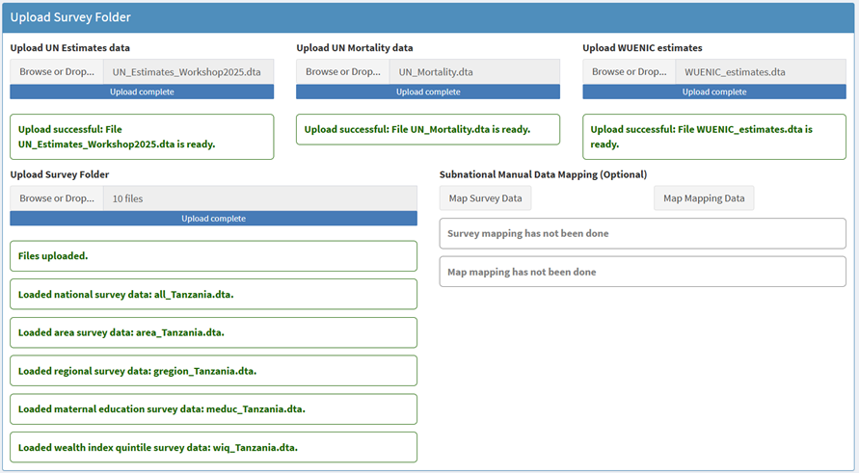
  + UN Estimates data -
  + UN Mortality data
  + WUENIC estimates data
  + Survey data (uploaded as a folder)

The first part is to assess the accuracy and consistency of the projected population numbers in the DHIS-2 by comparing them to external sources. The second part is to compare results from the different methods - both at the national and sub-national levels.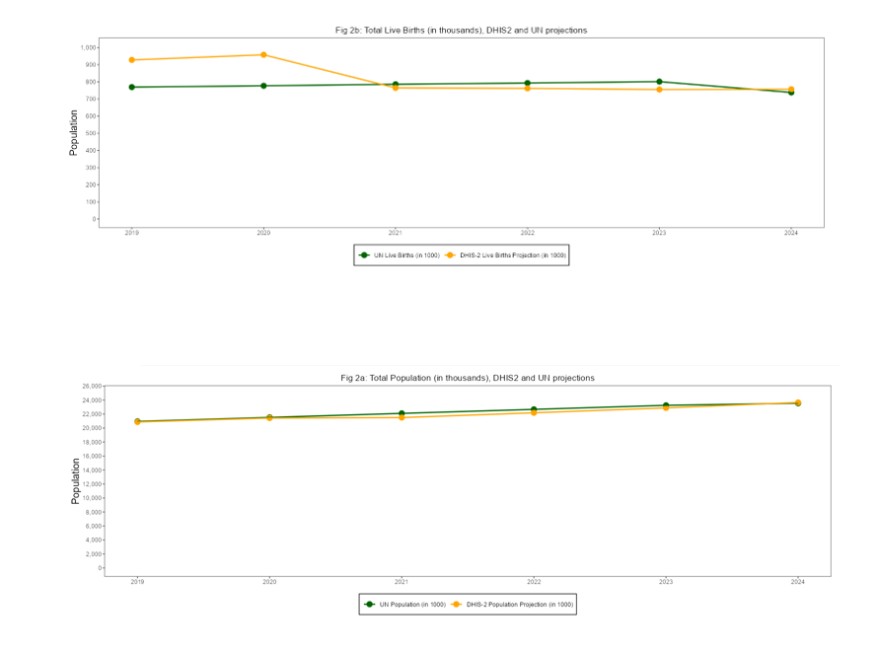

The final step is to select the best performing denominator for the coverage analyses with health facility data. The results on the national gap and the median sub-national gap should be taken into account to make that choice.

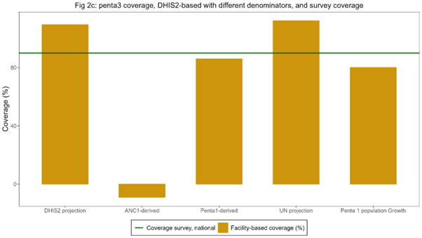

The best methods have the smallest gaps with the survey results. Ideally, one method is selected but it is also possible to select one denominator method for the MNH coverage indicators (ANC, delivery, PNC) and another method for the immunization coverage analyses. It will be important to clearly state the chosen denominator method in all tables.

The interpretation should focus on the extent to which the DHIS2 projections are considered robust which is the case when:

* The DHIS2 total population projection is consistent over time with regular population growth
* The DHIS2 total live birth projection is consistent over time (regular trend)
* The projected numbers of total population and live births are close to the UN population projection
* The DHIS2 population projections are consistent with UN estimates for crude birth rate and crude death rate.

The interpretation should describe, based on the graphs:

* Which denominator methods performed best at the national level for the two indicators?
* Which denominator performed best at the sub-national level for the two indicators?
* What selection is made for the indicators in the coverage analyses?

# National Coverage

## National coverage of interventions

### Rationale, Approach and implementation

**Rationale: Scientific basis for the analysis**

Coverage of interventions is a critical and direct output of health systems. Regular tracking of coverage at national and subnational levels has become the mainstay of monitoring progress in national health plans and international initiatives. Reproductive, maternal, newborn, child and adolescent health indicators with targets are the most common indicators of national health plans and global monitoring. Both health facility data and household surveys can provide coverage statistics, and an integrated analytical approach is desirable.

**Approach: Description of analytical steps**

Many coverage indicators can be estimated in both surveys and from health facility data. Both are critical pieces of information and need to be considered in conjunction with each other. The Table below lists the indicators, for antenatal and delivery care and child immunization, considered in the health facility data analysis in the workshop, including the variable names (in R) in the first column.

| **Name (in R)** | **Indicator title** | **Survey d enomin ator** | **Facility data den ominator** |
| --- | --- | --- | --- |
| **Antenatal care** |  |  |  |
| anc1 | Antenatal care at least one or more visits among all pregnant women (%) | Women aged 15-49 years with a live birth in the last 2 years | Estimated live births as d enominator |
| anc_1 trimester | Antenatal care 1+ visits in 1st trimester of pregnancy among all pregnant women (%) |  |  |
| anc4 | Antenatal care 4+ visits among all pregnant women (%) |  |  |
| ipt2  ipt3 | Intermittent preventive therapy for malaria - 2nd dose / 3rd dose during pregnancy among all pregnant women (%) |  |  |
| ifa90 | Iron folic acid supplementation given (90 days supply) during pregnancy among all pregnant women (%) |  |  |
| hiv_test | HIV test conducted among pregnant women (%) | Not available (in some survey re ports) |  |
| syph ilis_test | Syphilis test conducted among pregnant women (%) |  |  |
| **Delivery** **care** |  |  |  |
| instd eliveries | Institutional live births among all live births | Live births in the last 2 years | Estimated live births as de nominator. |
| sba | Skilled birth attendance |  |  |
| lo w_bweight | Low birth weight (below 2500 grams) among all live births |  |  |
| csection | C-section among all live births |  |  |
| pnc48h | Postnatal care within 48 hours |  |  |
| **Immunization** |  |  |  |
| bcg | BCG vaccination to infants | Children 12-23 months | N of surviving infants (beyond neonatal period) |
| penta1 | Penta vaccine - 1st dose to infants | Children 12-23 months |  |
| penta3 | Penta vaccine - 3rd dose to infants | Children 12-23 months |  |
| measles1 | Measles vaccine - 1st dose (to infants) | Children 12-23 months | N of surviving infants (beyond postNN period) |
| measles2 | Measles vaccine - 1st dose (older children) | Children 24-35 months | N of surviving infants (beyond po stneonatal period) (or age 1) |

The facility data can be used to generate annual coverage estimates, using the dataset for 2019-2024, through the Shiny App developed. These coverage results should be compared and interpreted alongside the results from recent surveys. The analysis results will include both coverage estimates.

**Implementation: Conducting analysis in the Shiny App**

### Antenatal care (ANC)

Most countries have at least one ANC indicator with a target in the national plan. The global ENAP/EPMM coverage targets for 2025 are: globally, at least 90% of pregnant women with 4 or more ANC care visits, and 90% of countries with at least 70% coverage. There are several ANC indicators that capture:

* *contact with health services* during pregnancy (ANC 1st visit, ANC 4 or more visits, ANC first visit in first trimester). ANC1 is often considered an indicator of basic access to health services. It is high in most countries, and in many instances, the numbers of ANC1 visits in the routine health facility data can provide a better denominator for the ANC and delivery indicators than population projections (see section 2 on denominators).
* *contents of services* provided (intermittent preventive therapy (IPT2 or IPT3) against malaria, HIV testing, syphilis testing and iron-folic acid (IFA) supplementation (at least 90 tablets given to the pregnant woman)). Some countries will not have policies for all of these diagnostic or therapeutic interventions during pregnancy (e.g., no IPT if no malaria risk).

For most indicators, the surveys also provide coverage estimates for the national level, with 95% confidence intervals. For most coverage indicators the data refer to a period before the survey: e.g., institutional birth coverage for the live births in the two years preceding the survey. This means that the midpoint of the coverage estimate lies one year before the survey.

An example of two graphs for ANC, based on facility and survey data, is shown below, showing both good concordance between the facility-based and survey results for coverage of ANC first visit in the first trimester and poor concordance in case of ANC4 visits. In the latter case, it is evident that ANC4 is overreported in the facility data as coverage is much higher than the survey and unlikely to be high (over 90% during 2021-23 and even 101% in 2023). Poor recording and reporting of ANC 4th visits in the DHIS2 data is likely the main cause.

Sometimes, an indicator may reach an unlikely high coverage at the national level, say over 125%. This may be because the data quality of the numerator of the coverage indicator is poor, the denominator is wrong, or the intervention is given and recorded more than once during pregnancy. An example is IFA supplementation. In that case, the computation of coverage is not useful. It is better to express it differently. For instance, if coverage is 200%, it is better to compute the average number of courses of 90 IFA tablets that a pregnant woman received (in this case 2.0 per pregnant woman in the population).[1]

![] (images/2-national-anc-cov.png)

### Delivery care

All countries have at least one delivery care indicator with a target in the national plan. The global ENAP/EPMM coverage target for 2025 is at least 90% global average coverage, and 90% of countries at least 80% coverage of skilled birth attendance (SBA). For postnatal care (PNC) within 2 days the global coverage target is 80% and the 90% of countries with at least 60% coverage.

*Institutional (live) birth coverage and SBA* are closely related, as almost all deliveries with a skilled attendant occur in health facilities. From the analytical point of view, institutional birth coverage is preferred because it is a more objective measure and avoids issues with the definition of what constitutes skilled birth. SBA is often preferred from the health care perspective, as it includes an element of quality: obviously, an institutional delivery without skilled attendance is not desirable, and in some countries home SBA may be part of the health care delivery strategy. attendance. Either indicator works well to capture delivery care.

*Caesarean section* is a live saving intervention and an important indicator. A general rule of thumb is, put forward by WHO, that in a population the need for Caesarean section is in the range of 10-15% of all deliveries. If the Caesarean section rate is below 10%, that means that there is unmet need. If the Caesarean section rate is over 10-15%, that implies that there most likely overuse of Caesarean section. It may however also imply that there is still unmet need among certain population groups (e.g. the poorest women or rural women) in combination with overuse in other subgroups of the population (such as urban and richer women).

*Postnatal care (PNC) within 48 hours* is provided to the mother/women and newborn. Country systems may have different ways of recording the type of PNC and also surveys are known to have data issues with PNC for the mother or the baby.[2] Some countries use multiple definitions of timing of the PNC visit (e.g., within the first week).

*Low birthweight* is a critical indicator of neonatal health. It is most meaningful if the distinction between prematurity and small-for-gestational age is made, but most facility reporting systems and most surveys do not have such data. All babies are supposed to have been weighed right after birth and the percent of newborns weighing less than 2500 grams is usually reported in the DHIS2 system. As general guidance for the interpretation of the data, low birthweight prevalence in sub-Saharan Africa was estimated at 13.9% (95% credibility interval: 12.4-15.7%) for 2020.[3]

### Immunization

Immunization coverage indicators are included in virtually every country’s health sector monitoring plan. A general target is at least 90% coverage for essential vaccines given in childhood and adolescence.

For the national coverage analyses, the focus is on BCG, first and third doses of penta/DTP (penta1 or DTP1 and penta3 or DTP3), and first and second doses of measles vaccine, often given in combination with rubella vaccine. *BCG and penta/DTP vaccinations* are recommended to be given at birth (BCG), 6 weeks (penta1) and 14 weeks (penta3). For facility data, the number of vaccinations given to infants is used and the denominator is the number of eligible children in the population, which is approximated as live births minus neonatal deaths. Survey data generally provide vaccination coverage among children 12-23 months (may also include the age at which the vaccination was given – mostly before the first birthday).[4]

The first dose of measles vaccine is generally recommended at age 9 months. For the facility data, the recording and reporting usually separate measles given to children under 1 year and children 1 year and older, though the quality of recording and reporting for the age group may vary (there may be a tendency to record measles vaccinations after 12 months as given to infants). Here, we use children who have survived the first year of life (live births minus neonatal deaths minus postneonatal deaths) as the denominator for measuring vaccination coverage. The second dose of measles uses children aged 24-35 months as denominator. This can be estimated as live births minus neonatal deaths = 2* postneonatal deaths).

WHO and UNICEF work with countries to produce annual estimates of immunization coverage based on all data sources. The national estimates, called WUENIC, are published and available for 2020-2024. These time trends are included in the Stata outputs, to compare the 2019-2023 annual estimates of the facility data produced in the workshop and the survey results.

### Family planning

The family planning coverage estimates are derived from a collaboration of the Countdown with Track20. Track20 has developed an advanced estimation tool called Family Planning Estimation Tool (FPET) which focuses on three indicators: modern contraceptive use, unmet need for modern contraceptives and demand satisfied with modern methods. The three indicators are closely related since demand is satisfied (this is the true coverage indicator) = use of modern contraceptives / (unmet need + use of modern contraceptives).

FPET uses statistical modelling that incorporates all available data from surveys and may also use estimates obtained from facility data if the quality is sufficient.[5] FPET allows for various types of survey data to be integrated into the estimates and fits a line that pulls from the trends. This utilizes the strength of multiple data points and minimizes the risk of comparing different surveys.

# National Inequality

National Inequality

# Global Coverage Targets

## Global coverage targets for coverage of health services

# Sub-national Mapping

## National and subnational mapping of health service coverage

# National Equity Assessment

# National Equity Assessment

# Sub-national coverage

## Sub-national Coverage

### Rationale, Approach and implementation

**Rationale: Scientific basis for the analysis**

Sub-national analysis of health intervention coverage is essential for advancing universal health coverage (UHC), which aims to ensure equitable access to quality health services for all populations. National averages often mask critical disparities that exist across regions, districts, or population subgroups.

Monitoring subnational data helps identify geographical areas where coverage is low, signaling potential inequities in health service access and prompting targeted interventions. This is particularly important for drawing attention to populations who are left behind and ensuring resources are directed where they are most needed.

**Approach: Description of analytical steps**

The focus should be on assessing the extent to which the country programs have succeeded in reducing the inequalities between regions/provinces and between districts, and the extent to which districts have reached a coverage target. Three global targets for coverage indicators are of particular interest:

* ANC4: 80% of districts have at least 70% coverage (EPMM/ENAP)
* SBA or institutional delivery: 80% of districts have at least 80% coverage (EPMM/ENAP)
* Penta3/DTP3: at least 80% coverage in every district or equivalent administrative unit with three doses of diphtheria-tetanus-pertussis containing vaccines (DTP – or pentavalent vaccine).

The regional and district analyses should use the best performing denominator for the coverage computations, as decided from the analysis in section 2 on denominators. There will be more “noise” in the subnational data with improbably high or low coverage rates, compared to the national analyses, and more so in the district analyses than in the regional (admin1) analyses. This is because district analyses are affected by small numbers (more fluctuations which may be random or due to data quality issues) and by the health service utilization patterns by women and children. For instance, a municipal district may get more deliveries than an adjacent rural district because of the location of the hospitals in the municipal district.

The key statistical measures for subnational inequalities are:

* MADM: median absolute distance from the median. This measure gives an indication on whether the country has been successful in reducing inequalities between subnational units.
* Percent of subnational units with coverage above a specific target or threshold: this indicator provides information on the extent to which a country has been successful in reaching universal coverage at the subnational level.

*Summary of district and regional performance*

Progress towards international and national targets can be measured by computing the percentage of regions and districts that have achieved these targets. The goal is for all regions and districts to have met the target. Higher percentages mean less inequality.

**Implementation: Conducting analysis in the Shiny App**

This would be done in the Sub-national analyses section in the app.

(insert screenshot)

Outputs will include Percent of regions and percent of districts that have achieved specific targets for ANC4, institutional deliveries and penta3 vaccination as shown below. (insert screenshot)

Further analyses may also include plotting of regional or district results by year, with the median absolute distance from the median (MADM, see screenshot below), as the summary measure to assess if inequalities have reduced.

(insert image)

To summarize the coverage situation according to the health facility statistics for 2024 can be done for the regional level and shown on a map. A composite coverage index is computed as an average in seven mother and child health indicators: **ANC4**, **institutional live birth coverage**, **SBA**, **IPT2**, **postnatal care**, **pentavalent vaccine 3rd dosage** and **measles 1** vaccination coverage. Equal weight is given to all indicators.

**Sub-national statistical summaries**

The aim is to produce a one-pager for each admin1 unit (generally region, province or county) that contains the regional information as well as a summary of the districts within the region. We refer to this as a regional subnational statistical summary.

The following components are included:

* Summary of key demographic information for the region and the districts: table with expected number of births in 2024 according to the DHIS2 projections and according to the preferred denominators derived from the health facility data (based on ANC1 for live births, and on penta1 for immunization indicators).
* Line graphs with the trend in coverage of institutional deliveries and penta3 vaccination that include the best estimates for 2020-2024 based on the health facility data, as well as the estimates from the most recent surveys (from 2015) for the same indicators (with confidence intervals if possible).
* Bar graphs that compare the 2024 coverage situation in the region compared to all other regions, and puts the region into the lowest, middle or upper third of regions in terms of coverage. This is done for both institutional deliveries and penta3 vaccination.
* Table that summarizes the coverage for institutional deliveries and penta3 vaccination in 2024 by district.
* Other indicators can be used as prioritized by the country (e.g., ANC4, measles1).

(insert screenshot)

# Sub-national Inequality

## Inequality: Health facility data

### Rationale, Approach and implementation

**Rationale: Scientific basis for the analysis**

Sub-national analysis of health intervention coverage is essential for advancing universal health coverage (UHC), which aims to ensure equitable access to quality health services for all populations. National averages often mask critical disparities that exist across regions, districts, or population subgroups. Monitoring sub-national data helps identify geographical areas where coverage is low, signaling potential inequities in health service access and prompting targeted interventions. This is particularly important for drawing attention to populations who are left behind and ensuring resources are directed where they are most needed.

**Approach: Description of analytical steps**

The focus should be on assessing the extent to which the country programs have succeeded in reducing the inequalities between regions/provinces and between districts, and the extent to which districts have reached a coverage target. Three global targets for coverage indicators are of particular interest:

* ANC4: 80% of districts have at least 70% coverage (EPMM/ENAP)
* SBA or institutional delivery: 80% of districts have at least 80% coverage (EPMM/ENAP)
* Penta3/DTP3: at least 80% coverage in every district or equivalent administrative unit with three doses of diphtheria-tetanus-pertussis containing vaccines (DTP – or pentavalent vaccine).

The regional and district analyses should use the best performing denominator for the coverage computations, as decided from the analysis in section 2 on denominators. There will be more “noise” in the sub-national data with improbably high or low coverage rates, compared to the national analyses, and more so in the district analyses than in the regional (admin1) analyses. This is because district analyses are affected by small numbers (more fluctuations which may be random or due to data quality issues) and by the health service utilization patterns by women and children.

For instance, a municipal district may get more deliveries than an adjacent rural district because of the location of the hospitals in the municipal district.

The key statistical measures for sub-national inequalities are:

* MADM: median absolute distance from the median. This measure gives an indication on whether the country has been successful in reducing inequalities between sub-national units.
* Percent of sub-national units with coverage above a specific target or threshold: this indicator provides information on the extent to which a country has been successful in reaching universal coverage at the sub-national level.

***Summary of district and regional performance***

Progress towards international and national targets can be measured by computing the percentage of regions and districts that have achieved these targets. The goal is for all regions and districts to have met the target. Higher percentages mean less inequality.

**Implementation: Conducting analysis in the Shiny App**

This analysis is conducted within the **Sub-National Analysis** section of the Shiny App

*insert image_Sub-national analysis tab*

*insert image_targets_achieved*

# Subnational: Global coverage targets

# Subnational Global coverage targets

# Maternal Mortality

## Maternal Mortality

### Rationale, Approach and implementation

**Rationale: Scientific basis for the analysis**

Maternal and perinatal mortality in health facilities are critical indicators of the quality of care (institutional mortality). Institutional maternal mortality is one of the key indicators proposed to monitor progress. Facility-based mortality statistics can also be a critical input into the estimation of population levels of mortality.

Reporting of maternal deaths, stillbirths, and early neonatal deaths (before discharge) may occur through the routine reporting system (DHIS2, aggregate or individual level) or be part of a maternal and perinatal death surveillance and response system (MPDSR).

Population mortality statistics (maternal mortality ratio, stillbirth rates, neonatal mortality rates) rely on household surveys and censuses, with major limitations, especially for maternal mortality and stillbirths. A promising development is the major increase in health facility deliveries observed in many countries.

Especially if coverage of births in health facilities is high (e.g., over 75%), the facility-based statistics will become a useful input into the estimation of population levels of mortality. The main challenge with mortality data from health facilities is under-reporting of deaths. Maternal deaths do not only occur during birth, but also in pregnancy and post-partum.

Reporting of stillbirth deaths requires well maintained maternity registers, but also cross-checks to the operation theatre registers for cases of Caesarean section. If that is not the case, deaths may not be recorded in the maternity register, and not reported into the national system. In addition, maternal deaths occurring in other hospital wards are more likely to be missed, such as deaths associated with abortion, or post-discharge due to sepsis and other causes. Neonatal deaths after discharge, which is often within 24 hours, are also more likely to be missed.

A critical step is a systematic assessment of data quality issues, which forms the basis for, if possible, adjustments, and more importantly should guide efforts to improve reporting quality.

**Approach: Description of analytical steps**

The definitions for institutional, community and population maternal mortality and for stillbirths are:

| **Indicator** | **Numerator** | **Denominator** |
| --- | --- | --- |
| Institutional maternal mortality ratio (iMMR) | Number of maternal deaths in health facilities[6] | Number of live births in health facilities * 100,000 |
| Population maternal mortality (MMR) | Number of maternal deaths in the population | Number of live births in the population * 100,000 |
| Community maternal mortality ratio (comer) | Number of maternal deaths in the community | Number of live births in the community * 100,000 |
| Institutional stillbirth rate (iSBR) | Number of stillbirths in health facilities[7] | Number of births in health facilities * 1,000 |
| Population stillbirth rate (SBR) | Number of stillbirths in the population | Number of births in the population * 1,000 |
| Community stillbirth rate (cSBR) | Number of stillbirths in the community | Number of births in the community * 1,000 |
| Neonatal mortality (before discharge) | Number of neonatal deaths before discharge | Number of live births in health facilities * 1000 |

### Data Analysis Components:

Data analysis has the following components:

#### **iMMR and iSBR review**

The annual mortality rates are computed using the unadjusted data on reported deaths and births/live births in health facilities. We do not adjust for reporting rates and outliers (as is done for other interventions) because it is difficult to adjust maternal deaths and stillbirths, where the number of deaths is small and fluctuating.[8] It is however advisable to check the data for any extreme outliers in the annual data (e.g., numbers of deaths that clearly indicate data entry errors) and replace these with the average of the surrounding years.

The figure below displays the institutional maternal mortality per 100,000 live births for regions (dots) and for the country as a whole (line and annual values) by year.

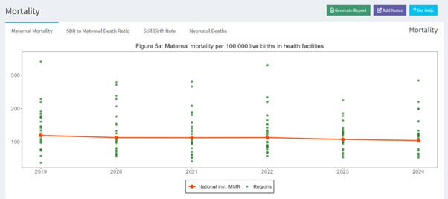

Institutional maternal mortality ratio per 100,000 live births, by region (dots) and national (line), 2019-2024

Several considerations need to be made:

* Are there any extreme outliers on the high side which may be due to major data errors which need correction?
* How many regions have implausibly low iMMR which is arbitrarily defined as less than 25 per 100,000 live births (25 is two times the MMR in high-income countries of 12.5); are these more advanced regions where mortality is expected to be lower, or are there less-developed regions with low mortality, which could be an indication of major underreporting of deaths.
* A map with the iMMR by region/province would be a useful addition to guide the interpretation of the data, especially focusing on potential data quality issues.

The figure below presents the stillbirth rate per 1,000 births for regions and the country, using the same format as for maternal mortality. The interpretation should explain:

* How many regions have implausibly low iSBR which is defined as less than 6 per 1,000 births (which is two times the SBR in high income countries)?
* Are these more advanced regions where mortality is expected to be lower, or is this a sign of major under-reporting of deaths in less-developed regions of the country.
* 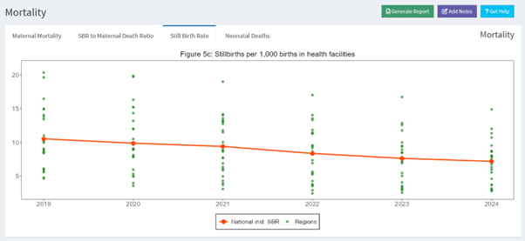
* Institutional stillbirth rate per 1,000 births, by region (dots) and national (line), 2019-2024

In addition, the institutional mortality levels can be compared to the most recent mortality estimates for the population. These population estimates could be coming from a recent national survey or census, or we can use the UN estimates for maternal mortality (for 2020) and stillbirth rates (for 2021).

This is to obtain an idea of the difference between the institutional mortality and the population mortality. Interpretation should seek to explain:

* How far is the iMMR (or iSBR) from the UN estimates of the population mortality, including the uncertainty range of the global estimates: this difference will be used further to assess the data quality.

The institutional neonatal mortality rates (per 1,000 live births) based on reported neonatal deaths may also be graphed similar to iMMR and iSBR, but have to be interpreted with additional caution. Almost all babies stay at least 24 hours after delivery in the hospital but after that many are discharged and the observation time in health facilities is variable. Therefore, the statistic is mostly referred to as neonatal deaths before discharge per 1,000 live births, which includes day 1, some deaths on day 2, fewer deaths on day 3 etc.

A rough guide to assess reporting completeness is that expected mortality of neonatal deaths before discharge in health facilities should be at least half of neonatal mortality in the population. So for instance, if population neonatal mortality is 20 per 1,000 live births, we expect institutional neonatal mortality at least 10 per 1,000 live births in the health facilities.

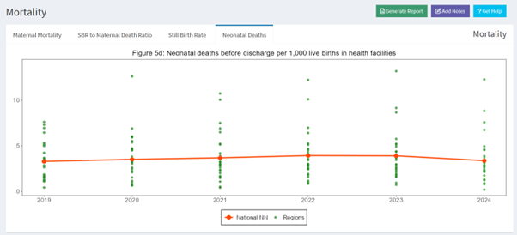

Neonatal mortality before discharge per 1,000 live births in health facilities, based on DHIS2, 2019-2024, national and regions

#### Data Quality metrics

* ***Ratio stillbirth to maternal deaths in the health facility data at national level***

We expect maternal mortality and stillbirth to be positively correlated given the commonalities in causes. Based on a review of the global estimates, historical data, and health facility studies, we expect the ratio of stillbirth to maternal death to be in the range of 7 to 30 for countries in sub-Saharan Africa. We compute the ratio as the number of reported stillbirths divided by the number of reported maternal deaths in DHIS2 or MPDSR, in a specific time period (usually a year) and raise a “data quality flag” if the ratio is outside the 7-30 range.

Interpretation:

* If the ratio is lower than 7: under-reporting of stillbirths is likely greater than under-reporting of maternal deaths
* If the ratio is equal or greater than 30: under-reporting of maternal deaths is likely to be the main issue, under-reporting of stillbirth less serious than for maternal deaths.
* If the ratio is between 7 and 30: under-reporting of maternal deaths and under-reporting of stillbirths are both possible, or reporting of both is of good quality (this requires that the level is also in the expected range - component 1).

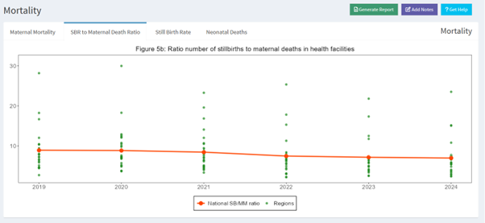

Ratio of stillbirths to maternal deaths in health facilities, based on the reported data in DHIS2, 2019-2024, national and regions

* ***Consistency of institutional MMR with estimated population MMR and community MMR***

The completeness of reporting by health facilities can be estimated by comparing the reported iMMR based on facility data with an expected iMMR. The population MMR, community MMR and institutional MMR should be consistent. There will be variation in the community to institutional MMR between populations, but it is not likely that, for instance, the community MMR is 1,000 when the institutional MMR is 100.

We compute an expected MMR in health facilities based on assumptions about:

* MMR in the whole population (including community and institutional deaths): For example, the lower bound, median, upper bounds of global estimates for each country (2023 UN estimates) could be used, or the results from a recent survey.
* Ratio of community to institutional maternal mortality: We use assumptions ranging from 1.0 (where we assume community MMR is the same as iMMR) to 2.0 and 3.0 (cMMR is 2 or 3 times higher than iMMR).[9] For each country, one should consider what this ratio could be which may depend on the proportion of births in health facilities. There is some evidence that the community to institutional ratio increases as institutional birth rates increases, as well as the observed percent of births in health facilities.

The population MMR is the sum of the institutional and community MMR, weighted by the percent of births occurring in facilities. For instance, if the institutional MMR is 100 and the community MMR is 200, and 75% of births are in health facilities, then the population MMR equals

live births. This can be expressed in the following formula:

Where;

* Mp = maternal mortality ratio in the population;
* Mi = institutional maternal mortality ratio;
* Mc= maternal mortality ratio in the community;
* Pi the proportion of live births in institution

Here, we have (1) iMMR from the DHIS2 data and (2) population mortality from the UN estimates, and can compute the community MMR as

, or

In the example, the ratio community to institutional mortality

equals 200 / 100 = 2, in other words the community mortality is two times higher than the institutional mortality.

We can now compute the expected MMR based on 1) an estimate of population MMR 2) the ratio Mc/Mi. For instance, if 75% delivers in health facilities, the population MMR is 200 and the ratio (Mc/Mi) is 2, then the expected institutional MMR is

live births. (and the community MMR is

).

In a formula:[10]

Expected

Finally, the completeness of facility reporting is reported iMMR (e.g. based on DHIS2) divided by the expected iMMR. For instance, if the reported MMR was 100 and the expected MMR 160, then the level of completeness of reporting is

Below is an example of the estimated completeness of facility reporting of maternal deaths using different scenarios. The figure shows the results on completeness of reporting with three levels of population MMR (lower bound, median or best estimate, upper bound) and three community to institutional mortality ratios (0.5-2.5), shown on the X-axis.

Not all scenarios are equally relevant to each country. For instance, if there is evidence that the population MMR is lower than the UN median, pick the scenario with the lowest MMR (the blue line). If it is considered that community MMR could be 1.5-2.0 times higher than institutional MMR, then the completeness estimate is 59-64%. The choices are arbitrary, but it is useful to consider if the range of estimates of completeness of facility reporting can be narrowed down by using the most plausible scenario. As default values, the ratios of 1.0, 2.0 and 3.0 are used.

A similar approach can be used for stillbirths using all births instead of live births. The UN global stillbirth estimates for 2021 with uncertainty ranges can be used (lower and upper bound are 90% uncertainty intervals from the model). There is little research on the community to institutional stillbirth ratio (partly because community level stillbirth reporting is more uncertain) but it is likely that the ratios are lower than for maternal mortality, as institutional mortality levels are much higher for stillbirth rates than for MMR. A range of 0.5-1.5 may be used for the estimation of the level of completeness of facility reporting.

# Curative health services utilization

## Curative health services utilization for sick children

### Rationale, Approach and implementation

**Rationale: Scientific basis for the analysis**

There is only limited information about curative service utilization, even though diarrhoea and pneumonia are leading causes of death in children. Service utilization statistics on care-seeking behaviour among children with recent illnesses (diarrhoea, acute respiratory infection, or fever in the last 2 weeks) is usually obtained from household surveys, relying on mother’s recall.

Health facility data on outpatient (OPD) visits is an indicator of access to curative services: **less than one visit per person is often considered an indicator of poor access**. Similarly, data on hospital admissions is an indicator of access to services, while hospital mortality (case fatality) is an indicator of the quality of care.

**Approach: Description of analytical steps**

The data on OPD visits should include new and re-visits. Data are usually reported for under-5 years and 5 years and older. As with data on maternal and newborn care and immunization, the data quality is assessed, and adjustments are made for completeness of reporting and extreme outliers are corrected. The adjusted clean data are used for analysis at national and subnational levels.

### Outpatient service utilization

The data on outpatient visits should include both new and re-visits.

**Mean number of OPD visits per child per year:**

* The numerator is the adjusted number of under-5 OPD visits in a year and the denominator is the total number of children under-5 which is taken from the DHIS2 projections. We do not expect this statistic to change much between years (less than 0.2 visits per child per year). A gradual increase suggests either improvements in access to OPD services or a greater disease burden for children. There is no fixed cut-off, but if the attendance is less than 1 visit per year per child, access to services is likely an issue. The OPD statistics are computed for the national and regional/provincial levels.
* A map with OPD use by region or province can reveal important sub-national differences.
* Regarding the interpretations for OPD:
  + What can be said about the data quality for OPD visits? Is there consistency of reported numbers between years?
  + What is the number of OPD visits per child per year during 2019-2023, is it increasing?
  + Is it lower than 1 visit per year, which is considered indicative of low access?
  + What can be said about the OPD visits per child per year by region/province in 2023? How large is the difference between top and bottom regions?

**Insert pic

The percentage commonly lies between 15-45% of all visits that are under-fives. In high fertility countries (e.g., total fertility rate > 4) we expect a higher percentage (e.g., over 30%) than in lower fertility countries. If the percent lies outside this range, there may be a data quality problem. Furthermore, if the percent changes much between years (e.g. more than 5 percentage points) then there may also be a data quality issue.

**Insert pic

### Inpatient service utilization

The data on hospital admissions (or discharges + deaths) include new and re-admissions. Data are usually reported for under-5 and 5 years and over. Some countries report discharges rather than admissions which would be the preferred data (discharges = admissions – deaths).

A review of completeness of reporting and the presence of extreme outliers is used to assess data quality. Reporting rates of hospitals (and other facilities with in-patient services) may be more difficult to assess than for other services. Therefore, the decision to adjust for incomplete reporting also depends on the judgement by the country teams regarding the quality of the reporting rate for in-patient services.

Also, extreme outliers may be more common for monthly admissions because of poor reporting, and adjustments need to be made cautiously. It is recommended to assess both the unadjusted and adjusted results.

Number of admissions per 100 children under-5 per year:

* This is an indicator of access. A low value, e.g., less than 2 admissions per 100 children under-5 per year, is indicative of low access to services. The median for countries in sub-Saharan Africa for 2018-2022 was 4.5 admissions per year. Also here, we do not expect the indicator to change much per year: e.g. a change of 1 or more admissions per 100 children between years is unlikely, unless a specific explanation can be found (such as an epidemic).
* A map with IPD admissions among under-five use by region or province can reveal important sub-national differences.
* Regarding the interpretations for IPD:
  + Is there consistency of reported numbers of admissions / admission rates over time?
  + What is the number of admissions per 100 children under 5 per year during 2019-2023?
  + Trend - Is it low or high? What can be said about admissions per 100 children under-5 per year by region/province in 2023?

**Case fatality rate:**

An indicator of the quality of care, defined as the number of children who die in hospital divided by the total number admitted (discharges + deaths). This should be done using the unadjusted data, as we do not adjust: neither the numbers of deaths nor the number of admissions. The case fatality rate is considered an indicator of the quality of care. The lower the mortality in health facilities, the better the quality of care.

**insert pic

Percent of admissions that are children under five:

an indicator of data quality. The percentage commonly lies between 10-40% of all admissions that are under-fives. If the percentage lies outside this range, there may be a data quality problem or an exceptional situation. Furthermore, if the percent changes much between years (e.g. more than 5 percentage points), then there may also be a data quality issue.

# Health systems inputs

## Health systems inputs

First, the assessment focuses on the quality of data for the health system indicators at national and sub-national levels. For selected indicators, the assessment should focus on:

1. 1) comparison with global data for selected indicators (national level only)
2. 2) plausibility of indicator values by subnational units – major outliers? Improbable patterns?
3. In addition, it is useful to explore the associations of the health system indicators with each other (e.g. workforce and beds), if only to detect inconsistencies by admin1 (province, region, county).
4. It is also useful to assess the association of the health system performance between different administrative levels (e.g., admin 1 and district) to detect outliers or inconsistencies.

**No health financing indicator:**

Health financing indicators at the district or admin1 levels are difficult to obtain and are often limited to budget and not expenditures. The data also tends to be limited to government resources and may miss on other sources of financing. (*These data are not used here, but if available, the financial data should be used to assess health system inputs.)*

**Core health professionals per 10,000 population:**

Health workforce indicators are often of poor quality and not easy to obtain. The main indicator is the number of core health professionals per 10,000 population. These include physicians, non-physician clinicians (depending on the country, but often with surgical skills and multiple years of training but no academic degree), nurses and midwives.

In 2006, WHO suggested that at least 23 core health professionals were needed to make major progress in reducing maternal and child mortality with high skilled birth attendance. More recently, higher thresholds have been used: at least 44.5 per 10,000 population to achieve universal health coverage.

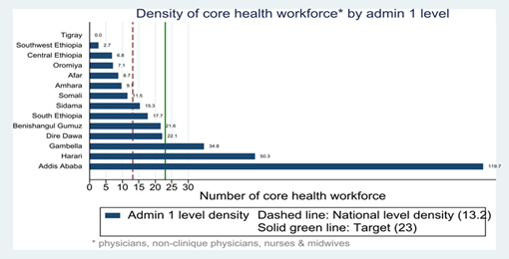

Core health professionals per 10,000 population

**Number of health facilities per 10,000 population:**

Health infrastructure is another useful indicator, including all hospitals, health centers and lower level health facilities such as health posts and dispensaries. Both private and public sectors should be included. The number of health facilities per 10,000 population is a crude indicator as it mixes small and large facilities (2 per 10,000 could be used as an indicative number, where less than 2 is considered low).

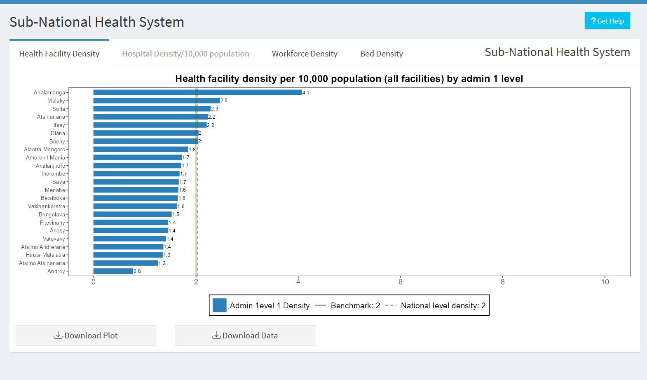

Number of health facilities per 10,000 population

**Number of hospitals per 100,000 population and number of hospital beds per 10,000 population:**

Additional insights into the infrastructure for in-patient services can be obtained by computing the number of hospitals per 100,000 population and by the number of hospital beds per 10,000 population.

***Figure: Number of hospitals per 100,000 population, by region and national***

***Figure: Number of hospital beds per 10,000 population, by region and national***

# Health Systems Outputs

## Health systems outputs

The second part of the analysis explores the association between health system inputs and service utilization and coverage by sub-national units (admin1).

The following can be examined:

1. ***Association between hospital density (per 100,000) and admission rates for children under 5 and beds per 10,000 population and admission rates for children under 5, by admin1.***

* We expect that regions with lower hospital density have lower admission rates for children, and those with higher density have higher admission rates. This would show as a positive slope of a linear regression line, as below.
* *Insert screenshot (6-ipd_use)*
* There may be major outliers. For instance, regions with low density and high admission rates: this may be because:
  + Hospital density is under-reported by these regions
  + Hospitals in the low density regions have very high admission and bed occupancy rates
  + Hospital admission are over-reported in these regions.
* The interpretation should be based on knowledge of the actual situation in the regions.

1. ***Association between health workforce (core health professionals per 10,000) and outpatient visits among children under 5, by region***

* We expect that regions with lower health workforce density have lower OPD utilization rates for children, and those with higher density have higher admission rates. This would show as a positive slope of a linear regression line, as in the figure below.

*(insert screenshot: 6-opd_use)*

* There may be major outliers, for instance, regions with low health workforce density and high OPD utilization rates. This may be because:
  + Health workforce density is under-reported by these regions
  + Health workers have a very high workload in these regions
  + Health workforce density is over-reported in these regions (less likely).
* The interpretation should be based on knowledge of the actual situation in the regions.

1. ***Association between health workforce (core health professionals per 10,000) and institutional live birth coverage, by region***

* For delivery coverage, data by region from either a recent household survey or the most recent DHIS2 data derived estimate can be used.
* We expect that regions with lower health workforce density have lower institutional delivery rates for children, and those with higher density have higher rates. This would show as the positive slope of a linear regression line.
* *insert screenshot (6-inst_delivery)*
* The considerations for the interpretation are the same as above.

# Private Sector Analysis

## Private sector and RMNCH services

### Rationale, Approach and implementation

**Rationale: Scientific basis for the analysis**

The private sector plays a significant role in delivering RMNCH (Reproductive, Maternal, Newborn, and Child Health) services, although its contribution varies both between and within countries. While routine health facility data are intended to capture private sector service delivery—such as the number of deliveries or family planning visits—this information is often incomplete, as reporting from private facilities tends to be less consistent than from public ones. Ideally, all private facilities should be included in the master facility list, but this is frequently not the case.

To estimate the private sector’s contribution more accurately, survey data such as those from DHS and MICS can be used. These surveys include questions about the source of health services, distinguishing between public and private providers.

**Approach: Description of analytical steps**

In this analysis, we use three key indicators to assess the private sector’s role at the national level and disaggregated by urban and rural residence.

The three indicators are:

1. **Deliveries**: Percent of live births occurring in health facilities among all live births in the last two years, by public private; with the share that is private
2. **Surgical interventions**: Percent of C-sections that occur in health facilities among all live births in the last two years, by public private; with the share that is private
3. **Curative care for children**: Percent of children under-five who have sought care for fever, acute respiratory illness or diarrhoea in the last two weeks before the interview, by public private; with the share that is private

It is generally expected that women and children in urban areas rely more on privately provided services than those in rural areas.

There are, however, two caveats to the interpretation:

* Rural women may use private services located in urban areas, which means that the percentage of women / children is overestimated for rural residents.
* The distinction between private-for-profit and non-profit private facilities is not made in this analysis. Each country uses a different classification and naming convention, and also for the survey respondent this distinction is difficult to make.

**Implementation: Conducting analysis in the Shiny App**

This can be analyzed using the Health System Performance tab -> Private sector as shown in **?@fig-hs_performance**.

# Planning Ahead

# Planning Ahead

1. Surveys can provide coverage of IFA supplementation, as here the unit of data analysis is individual pregnant women.
2. Amouzou A, Hazel E, Vaz L, Sanni Y, Moran A. Discordance in postnatal care between mothers and newborns: Measurement artifact or missed opportunity? J Glob Health. 2020 Jun;10(1):010505.
3. Okwaraji YB, et al. National, regional, and global estimates of low birthweight in 2020, with trends from 2000: a systematic analysis. Lancet. 2024 Mar 16;403(10431):1071-1080.
4. Therefore, the survey data on immunization roughly refer to the program performance in the year before the survey
5. https://www.track20.org/pages/data_analysis/publications/methodological/family_planning_estimation_tool.php
6. Maternal death is defined as any cause related to or aggravated by pregnancy or its management (excluding accidental or incidental causes) during pregnancy and childbirth or within 42 days of termination of pregnancy, irrespective of the duration and site of the pregnancy
7. A baby who dies after 28 weeks of pregnancy, but before or during birth, is classified as a stillbirth. Often the distinction is made between ante-partum (macerated) and intrapartum (fresh) stillbirths.
8. It is however good to inspect the data and consider extreme outliers (more than 3 standard deviations from the annual, or more than 5 times the median absolute deviation – see data quality section.
9. The assumptions on the range of ratios for community to institutional MMR were selected based on studies that measured both institutional and population mortality estimates (or had information about the percent of all maternal deaths that occurred at health facilities and the percent of deliveries that took place at health facilities.
10. An important factor affecting MMR estimates from health facilities, especially if the data are gathered through MPDSR, is that many deaths occur outside of the maternity ward (upon re-admission). If the DHIS2 is based on the reporting of all cause-specific deaths in health facilities, and the maternal death is correctly classified, this is not an issue.