**Step one:** build the database

We use the MySQL database. First, build or select a new schema. Second, use three following files under the folder ***src\main\java\resources\final*** to create tables:

* apichange.sql
* example.sql
* inner_example.sql

**Step two:** modify the configuration.xml

Modify configuration.xml under the folder ***src\main\java\resources.*** Change the third element **environment** in the element **environments** to your own configuration.

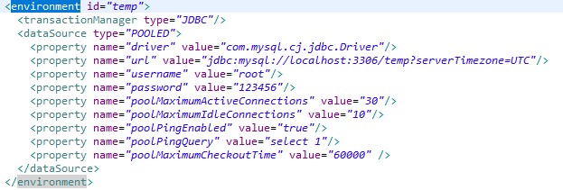

**Step three:** package by maven

Use the command ***mvn package -Dmaven.test.skip=true*** to package the project.

Then we can run it by using ApiChangeExtractor-0.7.0-jar-with-dependencies.jar in the target folder:

***java –jar ApiChangeExtractor-0.7.0-jar-with-dependencies.jar res***.

**PS**: ApiChangeExtractor-0.7.0-jar-with-dependencies.jar is the jar that we get by step three, and res is the file that contains all projects’ absolute paths we want to analysis, one line one project.