**Create TEMCO token contractor**

*** Remix cannot accept large number as integer. Put "" on the number to pass. Double quote word file and notepad are different. Please copy value in notepad and put correct double quote

Test environment:

* <https://remix.ethereum.org>
* MetaMask on Ropsten
* https://www.myetherwallet.com

Total supply, token name, and token symbol

Input)

10000000000, "TEMCO", "TMC23"

Gas limit: 4000000

* **Basic coin send test**

Wallet address: 0xd3B06D300ee69f74f0425283DBdd2f55587D6F59

Contract address: 0x760b7c2d342140d0c02edb59b71dd3574b495de8

Send to address total 875 coin: 0xeE5Dc613fd97009ec0c363320087BE463a2A246f

Go to Myether wallet (<https://www.myetherwallet.com/#send-transaction>)

Add token to “Add Custom Token”

Transaction result: <https://ropsten.etherscan.io/tx/0x156445255b53ab0457ffc3084c6138af6420e1a196b97fa0550d057084e2b428>



* **Increase total amount from Mint**

Before:

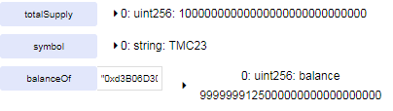

Increase 875

*** Remix cannot accept large number as integer. Put "" on the number to pass. Double quote word file and notepad are different. Please copy value in notepad and put correct double quote

Parameter: "0xd3B06D300ee69f74f0425283DBdd2f55587D6F59", "875000000000000000000"

Function: mint

After:

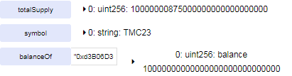

* **Disable Mint**

Function: finishMinting

After:



Try run **Increase total amount from Mint**

Exception cannot run Mint

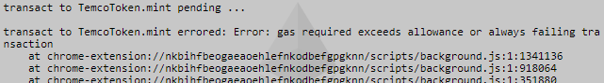

* **Decrease total amount from Burn**

Before:



Burn 321 coins

Parameter: "321000000000000000000"

Function: burn

After:

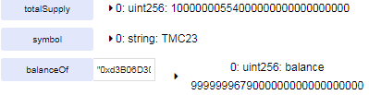

* **Ownership permission**

Open one more Remix, copy and paste contract address on “At Address” and change different account on MetaMask

Wallet address: 0xeE5Dc613fd97009ec0c363320087BE463a2A246f

Contract address: "0x760b7c2d342140d0c02edb59b71dd3574b495de8"

* Ownership deny scenario from new address

Try run burn

Burn 543 coins

Parameter: "543000000000000000000"

Function: burn

After:

Exception thrown since no permission for the wallet address

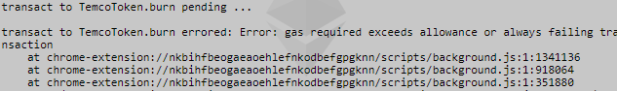

* Ownership add function deny scenario

Add ownership to the address

Parameter: "0xeE5Dc613fd97009ec0c363320087BE463a2A246f"

Function: addOwnership

After:

Fail since the address does not have ownership. Cannot add ownership.

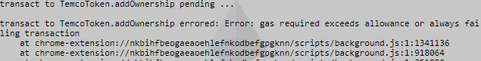

* Ownership add scenario

Change to previous address which created contract (0xd3B06D300ee69f74f0425283DBdd2f55587D6F59)

Add ownership to the address

Parameter: "0xeE5Dc613fd97009ec0c363320087BE463a2A246f"

Function: addOwnership

After: Ownership added to the address



* Ownership run scenario

Try run again burn from new ownership address 0xeE5Dc613fd97009ec0c363320087BE463a2A246f

Burn 543 coins

Parameter: "543000000000000000000"

Function: burn

After:



* Ownership remove scenario

Parameter: "0xeE5Dc613fd97009ec0c363320087BE463a2A246f "

Function: removeOwner

After: ownership removed



* **Add lock up for private sale**

Transfer 789 coin to 0xe1510988B463D705E98c8B100a0Fd52a72D43aa3

<https://ropsten.etherscan.io/tx/0x863b0fc886bd63f5dc766adcb08601b3e9826c70b01ffb80e55ef41b5ce7aca3>



Send 89 TMC coin to 0x1C8b5098C806092D9Aaa63e5F4757F61584d0de9

<https://ropsten.etherscan.io/tx/0x041ca31bc6d2bc699c72695201dc523464c1aeb11c57adb5f8f5b2068ebdd48f>



* Coin cannot transfer during lock up period scenario

Add 10 minutes lock up for the address

Parameter: "0xe1510988B463D705E98c8B100a0Fd52a72D43aa3", 10

Function: addLockUp

After:



Try to send 70 TMC coin to 0x1C8b5098C806092D9Aaa63e5F4757F61584d0de9

Exception thrown.

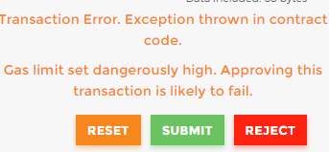

* Coin transfer after lock up period passed scenario

After 10 minute, try to send 70 TMC coin to 0x1C8b5098C806092D9Aaa63e5F4757F61584d0de9

<https://ropsten.etherscan.io/tx/0x306fe32284f0452c7b65570f9b647f58d08805b3a44abf28b875dc65041b0d4c>

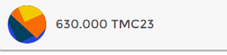

**Create TEMCO Crowd Sale contractor**

* temcoAddress TEMCO token address
* temcoTokenContractAddress TEMCO token contract address
* etherAddress wallet to transfer amount raised
* crowdStartInMinutes crowd sale start time. Unit is days
* crowdDurationInMinutes crowd sale duration. Unit is days
* minEther minimum ether to receive. Unit is 0.1 ether
* fundingGoal funding goal for crowd sale
* rate conversion rate from ether to temco coin
* lockUp lock up duration for current sale. Unit is days)

Input)

"0xd3B06D300ee69f74f0425283DBdd2f55587D6F59", "0x760b7c2d342140d0c02edb59b71dd3574b495de8", "0xd3B06D300ee69f74f0425283DBdd2f55587D6F59", 0, 10, 1, "5000000000000000000", 31547, 20

* Crowd sale close after goal is matched scenario

Goal reached

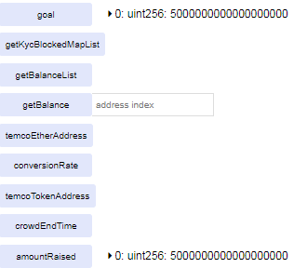

Cannot send ether anymore.

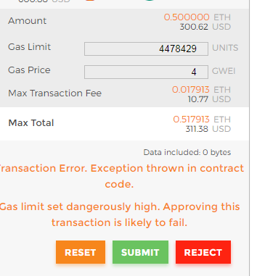

* Crowd sale after times up

"0xd3B06D300ee69f74f0425283DBdd2f55587D6F59", "0x760b7c2d342140d0c02edb59b71dd3574b495de8", "0xd3B06D300ee69f74f0425283DBdd2f55587D6F59", 0, 5, 1, "5000000000000000000", 31547, 20

1 ehter able to receive.

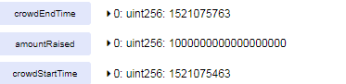

Wait 5 min, send falling

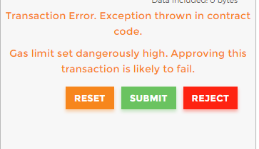

* Full crowd sale scenario.
* Investors send ether to crow sale
* Close crowd sale when reached to goal
* KYC block
* Send ether to TEMCO wallet after crowd sale closed
* Lock investors

"0xd3B06D300ee69f74f0425283DBdd2f55587D6F59", "0x760b7c2d342140d0c02edb59b71dd3574b495de8", "0xd3B06D300ee69f74f0425283DBdd2f55587D6F59", 0, 20, 1, "9000000000000000000", 340, 30

|  |  |  |  |  |
| --- | --- | --- | --- | --- |
| **Address** | **Invest** | **KYC Block** | **Rate** | **Expected TEMCO coin** |
| 0xeE5Dc613fd97009ec0c363320087BE463a2A246f | 1 | N | 340 | 340 |
| 0xe1510988B463D705E98c8B100a0Fd52a72D43aa3 | 1.5 | N | 340 | 510 |
| 0x1C8b5098C806092D9Aaa63e5F4757F61584d0de9 | 2 | Y | 340 |  |
| 0x381881C9D089362d5bdF8B4683690E1Ea6Ab74fa | 0.8 | N | 340 | 272 |
| 0xd5FcAD68062f4B532D56De65ec30BfFa05511986 | 2.5 | N | 340 | 850 |
| 0x8e087Db829C6426E96C3C567a1397904A599698F | 1 | N | 340 | 340 |
| 0xb5cdB28705afE893824aD823fF1Fd068C59a73c7 | 0.6 | N | 340 | 204 |

After sale closed,

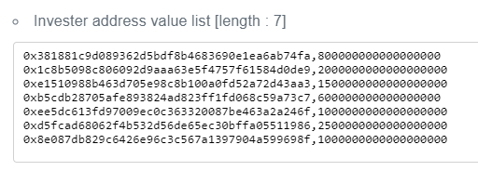

Add block user for 0x1C8b5098C806092D9Aaa63e5F4757F61584d0de9

Parameter: "0x1C8b5098C806092D9Aaa63e5F4757F61584d0de9"

Function: addBlockList

KYC block list added.

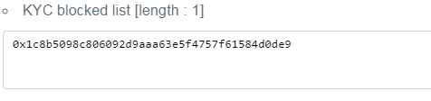

Send out TEMCO token to investor

Add ownership to crowd sale contractor on TEMCO token contractor

0x845153e0c0b7599c0a78adde5ff74043f3e43001

0xeE5Dc613fd97009ec0c363320087BE463a2A246f

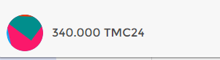

0xe1510988B463D705E98c8B100a0Fd52a72D43aa3

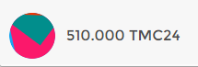

0x1C8b5098C806092D9Aaa63e5F4757F61584d0de9

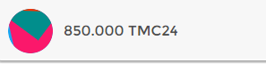

0x1C8b5098C806092D9Aaa63e5F4757F61584d0de9

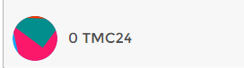

0x381881C9D089362d5bdF8B4683690E1Ea6Ab74fa

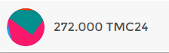

0x8e087Db829C6426E96C3C567a1397904A599698F

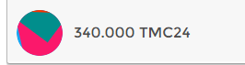

0xb5cdB28705afE893824aD823fF1Fd068C59a73c7

