Enter only names of Teammates who are present to work on this Milestone.

|  |  |  |  |  |  |  |  |
| --- | --- | --- | --- | --- | --- | --- | --- |
| **Teammate FNs:** | Micah | Alex | | | Peter | | Colin |
| **Purdue Logins:** | huffma11 | apieprzy | | | pswales | | cjamison |
| **Section Number:** | 014 | |  | **Team Number:** | | 05 | |

|  |
| --- |
| **Read these Instructions:**   1. Read through this Milestone before beginning your work so you understand its scope. Also, carefully read the contributions sections so you understand what is expected of each teammate. 2. Save this answer sheet as **M4_*sss*_*tt*.docx** where ***sss*** is your section number (07, 14, or 15) and ***tt*** is your team number (e.g., 03 for team 3).    * Make sure all teammates have copies of all submitted project files all the time. 3. **BE SURE** to indicate in your MATLAB .m file, using as many comments as necessary, the specific details of your refinements. Please label them “Category 1” and “Category 2” or “Category 3”, and use comments to briefly describe the nature of the refinements. 4. Cite your sources in APA format with (1) an in-text citation where referenced in the body of the text **and** (2) a full citation in the Reference section of this Milestone. As a reminder, it would be an example of **Academic Dishonesty** if you don’t include in-text citations and references. 5. FOR UPLOAD TO Bb prior to Class 30   You MUST submit your PUBLISHED .m files. Publish with input and include output – do NOT suppress output!  Compress all deliverables into one zip file named **M4_*sss_tt*.zip**.  Update all MATLAB .m file names to **M4** and name the algorithm files as explained in this document. You will be submitting ***three*** .m files, the **M4** answer sheet, and the **M4 Technical Brief** as part of this assignment:   * + **M4Exec_*sss_tt*.m**   + **M4Alg_*sss_tt*.m**   + **M4Regr_*sss_tt*.m**   + **M4_*sss_tt*.docx**   + **M4TechBrief_*sss_tt*.docx**   Submit the zipped file to the M4 Dropbox on Bb prior to Class 30.   * Only one submission of the zip file with all documents is required per team. * Only the last submission will be graded; make sure all deliverables are submitted at the same time.  1. BRING A COMPLETE SET OF THESE DOCUMENTS to Class 30   All docs (Milestones **and** Matlab code) should be double-sided printed stapled  For M4 iterations, use ***CAPS BOLD ITALIC*** to identify corrections from your prior version  For .m files, use “format compact” to suppress the display of blank lines  You MUST print your PUBLISHED .m files. Publish with input and include output – do NOT suppress output! |

|  |
| --- |
| **Particular Learning Objectives are highlighted throughout the document. However, all LOs that you have encountered throughout the semester may apply where appropriate to your work on the Milestones.** |

**Part 0: M3 Feedback Review**

|  |
| --- |
| **Learning Objective (LO): 22.00 Reflect on feedback for the purpose of improvement**  ***Evidence of Proficiency Requires*:**   * Feedback summarization is clear and useful * Response plan is clear and practical |

1. In your own words, summarize the feedback you received on project milestone M3 that could lead to improvements in your work.

|  |
| --- |
| Based on our feedback from M3, it appears that a couple of our average tau values were inaccurate. In addition, we failed to report the linear form of the equation for the price vs tau regression, and a few syntactical errors were present in the graph legend as well. Finally, it appears that we overlooked and failed to update the function call description for our executive function. |

1. Based on your feedback, what do you need to do to improve your parameter identification approaches? (Do not just reword your response to Part A. Consider how you will incorporate your feedback into your work.)

|  |
| --- |
| Based on our feedback from M3, it is clear that we need to look over and double-check our work. Nearly all of the above errors could have been avoided with a second glance over our code and/or outputs. In determining the success of our identified parameters, it may be beneficial in the future to consider the accuracy of our parameter values with regards to the given data before moving on. This may include creating graphs in MATLAB to qualitatively assess our mean tau values among other parameters overlaid with the raw data. |

**Part 1: Refinements Preview**

Consult the M4 memo from FOS, Inc. for the details concerning your task. Respond to each of the prompts below in the space provided. Your goal is to introduce ***two refinements*** to your original algorithm, and these refinements must improve your solution to the FOS parameter identification problem. ***Read the rest of this document*** ***carefully*** ***before you begin your work on this milestone***.

**Definition of “refinement”**

In this milestone, a refinement will fall into one of the following categories:

* **Refinement Category 1: Parameter Identification:** an improvement that changes the way you are doing parameter identification, and that improves your parameter identification results.
* **Refinement Category 2: Algorithm Efficiency:** an improvement that improves the efficiency of your code by (for example) removing unnecessary looping structures, streamlining data handling, or otherwise reducing the execution time of your code.
* **Refinement Category 3: Algorithm Insight:** an improvement that involves analysis of your code and its limitations. For example, if you use any kind of thresholding in your code, you could determine the sensitivity of the solution to changes in that threshold parameter, and report how those changes affect your parameter identification and/or regression results.

In this milestone, you are ***REQUIRED*** to implement the Parameter Identification refinement (**Refinement Category 1)**. You must *also implement one of the other two refinements (either Refinement Category #1 or #2)*. You are therefore required to implement ***two*** total refinements.

Which refinements are you implementing in your code? [*Clearly mark your selection*]

Top of Form

 A parameter identification refinement. This refinement is ***required***. Report your results in the section labeled **Refinement Category 1** below.

 An efficiency refinement. If you chose to implement this kind of refinement, report your results in the section labeled **Refinement Category 2** below.

 An insight refinement. If you chose to implement this kind of refinement, report your results related in the section labeled **Refinement Category 3** below.

Bottom of Form

|  |
| --- |
| **Learning Objective (LO): 21.02 Communicate ideas clearly and concisely**  ***Evidence of Proficiency Requires:***   * Purpose of communication is clear * Improvements are fully but concisely described   + All steps are included   + Appropriate technical language is used   + Clarifying images (e.g., sketches, graphs and/flow charts) are provided (as necessary) * External research is accompanied by an in-text citation and full reference |
| **Learning Objective (LO): 21.03 Evaluate model or algorithm development (e.g. ideas, work, functionality) using evidence-based rationales**  ***Evidence of Proficiency Requires:***   * Assumptions, claims, and critical decisions are clearly stated * An appropriate source of evidence is used to support assumptions, claims, and critical decisions * The evidence is clearly articulated * External research is accompanied by an in-text citation and full reference |

Briefly describe, in words (not code), the nature of the refinements you will implement in your MATLAB code. Provide a brief, but thoughtful, description of your refinement, *using evidence-based rationales for why the refinement is necessary and how it should improve your solution*.

|  |
| --- |
| **Refinement 1. Category 1: Parameter(s) Targeted: __ Tau __** |
| Description  We will be adjusting the increment by which we are testing for tau, i.e. the hardcoded value that determines the range for the moving average, and determining which increment gives the best SSE. Thus, the SSEmod is our metric for improvements to tau. |
| Rationale for Refinement  Although our value for tau is quite accurate, it still can be improved. By comparing our parameter values from our algorithm from M3 to the actual values, we determined our value of tau was the most inaccurate of them all. Since tau is integral in determining the modeled temperature values, it has a direct correlation to the SSEmod, which determines the approximate error with which our algorithm represents the data. |

|  |
| --- |
| **Refinement 2. Category 3: __Algorithm Insight___** |
| Description  We plan on adjusting our algorithm by getting rid of or adjusting hard coded values used to calculate our parameters. These hard coded values resulted in errors when they were too low, i.e. our code couldn’t find a value within the range for the moving average. We plan on changing these hard coded values through an analysis of the slope of the moving average for each iteration to approximate the rate at which the thermocouple is heating up or cooling down. In short, we will adjust our hard coded values to accommodate steep and shallow data. |
| Rationale for Refinement  Our team noticed that the SSE calculated with our parameter values deviated significantly from the SSE calculated with the actual parameter values. We think the source of the problem stems from the error in our tau values and the range being a static test. By having a dynamic range that accommodates different data behaviors (e.g. shallow slope, large deviation of data points, etc.) when evaluating data points for tau, we should improve our SSE dramatically. |

**Part 2: Refinements**

Resave all M3 files as **M4Exec_*sss*_*tt*.m**, **M4Alg_*sss*_*tt*.m**, and **M4Regr_*sss*_*tt*.m** before starting to make refinements.

**Refinement Category 1: Parameter Identification (*Required*)**

Make all necessary refinements to your M3Alg in your **M4Alg_*sss_tt*.m** file.Refinements must be clearly commented in your code with the text “Category 1” AND with an adequate description.Then evaluatethe improvement in your refined parameter identification algorithm. Use the clean and noisy calibration data from M2 and compare the parameters identified from the calibration data using the algorithm you submitted as your solution for M3 and your refined algorithm for M4. Report your results in Tables 1 and 2. Take care with units and decimal places when presenting results.

**Table 1. Algorithm performance comparison to HEATING calibration parameters**

|  |  |  |  |  |  |  |
| --- | --- | --- | --- | --- | --- | --- |
|  |  | |  | | **HEATING** | |
| Parameter | M3 Algorithm | | M4 Algorithm | | Actual | |
| Clean | Noisy | Clean | Noisy | Clean | Noisy |
| yL | 0.25 oC | -1.51 oC | 0.25 oC | -1.51 oC | 0.25 oC | -0.96 oC |
| yH | 99.38 oC | 98.04 oC | 99.38 oC | 98.04 oC | 99.38 oC | 98.75 oC |
| ts | 1.34 sec | 1.84 sec | 1.3438 sec | 1.8369 sec | 1.37 sec | 1.84 sec |
| τ | 0.24 sec | 1.34 sec | 0.2356 | 1.3600 sec | 0.21 sec | 1.35 sec |
| SSEmod | 0.6433 | 2.1535 | 0.6432 | 2.1010 | 0.0033 | 2.6468 |
| ***Note:*** Verify your SSEmod calculatin. Heating Actual Clean SSEmod should be between 0.00 and 0.05 sec2; Heating Actual Noisy SSEmod should be between 2.30 and 2.90 sec2 | | | | | | |

**Table 2. Algorithm performance comparison to COOLING calibration parameters**

|  |  |  |  |  |  |  |
| --- | --- | --- | --- | --- | --- | --- |
|  |  | |  | | **COOLING** | |
| Parameter | M3 Algorithm | | M4 Algorithm | | Actual | |
| Clean | Noisy | Clean | Noisy | Clean | Noisy |
| yH | 100.06 oC | 97.23 oC | 100.06 oC | -0.91 oC | 100.06 oC | 97.99 oC |
| yL | -0.93 oC | -0.91 oC | -0.93 oC | 97.23 oC | -0.93 oC | -0.01 oC |
| ts | 1.03 sec | 1.92 sec | 1.0254 sec | 1.9150 sec | 1.02 sec | 1.93 sec |
| τ | 1.89 sec | 1.02 sec | 1.8673 sec | 1.0283 sec | 1.92 sec | 1.03 sec |
| SSEmod | 0.2653 | 3.2411 | 0.2174 | 3.2352 | 0.5288 | 4.5431 |
| ***Note:*** Verify your SSEmod calculation. Cooling Actual Clean SSEmod should be between 0.50 and 0.62 sec2; Cooling Actual Noisy SSEmod should be between 4.01 and 5.01 sec2 | | | | | | |

Using your M4 algorithm, analyze the 100 time histories provided by FOS, Inc. to identify the four relevant first-order system parameters (yL, yH, ts, and τ) from each time history. In Table 3, copy your results from M3 for the M3 algorithm, and record your results for your M4 algorithm. Take care with units and decimal places when presenting results.

**Table 3. Algorithm performance comparison for FOS designs**

|  |  |  |  |  |  |  |
| --- | --- | --- | --- | --- | --- | --- |
| **Model Number** | **M3 Algorithm** | | | **M4 Algorithm** | | |
| **τ Characteristics** | | **Mean SSEmod** | **τ Characteristics** | | **Mean SSEmod** |
| **Mean** | **Standard Deviation** | **Mean** | **Standard Deviation** |
| FOS-1 | 0.1822 sec | 0.0399 sec | 2.2443 sec | 0.1835 sec | 0.0387 sec | 2.2349 sec |
| FOS-2 | 0.3826 sec | 0.0375 sec | 1.3680 sec | 0.3822 sec | 0.0375 sec | 1.3596 sec |
| FOS-3 | 0.8665 sec | 0.0401 sec | 1.0563 sec | 0.8672 sec | 0.0387 sec | 1.0509 sec |
| FOS-4 | 1.2595 sec | 0.0302 sec | 1.0342 sec | 1.2591 sec | 0.0312 sec | 1.0238 sec |
| FOS-5 | 1.8171 sec | 0.0330 sec | 1.2678 sec | 1.7996 sec | 0.0288 sec | 1.2160 sec |

As necessary, make improvements to your price versus time constant (τ) regression model in **M4Regr_*sss_tt*.m**. Complete the price versus tau regression analysis on the 100 datasets using your M3 algorithm and your M4 algorithm. Generate a regression plot for your M3 algorithm and your M4 algorithm. Report the results of each model in Table 4.

|  |
| --- |
| **Learning Objective (LO): 12.00 Perform linear regression** |
| **Learning Objective (LO): 13.00 Perform function discovery and data transformations** |
| **Learning Objective (LO): 07.00 Create and evaluate x-y plots suitable for technical presentation (this includes all appropriate sub-LOs)** |

**M3 Regression Plot**

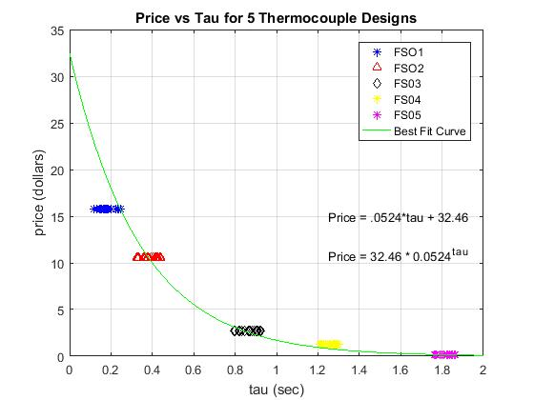

**M4 Regression Plot**

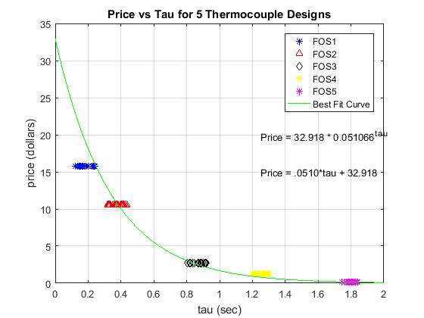

**Table 4. Algorithm performance comparison for price vs time constant regression models**

|  |  |  |
| --- | --- | --- |
| **Regression Result** | **M3 Algorithm** | **M4 Algorithm** |
| General Equation | price = 32.46 * 0.0524tau | price = 32.92 * 0.0511tau |
| SSE | 0.8883 | 0.9349 |
| SST | 35.2168 | 34.5307 |
| r2 | 0.9748 | 0.9729 |

**Refinement Category 2: Algorithm Efficiency**

***If you have refined the efficiency of your code***, complete Table 5 below to show the effects of your refinements. Use the MATLAB built-in functions **tic** and **toc** to measure how long it takes your code to execute. *Efficiency refinements must be clearly commented in your code with the text Category 2 AND adequate description.**Do not remove code; comment out unnecessary code and comment on the change. New code must be designated as such.*

**Table 5. Efficiency measurement results**

|  |  |
| --- | --- |
| **Algorithm** | **Execution Time (sec)** |
| **M3 Algorithm** |  |
| **M4 Algorithm** |  |

**Refinement Category 3: Algorithm Insight**

***If you have refined the robustness and performance of your algorithm*** in light of changes in a thresholding or other variable hardcoded in your algorithm, create one or more plots that illustrate the insights you have gained. The plot(s) should be suitable for technical presentation and clearly illustrate the effect of changes on the parameter identification and/or regression results. Write a paragraph that complements the plot(s). This paragraph must clearly describe changes to the thresholding or other variables hardcoded in your algorithm and the insights you gained. *The variables used in this analysis must be clearly commented in your code with the text Category 3 AND adequate description.*

*If you need guidance or other suggestions about how to execute this refinement, be sure to ask the teaching team*.

|  |
| --- |
| **Learning Objective (LO): 07.00 Create and evaluate x-y plots suitable for technical presentation (this includes all appropriate sub-LOs)** |

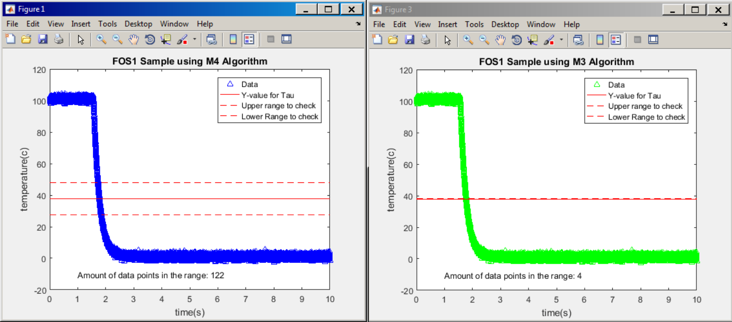

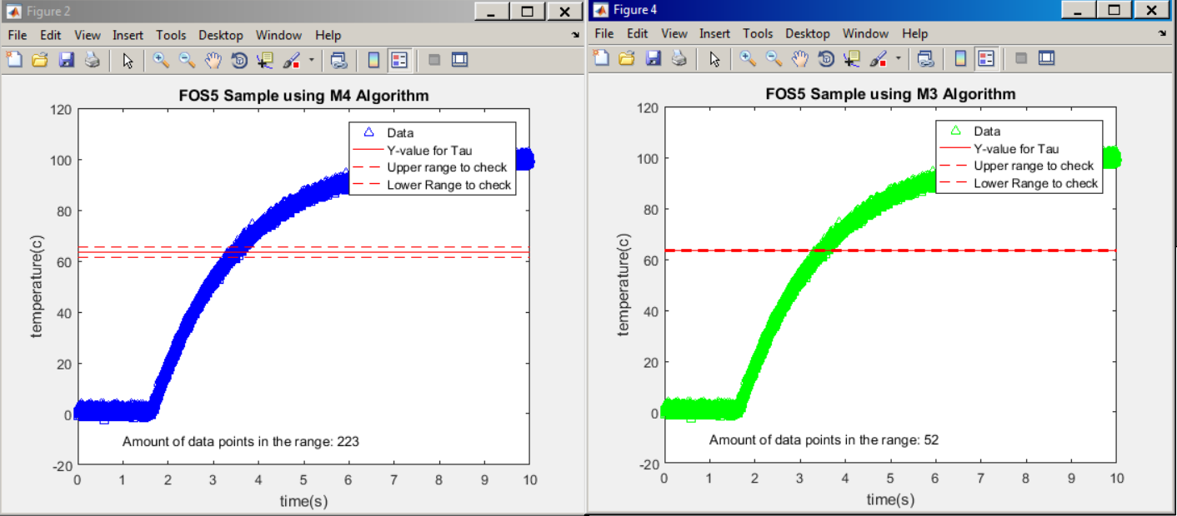

|  |
| --- |
| **Learning Objective (LO): 21.02 Communicate ideas clearly and concisely** |

|  |
| --- |
| **Description of Insights Gained**  What we discovered in M3 was that our SSE values for thermocouples that had very small tau values (i.e. fos1, fos2), were larger than the sets of thermocouples that had higher tau values. This was because we were using a hardcoded value of .4 to establish a “range” above and below our calculated temperature value for tau, this range is illustrated in the graphs above. Then using this range we took an average of the time values for every data point in the range, and called that tau. What we noticed was that for very steep rises in temperature, our range was catching very little data points, as shown in the M3 charts above, only 4 data points in a sample in fos1 were caught, this explains the difference in SSE between fos1 and fos5. What we decided to do to fix this problem, was to make the range dynamic based on the slope of the temperature spike. We first calculated the slope using an average of 2 clumps of 5 data points, the clumps are separated by 50 data points, this gives us a fairly accurate slope of the temperature spike near the tau value. Then to calculate the range we should use we took the square root of the slope and subtracted by a constant 5. What this allowed was that for very steep slopes, the range was big, which let us catch much more data points in our range, but for shallow slopes the range was lower, because shallow slopes still generate a lot of data points with a small range. **The dynamic range seen can be seen from the M4 graphs, the steeper slope fos1 sample has a big range, allowing us to catch many points and get a more accurate tau. The fos5 sample has a smaller range, which still generates a lot of points in range but makes our algorithm more efficient.** The amount of data points caught in the fos1 range increased by a factor of 30.5 from M3 to M4. |

**Technical Brief Draft**

|  |
| --- |
| **Learning Objective (LO): 21.02 Communicate ideas clearly and concisely** |
| **Learning Objective (LO): 21.03 Evaluate model or algorithm development (e.g. ideas, work, functionality) using evidence-based rationales** |
| **Learning Objective (LO): 07.00 Create and evaluate x-y plots suitable for technical presentation (this includes all appropriate sub-LOs)** |

Read M4 FOS Memo for final instructions for your Technical Brief and note the requirement to include a table and a figure. Then open your Technical Brief document, **M4_TechBrief*_sss_tt*.docx**, and once you complete M4, reread prior sections and make final corrections in ***CAPS BOLD ITALIC***. Then write Part 1 Section C2 (see note below) and Part 4.

Note: a small change to Part 1 Sections C1-C2 of limiting this section to 3 critical decisions:

Summarize three critical decisions your team made to improve the accuracy of the parameter identification during the development of your algorithm. For each decision, provide a clear description, evidence-based rationale(s) for decision, and a discussion of how the accuracy of your model was enhanced based on the decision.

Note: If you want this version to be your final version, make sure you make a note that the document you submit in Class 30 is your final version and you will not be providing any further changes in Class 32.

**REFERENCES (written in APA format – see Word>reference>manage sources>new tab)**

List your References used in evidence-based rationales for this Milestone. Also, copy and paste them into your M4 Tech Brief Reference Section. Each of your References requires an in-text citation!

|  |
| --- |
| Example (reference for an internet source):  Author Last, X. (year). Title xxxx xxx xxxx. Retrieved from http://www.url.xxx/xxxx/xxxx |
| No external sources used |

**INDIVIDUAL CONTRIBUTIONS on PROJECT**

**Part 1: Rate Self on Specific Criteria**

Write each teammate’s name in a separate column. Each teammate must **score** just your *own* behaviors during *this* Milestone. Indicate the extent to which he/she agrees with the statement on the left using a scale of 1-4 (0=did not attend or did not do; 1=strongly disagree; 2=disagree; 3=agree; 4=strongly agree). Each teammate totals the numbers in his/her own column. As a reminder, it would be an example of **Academic Dishonesty** if you record a false evaluation of your work or attendance for this Milestone.

|  |  |  |  |  |
| --- | --- | --- | --- | --- |
| Teammates Names:  Evaluation Criteria: | TM1:  Alex | TM2: Micah | TM3:  Peter | TM4: Colin |
| Came to classes prepared to work on current Milestone. | 3.7889450 | 4 | 4 | 4 |
| Was not distracted any time during class (phone, text, other hw, etc). (ONLY a 1 or 4) | 4 | 4 | 4 | 4 |
| Contributed meaningfully to team discussions and coding progress in class. | 3.9612458 | 4 | 4 | 4 |
| Demonstrated a cooperative and supportive attitude in class. | 3.7412580 | 4 | 4 | 4 |
| Attended team meeting(s). (ONLY a 0 or 4) | 4 | 4 | 4 | 4 |
| Arrived to team meeting on time.  (ONLY a 0 or 4) | 4 | 4 | 4 | 4 |
| Stayed at the team meeting for the entire time.  (ONLY a 0 or 4) | 4 | 4 | 4 | 4 |
| Came to team meeting prepared with assigned work completed and gave 100% during meeting. | 3.2154800 | 3 | 3 | 3 |
| Contributed meaningfully to team discussions and coding during team meeting. | 3.8954120 | 4 | 3 | 4 |
| Was not distracted any time during meeting (phone, text, other hw, etc). (ONLY a 1 or 4) | 4 | 4 | 4 | 4 |
| Demonstrated a cooperative and supportive attitude during team meeting. | 3.6745200 | 4 | 4 | 4 |
| Provided assigned code and answers to this Milestone on time and in a quality manner. | 3.5124780 | 4 | 3.33 | 3 |
| List specific range of lines of code you wrote *on your own* HERE - - - - - - - - - - - - - - - - -> | M4Alg2 ln 85-104  Executive  lines 100-137 | M4Alg2  ln 1-47  Executive lines 30-99 | M4Alg2 ln 69-84  M3Alg  ln 50 - 69  Executive lines 1-41, | M4Alg2  ln 48-68  M3Regr  ln 49-53  Executive lines 42-56 |
| Wrote your name in the comments of the code you wrote. | 3.999990 | 4 | 4 | 4 |
| Completed equal portion of this week’s Milestone. | 3.9695400 | 3 | 3 | 3 |
| If corrections were made to the code, added 2nd teammate’s name in the comments of edits made to original coder’s lines of code. (ONLY a 1 or 4 or N/A) | N/A | N/A | N/A | N/A |
| **TOTALS** | 53.7588688*i^4 | 54 | 51.33 | 52 |

Exceptions:

* If you feel your teammate's scoring is not accurate or a teammate contributed extremely little or a lot more to this milestone, please talk to your Instructor/GTA in class or send an email to your Instructor so we can help resolve any issues or imbalanced workload.

**Part 2: Describe Specific Contributions**

**Individually**, also **write** just your *own* specific task-oriented and detailed description of what you contributed to *this* Milestone. Your description should match your score! As a reminder, it would be an example of **Academic Dishonesty** if you write false contributions of your work for this Milestone or if you write the contributions for another Teammate, so only write your own contributions. Sign your name in your cell verifying true authorship of your work.

Teammate name Contributions (described in **DETAIL**)

|  |  |
| --- | --- |
| TM1 Alex | Developed improvements for the algorithm. Specifically worked on improving tau through using M4 Regression and creating a dynamic range for calculating tau. Created plots to show insight for dynamic range improvement. |
| TM2 Micah | Responsible for organizing team meetings and ensuring team stays on track towards the goal of the meeting and the desired progress on the assignment. Assisted in the development of M4Alg and M4Exec. Polished M4 technical brief. |
| TM3 Peter | Worked on improvements to the code, mostly to M4Alg, as well as describing the code in the technical brief. |
| TM4 Colin | Worked on feedback from milestone 3 and typed responses on how to improve. Typed sections of M4 technical brief and revised previous parts paragraphs. Generated ideas for improvements of algorithm |

Exceptions:

* If a teammate did not contribute in class or at a team meeting, then the space next to that teammate’s name should be left blank and an appropriate grade will be assigned.
* If a teammate does not write anything, then that will represent having not contributed to the milestone and an appropriate grade will be assigned.
* If you feel your teammate's description is not accurate or a teammate contributed extremely little or a lot more to this milestone, please talk to your Instructor/GTA in class or send an email to your Instructor so we can help resolve any issues or imbalanced workload.

**DELIVERABLES BY CLASS 30**

**ELECTRONIC – upload to M4 Dropbox on Bb by Class 30**

You MUST PUBLISH your .m files with input and include output – do NOT suppress output!

In the same submission, upload a zipped file that contains:

* M4_*sss_tt*.docx
* M4Exec_*sss*_*tt*.m
* M4Alg_*sss*_*tt*.m
* M4Regr_*sss*_*tt*.m
* M4_TechBrief_*sss_tt*.docx (final updated draft version or final version (let us know)); note change written in red in M4_Tech Brief section above

**HARD COPIES – bring a set of these documents to Class 30**

All docs (Milestones **and** Matlab code) should be double-sided printed stapled

For M4 iterations, use ***CAPS BOLD ITALIC*** to identify corrections from your prior version

For .m files, use “format compact” to suppress the display of blank lines

You MUST print your PUBLISHED .m files with input and include output – do NOT suppress output!

* M4_*sss_tt*.docx
* M4Exec_*sss*_*tt*.m
* M4Alg_*sss*_*tt*.m
* M4Regr_*sss*_*tt*.m
* M4_TechBrief_*sss_tt*.docx (final updated draft version or final version (let us know)); note change written in red in M4_Tech Brief section above

These documents will be graded and returned to you with feedback on Sunday afternoon. Dr. Strutz will post on Bb that you may come by ARMS 1335 to pick up your graded Milestone. You may also pick it up from Carlene on Monday in ARMS 1300 from 8am-5pm.