apiGrove tutorial 1: onboard Twitter API using GUI

NOTE: A KNOWN ISSUE WITH REDIRECTS PREVENTS APIGROVE TUTORIALS RESULTS.

Purpose

This tutorial shows how to onboard an API into apiGrove using the drupal GUI.

Prerequisites

Please ensure the following prerequites are met
- Ports 80 and 24100 on the apiGrove host are accessible from your test machine.
- A web browser is installed on the test machine.

Unless otherwise stated the tutorials commands are run from your testing host.

Instructions

- Open apiGrove url http://<hostname>:24100/e3
- Login as an administrator
  - Username admindrupal
  - Password adMin;123

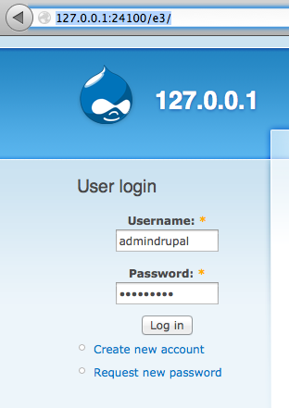

- Click E3 Link in the top left menu
- Click APIs link
- Click Add API link
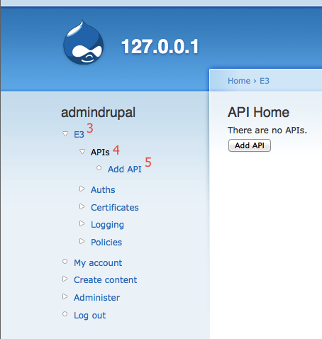
- Add API – Basic Details
Basic Information
ID | twitter
Name | twitter
Version | 1.0
Endpoint | twitter
Status | Active
Uses HTTPS
Composite API
Subscription Step | none

Authentication
HTTP Basic
IP White List
AuthKey
WSSe
Anonymous | checked

Validation
XML Validation
SOAP Validation
Content Validation

HTTP Method Filtering
Filter Methods

- Click Next
- Add API secondary details
- Add property required by the twitter API

Properties
Key | q
Value | news
Header Transformations
Transform Enabled
TDRs
TDR Enabled

- Click Next
- Add API Contexts

Add Context
ID | Test
Status | Active
TPS Warning | 10
TPS Threshold | 10
TPM Warning | 10
TPM Threshold | 10

- Click the Add Target Host Button
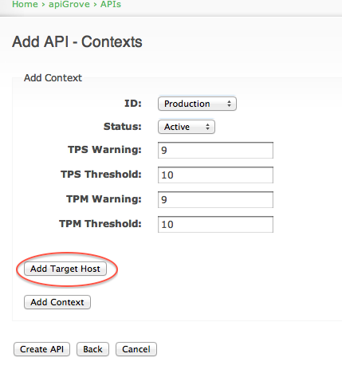

- Add Target Host data

Add Target Host
Host | http://search.twitter.com/search.json
Site | http://search.twitter.com/search.json
Proxy

- Click Submit Button (submits target host data)

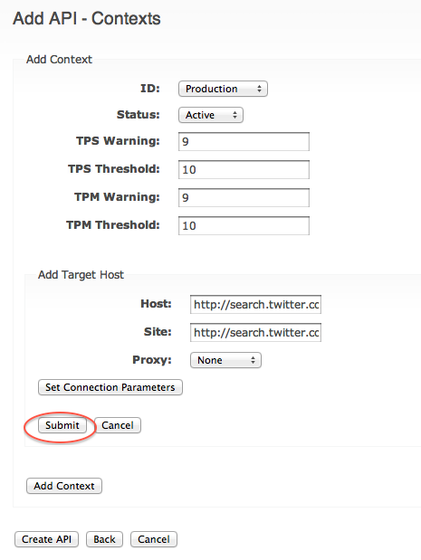

- Click Add Context (adds the context to the API)

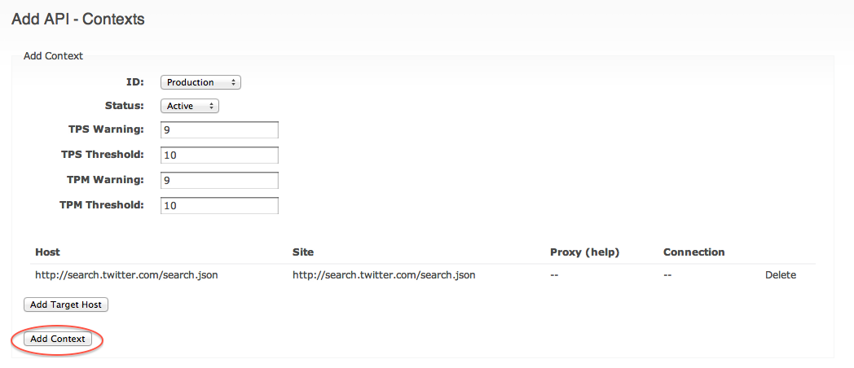
- Click Create API (creates and saves the API)

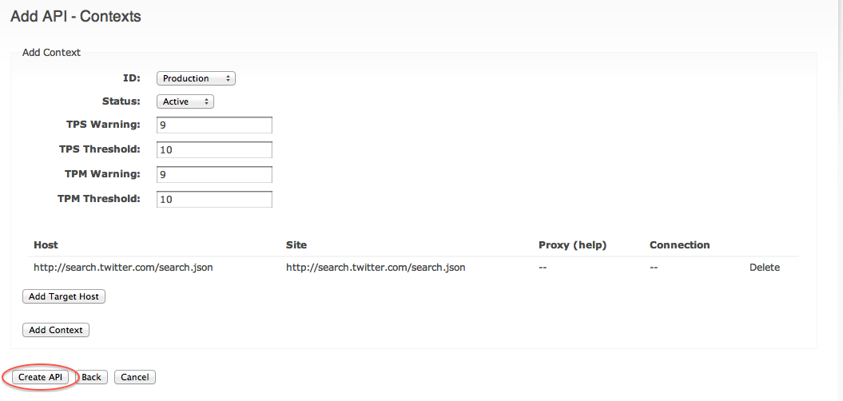
- Test the API by calling it 1 time http://<hostname>/twitter?q=news

{
"completed_in": 0.208,
"max_id": 2.3361934792971e+17,
"max_id_str": "233619347929714689",
"next_page": "?page=2&amp;max_id=233619347929714689&amp;q=news",
"page": 1,
"query": "news",
"refresh_url": "?since_id=233619347929714689&amp;q=news",
"results": [
{
"created_at": "Thu, 09 Aug 2012 17:42:47 +0000",
"from_user": "BritneyGriffit8",
"from_user_id": 747618186,
"from_user_id_str": "747618186",
"from_user_name": "Britney Griffith",
"geo": null,
"id": 2.3361934792971e+17,
"id_str": "233619347929714689",
"iso_language_code": "en",
"metadata": {
"result_type": "recent"
},
…

- Test the limits by calling the API 11 times http://<hostname>/twitter?q=news
Since we set the Transaction Per Minute at 10, the 11th call is rejected
Issue: Rate limit exceeded

