apiGrove tutorial 9: Onboard an API using the apigrove GUI

Purpose

This tutorial demonstrates how to add your API to apiGrove using the apiGrove GUI

Prerequisites

Please ensure the following prerequites are met
- A working install of apiGrove and apiGroveGUI
- A web browser

Instructions

- Open your installed apiGrove GUI url in a browser
- Login to apiGroveGUI

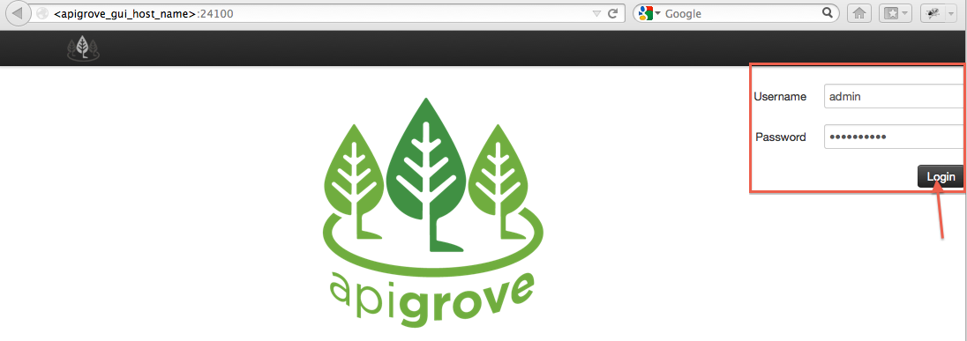
- Click on API in the top menu
- Click Create New
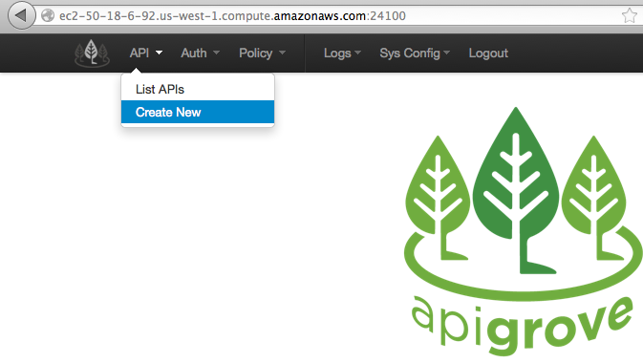

- Enter a Name for your API
- Enter an Endpoint (this is what consumers of the API will hit when they access it)
- Enter the target host where this API is hosted
- Click Part 2 button
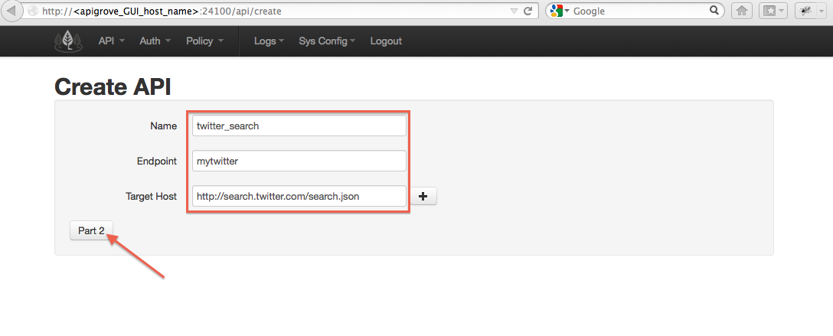
- Click The Enabled button (makes your API active immediately upon creation)
- Click the ‘No Auth’ button for Authenitcation Type
- Leave the HTTPS button unclicked
- Enter 9 for the Transactions Per Second (TPS) Threshold
- Enter 10 for the Transactions Per Minute (TPM) Threshold
- Select the GET button for allowed HTTP calls
- Click Save
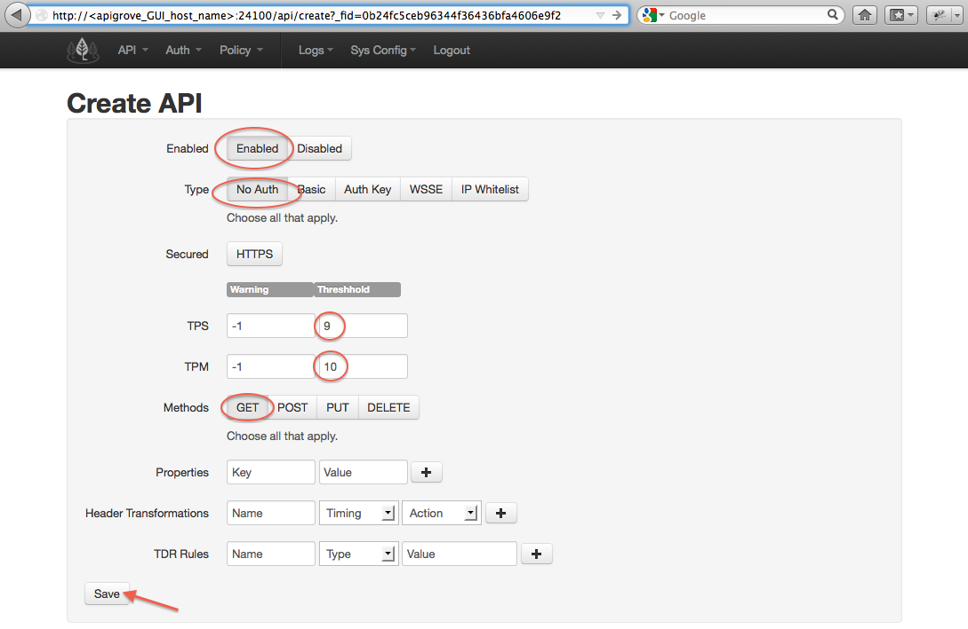

- apiGrove GUI returns a success message and lists your onboarded APIs
- Open the api endpoint against the apigrove host

The call returns json from your twitter search

